Salesman ID Maintenance (SLSM)

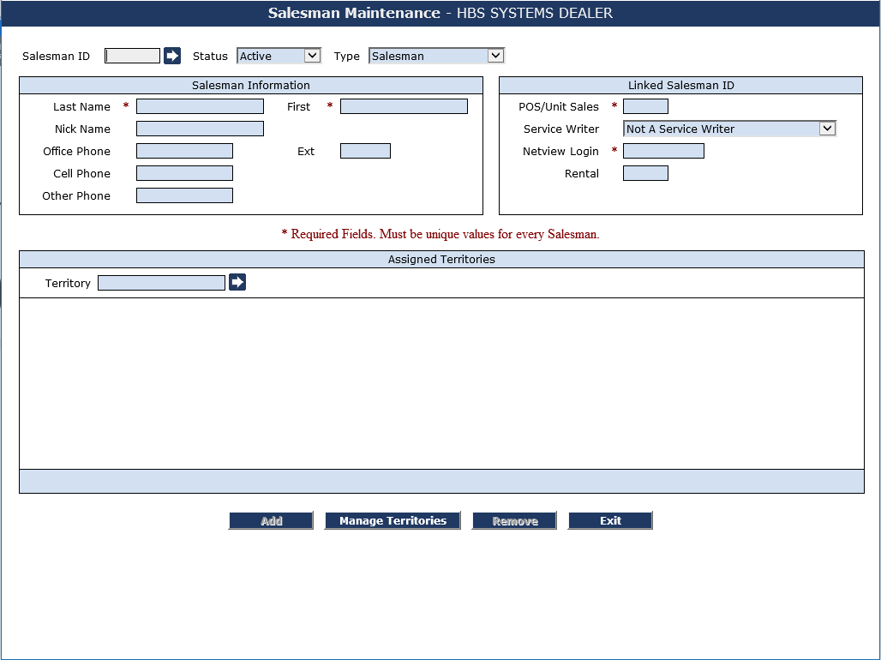

Salesman ID Maintenance is used to identify all sales personnel in Point-of-Sale (POS), Units, Service, and CRM. As noted in the section for logins, the login ID and the Salesman ID have to match.

To access this function, you can either:

- Select “System Maintenance” from the menu and choose the “Company File” submenu. Click on “Sales Person Maintenance.”
- Type “SLSM” in the Shortcuts Bar.

Field Definitions:

Salesman ID: Enter the login/Salesman ID

Status: Choose Active for the ID to be available in POS, Units, Service, or CRM.

Type: Choose the type that fits this ID:

- Salesman
- Manager (extended functions)
- Other

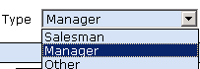

Salesman Information:
Fill in details about the Salesman in this section (see list below). First and Last Name are required and must be unique. Use middle initials if you have employees with the same name.

- Last Name
- First Name
- Nick Name
- Office Phone (with extension)
- Cell Phone
- Other Phone

Linked Salesman ID fields:

POS/Unit Sales: Fill in the 3-character ID for this Salesman (required field). These values will be available in a drop-down menu in POS and Units.

Service Writer: If you have the Service package, you may choose the appropriate service writer shown in the drop-down menu.

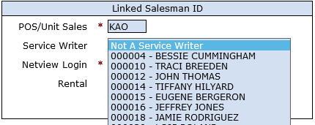

Netview Login: Enter the corresponding NetView Login in this field. It should match the Salesman ID and POS/Unit Sales ID.

Rental: If you have the Rental package, enter the Rental Salesman ID in this field.

Assigned Territories: This section of the Salesman ID is used to identify any assigned territories for the salesman.

Territory: Fill in the territory code or click on the arrow to the right of the field to display a list of the defined territories.

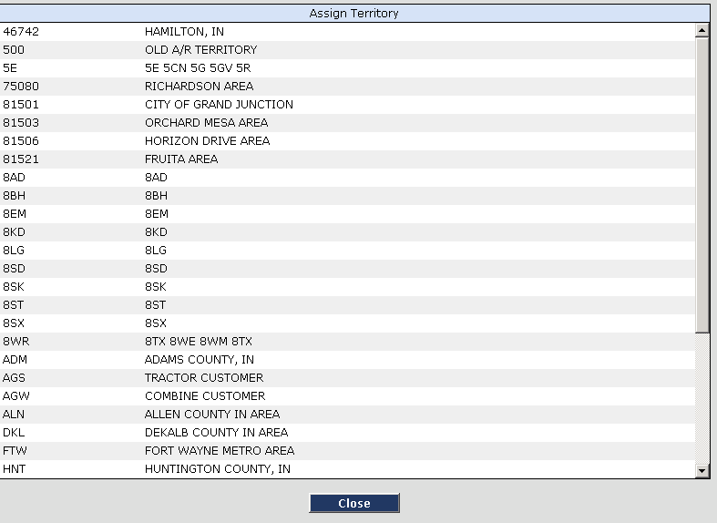

Click a territory shown to select it for the Salesman. Click Assign to add it to the Salesman.

Save: Click Save to save any changes made.

Exit: Click Exit to leave the Salesman screen.

