Source Master List (SML)

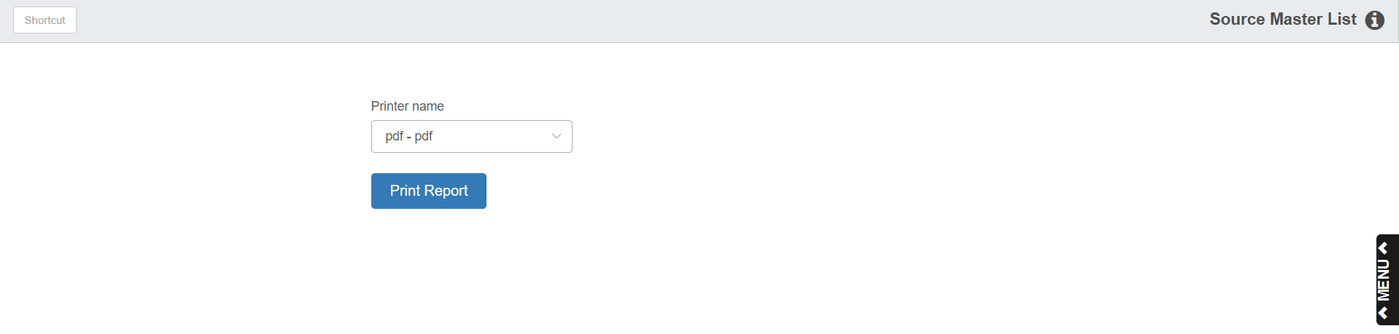

This report provides a listing of the detail found in all source masters. To access the Source Master List, you can:

- Select “Inventory” from the menu. Choose the “Reports” submenu and click “Source Master List.”
- Type “SML” in the Shortcuts Bar.

Printer Name: Select the printer to receive the printout. A default printer name is pre-filled, but can be changed as necessary. Use the pdf printer to view the report on the screen without printing a copy of it.

Print Report: Click this button to print your report.

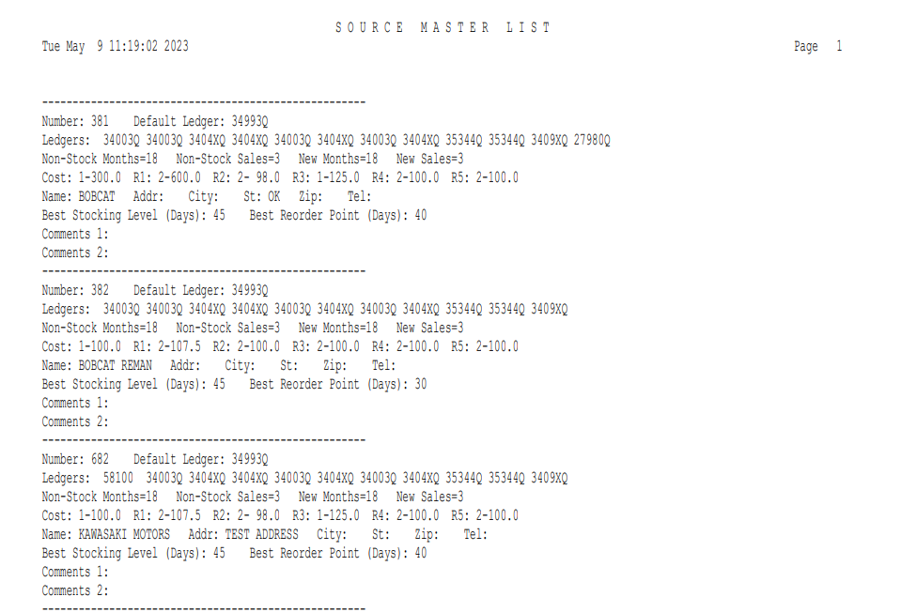

Report Details:

Number: This is the source number.

Default Ledger: This field is used to “catch” any transactions passed to an invalid account number or source number. The entry “34993” is appropriate for this field.

Ledgers: These are the General Ledger account numbers (Sales Codes) from the Parts Source Master.

Non Stock Months: The Number of Stocking Months holds the range of months used to determine the stocking class of the parts for this source.

Non Stock Sales: The Number of Stocking Sales field indicates how many months with actual sales activity are to be used for the calculation of the stocking class.

New Months: This field shows the time range a new part added with a stock class of 6 is kept at that stock class.

New Sales: This field works with the New Months field to set the number of months with actual sales activity to determine if the new part will be upgraded or downgraded depending on the activity.

Cost: This is the first tier of pricing from the Source Master.

Name: This is the name of the source.

Addr: This is the Address you listed for the source, including the city, state/province, zip/postal code, and telephone number.

Best Stocking Level (Days): This is the Best Stocking Level you specified in the Source Master.

Best Reorder Point (Days): This is the Best Reorder Point you specified in the Source Master.

Comments 1: This shows any information entered in the first comment line of the Source.

Comments 2: This shows any information entered in the second comment line of the Source.
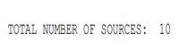

Total Number of Sources: The total number of source records on file appears as the last line on the report.

