Source Master Maintenance (SMM)

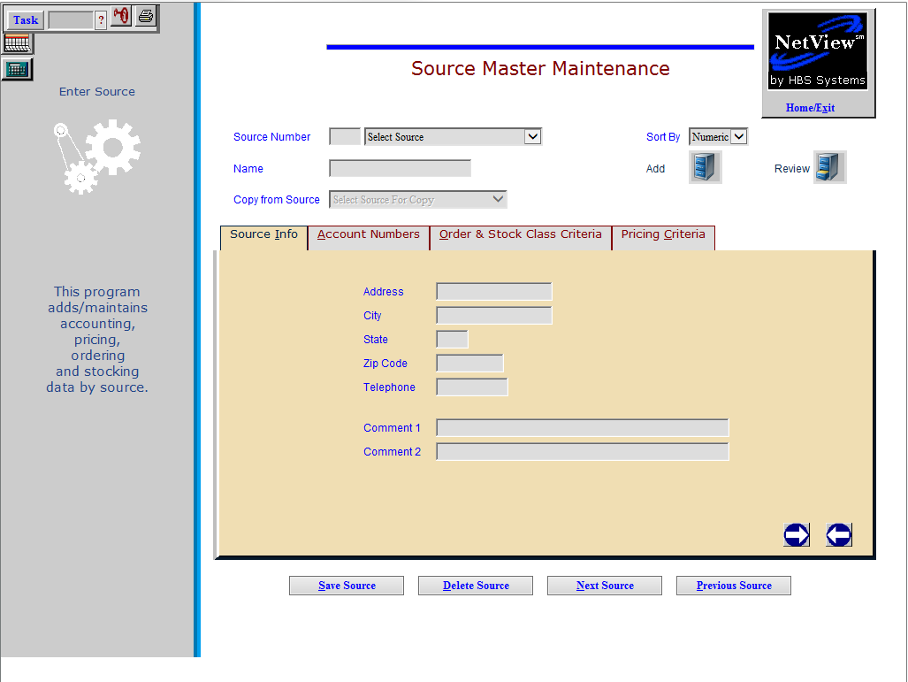

A Source Master Record is required for each manufacturer or “brand” of parts on the system. This record contains information which controls parts ordering, pricing, and accounting criteria for this manufacturer, and supplies defaults for new parts. The range of settings available in this area makes this program very flexible and adaptable to most dealership situations. In its simplest use, a Source Master Record should be present for each manufacturer’s parts line carried.

- Many of the settings in the Source Master Record are fed into the Part Master Record when a record is created. The vast majority of these settings are provided as a convenience to auto-fill the fields in the new Part Master Record.
  - Most of these settings can be overridden in the individual record to provide the ultimate level of customization.
- Some consideration can be given to the creation of a miscellaneous source to hold the information about a number of small, low volume parts manufacturers. This miscellaneous source is likely to be a collection of any number of small interests.
- How do you determine when a manufacturer’s parts deserve its own Source Record? Generally, if there are special pricing concerns, ordering requirements, or a price file available, then it would be wise to create a Source Master Record.

To access this function, either:

- Select “Inventory” from the menu. Choose the “Parts/Source Update” submenu and click “Source Master Maintenance.”
- Type “SMM” in the Shortcuts Bar.

General Application Fields

Source Number: The Source Number is a three-digit number which identifies the manufacturer or vendor for this source of parts. Usually, the Source Number is the number of the corresponding price file.

See Appendix A for a list of Vendor/Source Numbers for current price files.

Sometimes additional sources for the same vendor are added when there are multiple pricing schemes or ordering differences within the vendor’s parts.

If adding a new vendor, enter the new Source Number.

Name: The Name field holds 20 characters for the vendor or manufacturer’s name for a new source. The field auto-fills when an existing Source Number is chosen.

Sort By: This field offers the ability to sort the Sources numerically or alphabetically by Source Name. The default for this is kept in IPOS on the Inventory Defaults Tab.

Copy from Source: If entering a new Source Number and name, choose a current vendor from the drop-down menu to copy following information from:

Account numbers

Order

Stock class

Pricing criteria

Save Source: Click this button to save any changes made to the source record.

Delete Source: Click this button to delete the source record.

Next Source: Click this button to go to the next source record in the system.

Previous Source: Click this button to go to the next source record in the system.

Right Arrow/Next Tab: Click the right arrow icon to move to the next tab in the record.

Left Arrow/Previous Tab: Click the left arrow icon to move to the previous tab in the record.

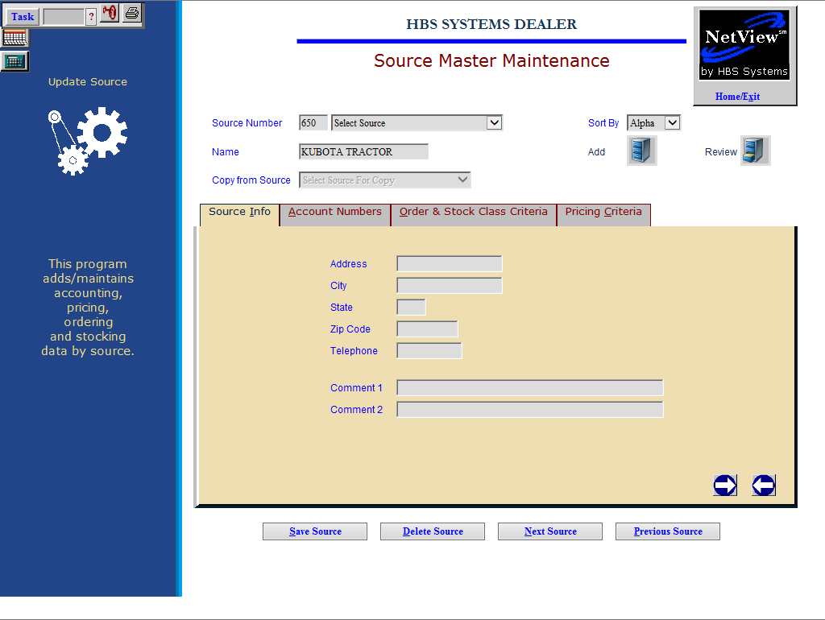

Source Info Tab (Alt I): This tab holds basic information about the source.

Address: The address field is a 20-character field for the vendor or manufacturer’s street address.

City: In this field, 20 characters are available to hold the vendor’s city name.

State: The State field is for the vendor’s State or Province. Use the standard two letter abbreviation.

Zip Code: Enter the vendor's Zip Code or Postal Code. It holds 10 characters for extended U.S. Zip Codes and Canadian Postal Codes. NOTE: Do not enter the hyphen, just the characters of the code.

Telephone: The Telephone Number field holds the vendor/manufacturer’s telephone number. The number entered should be the one most frequently used by the Parts Department.

Comment 1 & 2: These fields can be used for any information desired.

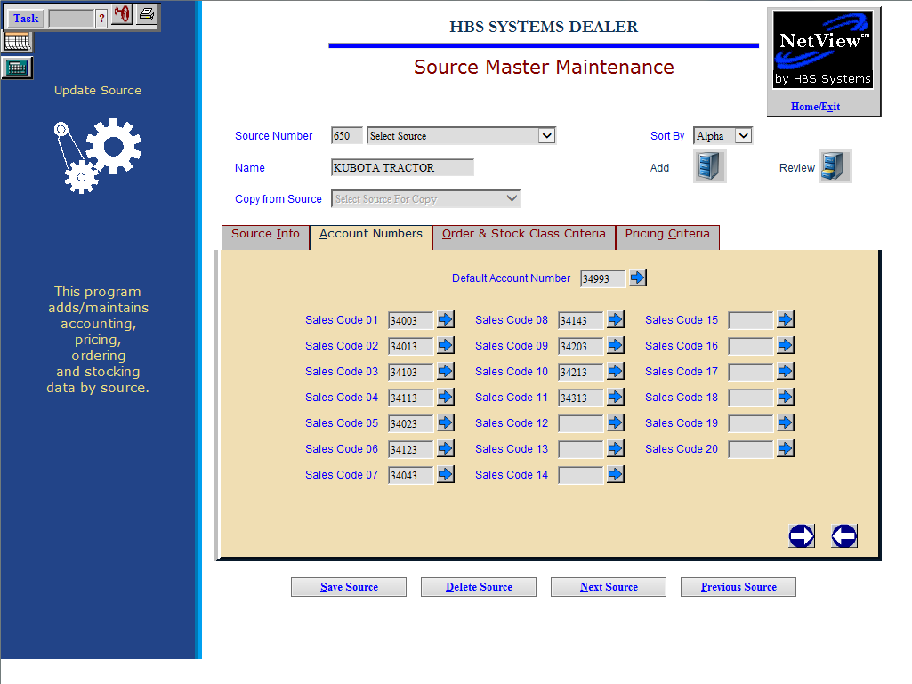

Account Numbers Tab (Alt A): The information on the Account Tab controls where accounting entries for this source are posted to the General Ledger.

Sales Code 1 – 20: These codes control where sales or cost of sales entries are posted to the General Ledger. Each field represents a Sales Code and holds a General Ledger account number that defines that Sales Code. For example, Ledger 1 represents Sales Code 01. Each sales transaction uses one of these fields to pass the accounting information to its proper place.

Ledgers 1 through 11 are filled for the typical dealer definitions and account numbers supporting them.

Ledgers 12 through 20 are for special or custom definitions per dealership (special sales categories, multi-state tax situations, etc.).

These same sales codes define the Sales Code fields in the Customer Master.

The following chart shows the typical Sales Codes and the relationship between the codes in the Source Master and the Customer Master.

Sales Code Mapping (ECI & SMM)

Sales Code | Sample Acct # | Description
1 | 34003 | Parts Counter (formerly Taxable)
2 | 34003 | Parts Counter (formerly Nontaxable)
3 | 34043 | Shop Parts (formerly Taxable)
4 | 34043 | Shop Parts (formerly Nontaxable)
5 | 34003 | Parts Counter (formerly Resale)
6 | 34043 | Shop Parts (formerly Resale)
7 | 34003 | Parts Counter (formerly Government)
8 | 34043 | Shop Parts (formerly Government)
9 | 34083 | Internal Taxable
10 | 34083 | Internal Nontaxable
11 | 34093 | Warranty
12 |  | Dealer Defined
13 |  | Dealer Defined
14 |  | Dealer Defined
15 |  | Dealer Defined
16 |  | Dealer Defined
17 |  | Dealer Defined
18 |  | Dealer Defined
19 |  | Dealer Defined
20 |  | Dealer Defined

The Sales Codes are actually defined in Parts Source Master Maintenance (SMM). This table shows some typical examples of how the codes can be defined for a dealership. This table is just an example; the actual definition and general ledger account numbers will vary from dealership to dealership.

The Account #’s shown are based on the following SAMPLE selection Chart of Accounts:

34003 – SLS Parts Counter
34043 – SLS Shop Parts
34083 – SLS Internal Parts
34093 – SLS Warranty Parts

In the past, we also often separated out the Sales and Cost accounts for Taxable, Nontaxable, Resale, and Government. We have stepped away from that approach because of the availability of STXR (Sales Tax Report) and its capability to separate information by tax code.

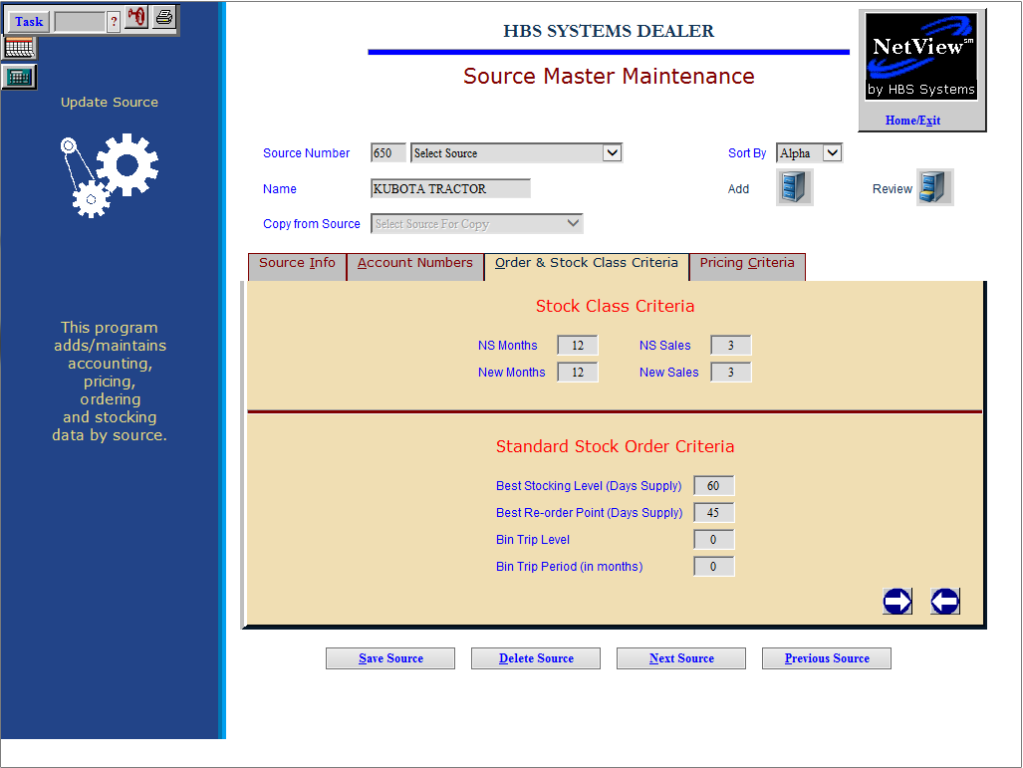

Order & Stock Class Criteria Tab (Alt O): Order and Stock Class Criteria tells the system based on the months of demand within a given period of time if a part is fast moving or slow moving. The key is to remember that we look at the months of demand, not the number of sales within a period of time to determine these. After the system determines the stock class, it will then determine how many to order and how frequently to make an order based on the settings in the Standard Stock Class Criteria.

NS Months: The NS Months (number of stocking months) is the range of months determining the stock class for parts in this source. The stock class is one factor used to determine parts eligibility for a stock order. This number indicates the number of months used to determine if a part is considered a fast moving or non-stock part. For example, 24 months means that sales activity for the past 24 months is used.

NS Sales: The NS Sales (number of stocking sales) is the number of months with actual sales activity used for calculating the stock class. Here Sales Activity is based on MONTHS with sales activity, not on the number of units sold. This field evaluates the value in the NS Months field and then finds the number of months with sales activity within that range. For example, if the NS Months is 24 and the NS Sales is 2, then the system examines 24 months of parts history. To qualify as a fast-moving part, it must then have at least 2 months within the 24 months with sales activity.

New Months: This field specifies the time range a new part added to the system with a stock class of 6 will be kept at that stock class. When the part reaches the number of months entered here, the Month End process will upgrade or downgrade its stock class based on the items performance and the value entered in the New Sales field.

New Sales: This field works with the New Months field to set the number of months with actual sales activity. The stock class 6 parts must have sales activity in the number of months entered here to qualify for fast moving status. If not, the Month End process downgrades it to stock class 8.

NS Months and NS Sales Relationship Examples

NS_Months |  | NS_Sales |  | Explanation
18 |  | 2 or 3 |  | This combination is ideal for dealerships that do not want to stock a high volume of parts. A part becomes a fast-moving part when it sells in at least 2 or 3 months out of an 18 month period.
24 |  | 2 or 3 |  | This combination is for dealerships that move an average amount of stock yearly. A part becomes a fast-moving part when it sells in at least 2 or 3 months out of a 24 month period.
36 |  | 3 or 4 |  | This combination is also for dealerships that move an average amount of stock yearly. A part becomes a fast-moving part when it sells in at least 3 or 4 months out of a 36 month period.
36 |  | 2 |  | This combination is for dealerships that turn a lot of stock yearly and prefer to keep a wider variety of parts on hand. A part becomes a fast moving part when it sells in at least 2 months out of a 36 month period.
60 |  | 2 or 3 |  | This combination allows for the overstocking of parts. A part becomes a fast moving part when it sells in at least 2 or 3 months out of a 60 month period.

Generally, dealers specify at least 2 months of sales in 18 months. These fields will accept any value, and not just the ones shown in this chart. Use values that reflect ordering and stocking preferences for the dealership.

Best Stocking Level (Days Supply): This field shows the desired stock to keep on hand in terms of days supply. It works closely with the Best Reorder Point.

Best Re-order Point (Days Supply): This field holds the lowest level of on-hand stock to reach before it triggers an order. Like the Best Stocking Level, it measures stock in days supply. This field is checked to see if the days supply has dipped to this level. Common Best Reorder Points are 20-45 days. Many calculate it as roughly one half to two thirds of the BSL.

Common BSL and BRP Settings

BSL  (In_Days) |  | BRP  (In_Days) |  | Comment
30 |  | 15-20 |  | A BSL of 30 and BRP of 20 are common settings for most major and fast-moving short line manufacturers.
45 |  | 22-30 |  | A BSL of 45 and BRP of 30 are common settings for most major and fast-moving short line manufacturers.
60 |  | 30-40 |  | A BSL of 60 and BRP of 30 or 40 are common settings for some manufacturers. Some dealers use this setting for those parts that are mostly seasonal or ordered infrequently throughout the year.
90 |  | 45-60 |  | A BSL of 90 and BRP of 45 or 60 could be used for manufacturers whose parts are primarily seasonal or ordered infrequently throughout the year.

These fields will accept any value and not just the ones shown in this chart. Use values that reflect the ordering and stocking preferences of the dealership.

Bin Trip Level: This field shows the bin trip level which, when reached, will trigger a stock order. Changing this field to a number other than zero will trigger its use in Standard Stock Order (SSO) and Multi-location Standard Stock Order (MSSO).

Bin Trip Period (In months): This field shows the bin trip period, in months, which when reached will trigger a stock order. Changing this field to a number other than zero will trigger its use in Standard Stock Order (SSO) and Multi-location Standard Stock Order (MSSO).

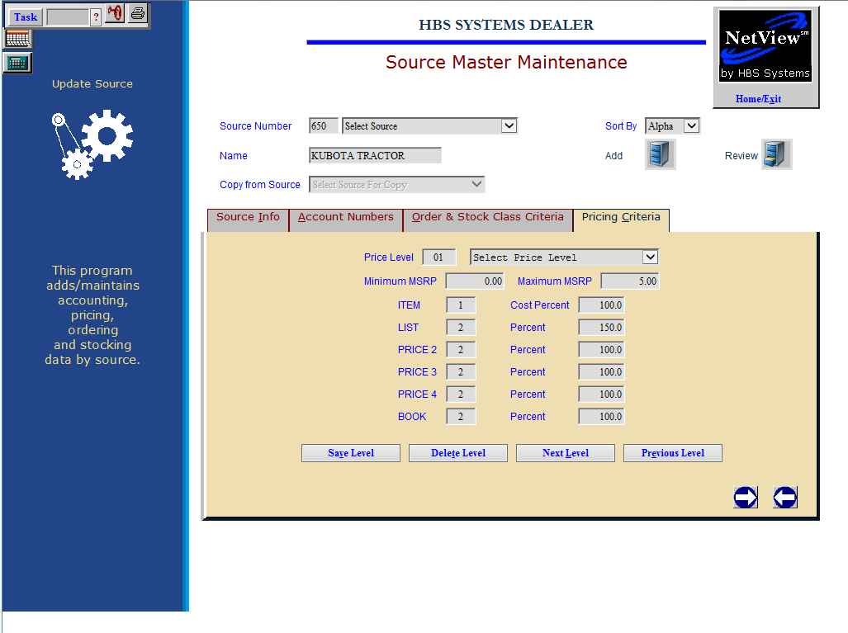

Pricing Criteria Tab (Alt C): This tab holds the information for setting the pricing of the parts in this source. Each dealership can define up to 99 Price Levels per source. These price levels offer the ability to design a price tier scheme that can, in some cases, provide a unique pricing and profitable way to sell these parts.

As values of parts change, they are automatically re-classified to another dollar range if necessary. These changes could come from a manual price change or the installation of a new price file. The price levels defined here are based on the MSRP (Manufacturer’s Suggested Retail Price) of the part number. These ranges of MSRP are used to determine the selling prices. Each range must end with a value higher than the previous range. The final range should be set at 9,999,999.99 to capture all the remaining parts at the upper end of the pricing structure. Since the dollar ranges can vary by parts source, we suggest using dollar ranges that represent the values of the parts in that source. For example, a source for hardware items would have lower value dollar ranges than one for planter parts.

Price Level: The Price Level field contains a number from 01-99. These Price Levels are simply a definition of a series of dollar ranges based on the MSRP of the parts for this Source Number. Each source MUST have a least ONE price level. To set the level, do one of the following:

Use the drop-down menu to select a price level.

Type the level directly into the field.

Minimum MSRP: The Minimum MSRP (Manufacturer’s Suggested Retail Price) is the low end of the Price Level.

For the first price level, it should be set at zero.

Following levels should have a minimum MSRP of one penny more than the previous range’s Maximum MSRP.

NOTE: It is very important that all dollar amounts are accounted for in the price levels, and that there are NO duplicate dollar values or missing dollar values.

Maximum MSRP: The Maximum MSRP (Manufacturer’s Suggested Retail Price) is the top end of the Price Level.

For the last Price Level, it should be set at 9999999.99.

Any levels should have a maximum MSRP of one penny less than the next Level's Minimum MSRP.

NOTE: It is very important that all dollar amounts are accounted for in the price levels, and that there are NO duplicate dollar values or missing dollar values.

Price Base Column: This column refers to the Price Fields (Mfr List, Pr Codes 3-6, and Mfr Cost) in the Parts Master. These numbers are the base for how the selling price of this level will be calculated.

Typically these numbers are one of the following:

1 (Cost)

2 (MSRP)

3 (DSO1)

This column works with the Price Factor Percent Column to determine the actual price.

There can be up to six groups of pricing for each price level (as defined in the Company Defaults – IPOS). These groups must at least include definitions for the following:

Cost

List

MSRP

Price Factor Percent Column: This column creates the pricing structure by applying a percentage to the value in the Price Flag Column. For example, if the Price Flag Column shows Cost (Price Flag 1), this column could say 100.0 if the pricing for this line was to be straight Cost. It could also say 120.0 if the pricing for this line should be Cost plus 20%. It might say 90.0 if the pricing for this line should be Cost minus 10%.

- Unless the vendor provides a List Price only, Cost should be 1, List 2, and the remaining price codes should be a 2 (unless Case/NH DS01).
  - If the vendor provides only List, the Cost will be a 2 and the percentage off list.
  - If that List only vendor gives a 25% discount, then the Cost will be a 2 and the factor would be 75.0.

Defining Price Factoring: Price Factoring may be defined as applying a percentage to the Manufacturer-supplied unit prices to create pricing categories. The fields on this screen affect the prices of parts sold in POS and SMS parts invoicing. They also affect the pricing shown in Manufacturer Price File Inquiry and Parts Inquiry. All manufacturers price their parts by an actual dollar figure or a percentage of another dollar amount.

- Many manufacturers provide both an MSRP and a Cost amount for each part number carried. Some vendors only give a dollar amount for the Cost or the MSRP. The other figure is derived from a percentage. For example, if a vendor provides MSRP, but not Cost, a percentage is applied to the MSRP to calculate the Cost. This could be shown by choosing Price Flag 2 for the Cost Flag and a percentage less than 100%. For example, a vendor doesn’t provide cost, but it is 70% of the MSRP. Select Price Flag 2 and 70.0 in the Percent Column to show this.

TIP—Tier Pricing Structure: These groups of fields work with each other to provide the option of using a tier pricing structure. This approach lets each dealership determine the selling price based on a specific range of MSRP dollars. Typically, a tier structure uses a higher markup on the smaller dollar parts and graduates downward to a lower markup for higher dollar parts. This approach can help recoup larger margins on lower cost items where the customer base is less likely to shop for price. Likewise, the graduated approach lets pricing levels set for the higher valued parts be competitive when customers are more likely to shop based on price. As this series of fields is available for each Source Number, pricing tiers for each source may develop, specific to just those goods. This provides a highly tailored approach to marketing based on factors specific to each business.
- Although this structure is available for each Source Number, it is not a mandatory item. A dealership may choose to use a single markup factor for all dollar ranges present.
- If a dealership chooses to implement a tier pricing structure, there are bound to be exceptions to any scheme. These exceptions can be handled through use of an additional source record for competitive or bulk purchase items.

Markup and Margin: What is “Markup” versus “Margin”? By definition, “Markup” is the amount added to the cost to determine the selling price. “Margin” is the net sales amount minus the cost of sales amount.

Markup Using MSRP: If you are looking to “markup” the MSRP 10%, the source will look like the example below. If the cost of the part is $70.00, the MSRP is $100.00, and sells for $110.00, what is the margin percentage?

$110 (selling price) – $70 (cost) = $40 (margin dollars)
$40 (margin dollars) / $110 (selling price) = 36.34% (margin percentage)

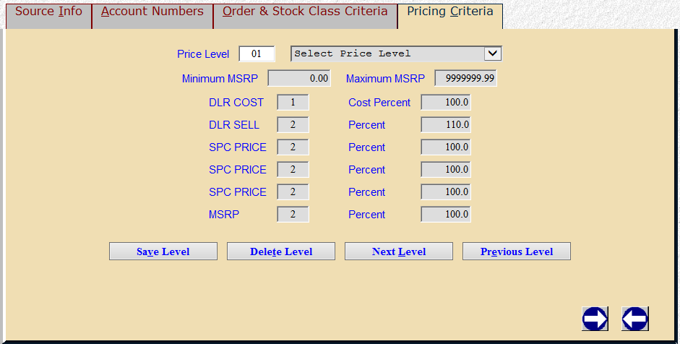

If you would like a 35% margin, take the $70 (cost) and divide it by 65% (100-35) to calculate $107.69 (selling price). Set the markup on the DLR SELL at 107.7 and pull 35% (34.995%) margin.

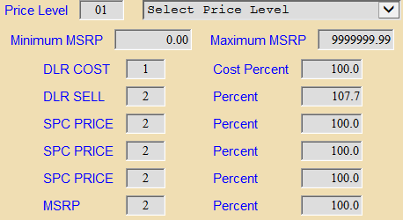

Markup Using Cost: If you would like to “markup” the COST 200%, the source will be setup like the example below.

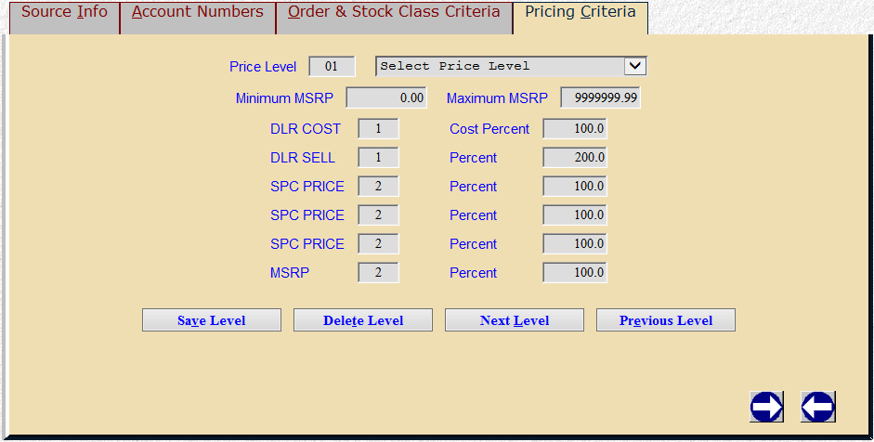

If the cost of the part is $100.00, the markup is 200%, and sells for $200.00, what is the margin percentage?

$200 (selling price) – $100 (cost) = $100 (margin dollars)
$100 (margin dollars) / $200 (selling price) = 50% (margin percentage)

If you would like a 50% margin marked up from cost, take the $100 (cost) and divide it by the margin percentage 50% to equal $200 (selling price).

Markup Using Factored Cost: What if the cost is factored off list and you want a specific margin percentage? If the price file provides list only, and you receive a 25% discount, and they want to have a 35% margin percentage:

$100 (MSRP) – 25 (dealer discount-drop the %) = $75 (cost)
$75 (cost) / 65% (100 – 35) = 115.38

You should set the markup on the DLR SELL at 115.4 and pull 35% margin like the example below.

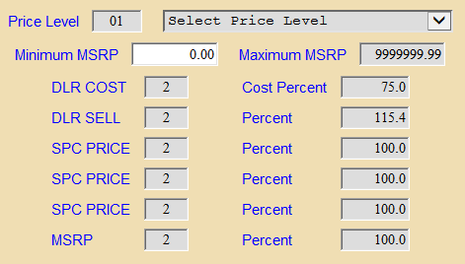

Price Codes: Within SMM you can set up various Price Codes to either markup or discount prices. In ECI you can set a customer to one of six price codes. Typically, the price codes are named as follows:

PC 1 is dealer cost

PC 2 is the dealer selling price

PC 6 is MSRP (Manufacturer Suggested Retail Price)

PC 3-5 are open to use for any of the following:

Customer discounts

Dealer discounts

Employee discounts

Mark ups

If you want certain customers to receive a discount off List (Dealer Selling Price), it can be setup in SMM like the example below.

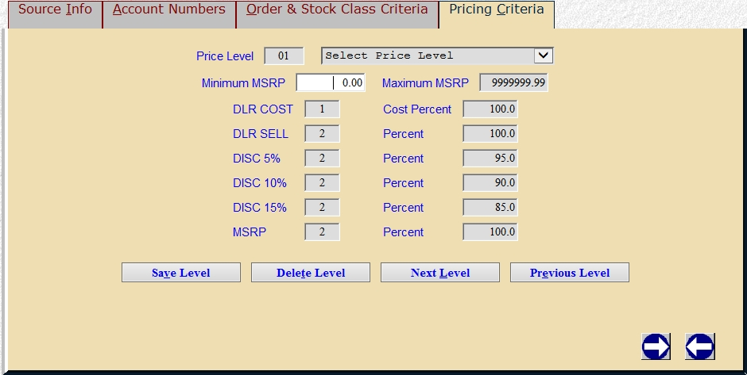

In PMM there are list and net prices, either taken from the price file or entered manually from the dealer. In PMM the mfr list price is Price Code 2 (the #2 in the previous example) and mfr net price is Price Code 1 (the #1 in the previous example). When looking at the Pricing Criteria tab, the previous example will not show the ECI Price Code. Imagine from top to bottom they are Price Codes 1-6.

ECI PC* SMM Desc SMM PC (Price Code)
1 DLR COST 1 = Look at mfr net price in PMM X 100.0%
2 DLR SELL 2 = Look at mfr list price in PMM X 100.0%
3 DISC 5% 2 = Look at mfr list price in PMM X 95.0%
4 DISC 10% 2 = Look at mfr list price in PMM X 90.0%
5 DISC 15% 2 = Look at mfr list price in PMM X 85.0%
6 MSRP 2 = Look at mfr list price in PMM X 100.0%

When a customer is set with Price Code 3 in ECI, the system will look at SMM for the Price Code, and tell POS and ROM to sell the part at the mfr list price in PMM times 95.0%, or 5% discount. A great example is when you have a “winter special” and all customers receive a discount based on a certain product line. Open the POS ticket under PC 3, and all parts sold will be billed based on the markup or discount in PC 3 in each source in SMM.

