Service Options and Defaults (SOD)

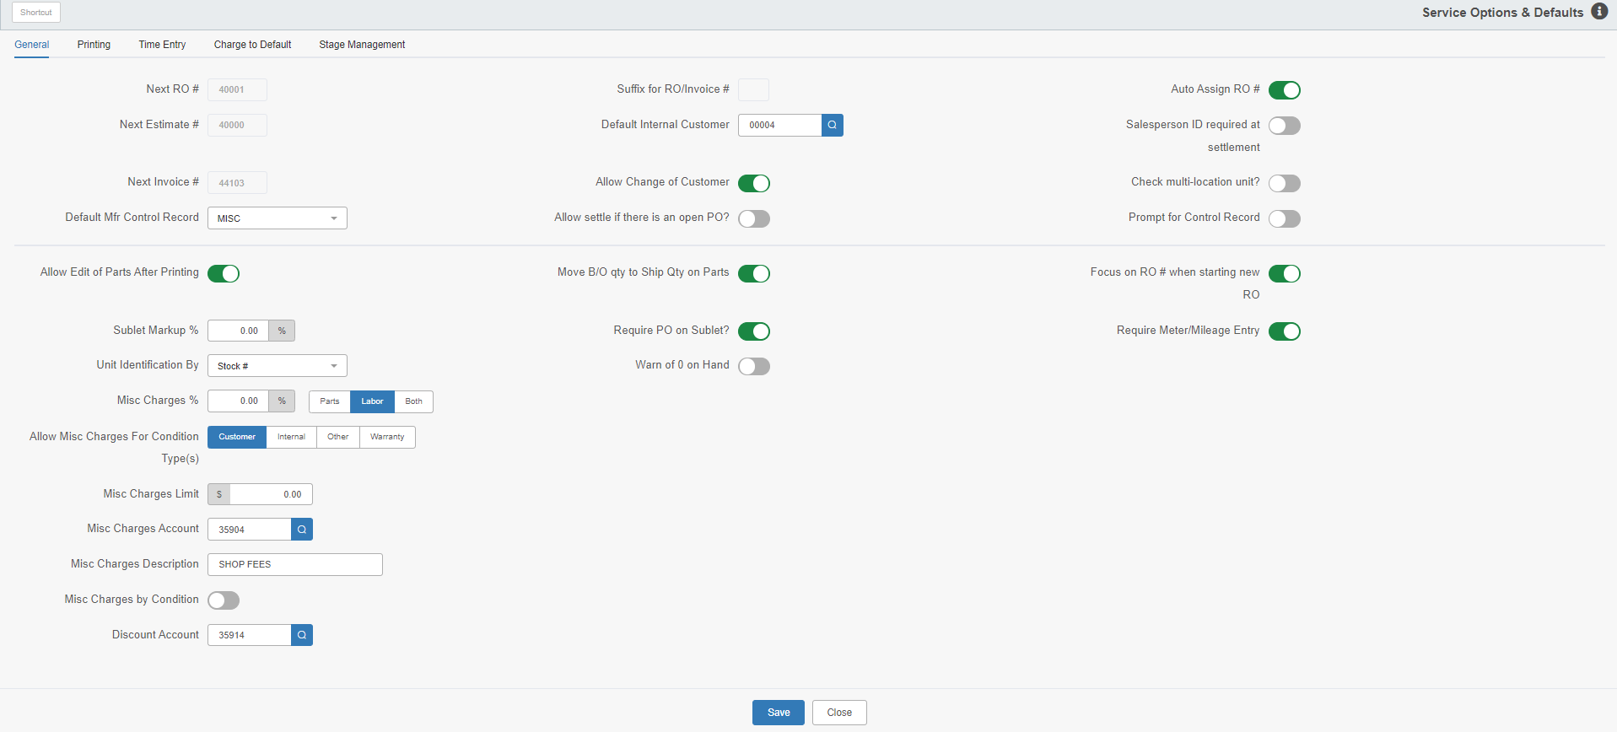

This program allows you to set and maintain your Service system’s options and defaults.

To access this function, type “SOD” in the Shortcuts Bar.

General Tab:

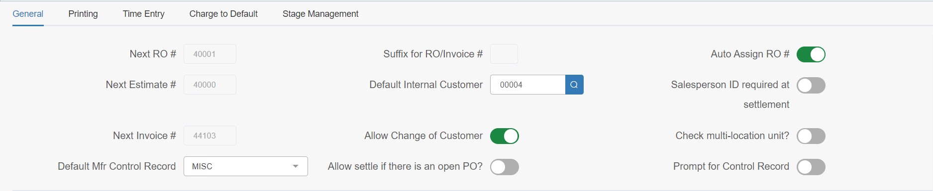

Next RO #: This field shows the next system-generated RO number. If it needs to be changed, please contact HBS Support.

Next Estimate #: This field shows the next system-generated estimate number. If it needs to be changed, please contact HBS Support.

Next Invoice #: This field shows the next system-generated invoice number. If it needs to be changed, please contact HBS Support.

Default Mfr Control Record: This field sets the default manufacturer control record.

Suffix for RO/Invoice #: This field shows the suffix applied to RO and invoice numbers (S13, S123456, etc.) created at the dealer location, which is typically only used by multi-location dealerships. If it needs to be changed, please contact HBS Support.

Default Internal Customer: This field sets the default internal customer number.

Allow Change of Customer: If login permits, you can turn this option on in order to change the customer number on an open RO.

Allow settle if there is an open PO?: Turn this option on to allow the RO to be settled even if there is an open PO on the unit.

Auto Assign RO #: Turn this option on have the system automatically assign repair order numbers when you create a new RO.

Salesperson ID required at settlement: Turn this option on to have a salesperson ID required at settlement for Service sales.

Check multi-location unit?: This is for multi-location dealers who do NOT use cross-location posting for repair orders, meaning that you do NOT work on another location’s units in your shop. When turned on, it provides a warning if another location’s unit is selected on a repair order.

Prompt for Control Record: Turn this option on to use the stock number as a control number or an RO number.

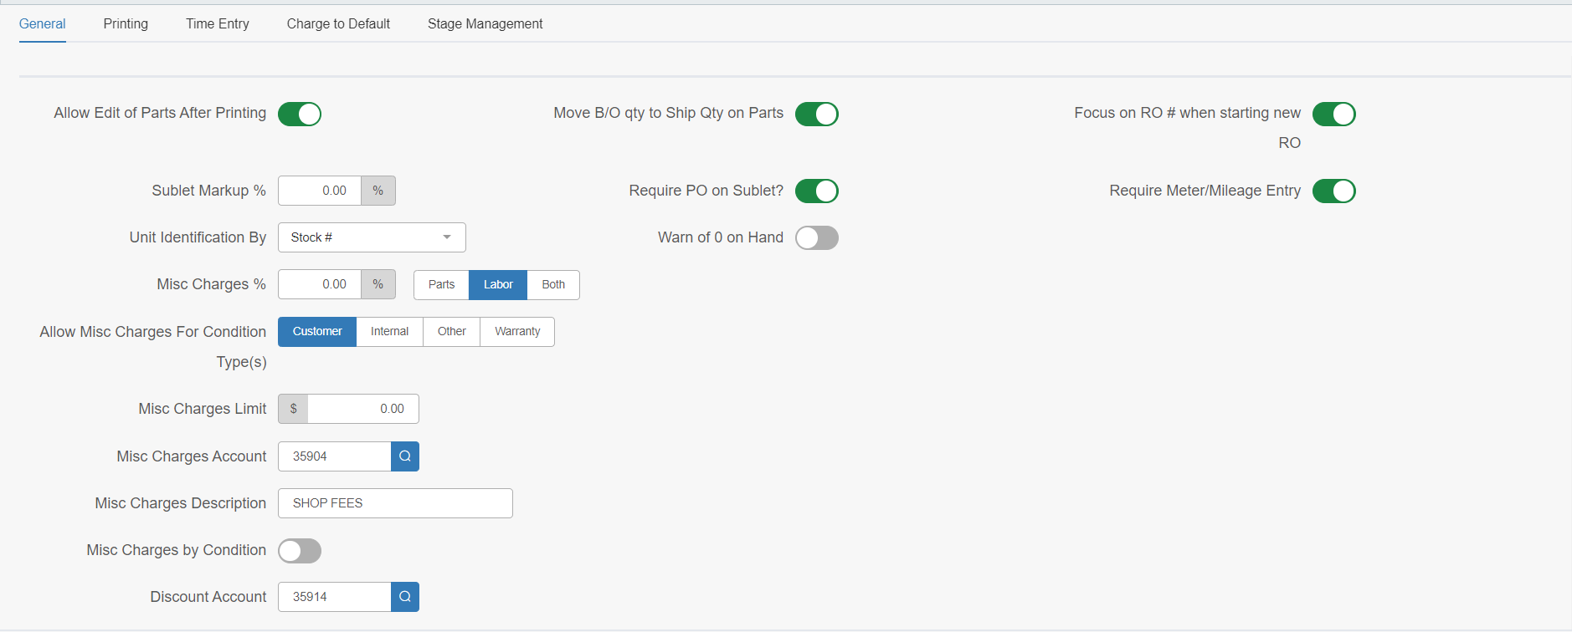

Allow Edit of Parts After Printing: Turn this option on to allow part lines to be edited on a repair order after the picking ticket is printed.

Move B/O qty to Ship Qty on Parts: If you are utilizing the Parts backorder feature, you need to have this option turned on for it to properly work on Service tickets.

Focus on RO # when starting new RO:

- If you turn this option on, the initial focus is on the “RO #” field to accommodate users who fill in their own RO number.
- If you turn it off, the system will focus on the “Service Writer” field and auto-assign the RO number.

Sublet Markup %: This field sets the sublet markup percentage.

Require PO on Sublet?: Turn this option on to require a PO number on an outside labor sublet.

Require Meter/Mileage Entry: Turn this option on to require the unit’s meter and/or mileage to be entered on the RO.

Unit Identification By: Select what number units will be identified by from the drop-down menu. The options are:

- Stock #
- Vin/Serial #
- Fleet #
- License #

Warn of 0 on Hand: Turn this option on to have the system warn you when you add a part with a zero on-hand quantity to a repair order.

Misc Charges %: This field sets the percent of miscellaneous charges that can be applied to the following (mark which ones to apply it to):

- Parts
- Labor
- Both

Allow Misc Charges for Condition Type: Select which condition types you want to allow miscellaneous charges on:

- Customer
- Internal
- Other
- Warranty

Misc Charges Limit: Type in the amount you wish to limit miscellaneous charges to.

Misc Charges Account: Type in or select the account number to which the miscellaneous charges will be charged.

Misc Charges Description: Type a description of the miscellaneous charges here.

Misc Charge by Condition: Turn this option on have the miscellaneous charges listed by condition on the invoice.

Discount Account: Type or look up the discount account for repair orders.

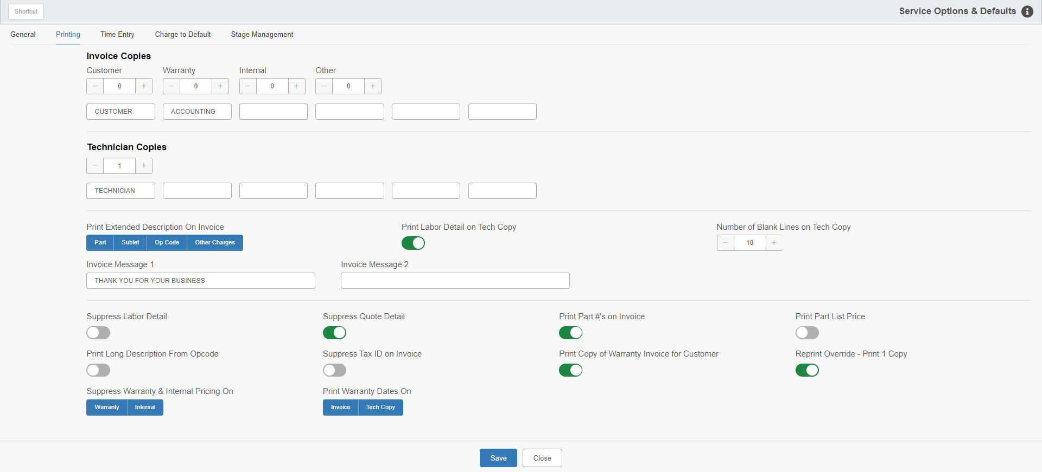

Printing Tab:

Invoice Copies: Enter how many copies of each condition type invoice you want to print by default. The condition types are:

- Customer
- Warranty
- Internal
- Other

Define Names of Invoice Copies: Here you can define names for each Invoice copy. This is a good way to indicate who is to receive a copy.

Technician Copies: Enter the number of technician copies you want to print by default.

Define Names of Technician Copies: Here you can define names for each technician copy. This is a good way to indicate who is to receive a copy.

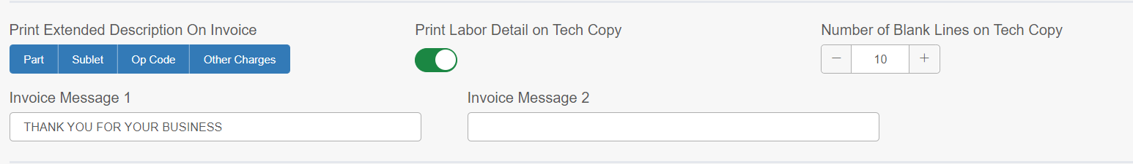

Print Extended Description on Invoice: Select each item you want to print an extended description for on the invoice. You can select up to all four options:

- Parts
- Sublet
- Op Code
- Other Charges

Print Labor Detail on Tech Copy: Turn this option on to print the labor detail on the technician copy.

Number of Blank Lines on Tech Copy: Set how many blank lines you want to include on the technician copy.

Invoice Messages: Type in up to two messages you wish to include on your invoices.

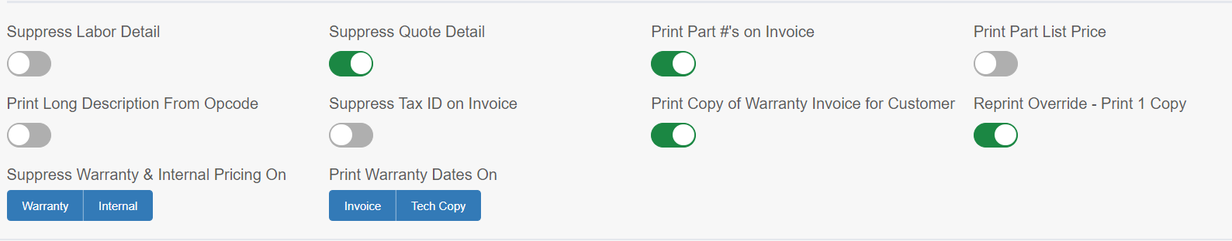

Suppress Labor Detail: Turn this option on to suppress labor detail on the invoice.

Suppress Quote Detail: Turn this option on to suppress quote detail on the invoice.

Print Part #’s on Invoice: Turn this option on to print the part numbers on the invoice.

Print Part List Price: Turn this option on to print the part’s list price on the invoice.

Print Long Description from Opcode: Turn this option on to print the long description from the Opcode on the Tech Copy.

Suppress Tax ID on Invoice: Turn this option on to suppress the tax ID on the invoice.

Print Copy of Warranty Invoice for Customer: Turn this option on to receive a copy of the warranty invoice for the customer.

Reprint Override-Print 1 Copy: Turn this option on to default the number of copies of a reprint out of Repair Order History (ROH) to 1 copy.

Suppress Warranty & Internal Pricing On: Select whether to suppress warranty pricing, internal pricing, or both on the invoice.

Print Warranty Dates On: Select whether to print the warranty dates on the invoice, the tech copy, or both.

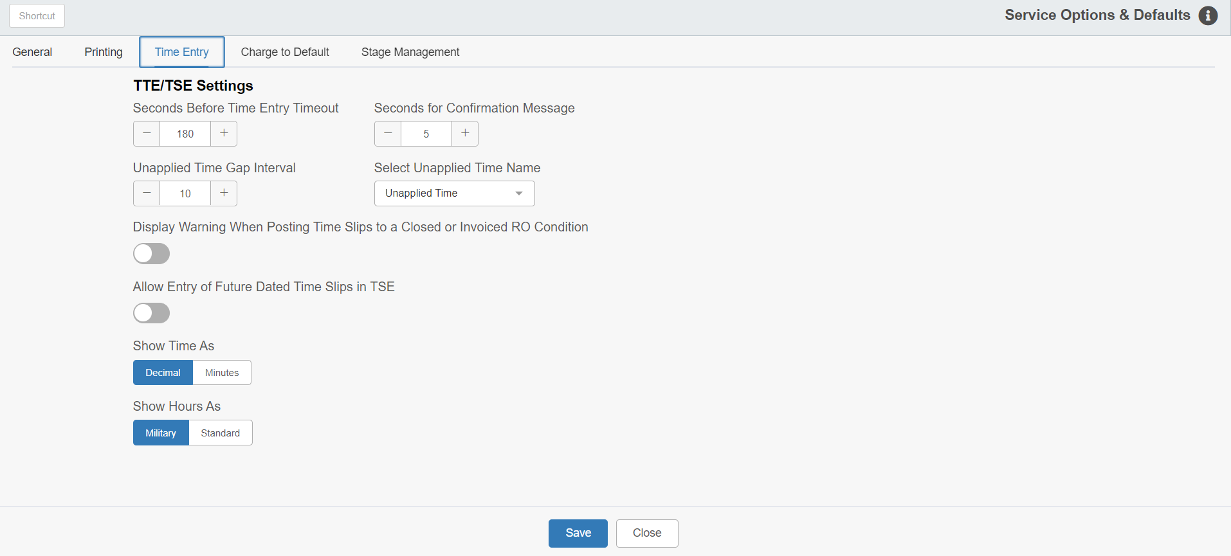

Time Entry Tab:

Seconds Before Time Entry Timeout: Type in how many seconds an employee will have to clock in or out before Technician Time Entry (TTE) resets.

Seconds for Confirmation Message: Enter the number of seconds that the confirmation message remains on the screen after a tech logs in in TTE.

Unapplied Time Gap Interval: Enter the maximum interval between clock out and clock in times for a technician. This field defaults to 10. Any time past the amount in this field generates a Time Slip to Unassigned Time.

Select Unapplied Time Name: Select a name for the unapplied time from the drop-down menu.

Display Warning When Posting Time Slips to a Closed or Invoiced RO condition: Turn this option on to have the system display a warning when a user tries to post a time slip to a closed or invoiced RO condition.

Allow Entry of Future Dated Time Slips in TSE: Turn this option on to allow the entry of future dated time slips in Time Slip Entry (TSE), as well as create an alert reminding the user that they are entering a future date.

Show Time As: Set the system to display time in either decimals or minutes.

Show Hours As: Set the system to show hours as standard (starting over after noon) or military (1-24).

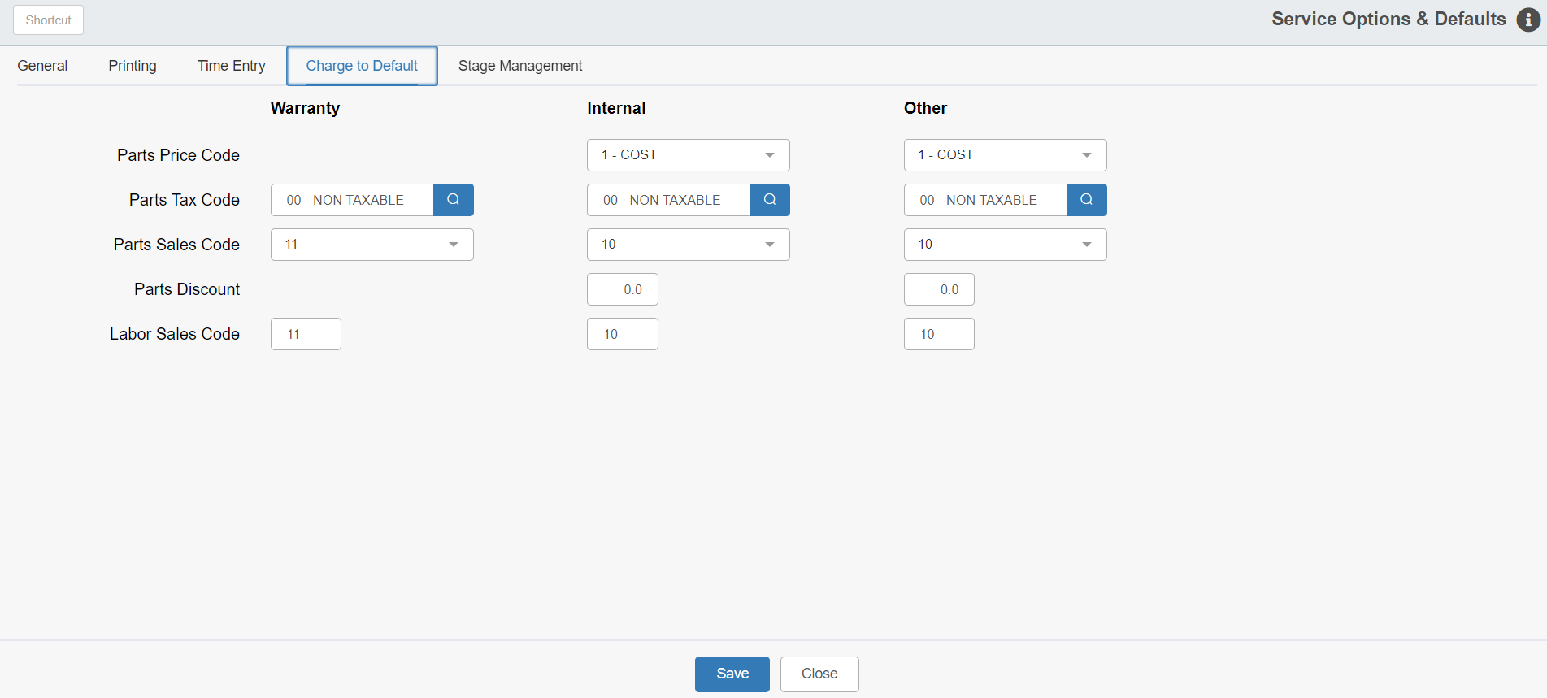

Charge To Defaults Tab:

Warranty: This column concerns warranty RO charging defaults.

Parts Tax Code: Enter or look up the Parts tax code for warranties.

Parts Sales Code: Choose the Parts sales code for warranties from the drop-down menu.

Labor Sales Code: Type the Labor sales code for warranties here.

Internal: This column concerns internal RO charging defaults.

Parts Price Code: Choose the Parts price code for internal repairs from the drop-down menu.

Parts Tax Code: Enter or look up the Parts tax code for internal repairs.

Parts Sales Code: Choose the Parts sales code for internal repairs from the drop-down menu.

Parts Discount: Type the Parts discount for internal repairs here, if any. If not applicable, leave it as “0.0.”

Labor Sales Code: Type the Labor sales code for internal repairs here.

Other: This column concerns other RO charging defaults.

Parts Price Code: Choose the Parts price code for other repair types from the drop-down menu.

Parts Tax Code: Enter or look up the Parts tax code for other repair types.

Parts Sales Code: Choose the Parts sales code for other repair types from the drop-down menu.

Parts Discount: Type the Parts discount for other repair types in this field, if any. If not applicable, leave it as “0.0.”

Labor Sales Code: Type the Labor sales code for other repair types in this field.

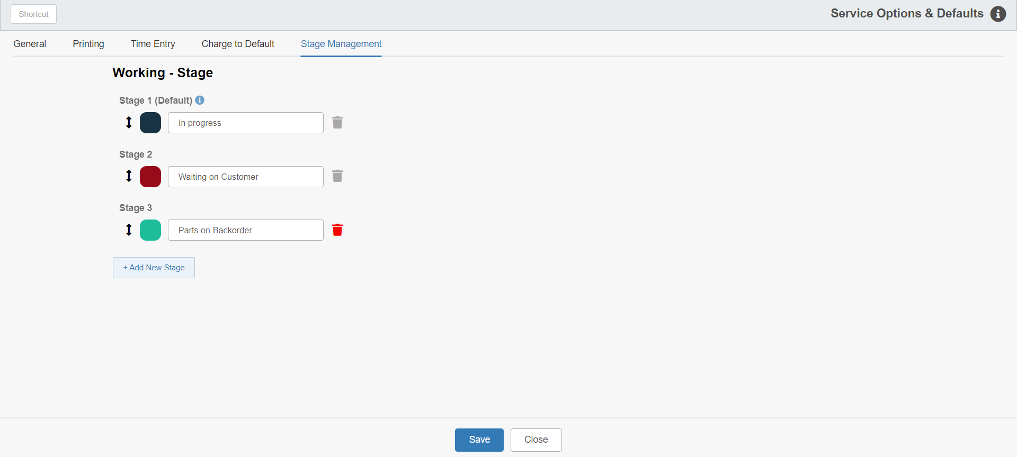

Stage Management: This tab creates and manages the available Stages that can be set on a repair order condition to indicate its progress.

Add New Stage: Click this button to add another Stage below the previous one, which will automatically be assigned as the designation for the next step in the condition’s progress (Ex: Not Started, In Progress, Need Parts, etc.). You can have as many stages as desired.

Resorting Stages: Click on the double-arrow icon on each Stage to drag and drop it to a new place in the list. This will change the order in which each Stage appears on a condition.

Stage Color: Click on the colored square on each Stage to change the color that distinguishes one stage from another. This feature is used most heavily in Service Connect (SC) to quickly indicate a condition’s Stage to anyone looking at the calendar. We recommend having a different color for each Stage if possible to better tell them apart.

Stage Name: Enter the Stage name once you create it. This will be what appears on the RO condition in Repair Order Maintenance (ROM). You may change the name of any Stage at any time in this screen.

Delete Stage: A trash can icon will appear next to each Stage.

- If the icon is greyed out, then the Stage cannot be deleted as it is in use on a condition.
- If the icon is colored red, it is not currently being used, and you may click the icon to safely delete the Stage. A warning message will pop up asking if you are sure you want to delete the Stage:

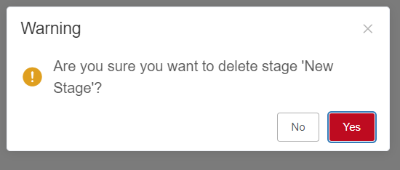

Click Yes to close the prompt and delete the Stage.

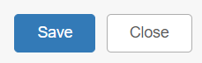

Save: Click this button to save any changes or additions.

Close: Click this button to exit the program at any time.

