Salesperson Commission Report: The Salesperson Commission Report in Rental Reports (RR) lists all sales made by your dealership’s rental salespeople within a selected period of time. You can run the report for all your salespeople or for just a single salesperson.

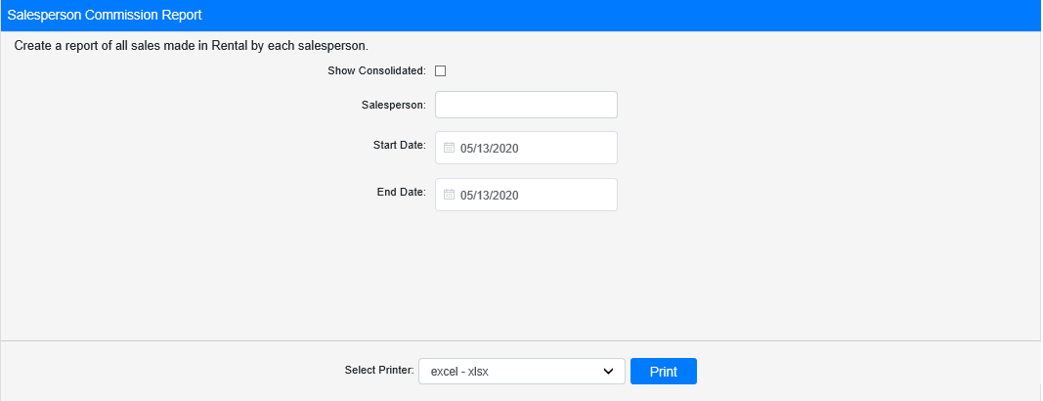

Field Definitions:

Show Consolidated: If you are a multi-location dealership with a Consolidated location, check this box to include the Consolidated location’s information on your report. Uncheck it to only print a report for your individual location. NOTE: If running the report in the Consolidated location, you must check this box to receive a report.

Salesperson: If you want to run the report for an individual salesperson, enter their designation in this field.

Start Date: Enter the start date for the report here. All sales listed on the report occurred on or after this day.

End Date: Enter the end date for the report here. All sales listed on the report occurred before or on this day.

Select Printer: Select the printer to receive the report. Use the pdf printer to preview the report.

Click “Print” to print the report.

Sample Report:

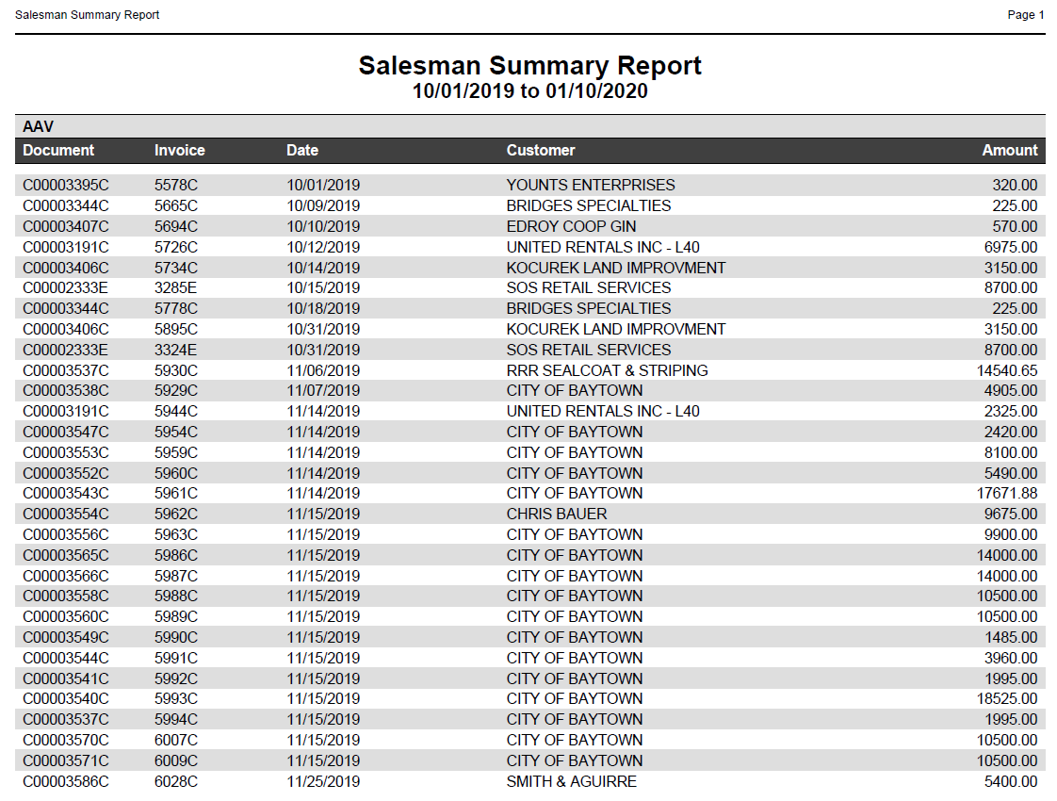

The report is divided into sections by salesperson. It lists the following details for each sale they made during the report period:

- Document number invoiced
- Invoice number
- Invoice date
- Renting customer
- Amount of the rental sale

