Service Productivity Report (SPR)

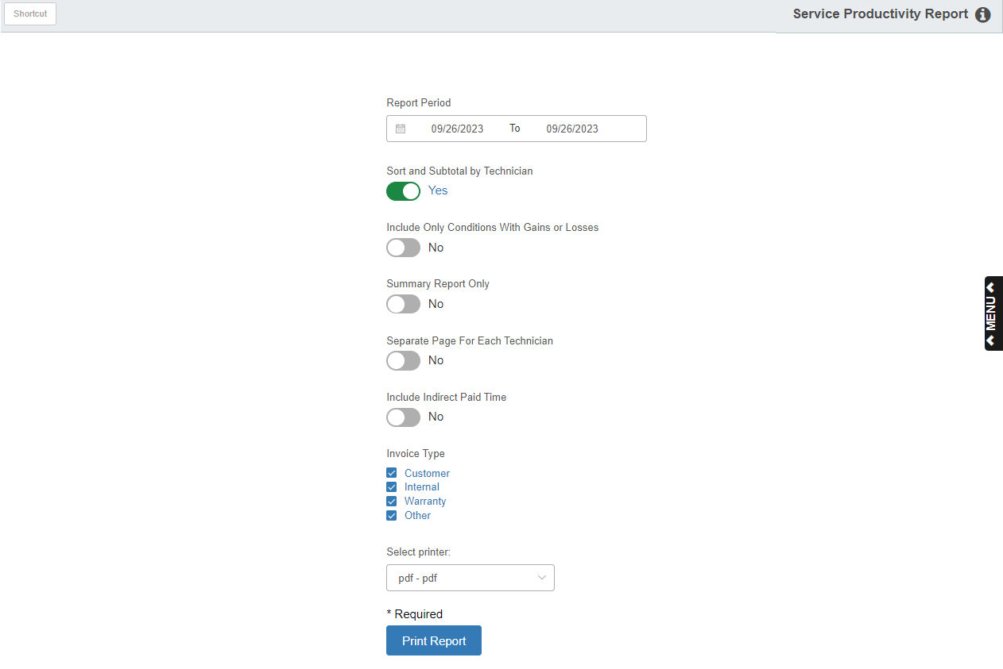

This program allows you to view and print the Service Productivity Report.

To access this function, type “SPR” in the Shortcuts Bar.

Field Definitions:

Report Period: If you want the report to only cover a specific range of dates, type the starting and ending dates here. The current date will initially fill in both fields.

- You can also select the dates from a calendar.
- You can leave these fields blank to have the report include all possible dates up to the present.

Sort & Subtotal by Technician: Set this option to “Yes” to have the report organized by Technician, with subtotals provided for each technician.

Include Only Conditions With Gains or Losses: Set this option to “Yes” to include only conditions with gains or losses on the report.

Summary Report Only: Set this option to “Yes” to receive a Summary version of the report, which only lists each technician’s totals.

Separate Page for Each Technician: Set this option to “Yes” to have the report put each technician’s information on a separate page.

Include Indirect Paid Time: Set this option to “Yes” to include any indirect paid time associated with a technician.

Invoice Type: Choose which invoice types to include on the report by checking these boxes. You can check up to all four. The options are:

- Customer
- Internal
- Warranty
- Other

Select Printer: Select a printer from the drop-down menu. Select the pdf printer to view a copy of the report before printing.

Print Report: Click this button to print the report.

Sample Report

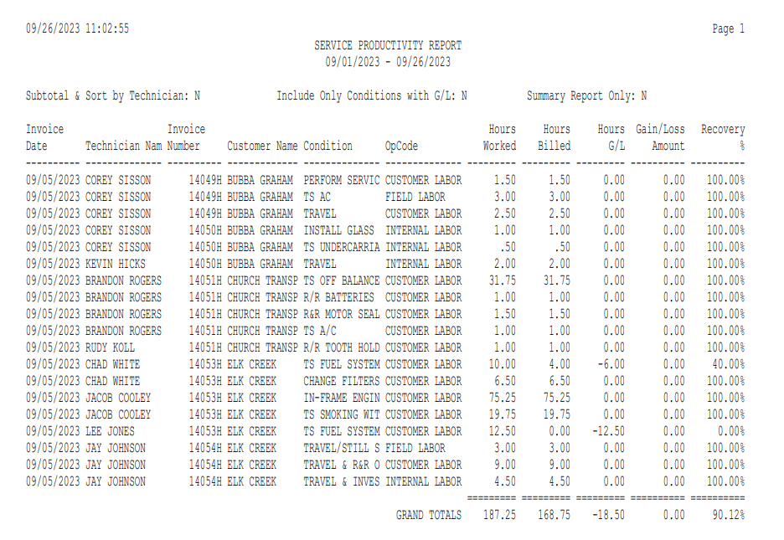

Sample Report Sorted & Subtotaled by Technician

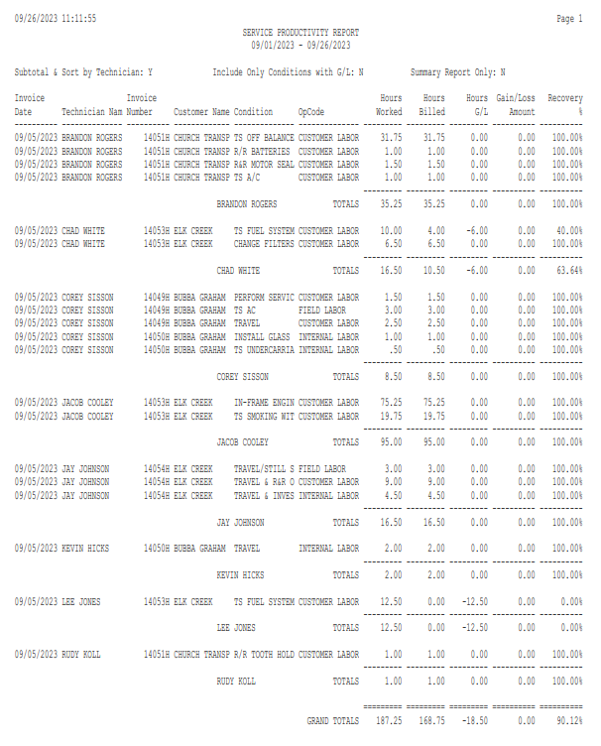

Sample Summary Report Sorted & Subtotaled by Technician

