Standard Stock Order (SSO)

The Standard Stock Order program suggests the parts for your regular orders based on the preferences you set-up in the Source Master records. Here is how the calculation works:

Terms and Definitions of the Calculation

- BSL = Best Stocking Level (optimum amount of stock to have)
- BRP = Best Re-Order Point (trigger point or “dip to point” for an order)
- Available = On Hand Qty + On Order Qty (what you have and you will have)
- Suggested Order = Demand – Available (what to order less what you have) The Suggested Order Qty can be further affected by a Pkg Multiple, if present. It will round up the Suggested Order Qty to meet the Pkg Multiple.
- Minimum Order = Stock Class 1 parts always suggest a minimum order quantity of at least 1.

BSL Calculation Formula
# of sales (in the # of mos) # of sales
--------------------------------- = -------------------- x # of days supply = Demand
# of days (26/mo x # of mos) per day
Demand – (on hand + on order) = Suggested Order

BSL is calculated using the number of months you enter on the setup screen of the SSO. From this number, it calculates the number of days in the months selected (26 per month). For example, if the number of months is 13 (includes the current month), the number of days is 26 x 13 or 338. That number is divided into the number of sales for the time period to get the number of sales per day. If we had 67 sales in the last 13 months (338 days), it would be 0.20 sales per day. The Daily sales amount is then multiplied by the number of days supply for Best Stocking Level from the Source Master. In our case, 0.20 times 60 is 12 (BSL/Demand). We currently have 6 on hand and 0 on order (available). These quantities (6+0 = 6) are subtracted from the calculated Demand to yield the suggested order: 12 – 6 = 6.

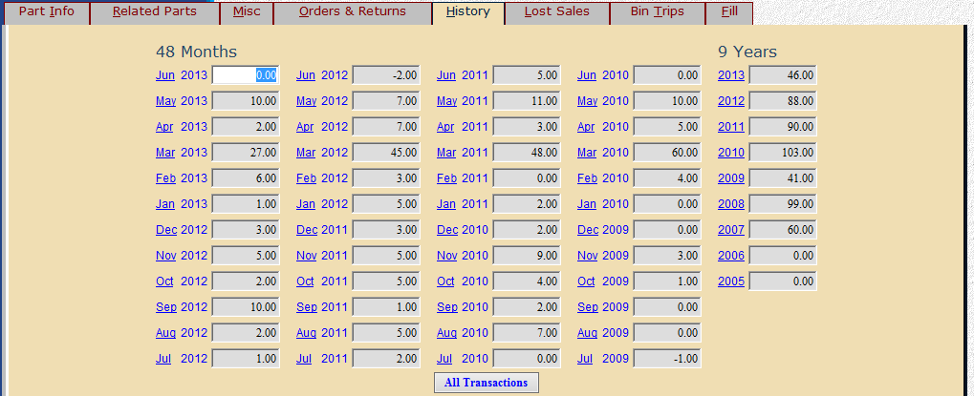

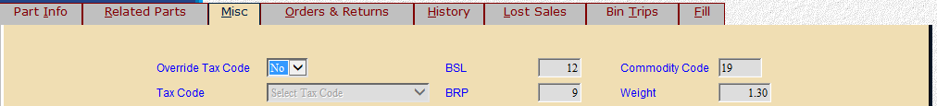

BRP Calculation Formula
# of sales (in the # of mos) # of sales
--------------------------------- = ----------------- x # of days supply = BRP
# of days (26/mo x # of mos) per day

BRP is calculated using the number of months entered on the setup screen of the Standard Stock Order. From this number, it calculates the number of days in the months selected (26 per month). For example, if the number of months is 13 (includes the current month), the number of days is 26 x 13 or 338. That number is divided into the number of sales for the time period to get the number of sales per day. If we had 67 sales in the last 13 months (338 days), it would be 0.20 sales per day. The Daily sales amount is then multiplied by the number of days supply for Best Reorder Point from the Source Master. In our case, 0.20 times 45 is 9 (our reorder point).

Seasonal Ordering with the Standard Stock Order: SSO examines Stock Class 5 parts when the parts are in season (seasonal parts are defined by a Stock Class of 5 and a seasonal indicator of “*” or “#”). The Dealer Season fields are checked to see if the part is in season. If the current date falls in the range of months in the Dealer Season fields, then the part is considered. When seasonal parts are considered, it looks back at the last full season for the seasonal part to calculate the BSL and BRP. An example is shown below.

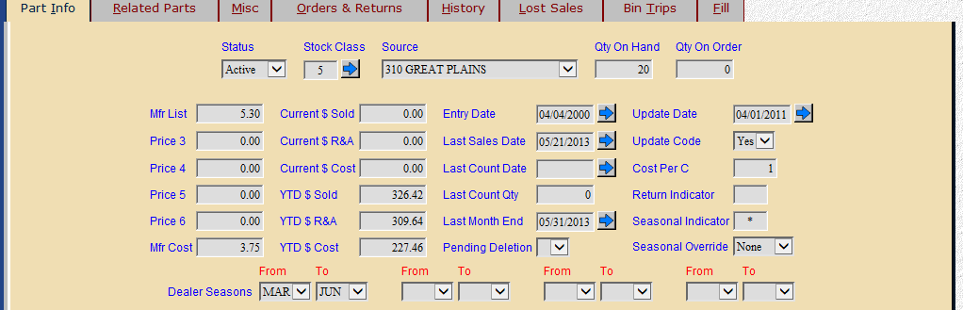

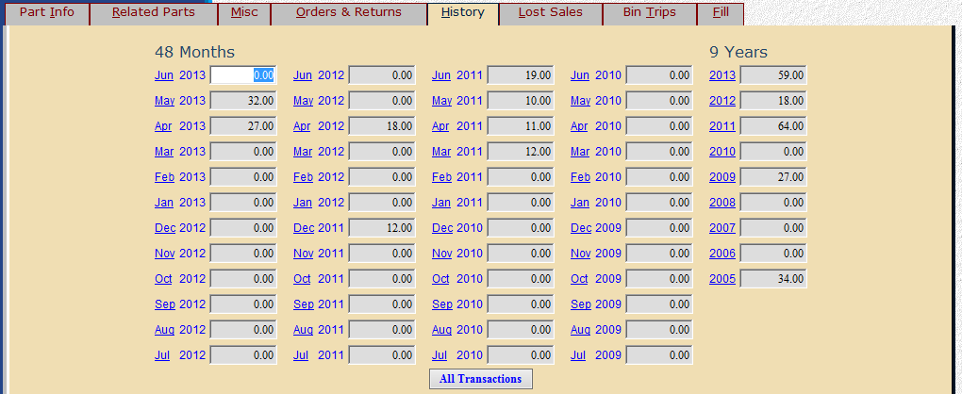

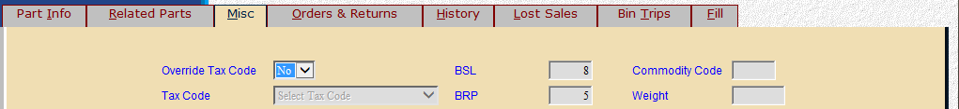

This part number has a seasonal selling period defined as March through June. If a Standard Stock Order is run during June 2013, the selling period examined to calculate the BSL and BRP is March through June of 2012. Here’s how the calculation works for this part number:

Seasonal BSL Calculation

# of sales 18 (in the past season) # of sales
------------------------------------------------------ = --------------- .17 x # of days supply 45 = BSL 8
# of days 104 (26/mo x 7 mos in season) per day

Seasonal BRP Calculation
# of sales 18 (in the past season) # of sales
------------------------------------------------------- = -------------- .17 x # of days supply 30 = BRP 5
# of days 104 (26/mo x 7 mos in season) per day

Parts that are not in season get a suggested order quantity of 5% of the past 12 months’ sales.
We currently have 20 on hand of this part, so no order would be suggested as this exceeds our BSL of 8.

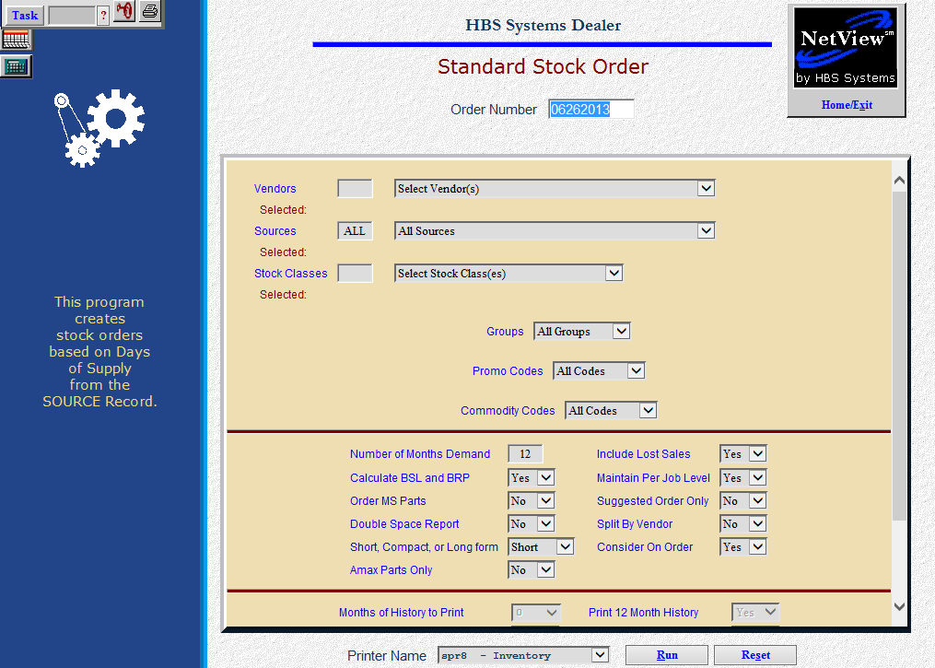

To access this function, you can:

- Select “Inventory” from the menu. Choose the “Orders” submenu and click “Standard Stock Order.”
- Type “SSO” in the Shortcuts Bar

Field Definitions

Order Number: The system will automatically show today’s date in this field. You can accept the provided order number or enter your own.

Vendors: Select “All Vendors” from the drop-down menu or choose/type up to 25 individual vendors. By including specific vendors, you can capture the parts for that vendor regardless of the source they are in. They will display on the screen as chosen.

Sources: Select “All Sources” or choose/type up to 25 individual sources. They will display on the screen as chosen.

Stock Classes: Choose which stock classes you want to examine. You can limit your order to specific stock classes with only the types of parts you want to order. You can also select ALL Stock Classes for the specified Vendor and Source selections made.

Common stock classes for ordering:
  - Stock Class 1=Fast moving parts or regular stocking parts
  - Stock Class 5=Seasonal parts
  - Stock Class 6=New parts with sales potential
  - Stock Class F=Dealer controlled or stocked by exception parts

Less frequently used stock classes for ordering:
  - Stock Class 7=Dealer-controlled or manually ordered parts
  - Stock Class 8=Non-stocking or slow moving parts
  - Stock Class 9=Slow moving or non-stocking parts
  - Stock Class U=Non-stocking parts ordered on emergency orders
  - Manual Stock Classes=2 3 4 B C D E G H I J K L M N O P Q R S TV W X Y Z

Never Used Stock Classes:
  - Stock Class A=Manufacturer use or “non-part” numbers

Groups: Here you can limit your order to specific Group ID codes. Some manufacturers provide ordering incentives with group codes. Select “All Groups” for ALL Group ID codes for the specified Vendor, Source, and Stock Class or choose up to 25 ranges of individual Groups to limit the order.

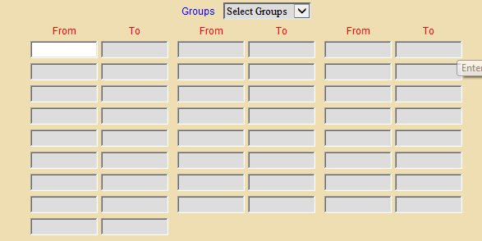

Promo Codes: Some manufacturers provide Promo Codes for ordering specials, incentives, etc. If you select “All Promo Codes” from the drop-down menu, the system will select the parts for ALL Promo Codes. Choose “Select Codes” and enter up to 25 ranges of Promo Codes. Case/New Holland dealers may use this field for generating orders from the PMC (Parts Market Codes), which is in the Promo Code 3 field.

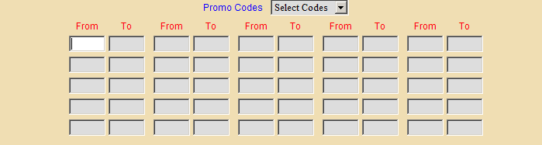

Commodity Codes: Some manufacturers provide Commodity Codes for ordering specials, incentives, etc. The Commodity Codes are added from the price file, if present. If you select “All Codes” from the drop-down menu, the system will select the parts for ALL Commodity Codes. You can select up to 25 ranges of commodity codes to consider.

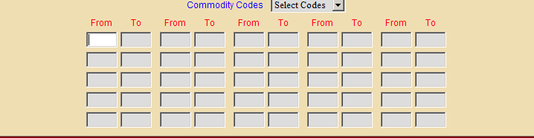

Number of Months Demand: Here you type the total number of months you want to review. The system will examine the number of months of sales history you enter and calculate the “demand” (Sales history / number of months you enter). It starts with the current month and counts back the number of months you enter. For example, if the current month is June 2013 and you enter 13 for this field, the system will use the sales history for 06/13, 05/13, 04/13, 03/13, 02/13, 01/13, 12/12, 11/12, 10/12, 09/12, 08/12, 07/12, and 06/12.

- The optimum range is probably 12 or 13 months. If you enter a number less than these, you risk the calculation of BSL and BRP based on less than a good yearly average number of sales.
  - This number may not reflect an average shelf supply and may be higher or lower depending on the amount of sales activity in the period specified.
  - The same is true when more than 12 or 13 months are used. If you use 24 months you may then find that months 13 through 24 may be high or low and may actually distort the calculation of the numbers.
  - A reason to use months beyond the 12 or 13 month suggestion would be when the current year’s activity is unusually low when compared to past years. In this case, it may be wise to look beyond the current year’s “lower” sales counts.

Months Demand Calculation Example
Part Number 76003452 (Order Date of Dec. 2012) BSL = 30 days BRP = 15 days
 | Total | Jan | Feb | Mar | Apr | May | Jun | Jul | Aug | Sep | Oct | Nov | Dec
Current Yr Total | 26 | 1 | 2 |  | 1 |  | 3 |  | 4 | 6 | 2 | 4 | 3
Prior Yr 1 Total | 9 | 2 |  | 1 |  | 3 | 2 |  | 1
Prior Yr 2 Total | 16 |  | 1 | 1 |  | 2 | 4 | 2 | 2 |  | 1 | 2 | 1

Months Demand: 12 (last 12 months including current month)
26 units in 12 months
BSL = 2 BRP =1
Months Demand: 13 (last 13 months including current month)
28 units in 13 months
BSL = 2 BRP =1
Months Demand: 6 (Dec, Nov, Oct, Sep, Aug and Jul for Cur Yr = 19 units)
19 units in 6 months
BSL = 4 BRP = 2
Months Demand: 24 (system uses all fields in Cur Yr and Pr Yr 1)
35 units in 24 months
BSL = 2 BRP = 1
Months Demand: 36 (system uses all fields in Cur Yr, Pr Yr 1 and Pr Yr 2)
41 units in 36 months
BSL = 1 BRP = 1

Include Lost Sales: This field lets you consider any identified Lost Sales for the parts selected.

Choose Yes and the lost sales hits for the months chosen will be added to actual parts sales quantities to arrive at the BSL, BRP, and ultimately the suggested order quantity.

Choose No here to exclude lost sales quantities from the calculation.

Calculate BSL and BRP: Here you request the system to re-calculate the Best Stocking Level and Best Re-Order Point based on the latest sales information. This option is recommended as it provides up to the minute levels.

Choose Yes to re-calculate the BSL and BRP for each part number.

Select No to use the existing BSL and BRP levels in the part master.

It is strongly recommended that you have the system re-calculate these figures at least once a month.

Maintain Per Job Level: This field works with the Per Job field in the part master. The Per Job field lists a preference for the quantity used for a particular shop job or sale.

Select Yes to use the Per Job field.

If the BSL and BRP quantities are less than the Per Job quantity, the system will recommend an order that will keep your quantity on hand in multiples of the Per Job quantity.

If you choose No here, the system will ignore the Per Job quantities and use only the recommended BSL and BRP levels.

Order MS Parts: This field offers the option to order parts that are linked with the multiple super-session fields in the part master. If shelf quantities of these numbers are low, they may be placed on order.

Choose Yes to check the stocking levels of the parts listed as the multiple super-cession numbers. They are placed on order if they qualify for re-order.

Select No and the system will ignore the multiple super-session numbers listed in the part master.

Suggested Order Only:

- Choose Yes to create the order for printout purposes only. In this case, no order is created. This can be useful if you want to experiment with several settings before making the final decision.
- Select No to generate a live order.

Double Space Report: This field lets you select single or double spacing for the printout.

Choose Yes to get a printout in double spaced format.

Choose No for a single spaced format.

Split By Vendor: This field lets you choose between page splits by vendor or all items sorted together.

Choose Yes to create the order split into pages by vendor.

Choose No for a printout of the order all together with no breaks by vendor.

Short, Compact, or Long Form:

- Short Form only prints the necessary information to place an order. This format is an easy-to-read, faxable printout. Select “Short” to receive this style of order printout. It includes the following information:
  - Part Number
  - Qty
  - Mfr ID
  - Type
  - Amax Code
  - Description
  - Weight
  - Cost
  - Extended Cost
- Compact Form is a condensed version that includes slightly more information than the Short Form. Choose “Compact” to receive this style of order printout. A Compact Form printout includes:
  - Order Qty
  - Part Number
  - Description
  - On Hand
  - Bin Location
  - Ext. Cost
  - Vendor
  - Part Type
  - Amax Code
  - Return Indicator
  - Stock Class
  - Prev On Order Qty
  - BSL
  - BRP
  - Per Job
  - Package Multiple
  - Cur Yr Sales
  - Prior Year 1 Sales
  - Prior Year 2 Sales
  - Prior Year 3 Sales.
- Long Form is a very detailed version of the report that offers numerous sales history options along with all of the above listed information. Choose “Long” to receive this style of order printout. The Long Form requires you to answer all the prompts on the screen.

Amax Parts Only: If you are a CNH dealer, this prompt will be on the SSO screen to offer the options of only looking at AMAX parts:

- Choose Yes to limit the order to AMAX parts only.
- Leave it at No to include any parts.

Consider On Order:

- Choose Yes if you want the system to take into consideration other outstanding orders.
  - “Yes” in this field subtracts the on order quantity from the suggested order quantity.
- Choose No if you want to ignore them.

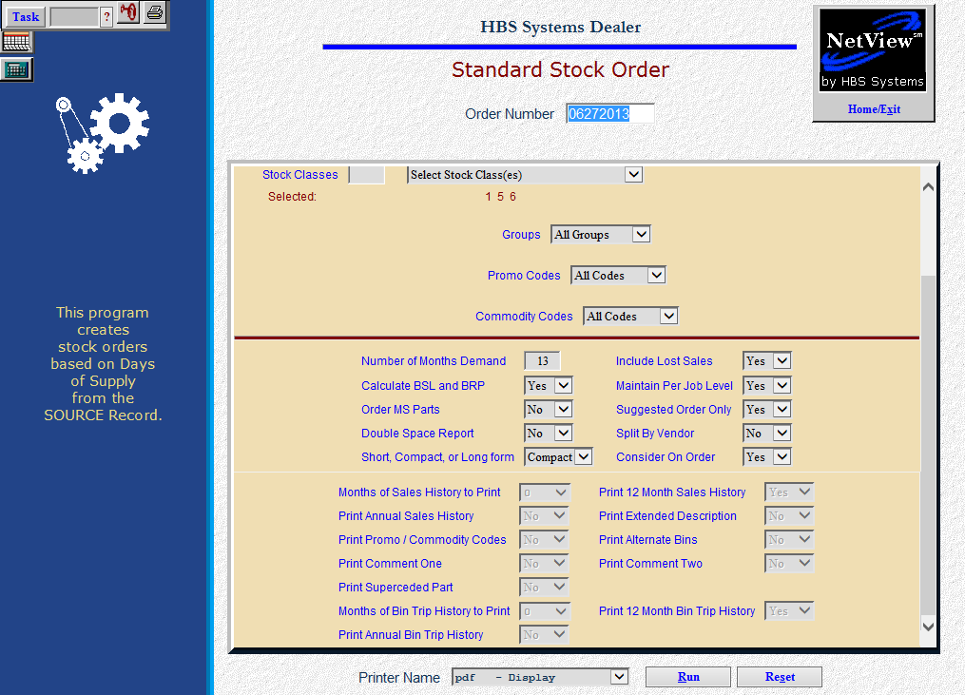

The following fields are only available if you choose the Long Form.

Months of Sales History to Print: This field offers the choice of how much month-by-month sales history to include on your printout. Detailed sales history can be useful when evaluating the system’s suggested order quantity and to provide further insight for the person reviewing the order. For instance, if you have based the order on 12 months demand, you may find it helpful to have it display that year’s data plus the previous year’s data for comparison.

Answer 0 to print no detailed sales history.

Answer 12, 24, 36, or 48 to print that number of months of detailed sales history.

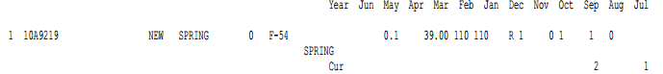

Print 12 Month History: This option lets you print totals only for 12 month sales history counts.

If you select Yes here, you will receive a total for the last 12 months and a total for 3 more 12 month periods to cover the full 48 months of history.

Choose No to leave these off your printout.

Print Annual Sales History: This option lets you print sales history count totals by year.

If you choose Yes here, you will receive a total for the current calendar year and the eight previous years.

Select No to leave these off your printout.

Print Extended Description:

- Select Yes to print the extended description from the part master.
- Select No to leave this description off your printout.

Print Promo/Commodity Codes:

- Select Yes for the report to include the promo and commodity codes set up in the part master.
- Select No to leave this information off the printout.

Print Alternate Bins:

- Choose Yes to have the alternate bin 1 and 2 for this part number print on the order.
- Select No to leave this information off the printout.

Print Comment One: This field lets you print the first line of comments from the part master on the printout.

Choose Yes to have the first line of comments appear on the order printout.

Choose No to ignore any comment line 1 information.

Print Comment Two: This field lets you print the second line of comments from the part master on the printout.

Choose Yes to have the second line of comments appear on the order printout.

Choose No to ignore any comment line 2 information.

Print Superseded Part: Here you can have the old or superseded part number appear on the order printout. The program does make use of the sales history from the old part number when calculations for BSL and BRP are made.

Choose Yes to show the old part number on the order printout.

Choose No to leave off any “old” part number information if present.

Months of Bin Trip History to Print: This field offers the choice of how much month-by-month bin trips to include on your printout.

- Answer 0 to leave the bin trips off the printout.
- Answer 12, 24, 36, or 48 to print that number of months of bin trip history.

Print 12 Month Bin Trip History: This option lets you print bin trip totals only for 12 month trip history counts.

- If you select Yes here, you will receive a total for the last 12 months and a total for 3 more 12 month periods to cover the full 48 months of history.
- Choose No to leave these off your printout.

Print Annual Bin Trip History: This option lets you print bin trip count totals by year.

- If you choose Yes here, you will receive a total for the current calendar year and the eight previous years.
- Select No to leave these off your printout.

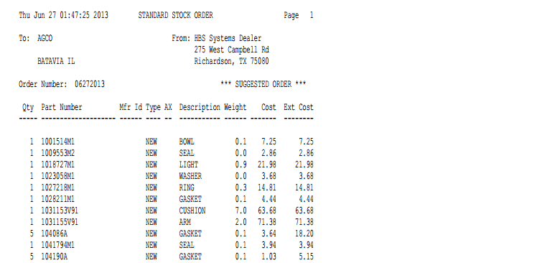

Short Form: The Standard Stock Order Short Form lists the vendor name and address, along with your dealership name and address. It includes the following information:

Order Number: This is the order number that was either assigned by you or provided by the system when the order was created.

Qty: Here you will find the suggested order quantity for the part.

Part Number: This is the part number to be ordered.

Mfr ID: This is the manufacturer ID of the part.

Type: The type field shows the part type. This could be:

N=New

U=Used

R=Reman

C=Core

M=Memo

AX: This column shows the CNH Amax code, if any.

Description: Here you will see the description of the part number listed on the order.

Weight: This field shows the weight of the part number listed.

Cost: The cost is the manufacturers cost for this part.

Ext Cost: This is the Extended Cost for the part number (cost times suggested order quantity).

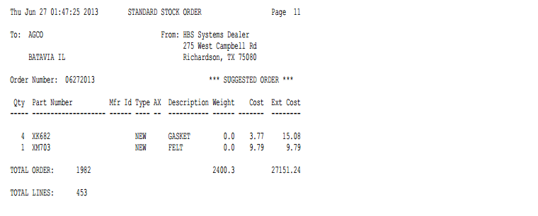

Totals: Totals on this version of the printout include:

Total piece count

Total line count

Extended weight

Extended cost

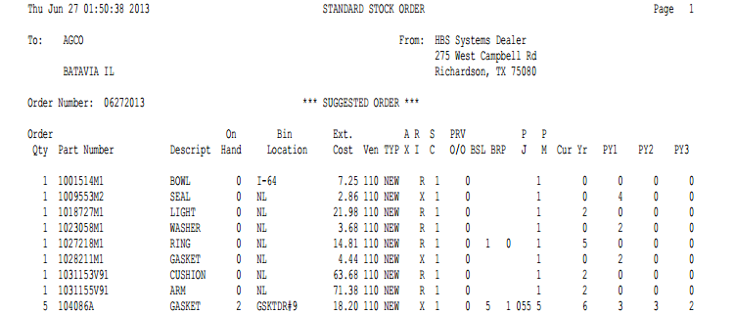

Compact Form: The Standard Stock Order Compact Form lists the vendor name and address, along with your dealership name and address. It contains the following information:

Order Number: This is the order number that was either assigned by you or provided by the system when the order was created.

Order Qty: Here you will find the suggested order quantity for the part.

Part Number: This is the part number suggested for the order.

Description: Here you will see the description of the part number.

On Hand: This field shows the current quantity on hand.

Bin Location: Here you will find the primary bin location of the part.

Ext. Cost: Here you will find the Extended Cost for the part number (cost time suggested order quantity).

Ven: This field is the Vendor number that is assigned to this part.

TYP: The Type field shows the part type. This could be:

N=New

U=Used

R=Reman

C=Core

M=Memo

AX: This column shows the CNH Amax code, if any.

RI: This is the return indicator or the return code.

SC: Here you will find the stock class for this part number.

PRV O/O: This field lists the previous on order quantity, which is the quantity on order prior to this order.

BSL: The best stocking level is from the part master.

BRP: The best re-order point is from the part master.

PJ: This is the per job quantity from the past master.

PM: This indicates the package multiple or package quantity from the part master.

Cur Yr: The current year field shows sales in the current calendar year.

PY1: The prior to year one field shows sales in the calendar year 1 year ago.

PY2: The prior to year two field shows sales in the calendar year 2 years ago.

PY3: The prior to year three field shows the sales in the calendar year 3 years ago.

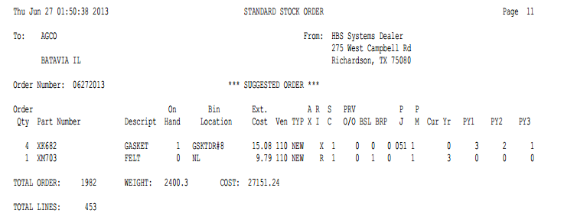

Totals: This version of the printout includes:

Total piece count

Total weight

Extended cost

Total line count

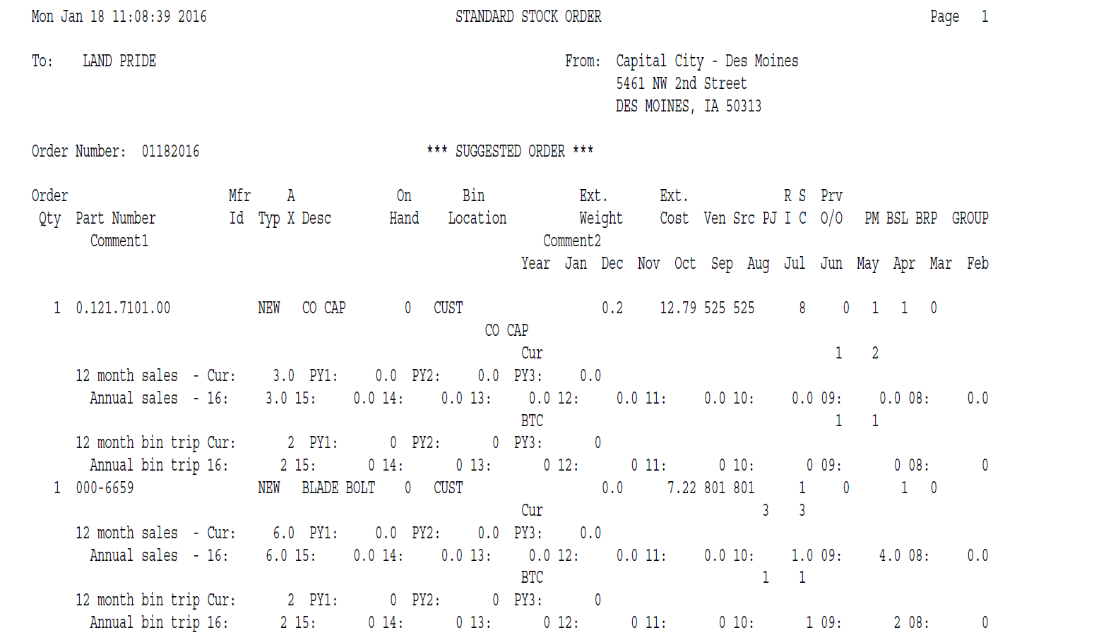

Long Form: The Standard Stock Order Long Form shows the vendor name and address that the order is issued to, the order number, and your dealership name and address. It can contain the following detailed order information (depending on your selections):

Order Qty: Here you will find the suggested order quantity for the part.

Part Number: This is the part number suggested for the order.

Mfr ID: This is the manufacturer ID.

Typ: This field shows the part type from the part master. This could be:

N=New

U=Used

R=Reman

C=Core

M=Memo

Desc: Here you will see the description of the part number.

On Hand: This field shows the current quantity on hand.

Bin Location: Here you will find the primary bin location of the suggested part.

Ext. Weight: Here you will find the extended weight for the part number (weight times suggested order quantity).

Ext Cost: This is the extended cost for the part number (cost time suggested order quantity).

Ven: This is the vendor number for this part.

Src: This is the source code of the part number.

PJ: This is the per job quantity from the part master.

RI: This is the return indicator or return code from the part master.

SC: Here you will find the stock class for this part number.

Prv O/O: This field lists the previous on order quantity, which is the quantity on order prior to this order.

PM: This indicates the package multiple or package quantity from the part master.

BSL: The best stocking level is from the part master.

BRP: The best re-order point is from the part master.

Group: This shows the group ID from the part master.

Comment 1: This field lists any comments that are in the comment 1 field of the part master.

Comment 2: This field lists any comments that are in the comment 2 field of the part master.

Month History: This optional area may show up to four lines of monthly history by year, depending on the history you selected for the printout (0/12/24/36/48). They are titled by month names.

12 month totals: This optional area shows totals only for 12 month sales history counts. They are titled:

Cur

PY1

PY2

PY3

PY4

The columns are calculated from the date of the printout/order (the 1st shows the last 12 months, PY1 shows the 12 months prior to that, and so on).

Annual totals: This optional area shows totals by calendar year. Years are shown by the last two digits of the year (i.e. 13 for 2013, 12 for 2012, 11 for 2011, etc.).

Bin Trip Month History: This optional area may show up to four lines of monthly bin trip history by year, depending on the history you selected for the printout (0/12/24/36/48). They are titled by month names.

12 month bin trip totals: This optional area shows bin trips only for 12 month sales history counts. They are titled:

Cur

PY1

PY2

PY3

PY4

The columns are calculated from the date of the printout/order (the 1st shows the last 12 months, PY1 shows the 12 months prior to that, and so on).

Annual bin trips: This optional area shows bin totals by calendar year. Years are shown by the last two digits of the year (i.e. 13 for 2013, 12 for 2012, 11 for 2011, etc.).

Superseded: These “old” part numbers will print immediately below the number that has replaced them. They are shown with a left arrow <-- before their numbers.

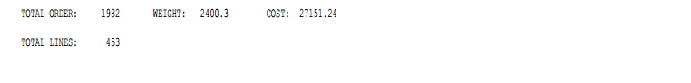

Vendor/Total Order: This line shows:

The total piece count

The total extended weight

The total extended cost on this order

Vendor/Total Lines: This is the total number of lines (unique parts numbers) on this order.

