POS—Saving and Searching for Open Tickets

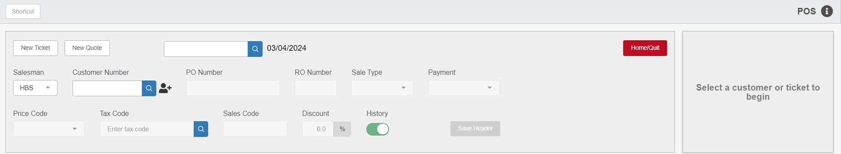

Saving and Exiting an Open Ticket: It is not uncommon for a dealership to save open picking tickets or repair orders for later completion, closing, and/or invoicing. POS makes it simple to exit an open ticket, and to find and complete tickets later. When “Save Header” is used or if a part is entered on a picking ticket, the Picking Ticket is automatically saved.

NOTE: POS allocates (removes from inventory) parts on an open ticket the moment the part is entered on a line. These parts remain allocated unless either the line or the picking ticket is voided. Quotes are not allocated until they are converted to a sale.

Searching for an Open Picking Ticket – Singular/Specific Customer: Enter or select the salesperson’s ID and the customer number. If the customer number is unknown, enter a few letters of the customer’s name and press “Enter” to start a search. A screen with an alphabetic listing of customer names and addresses will appear.

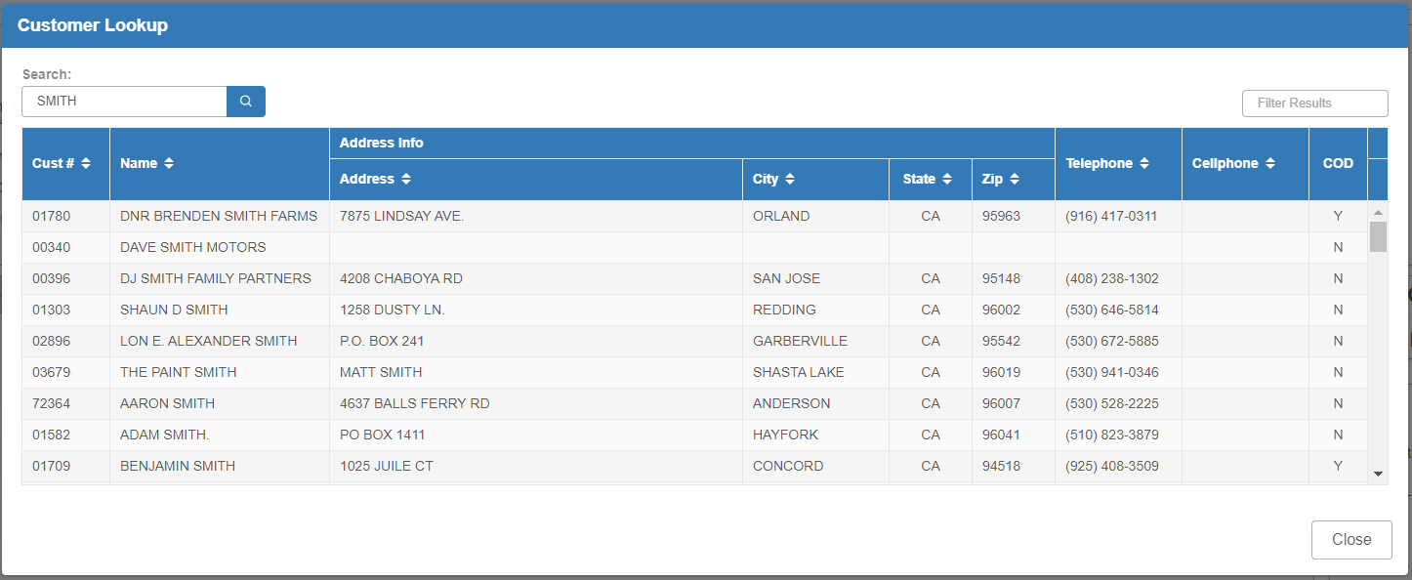

Select the desired customer by clicking on the name of the business. The customer’s open picking tickets will appear.

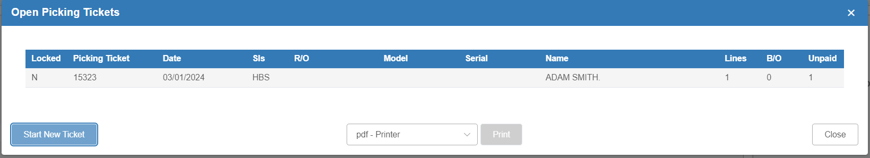

Select the appropriate ticket by clicking on the chosen line (any field).

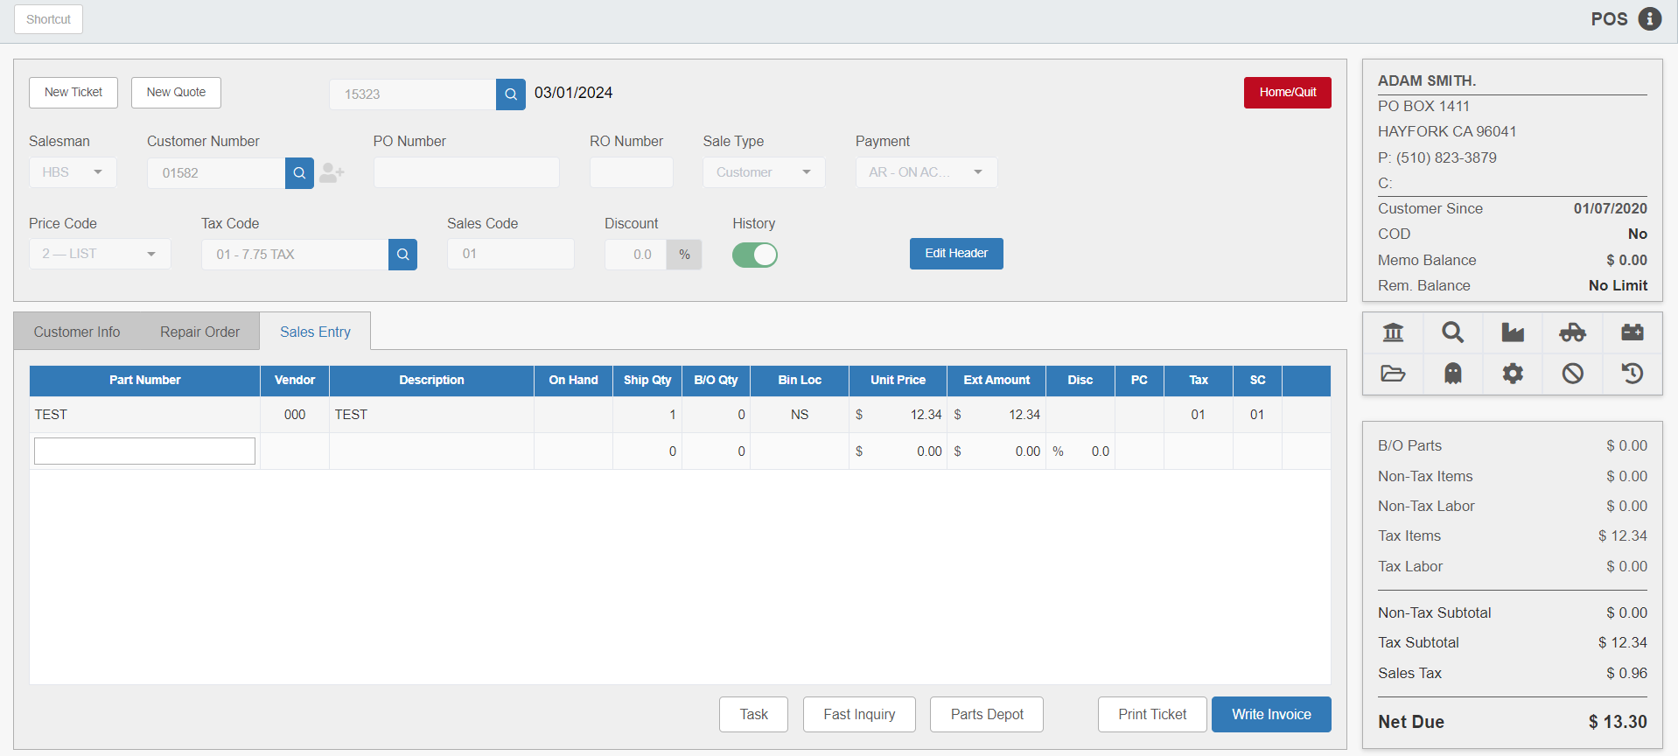

You can add or delete additional parts at this time.

Save Header: Select Save Header to save the header and begin a new ticket for this customer.

New Ticket: Choose New Ticket to begin a ticket for a different customer.

New Quote: Choose New Quote to open a new quote.

Searching All Open Tickets: It is possible to search for picking tickets by category or to see ALL open tickets rather than only those for a single, specific customer. Click the “Search” icon at the end of the Picking Ticket # field to open the Picking Ticket List window.

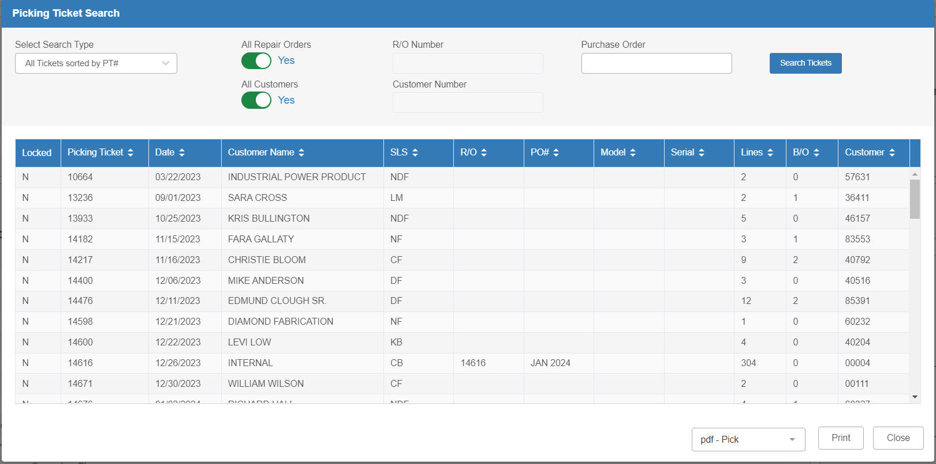

Select Search Type: This drop-down menu shows sorting options. You can also resort the lists using the column headers.

All Repair Orders:

- Setting this option to Yes will include all repair order picking tickets in the selected listing.
- Setting it to No will limit the selection to the RO number entered in the “R/O Number” field.

All Customers:

- Setting this option to Yes will include all customers with open picking tickets in the listing.
- Selecting No will limit the selection to a specific customer number typed in the following field. Enter a number or a few letters of the customer’s name to do a Customer search if needed.

Purchase Order: You can enter a purchase order number in this field to filter the open picking tickets for any ticket that holds a matching number.

Open Ticket List: You can also view all open picking tickets by clicking the Open Ticket List button on the right side of the screen.

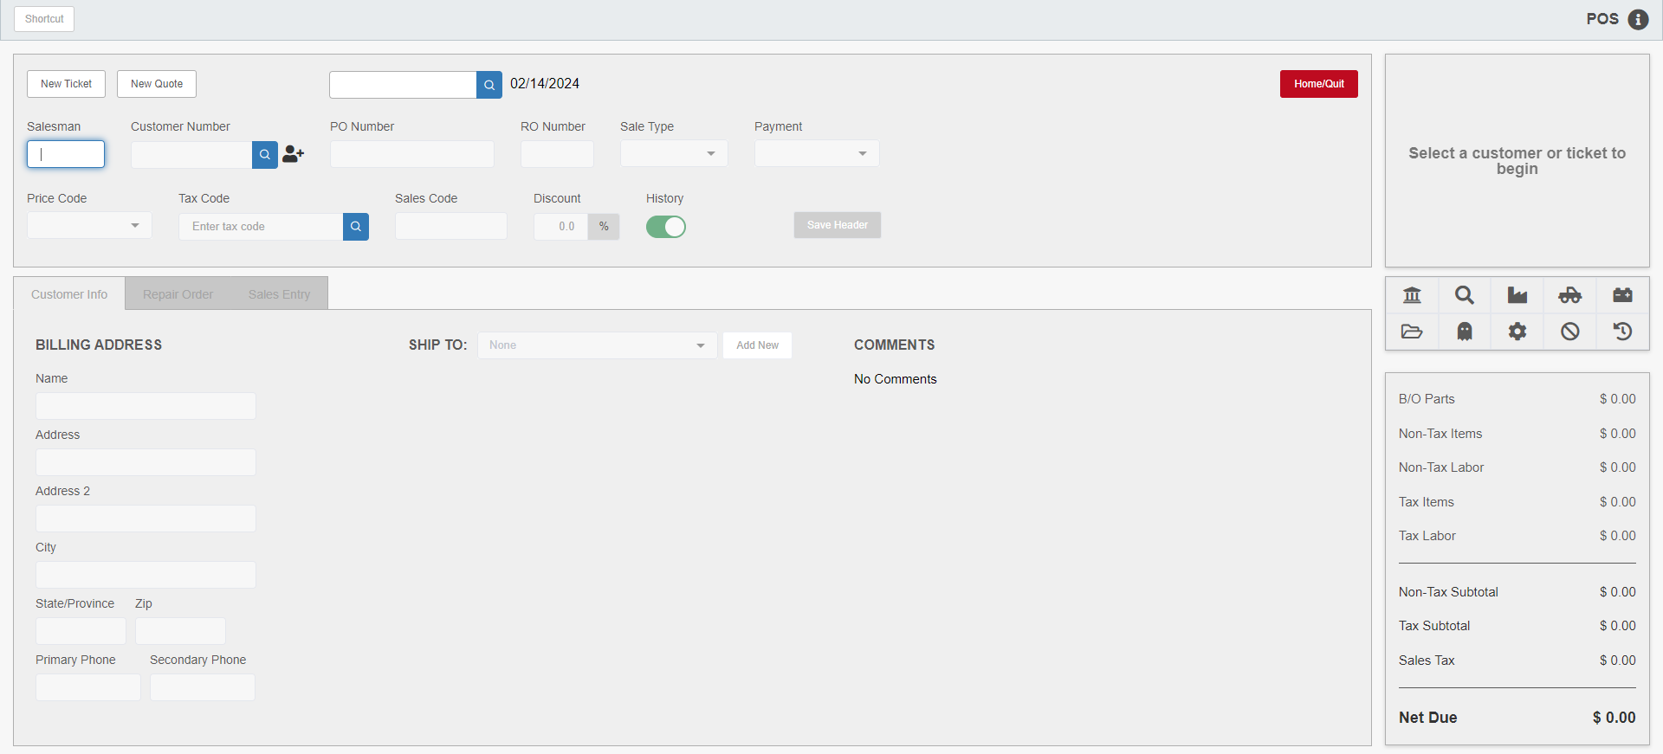

Creating a New Picking Ticket While Editing a Ticket: If, at any time while working on or editing a picking ticket, you need to create a new picking ticket, click the New Ticket button. The original picking ticket will be automatically saved and closed when the new ticket is created.

