Service System Post Journals (SSPJ)

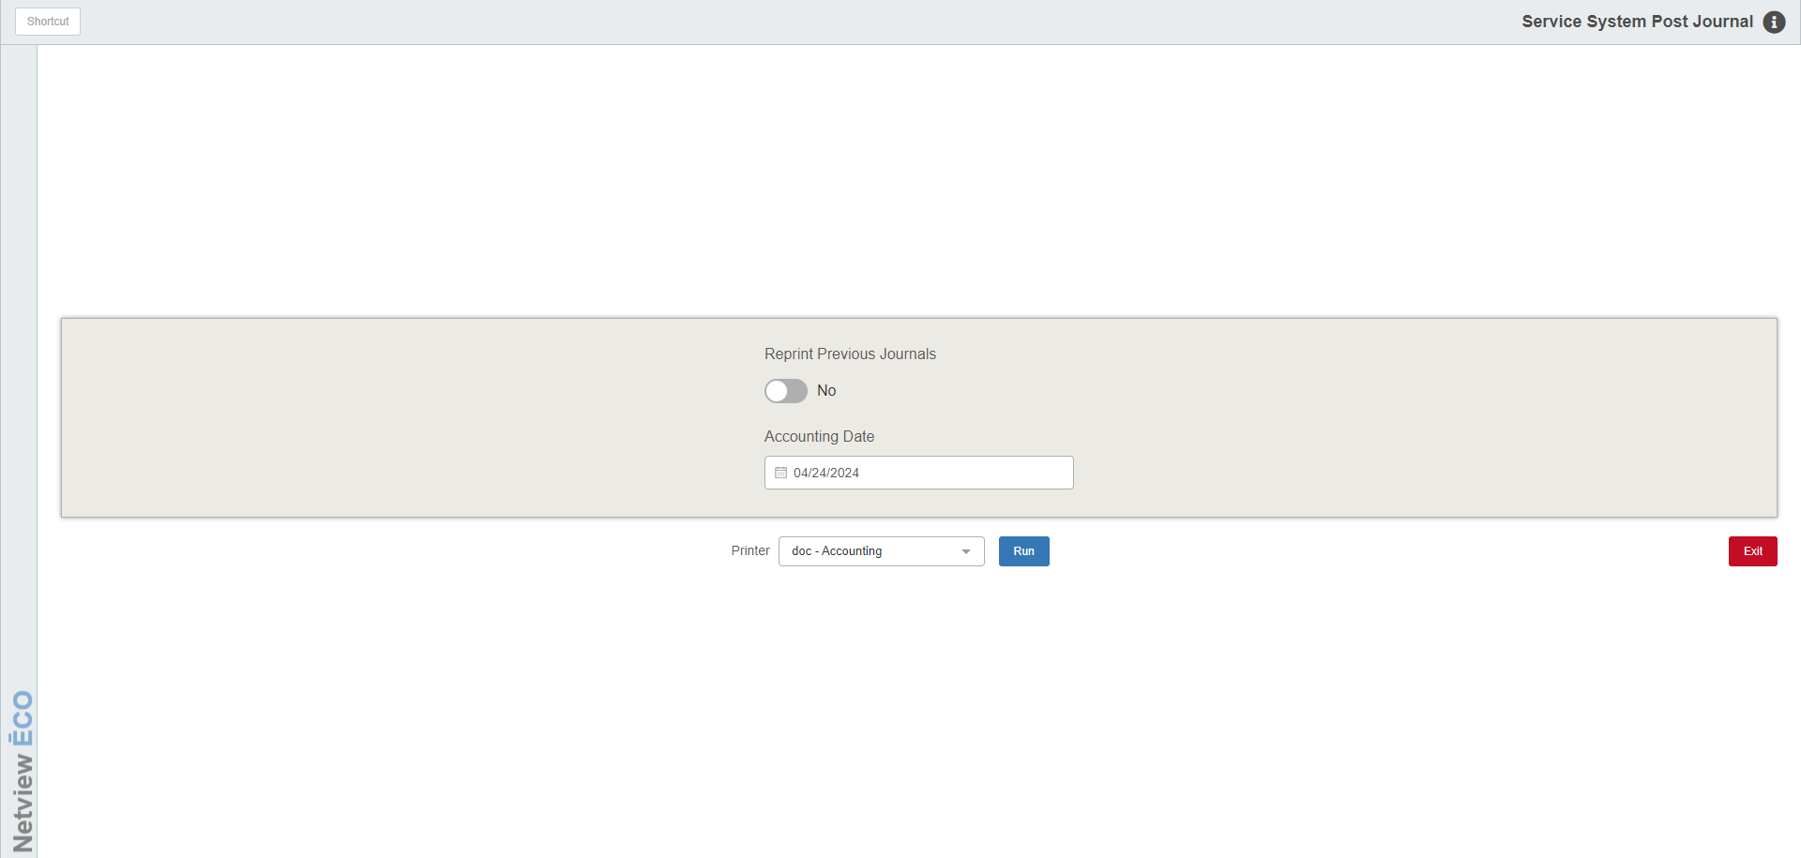

This program allows you to journalize all Service system entries and post them to the General Ledger.

To access this program, type “SSPJ” in the Shortcuts Bar.

Reprint Previous Journals: Set this option to “Yes” or “No.” The default setting is No.

Accounting Date: Type in the accounting date for the Journal. You can also select it from a calendar. The date will default to the current date. NOTE: This field will be disabled if you set Reprint Previous Journals to Yes.

Printer Name: Select the printer name from the drop-down menu. Use the pdf printer to view the printout before printing.

Run: Click this button to post the Journals.

Sample Journal Printout

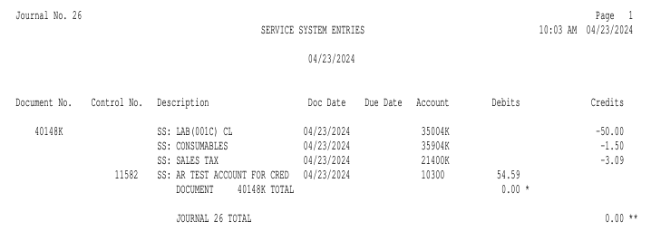

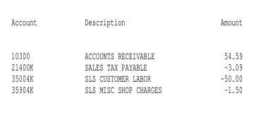

Exception Report: Sometimes, after running the Journal, the application will generate
an Exception Report after the Journal is run. This occurs if there are documents
unable to be journalized when the Journal ran. The following information will show
on the report:

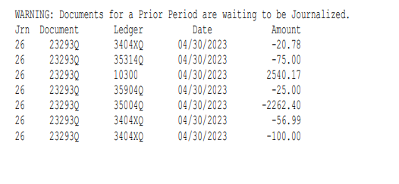

Jrn: This is the Journal number where the exception error occurred.

Document: This is the document number of the unjournalized document.

Ledger: This is the General Ledger account number associated with the document.

Date: This is the document date.

Amount: This is the dollar amount (debit or credit) of the document.

