Sales Tax Group Report (STGR): Sales Tax Group Report (STGR) provides Sales Tax information to help complete State Sales Tax reports. STGR provides the amount of sales tax collected plus the option to print the details by account of the taxable and nontaxable sales for the period of the report.

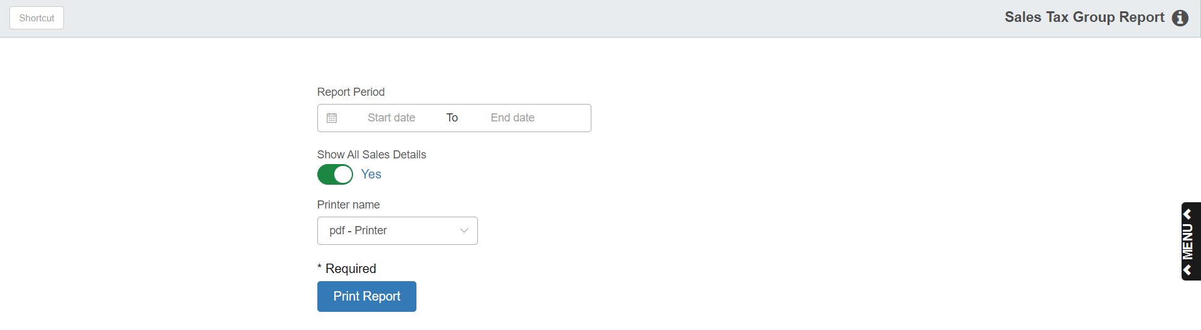

To access this function, you can either:
- Select “General Ledger” from the menu. Choose the “Memo Reports” submenu and click “Sales Tax Group Report.”
- Type “STGR” in the Shortcuts Bar.

Screen Fields

Beginning/Ending Date: Enter the date range for your report. For a monthly report, your date range might be from the first to last days of the month (such as, 05012013 to 05312013 for the month of May 2013). Reports can be run for any OPEN accounting period.

Show all sales detail:

- Select Yes to include all sales detail. Sales Detail provides totals for all individual general ledger accounts with activity in the time frame selected for the report.
- Choose No to exclude the sales detail and just receive a total per Tax Group for the activity in the time frame selected for report.

Printer Name: Identify the printer to receive your printout. A default printer is pre-filled but you may change it as necessary. Use the PDF printer to display the report.

STGR Set-up: STGR requires set-up in two areas.

The details of the Sales Tax breakdown need to be entered in Sales Tax Group Maintenance (STGM). See “Sales Tax Group Maintenance (STGM)” for information on this program.

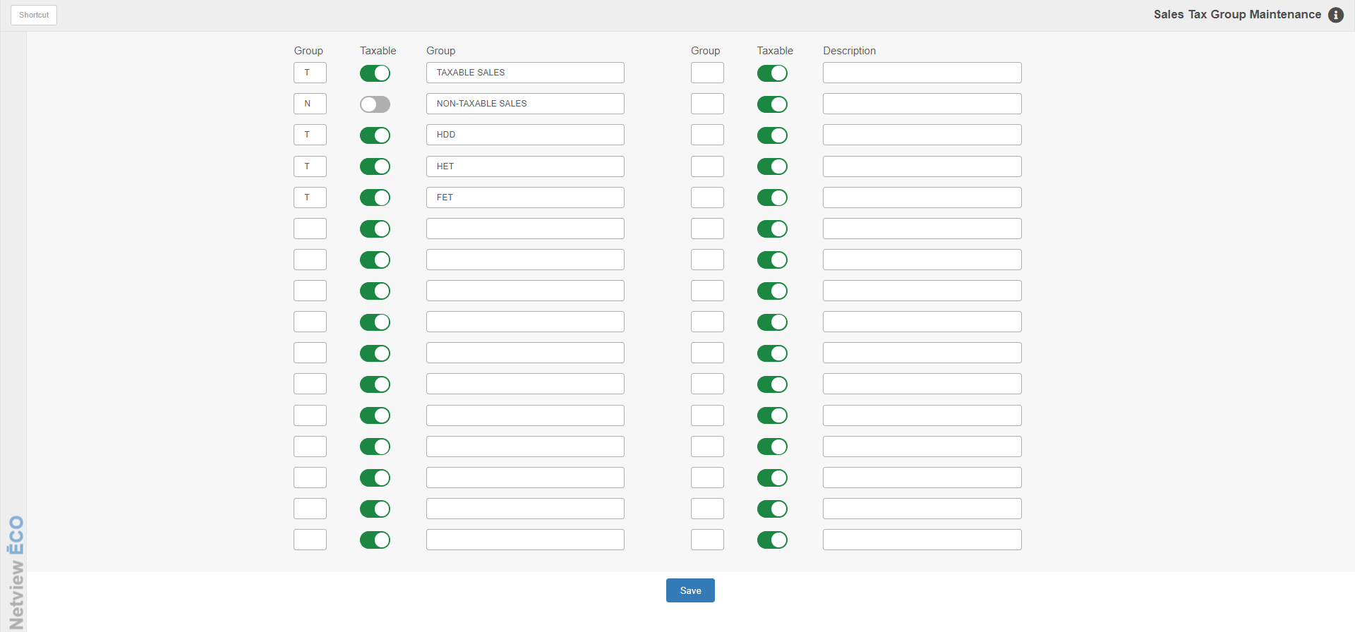

- All general ledger accounts that “define” the different groups of taxable/non-taxable sales must have that group’s code placed in the Sales Tax Group Code field for that account number in Account Number Maintenance (ANM).

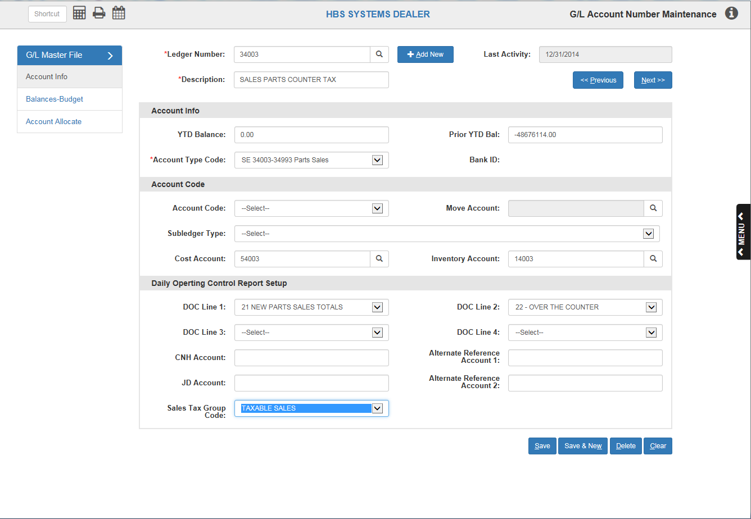

Report Printout: This report is divided into two separate sections:

Accumulated Tax Calculations

General Ledger Sales Account Amounts

Accumulated Tax Calculations Section Columns:
HBS SYSTEMS DEALER
SALES TAX REPORT
Mon Jun 3 12:15:36 2013 ACCUMULATED TAX CALCULATIONS Page 1

--------------------------------------------------------------------------------------------------
Cur Activity YTD Activity
Description Acct# Tax Sales Tax Sales
--------------------------------------------------------------------------------------------------

6.6% TAX 21400 5347.53 81023.18 2660.89 40316.52

ALL TAX TOTALS: 5347.53 81023.18 2660.89 40316.52

Description: This area shows the name of the sale tax accounts used for this portion of the report.

Acct #: This column shows the general ledger account number for the sales tax account used.

Cur Activity Tax: This figure represents the amount of sales tax collected during the period covered by the report.

Cur Activity Sales: This figure shows the calculated amount of Sales on which tax was collected during the period covered by the report. It is figured by dividing the sales tax dollars collected by the sales tax percentage rate.

YTD Activity Tax: This figure represents the balance in the Sales Tax Account at the end of the last accounting period closed prior to the time frame of the report.

YTD Activity Sales: This figure shows the calculated amount of Sales on which tax was collected for the accounting period closed prior to the time frame of the report. It is figured by dividing the sales tax dollars collected by the sales tax percentage rate.

General Ledger Sales Account Amounts Section Columns:
HBS SYSTEMS DEALER
SALES TAX REPORT
Mon Jun 3 14:52:41 2013 GENERAL LEDGER SALES ACCOUNT AMOUNTS Page 2

--------------------------------------------------------------------------------------------------
Description Acct # Cur Sales YTD Sales
--------------------------------------------------------------------------------------------------
Tax Group A: WG SALES TAXABLE
S USED TRACTORS TAX 33101 39978.00 103593.57
S USED HAY EQUIP TAX 33201 17500.00 90500.00
S USED OTHER TAX 33301 3500.00 28944.84
** WG SALES TAXABLE Totals ** 60978.00 223038.41

Tax Group B: WG SALES NON-TAXABLE
S NEW AGCO TRACTORS N/T 32111 69369.98 563991.20
S NEW AGCO IMP N/T 32211 13288.02 10433.00
S USED HAY EQUIP N/T 33211 11150.00 179094.71
S-USED FORAGERS N/T 33411 37000.00 119995.00
** WG SALES NON-TAXABLE Totals ** 130808.00 873513.91

Tax Group C: PARTS SALES TAXABLE
S MF PARTS CTR TAX 34003 4678.07 241085.17
S MF PARTS SHOP TAX 34023 7274.42 28679.70
S HS PARTS CTR TAX 34143 1244.99 30554.06
S HS PARTS SHOP TAX 34163 2974.40 5097.34
S WS PARTS CTR TAX 34283 691.09 2352.77
S AL PARTS CTR TAX 34563 661.80 8984.63
S AL PARTS SHOP TAX 34583 0.48 26.85
S PARTS FREIGHT 34913 2519.92 23705.65
** PARTS SALES TAXABLE Totals ** 20045.17 340486.17

Tax Group D: PARTS SALES NON-TAXABLE
S MF PARTS CTR N/T 34013 16891.62 271784.63
S MF PARTS SHOP N/T 34033 6697.29 26111.48
S MF RESALE CTR N/T 34043 5.18 292.21
S MF RES WARRANTY 34103 38577.29 48407.61
S HS PARTS CTR N/T 34153 8203.57 39594.72
S HS PARTS SHOP N/T 34173 3441.14 10865.71
S HS RES WARRANTY 34243 -32.55 5983.85
S AL PARTS CTR N/T 34573 401.76 15498.10
S AL PARTS SHOP N/T 34593 11.39 33.82
S AL RES WARRANTY 34663 179.96 1717.32
** PARTS SALES NON-TAXABLE Totals ** 74924.87 429340.39

Tax Group E: LABOR SALES NON-TAXABLE
S LABOR SHOP N/T 35004 44495.00 211955.87
** LABOR SALES NON-TAXABLE Totals ** 44495.00 211955.87

ALL SALES TOTALS: 338823.78 2078334.75

Description: This area shows the name of the tax group and optionally the names of the individual sales accounts with activity during the period covered by the report.

Acct #: This column shows the general ledger account number for the sales accounts used.

Cur Sales: This figure shows the amount of sales activity that was posted to the general ledger account during the period covered by the report.

YTD Sales: This figure represents the balance in the general sales account at the end of the last accounting period closed prior to the time frame of the report.

