Sales Tax Reports (STXR)

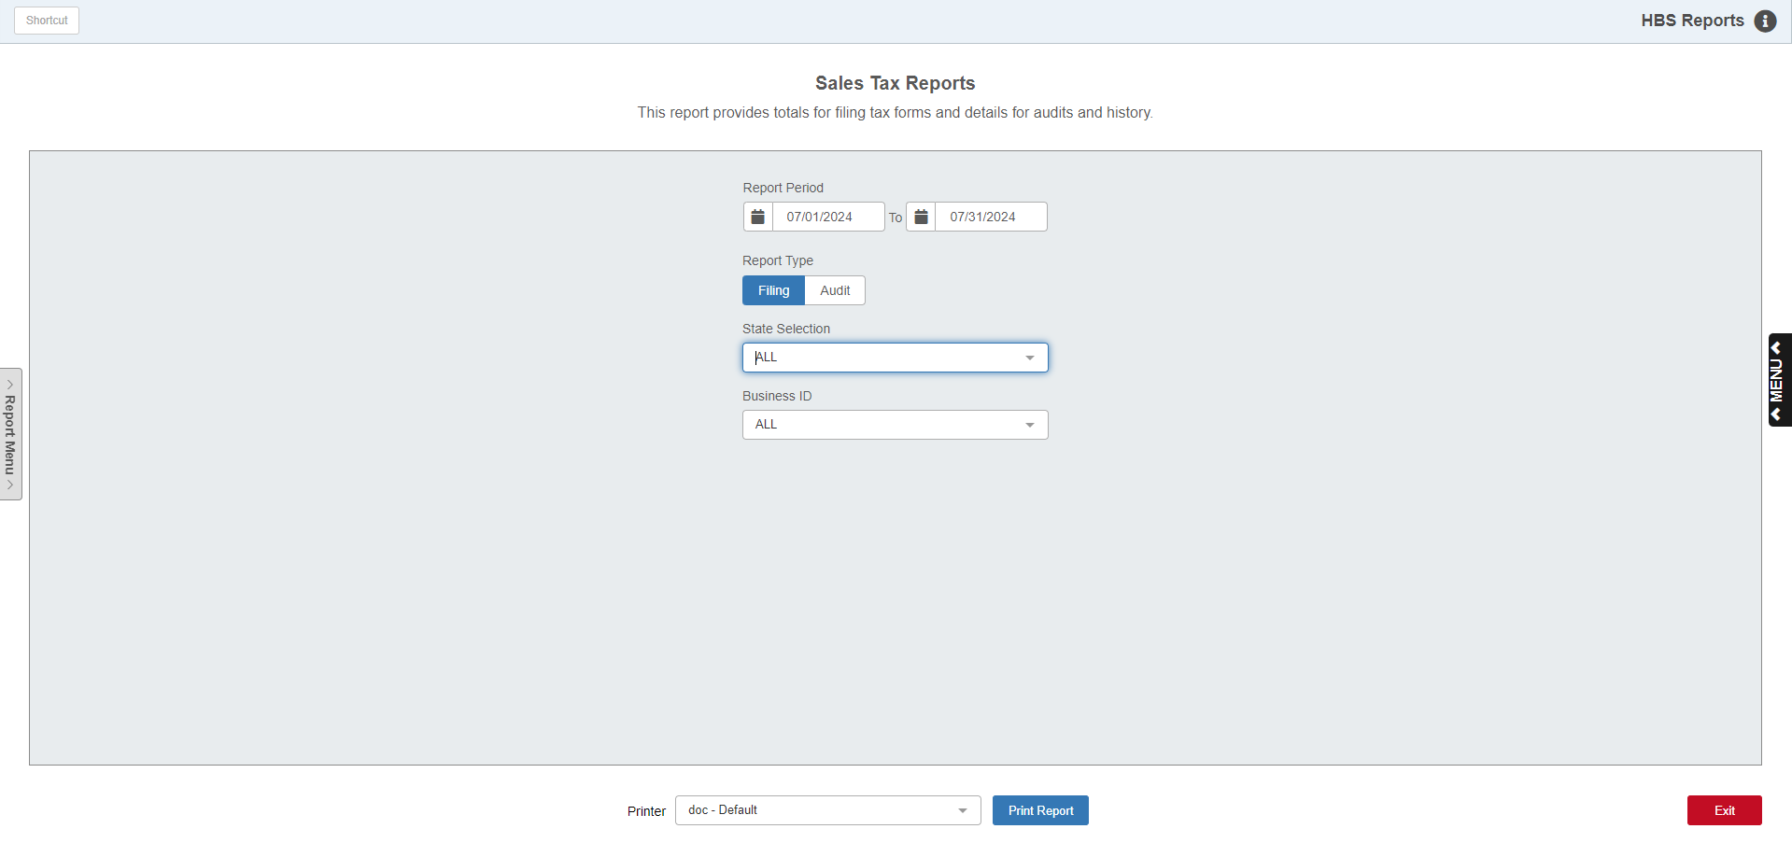

The Sales Tax Report (STXR) reports the taxable and nontaxable sales processed through POS (Parts), ROM (Service), US (Units) and RENT (Rental). All items on invoices run through programs that are "sold" to the customer or the party paying the invoice are included in this report.

The GL account where those sales are posted is not considered for this report since the item is considered a "sale." Typically, most sales are run to accounts that begin with "3" which puts them on the Operating Statement pages of a Financial Statement. Many dealerships choose to run the "sale" of various charges to accounts other than those that begin with "3". Some examples might be Prep Fees, Processing Fees, Misc Shop Charges, Environmental Fees and so on. Even though other accounts (expenses, other income, etc.) may be used to "catch" the sales for these charges, STXR will correctly include them in its tally. The design of this report is to match the activity shown on the actual invoices. This can be seen by comparing invoices to the audit version of the report. However, if you are trying to match dollar to dollar from STXR to a financial statement, you would have to consider looking at the accounts used in Other Charg Maintenance (OCM), Source Master Maintenance (SMM), Service Options & Defaults (SOD), and Rental Class Maintenance (RCM), and look for everything that doesn’t begin with “3.”

To access this function, you can:

- Select “General Ledger” from the menu. Choose the “Memo Reports” submenu and click “Sales Tax Reports.”
- Type “STXR” in the Shortcuts Bar.

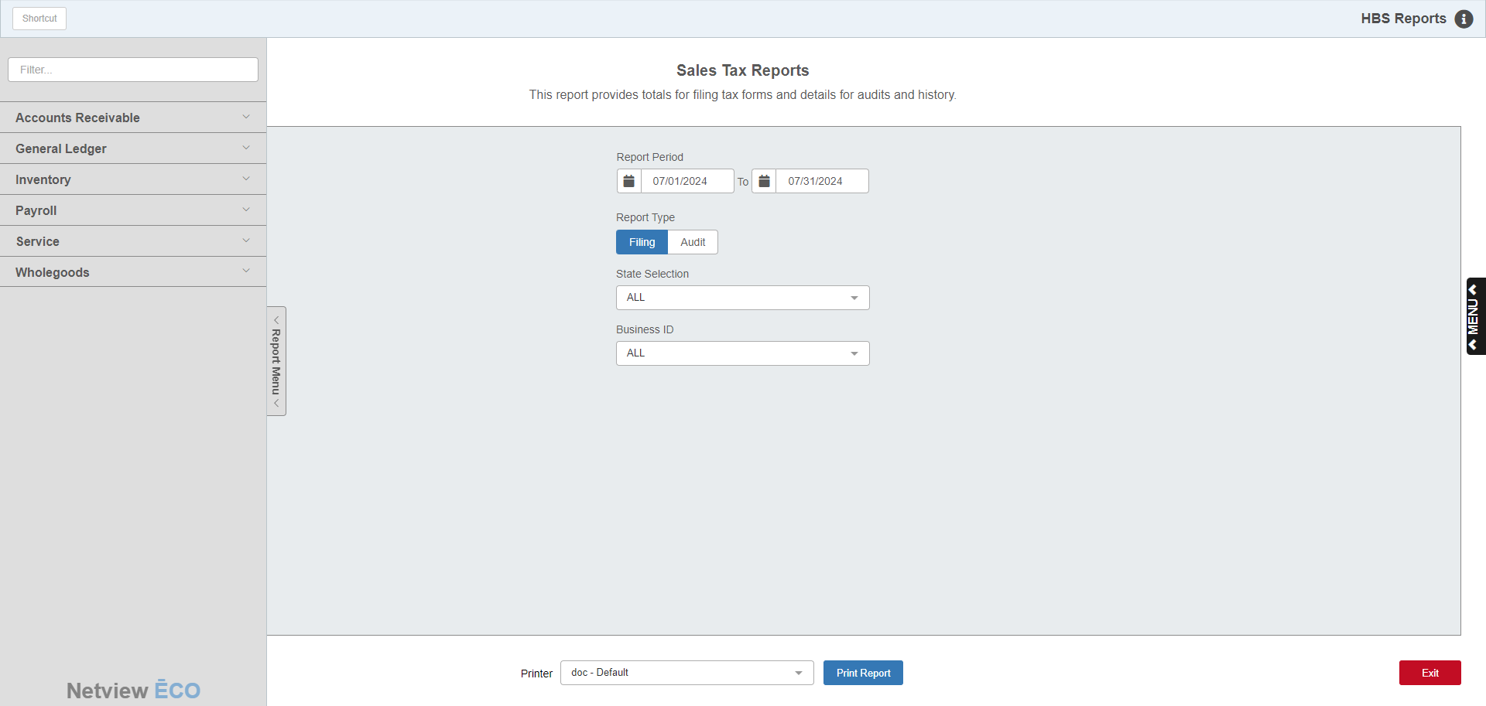

Reports Navigation Menu: This new menu appears on the left side of the screen for all reports and allows the user easy access to all report programs in the system. It is collapsable and can be easily hidden.

Report Period: Enter the start and ending dates for the report period or select them from the calendars attached to each field.

Report Type:

- Choose Filing to generate a summarized report suitable to collect the information needed to prepare a sales tax return.
- Choose Audit to produce a detailed report with all the transactions used to create the summary version.

Sort order: This field only appears if you selected the Audit Report.

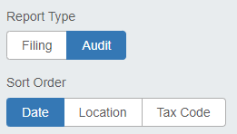

It offers you different options for sorting the report:

Choose Date to have the entries on the report list chronologically.

Choose Location to divided the entries into sections based on their location.

Choose Tax Code to divide the entries into sections based on their tax code.

State Selection: Choose an individual state for the report or choose “ALL” to report sales tax activity from all states within the selected dates.

Business ID: This field is for multi-location dealerships. You can choose from the list of dealership locations to generate reports for individual locations or “ALL” locations.

Printer Name: Identify the printer to receive your printout. A default printer is pre-filled, but you may change it as necessary.

Print Report: Click this button to print the report.

STXR - Sales Tax Reports – SST Filing: This variation of the sales tax report for SST states provides the information to prepare the sales tax return. You can select the range of dates and type of report (filing) to generate the information.

The information shown for Washington (WA) in the following report illustrates the Sales Tax Filing Report for an SST state.

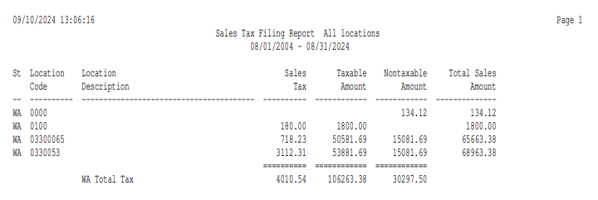

Report Columns include:

St: This column identifies the 2-letter abbreviation where the sales tax was collected.

Location Code: For SST states, this column shows the geo code or location code for the tax collected. The example above shows the Washington state location codes, which are a 5-character code starting with L (the city rate), a 3-character code (the county rate), and a 2-character code (the state rate). Other states may have a different style of code.

Sales Tax: This is the amount of sales tax collected. A grand total for this column is provided.

Taxable Amount: This column shows the amount of taxable sales for which the sales tax was calculated. A grand total for this column is provided.

NonTaxable Amount: This column shows the amount of nontaxable sales for this city, county, or state. A grand total for this column is provided.

Total Sales Amount: This column shows the total amount of sales (taxable plus nontaxable) for the city, county, or state.

STXR - Sales Tax Reports – SST Audit: This variation of the sales tax report for SST states provides line by line detailed information that is summarized on the Filing Report. You can select the range of dates and type of report (audit) to generate the information.

The partial report shown here is for Washington (WA), which illustrates the Sales Tax Filing Report for an SST state.

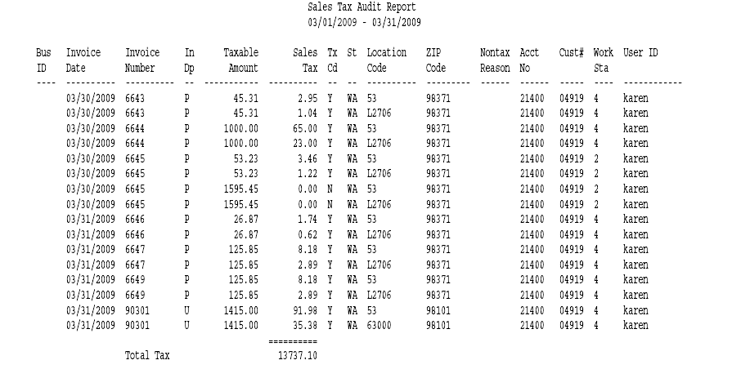

Report Columns include:

Bus ID: This column is for multi-location dealerships. It will show the location code for the transaction line.

Invoice Date: This column shows the invoice date for the line of detail.

Invoice Number: This shows the invoice number of the transaction.

In Dp: This column shows the invoice department:

P=Parts

R=Rental

S=Service

U=Units.

NOTE: An “X” appears after these letters if the entry has been manually added.

Taxable Amount: This column shows the amount of transaction that was taxable and was used as the basis to calculate the sales tax.

Sales Tax: This is the amount of sales tax collected. A grand total for this column is provided.

Tx Cd: This is the tax code column. It shows:

“Y” for Taxable lines in SST states

“N” for Nontaxable line in SST states

For non-SST states, the actual tax code

St: This column identifies the 2-letter state abbreviation where the sales tax was collected.

Location Code: For SST states, this column shows the geo code or location code for the tax collected. The example above shows the Washington state location codes, which are a: 5-character code starting with L (the city rate), a 3-character code (the county rate), and a 2-character code (the state rate). Other states may have a different style of code.

Zip Code: This column shows the zip code for the transaction.

NonTax Reason: This column is for future use.

Acct No: This field shows the G/L account where the sales tax is collected.

Cust#: This column shows the customer number for the transaction line.

Work Sta: This column shows the last digits of the IP address where the transaction was processed.

User ID: This column shows the login of the person who processed the transaction.

California Sales Tax: Although California is not a member of the Sales Tax Consortium, California provides a table to HBS to handle California Sales Tax. This table of the numerous sales tax rates in California is available and updated on a regular basis with changes. The table interfaces with POS, ROM, and US, and automatically calculates the sales tax rate for in-house sales as well as those delivered or sent to a different location within California. This optional package provides the details for taxable dollars and tax collected by location code to Sales Tax Report (STXR). It also provides the details of the Schedule B assessment by location for reporting purposes.

STXR – California Filing Report Example:

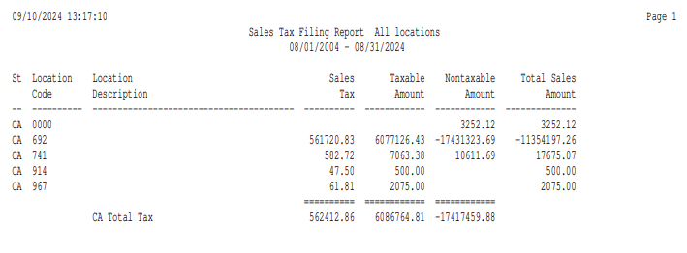

The filing report with the optional California Sales Tax Tables shows the break out for AG tax sales and other location codes used in sales transactions.

STXR – California Schedule B Detail Example:

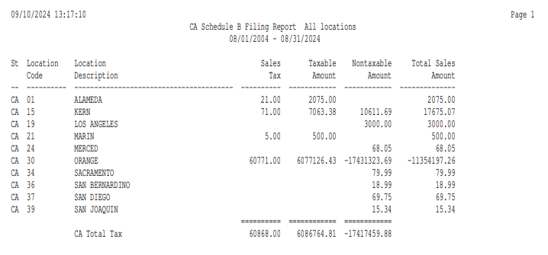

The audit report provides the details for any AG taxes collected, sales and tax by location code, and Schedule B by location for the 1% assessment.

SST State Setup – SSTXR: The key to determining the correct sales tax rate for each customer in an SST state is their precise address. SSTXR is a report that looks at all customer masters and ship-to addresses for missing and incorrect information.

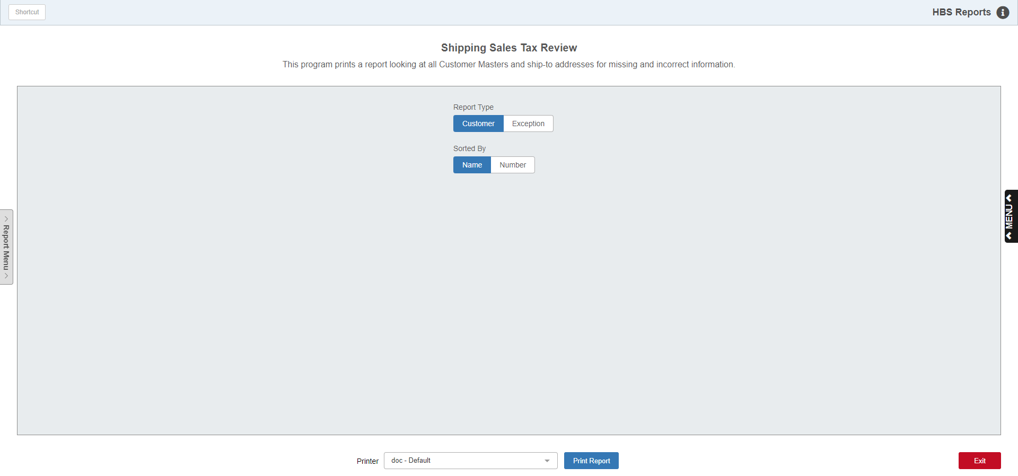

It can identify problems such as a Missing State, Missing Zip Code, Bad State Abbreviation, and so on.

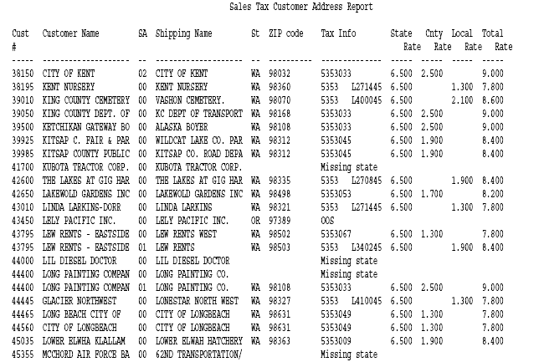

The columns on this report include:

Cust #: This is the five-digit customer number.

Customer Name: This field shows the customer name.

SA: This field shows the ship-to address number of the record—00 is the first record, 01 is the second, and so on. If there are no ship-to addresses, the name in the following field will be the same as the customer name.

Shipping Name: This field shows the name of the ship-to address. If there are no ship-to addresses, the name in this field will be the same as the customer name.

Zip Code: This field holds the zip code.

Tax Info/State Rate/Cnty Rate/Local Rate/Total Rate: The tax info field shows the information it has verified. “OOS” appears if the customer’s address is Out of State. You might find information about missing or bad entries: Bad State, Bad Zip, Missing State, Missing Zip, etc. You also see codes that identify the tax rate for the customer. If there is a string of numbers, these identify the geo code the customer belongs to. To the right of those numbers, you will see the different components of the tax rate for that customer. Any exceptions noted in this column should be corrected.

Every customer’s address and zip code should be examined for completeness and accuracy. In addition, we recommend that you update all zip codes in the system to the correct plus-four format. In some areas, the plus four number is needed to clarify the correct geo code and tax rate. You can create a Report Writer report to help with this project. A sample is shown below.

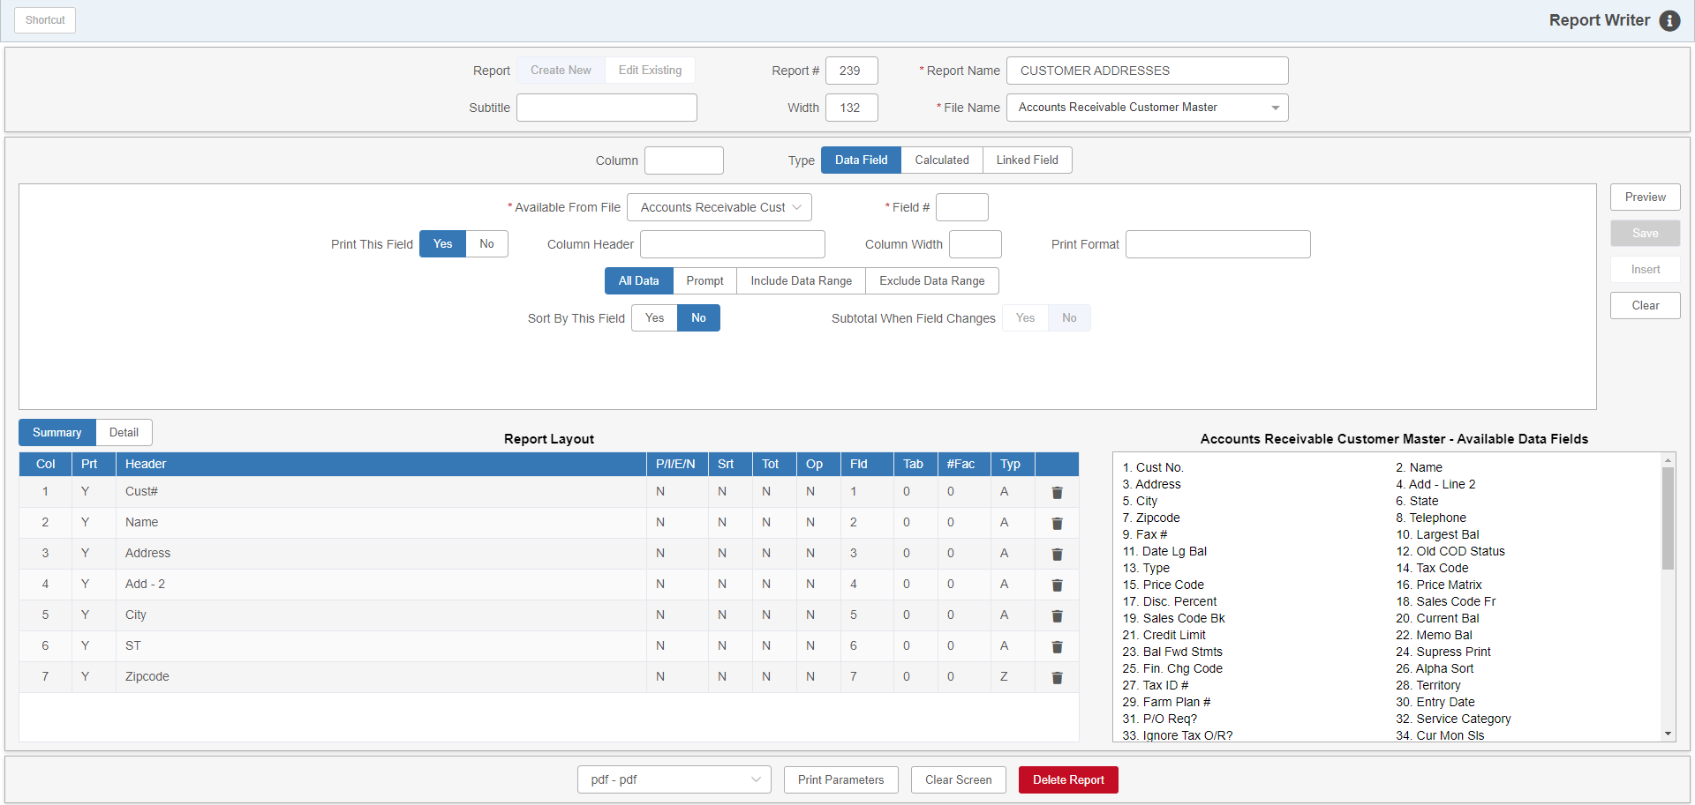

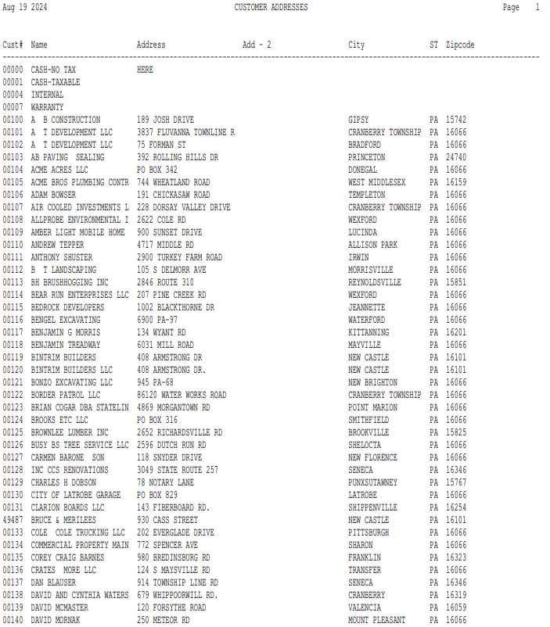

To determine the correct plus 4 zip code for each customer, you can use the USPS website: http://zip4.usps.com/zip4/welcome.jsp

The zip code changes can be entered in Enter Customer Information (ECI) or in Custom Customer Maintenance (CCM). Again, all zip codes should be updated to the correct plus-four format.

Sales Collection Process—SST: Once the states are identified in the Business Presence screen (STXBP), the system will begin to collect sales tax information for the states selected. In SST states, the information is based on very detailed information called geo codes, which determine the tax rate based on the customer’s address. This detailed information is kept in a table on the system and will be updated quarterly based on new information supplied by the SST group.

Processing Sales in SST States:

Processing Sales in POS (Parts/Service): In SST states, you now need to consider the destination of the parts/service being sold.

- If the customer comes to the dealership to purchase or pick up the goods, then select the customer for the ticket as usual. When the ticket is run, the sales tax rate in force at the dealership will be applied to the parts/service invoice. Leave the Ship-To info blank. In the case of a non-taxable customer, the non-taxable rate on the customer will prevail, and no tax will be charged on the ticket when that customer is at the dealership to purchase or pick up the goods.
- If you are shipping or delivering the goods to a customer’s home or place of business, select the customer for the ticket as usual, then use the Ship To information to show where the merchandise is bound. Set the “Ship To” field to “Billing” when the customer is to receive the goods at their home or business address. Or, you can choose a ship to address on file by clicking the Add New button to add the Ship To address. When the ticket is run, the sales tax rate in effect for the customer’s home or business (or ship to address) will be applied to the parts/service invoice.
- If you are shipping or delivering the goods to a customer’s home or place of business and the customer is non-taxable and their tax code is not 00, select the customer for the ticket as usual, then use the Ship To information to show where the merchandise is bound. Set the “Ship To” field to “Billing” when the customer is to receive the goods at their home or business address. When the ticket is run, the sales tax rate in effect for the customer’s home or business will be applied to the parts/service invoice.

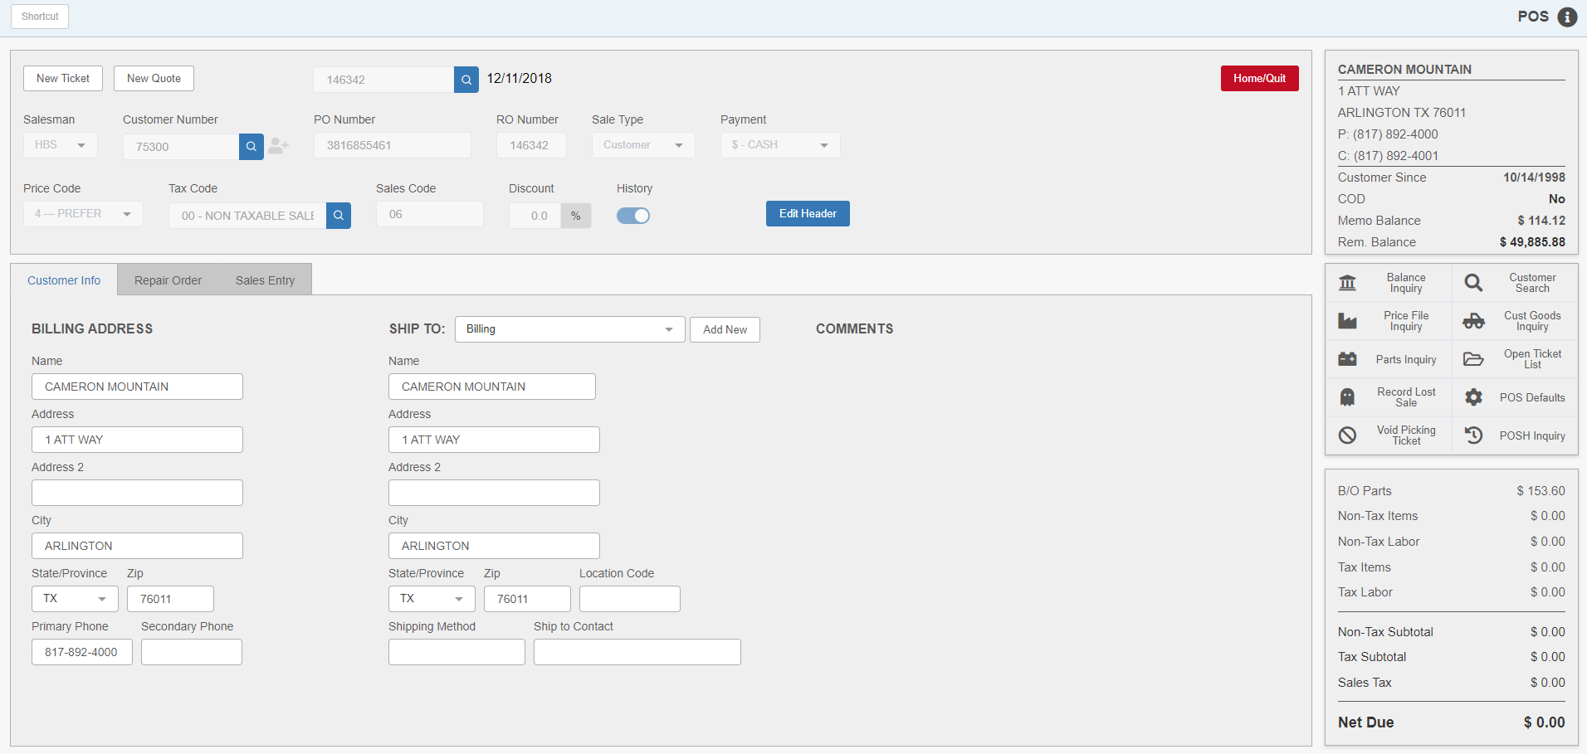

Processing Sales in US (Units): In SST states, you now need to consider the destination of the equipment being sold.

- If the customer comes to the dealership to purchase or pick up the equipment, then select the customer for the sale as usual. When the sale is run, the sales tax rate in force at the dealership will be applied to the unit sales invoice. Leave the Ship-To info blank. In the case of a non-taxable customer, the non-taxable rate on the customer will prevail, and no tax will be charged on the ticket when that customer is at the dealership to purchase or pick up the equipment.
- If you are shipping or delivering the equipment to a customer’s home or place of business, select the customer for the sale as usual, then use the Ship To information to show where the equipment is bound. Set the “Ship To” field to “Billing” when the customer is to receive the equipment at their home or business address, or choose any other ship to address shown in the dropdown. You can also press the Add New button to add the Ship To address. When the sale is run, the sales tax rate in effect for the customer’s home or business (or ship to address) will be applied to the unit sales invoice.
- If you are shipping or delivering the equipment to a customer’s home or place of business and the customer is non-taxable and their tax code is not 00, select the customer for the sale as usual, then use the Ship To information to show where the equipment is bound. Set the “Ship To” field to “Billing” when the customer is to receive the equipment at their home or business address. When the sale is run, the sales tax rate in effect for the customer’s home or business will be applied to the unit sales invoice.

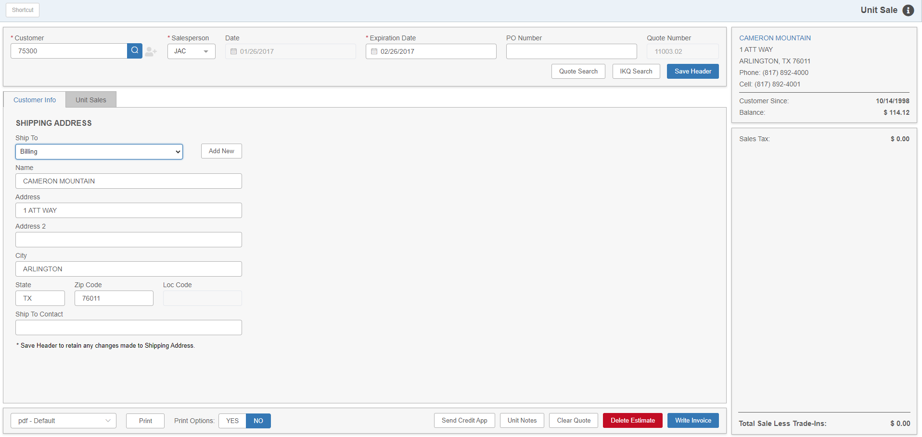

Processing Sales in ROM (Service): In SST states, you now need to consider the destination of the equipment being repaired.

- If the customer comes to the dealership to pick up the serviced equipment, then select the customer for the repair order as usual. When the service invoice is run, the sales tax rate in force at the dealership will be applied to the service invoice. Leave the Ship-To info blank. In the case of a non-taxable customer, the non-taxable rate on the customer will prevail, and no tax will be charged on the ticket when that customer is at the dealership to pick up the serviced equipment.
- If you are shipping, delivering or repairing the serviced equipment at/to a customer’s home or place of business, select the customer for the repair order as usual, then use the Ship To information to show where the serviced equipment is bound. Press the Use Billing button when the customer is to receive the serviced equipment at their home or business address. Or, choose a ship to address on file by pressing the Ship To Search button. You can also press the Add New button to add the Ship To address. When the ticket is run, the sales tax rate in effect for the customer’s home or business will be applied to the service invoice.
- If you are shipping, delivering, or repairing the serviced equipment at/to a customer’s home or place of business and the customer is non-taxable and their tax code is not 00, select the customer for the repair order as usual, then use the Ship To information to show where the serviced equipment is bound. Press the Use Billing button when the customer is to receive the serviced equipment at their home or business address. When the ticket is run, the sales tax rate in effect for the customer’s home or business will be applied to the service invoice.

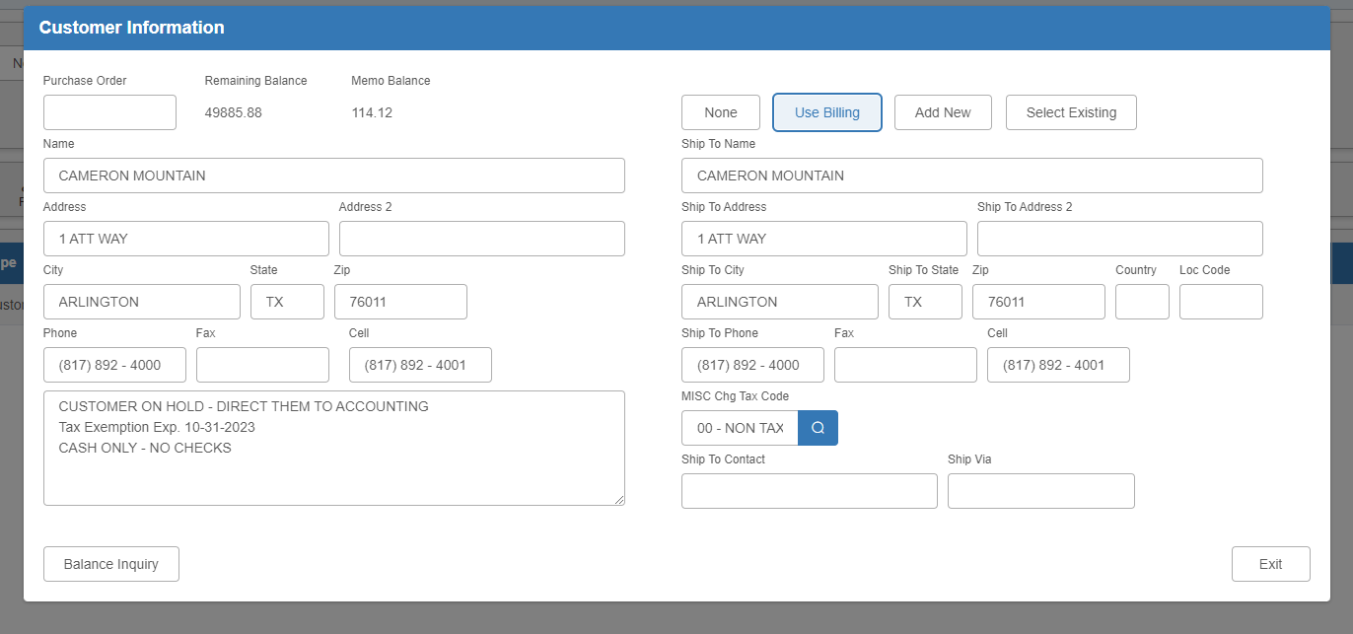

Processing Sales in Rental: In SST states, you now need to consider the destination of the equipment being rented.

- If the customer comes to the dealership to rent the equipment, then select the customer for the rental invoice as usual. When the invoice is run, the sales tax rate in force at the dealership will be applied to the rental invoice. Leave the Ship-To info blank. In the case of a non-taxable customer, the non-taxable rate on the customer will prevail, and no tax will be charged on the ticket when that customer is at the dealership to rent the equipment.
- If you are shipping or delivering the rented equipment at/to a customer’s home or place of business, select the customer for the rental order as usual, then use the Ship To information to show where the rented equipment is bound. Choose a ship to address on file for the contact or create a new one for billing by selecting “Custom” in the “Ship To Address” drop-down menu. Select “Billing” from the menu when the customer is to receive the serviced equipment at their home or business address. When the ticket is run, the sales tax rate in effect for the customer’s home or business will be applied to the rental invoice.

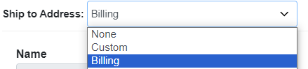

- If you are shipping or delivering the rented equipment at/to a customer’s home or place of business and the customer is non-taxable and their tax code is not 00, select the customer for the repair order as usual, then use the Ship To information to show where the serviced equipment is bound. Choose a ship to address on file for the contact or create a new one for billing by selecting “Custom” in the “Change Address” drop-down menu. Select “Billing” from the menu when the customer is to receive the serviced equipment at their home or business address. When the ticket is run, the sales tax rate in effect for the customer’s home or business will be applied to the rental invoice.

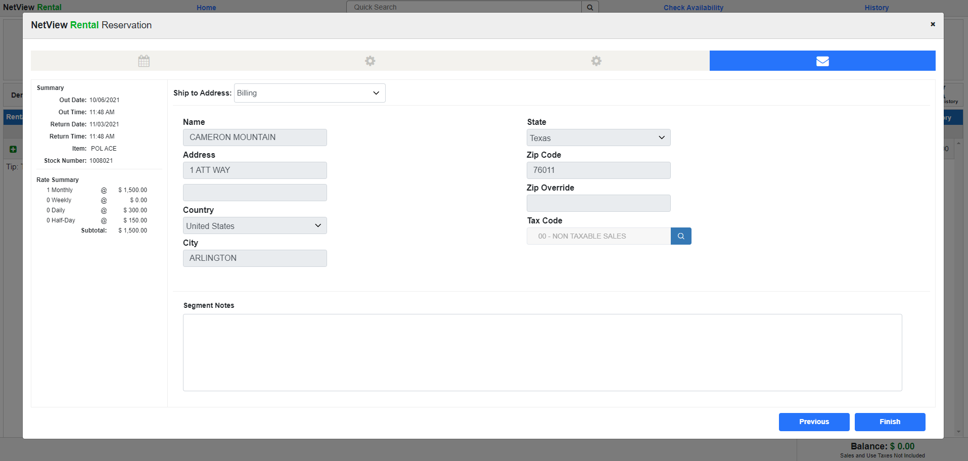

STXR - Sales Tax Reports – Non-SST Filing: This variation of the sales tax report for Non-SST states provides the information to prepare the sales tax return. You can select the range of dates and type of report (filing) to generate the information.

The information shown in the following report illustrates the Sales Tax Filing Report for a Non-SST state.

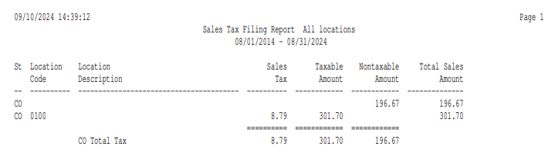

Report Columns include:

St: This column identifies the 2-letter abbreviation where the sales tax was collected.

Location Code: For Non-SST states, this column shows a four-digit location code for the tax collected. The first 2 digits are the tax code number. The last 2 digits are the tax lines within a tax code. When the last 2 digits are 00, it means this is the first line in the tax code line, 01 is the second line, and so on, up to 09.

Sales Tax: This is the amount of sales tax collected. A grand total for this column is provided.

Taxable Amount: This column shows the amount of taxable sales for which the sales tax was calculated. A grand total for this column is provided.

NonTaxable Amount: This column shows the amount of nontaxable sales for this city, county, or state. A grand total for this column is provided.

Total Sales Amount: This column shows the total amount of sales (taxable plus nontaxable) for the city, county, or state.

STXR - Sales Tax Reports – Non-SST Audit: This variation of the sales tax report for Non-SST states provides line-by-line detailed information that is summarized on the Filing Report. You can select the range of dates and type of report (audit) to generate the information.

The partial report shows lines for a Non-SST state, Colorado (CO), at the end of the display. The other lines on this report are for Washington (WA), which is an SST state.

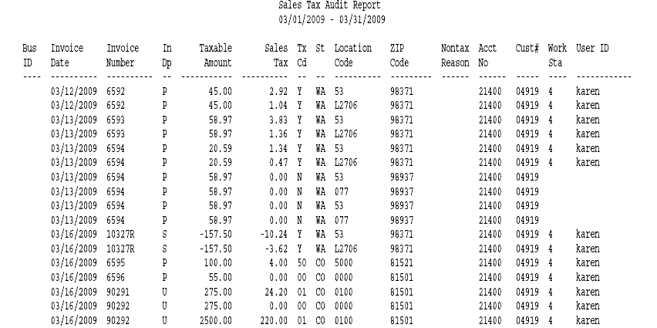

Report Columns include:

Bus ID: This column is for multi-location dealerships. It will show the location code for the transaction line.

Invoice Date: This column shows the invoice date for the line of detail.

Invoice Number: This shows the invoice number of the transaction.

In Dp: This column shows the invoice department:

P=Parts

R=Rental

S=Service

U=Units

NOTE: An “X” appears after these letters if the entry has been manually added.

Taxable Amount: This column shows the amount of transaction that was taxable and was used as the basis to calculate the sales tax.

Sales Tax: This is the amount of sales tax collected. A grand total for this column is provided.

Tx Cd: This is the tax code column. For non-SST states, it shows the 2-digit tax code for the transaction.

St: This column identifies the 2-letter state abbreviation where the sales tax was collected.

Location Code: For Non-SST states, this column shows a four-digit location code for the tax collected. The first 2 digits are the tax code number. The last 2 digits are the tax lines within a tax code. When the last 2 digits are 00, it means this is the first line in the tax code line, 01 is the second line, and so on, up to 09.

Zip Code: This column shows the zip code for the transaction.

NonTax Reason: This column may show any additional NON-TAXABLE tax codes in use. For example, if you need to separate out other non-taxable business for reporting purposes, the additional tax codes can be defined in TRM (i.e. for Resale, Government, etc.) When used, these additional non-taxable codes appear in this column of the report.

Acct No: This field shows the G/L account where the sales tax is collected.

Cust#: This column shows the customer number for the transaction line.

Work Sta: This column shows the last digits of the IP address where the transaction was processed.

User ID: This column shows the login of the person who processed the transaction.

Non-SST Setup—Tax Rates and Messages (TRM): This area holds the definition of different tax rates on the system. For Non-SST states, this area is very important because each tax code that is defined and used will be the source of details for the sales tax reports.

To get the most out of the sales tax reports, you must define each and every tax jurisdiction you need to track for tax reporting. For businesses with multiple locations, this step will need to be done in all locations.

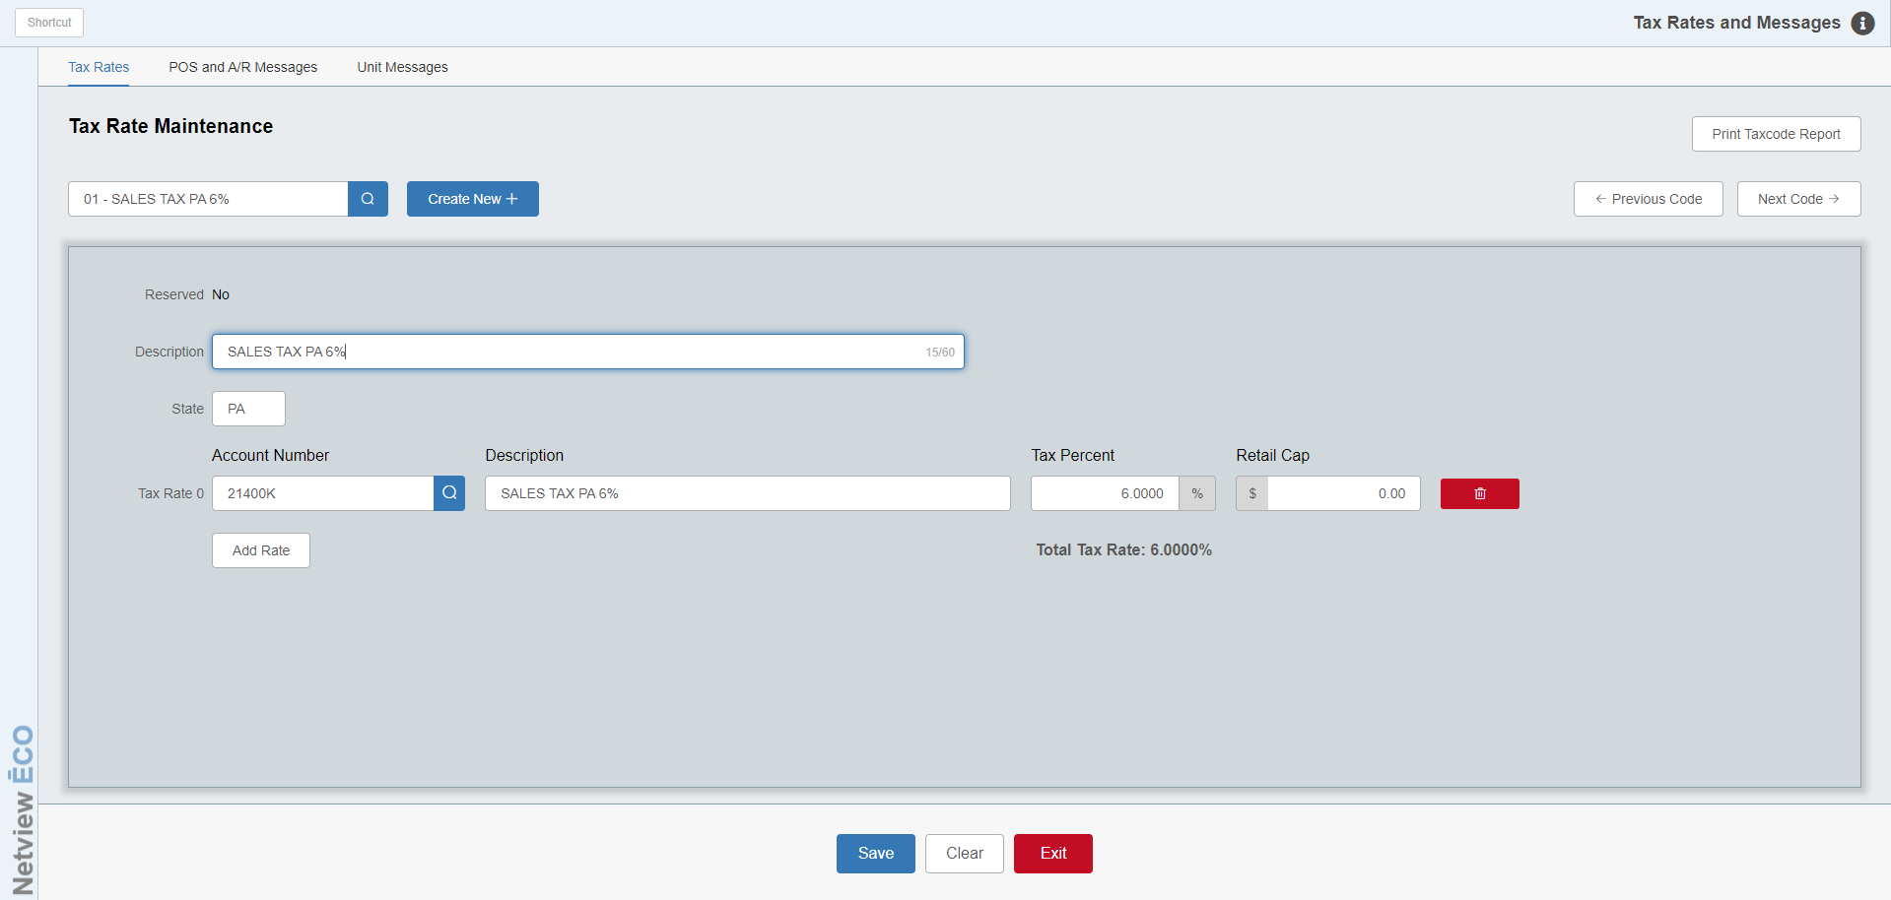

Tax Code: This field holds the tax code for this particular rate. You can type one in or use the drop-down menu to select one.

Reserved: This field indicates whether or not the tax code is “Reserved.” Making a tax code “Reserved” indicates that the system should not perform internal tax calculations on anything assigned that code under the assumption that the amount already had its tax calculated externally. For example, a dealer would reserve a tax code to handle amounts processed through our E-Commerce (ECOM) program, as TaxJar performs the tax calculations on those transactions rather than NetView itself. As a result, reserved tax codes do not have tax percents or retail caps assigned as they are unnecessary information, and are restricted to only having 1 G/L account assigned as a tax rate. See the Help documentation for TRM for more information.

Description: This field should contain a descriptive name for this tax rate (i.e. Non-Taxable, Dallas County 6.75, Collin County 8.25, etc.).

State: This optional field allows you to add a state/province designation to the tax code to make looking it up in the Tax Code Search easier.

Tax Rate 0–9: This section of the record lets you define the tax rate in different components, if necessary. In some US states, the prevailing tax rate (i.e. 5%) is actually made up of a state tax (i.e. 3.5%), a county tax (i.e. 1%), and a city tax (i.e. .5%). If you want the tax rate to be split between the various components and have the system make separate entries based on the individual rates (potentially to different tax accrual accounts), you can use the “Add Rate” button to utilize the 10 levels provided. As most sales tax dollars are paid to the same place, many dealerships simply choose to only use the single rate provided by default (i.e. the full 5%). NOTE: If you set a tax code as Reserved, you will only be allowed one Tax Rate, which serves mostly to indicate where in the system any amounts assigned that tax code need to go.

Acct #: The system will place the sales tax dollars collected for this rate in the General Ledger account number shown here. Typical G/L sales tax account numbers are 21400 through 21490.

Description: This field should contain a name for this tax rate on THIS line of the record. If the record has only one rate specified, we recommend using the description used for the main record (i.e. 5% Arkansas Sales Tax, State Sales Tax, Provincial Sales Tax, or Non-Taxable). If the rate is being split into different levels, the description should identify the type of tax defined on THIS line of the record (i.e. 5% State Sales Tax or 1.5% Dunbar County Tax). NOTE: This field will not appear for the tax rate on a Reserved tax code, as a Reserved code does not need to have an assigned percentage.

Percent: This field holds the tax percentage for this level. The system supports rates that extend three positions to the right of the decimal point (i.e. 3.275). NOTE: This field will not appear for the tax rate on a Reserved tax code, as a Reserved code does not need to have an assigned percentage.

Retail Cap: This field applies if there is a cap to the sales tax rate. In the US, some states have a dollar limit on which sales tax is calculated (i.e. $2500). If this is true for the sales tax rate being defined, enter that amount in this field. In most cases, the field will be left blank. NOTE: This field will not appear for the tax rate on a Reserved tax code, as a Reserved code does not need to have a retail cap.

Delete Rate: Use the red trash can button on the end of each Rate line to remove the Rate from the tax code.

Total Tax %: This field displays the total tax percentage for the tax code selected, as distributed across the recorded tax rates.

Non-SST Sales Collection Process: Once all sales tax rates are defined in TRM, the system will begin to collect sales tax information for these rates. In Non-SST states, the collected information is based on line by line details created when any transaction is processed in the system. This detailed information is permanently stored and will be used to generate sales tax reports when needed.

Sales tax transactions will be collected for all NetView system applications. If the tax from any outside programs or manual transactions needs to be included, they can be added via the History Maintenance program (STXHM).

Processing Sales in Non-SST States:

Processing Sales in POS (Parts/Service): In Non-SST states, you may continue to handle the sales transactions in the same manner they are being done. The sales tax reports will provide the details of tax collected by invoice for each tax rate used. It is a good time to get re-acquainted with your local tax laws.

- If the customer comes to the dealership to pick up the goods, then select the customer for the ticket as usual. When the ticket is run, the sales tax rate used for the invoice will be the one(s) selected on the invoice.
- If you are shipping or delivering the goods to a customer’s home or place of business, select the customer for the ticket as usual, then use the Ship To information to show where the merchandise is bound. Set the “Ship To” field to “Billing” when the customer is to receive the goods at their home or business address. Or, you can choose a ship to address on file by clicking the Add New button to add the Ship To address. When the ticket is run, the sales tax rate in effect for the customer’s home or business (or ship to address) will be applied to the parts/service invoice.

Processing Sales in US (Units): In Non-SST states, you may continue to handle the sales transactions in the same manner they are being done. The sales tax reports will provide the details of tax collected by invoice for each tax rate used. It is a good time to get re-acquainted with your local tax laws.

- If the customer comes to the dealership to purchase or pick up the equipment, then select the customer for the sale as usual. When the sale is run, the sales tax rate used for the invoice will be the one(s) selected on the invoice.
- If you are shipping or delivering the equipment to a customer’s home or place of business, select the customer for the sale as usual, then use the Ship To information to show where the equipment is bound. Set the “Ship To” field to “Billing” when the customer is to receive the equipment at their home or business address, or choose any other ship to address shown in the dropdown. You can also press the Add New button to add the Ship To address. When the sale is run, the sales tax rate in effect for the customer’s home or business (or ship to address) will be applied to the unit sales invoice.

Processing Sales in ROM (Service): In Non-SST states, you may continue to handle the sales transactions in the same manner they are being done. The sales tax reports will provide the details of tax collected by invoice for each tax rate used. It is a good time to get re-acquainted with your local tax laws.

- If the customer comes to the dealership to purchase or pick up the serviced equipment, then select the customer for the ticket as usual. When the ticket is run, the sales tax rate used for the invoice will be the one(s) selected on the invoice.
- If you are shipping, delivering or repairing the serviced equipment at/to a customer’s home or place of business, select the customer for the repair order as usual, then use the Ship To information to show where the serviced equipment is bound. Press the Use Billing button when the customer is to receive the serviced equipment at their home or business address. Or, choose a ship to address on file by pressing the Ship To Search button. You can also press the Add New button to add the Ship To address. When the ticket is run, the sales tax rate in effect for the customer’s home or business will be applied to the service invoice.

Processing Sales in Rental: In Non-SST states, you may continue to handle the rental transactions in the same manner they are being done. The sales tax reports will provide the details of tax collected by invoice for each tax rate used. It is a good time to get re-acquainted with your local tax laws.

- If the customer comes to the dealership to rent or pick up the equipment, then select the customer for the ticket as usual. When the ticket is run, the sales tax rate used for the invoice will be the one(s) selected on the invoice.
- If you are shipping or delivering the rented equipment to/at a customer’s home or place of business, select the customer for the ticket as usual, then use the Ship To information to show where the equipment is bound. Select “Billing” when the customer is to receive the equipment at their home or business address.

Or, you can choose a different Ship To address on file from the dropdown. You can also add the Ship To address. When this ticket is run, the sales tax rate in effect for the customer’s home or business (or the ship to address) will be applied to the rental invoice.

