POS—Task Buttons

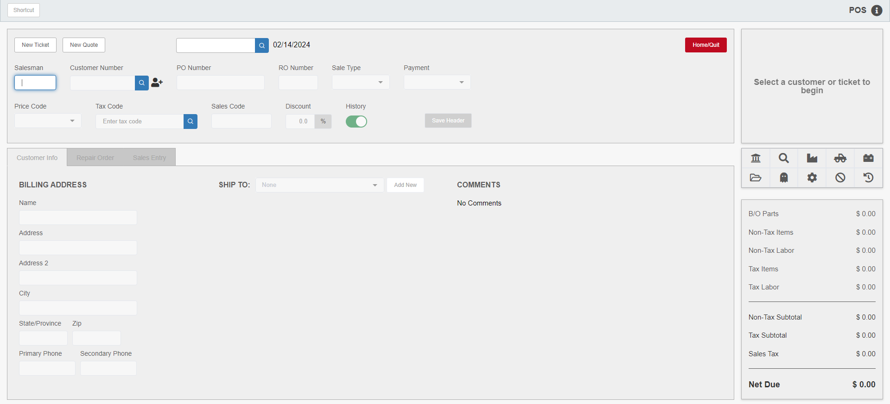

This set of buttons on the right side of the program screen provides specific options to better prepare, edit, and manage picking tickets and sales invoices.

A/R Customer Balance Inquiry ():

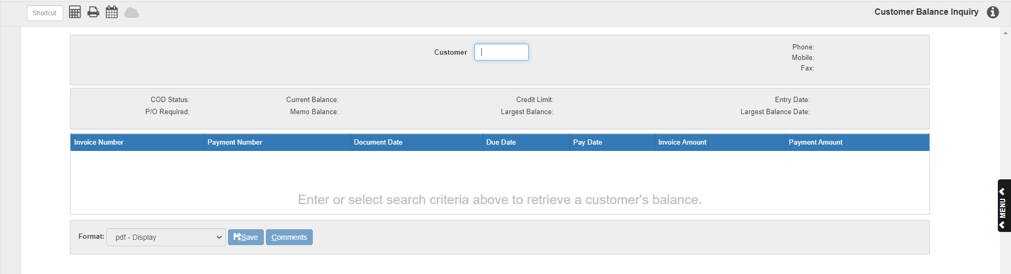

This button opens the A/R Customer Balance Inquiry (CB), which reviews the customer’s current open charges and payments, and provides an up-to-the-minute account balance total. Enter the customer number or type a few letters of the customer’s name to view their activity and net due.

Customer Search (): This button allows you to access the Customer Search.

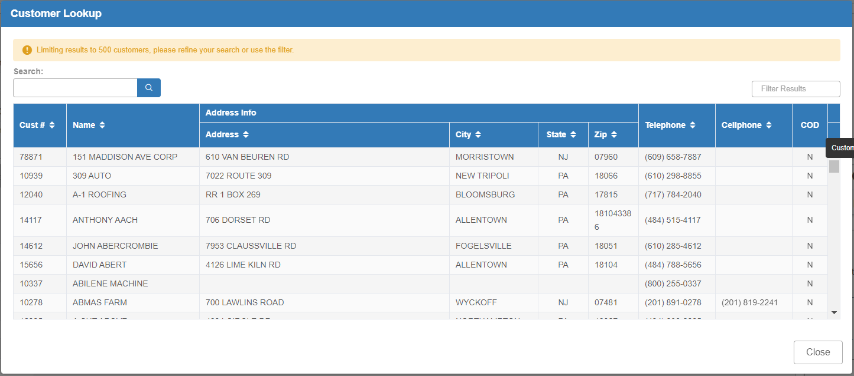

Price File Inquiry (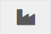): This button allows you to access Price File Inquiry (PFI) to look up parts in the manufacturer price files.

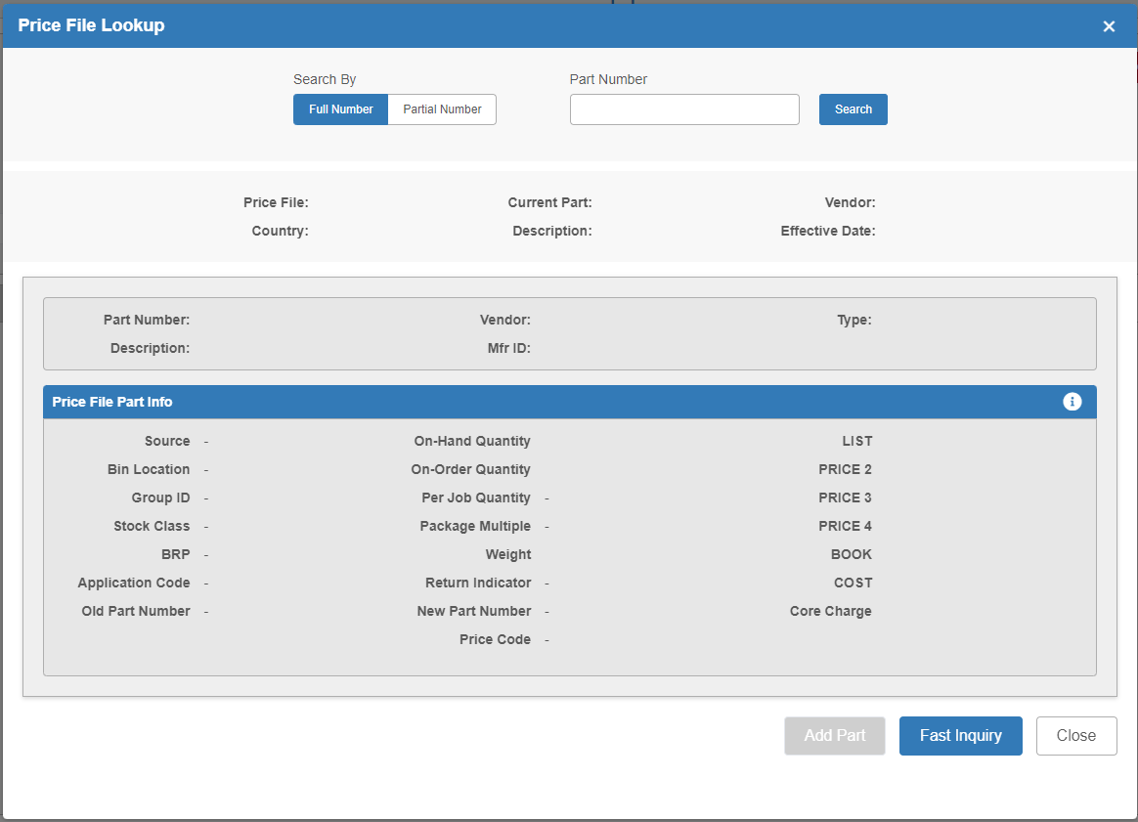

There are two main ways to perform a search:

- Full Number: Set “Search By” to “Full Number,” type the part number in, then click “Search.” The following screen will appear showing all matching parts from all available price files:

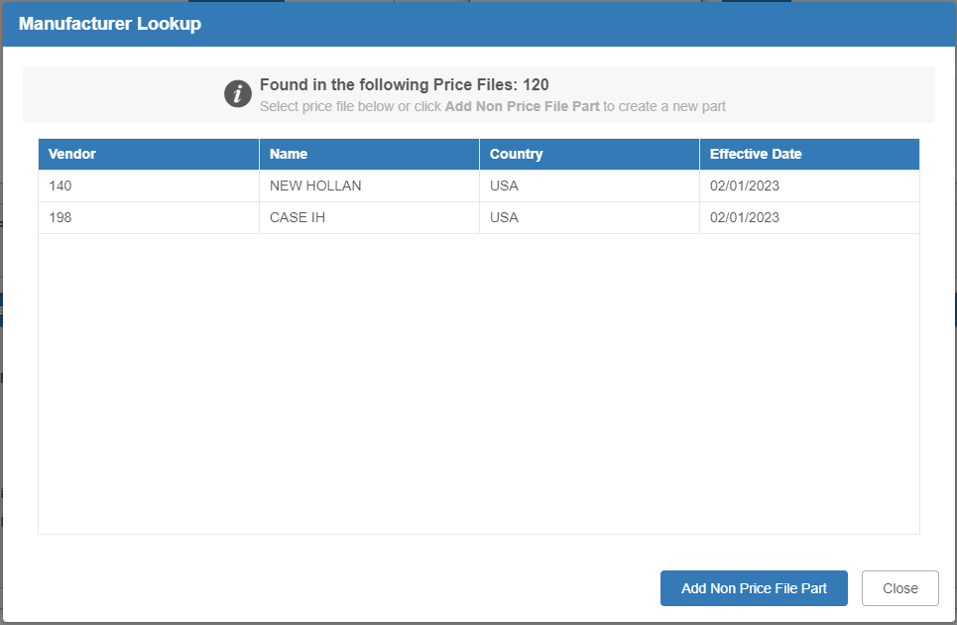

Choose a part by clicking on the desired price file. The matching part’s information will show in a new screen:

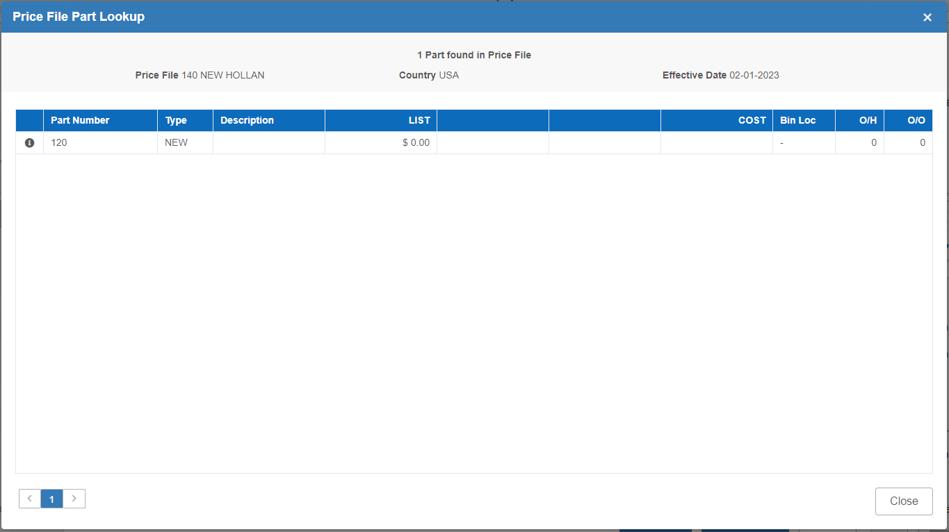

Click on the part to select it.

- Partial Number: If only part of the part number is known, select “Partial Number,” enter what you know, and click “Search.” The Lookup screen will open showing all price files with matching partial part numbers, including price files you may not have downloaded:

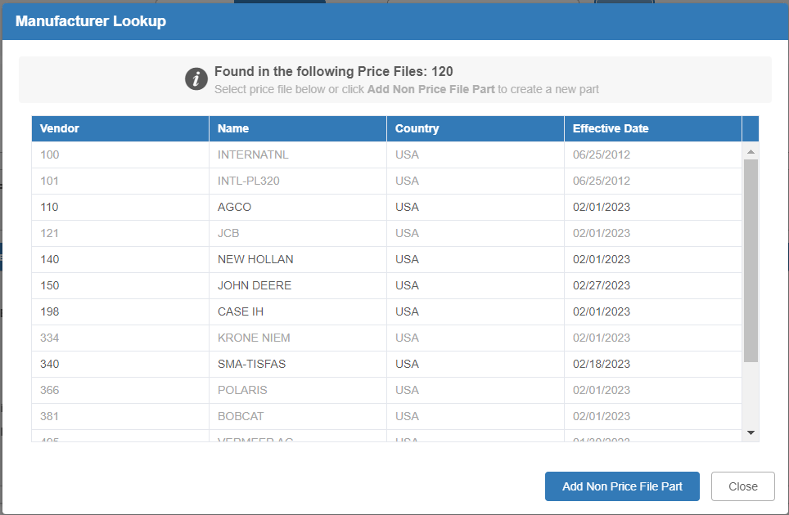

Select the price file whose matching results you want to view.

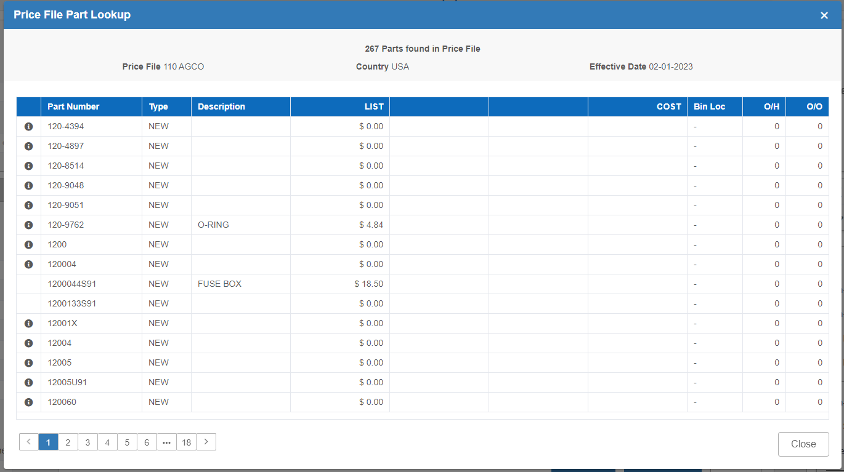

Click on the part to select it.

Once the part has been found, all fields in the Price File Inquiry are auto-filled:

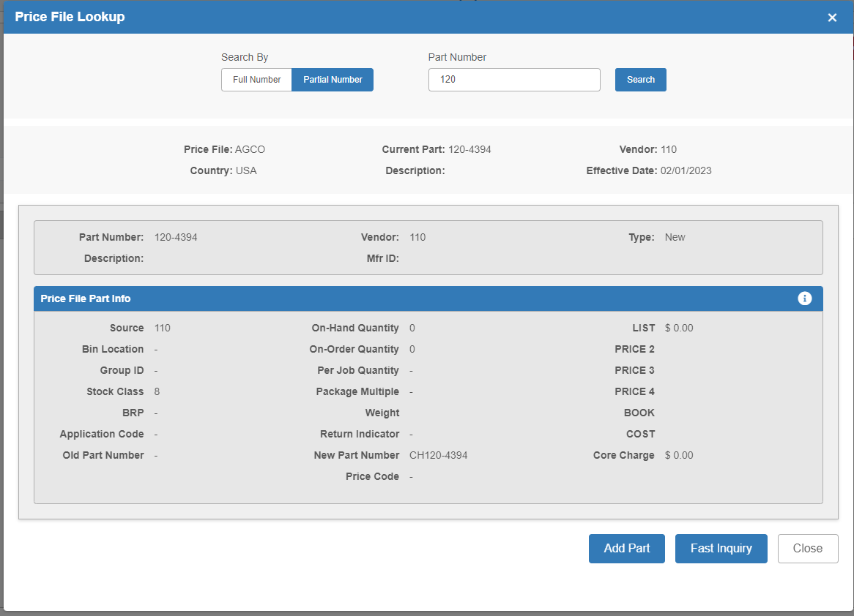

NOTE: If you have the system set to hide any part values by default, click the “i” icon to reveal the hidden values.

Customer Goods Inquiry (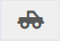): This button opens Customer Equipment Maintenance (CEM), which lets you look up the units a customer might own or have purchased from the dealership.

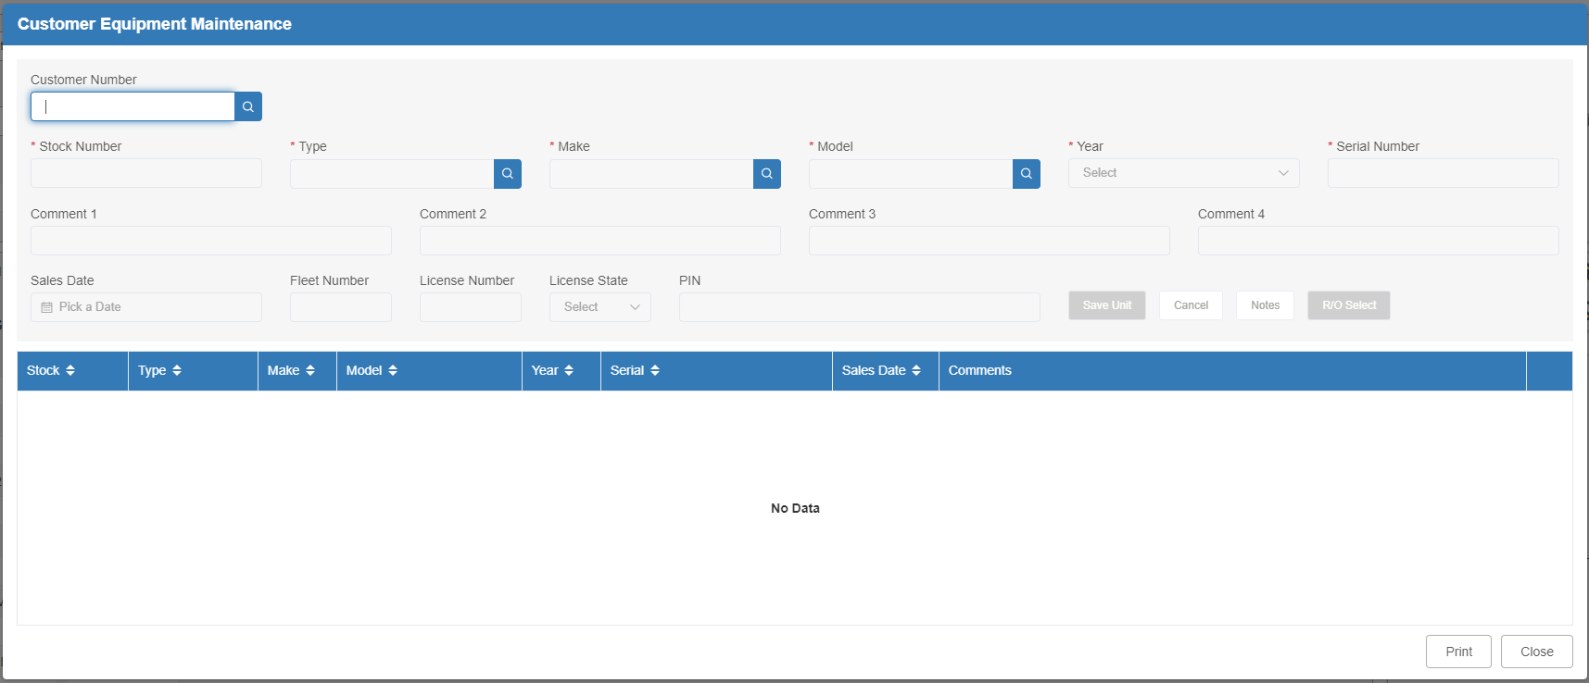

Enter the customer number and click the Search icon to look up their units.

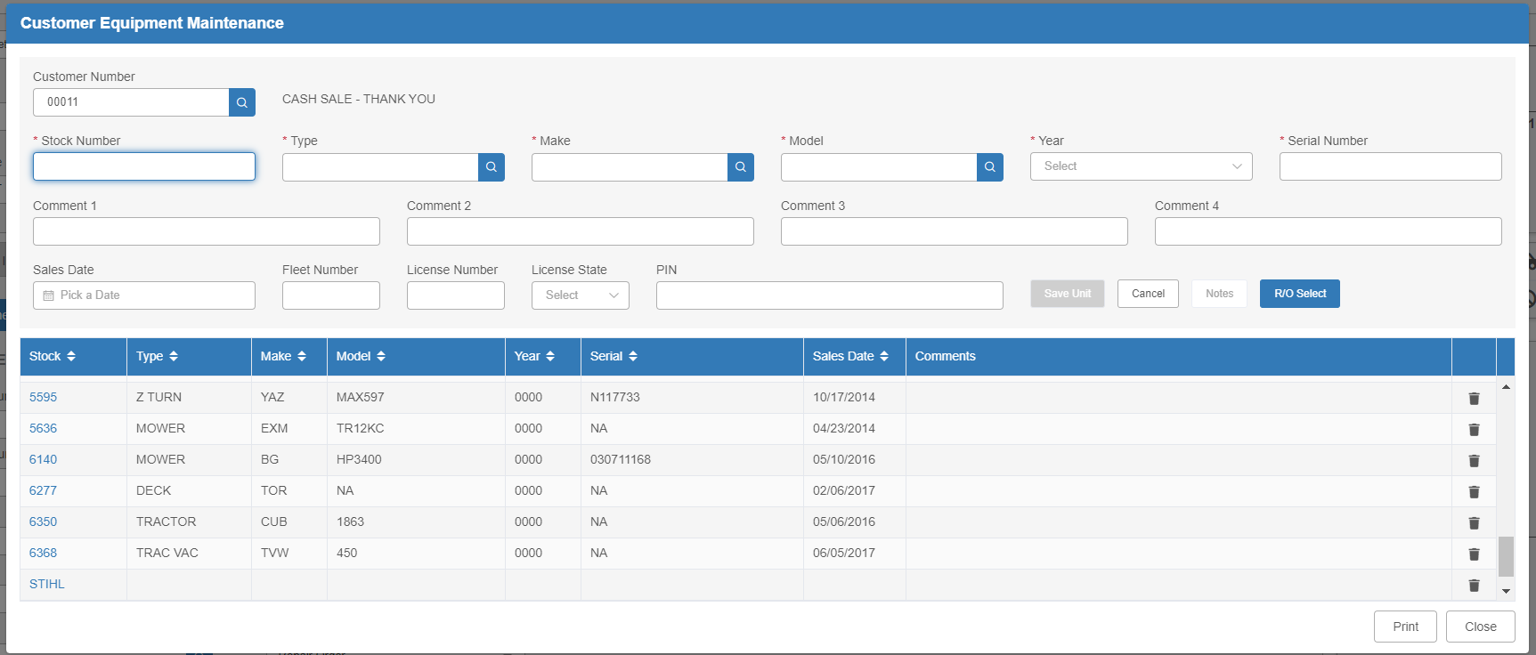

Parts Inquiry (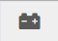): Click this button to open Parts Inquiry (PI) and look up part records.

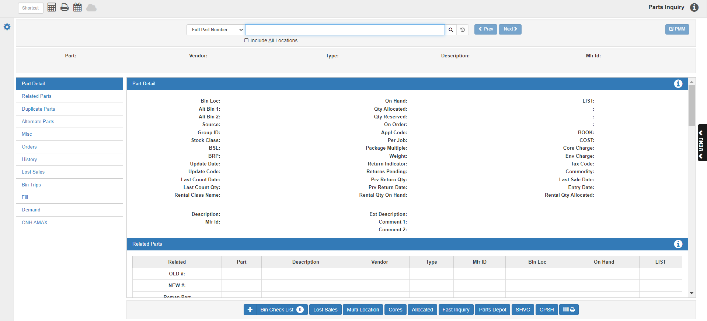

This screen can provide information for Parts Inquiries, including:

- Related Parts
- Duplicate Parts
- Alternate Parts
- Miscellaneous Info
- Orders
- Sales History
- Lost Sales
- Bin Trips
- Fills
- Demand

Also, the buttons for Bin Check List, Lost Sales, Multi-Locations, Core information, and Allocated parts can be accessed from this screen, among others.

Open Ticket List (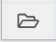): Click this button to view a list of all open picking tickets currently recorded in the system.

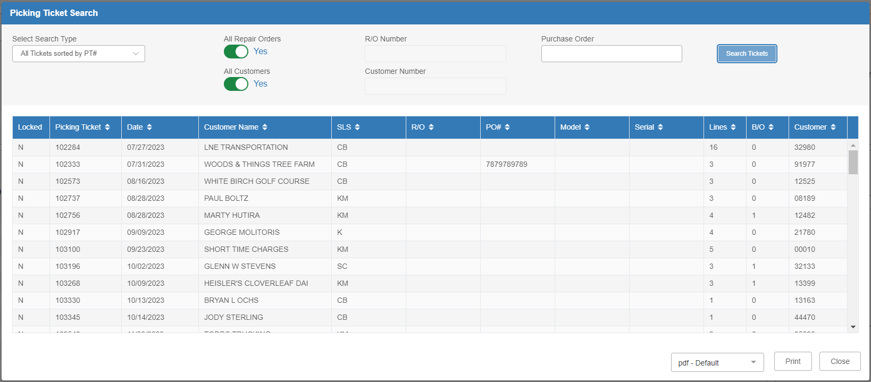

Record Lost Sale (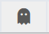): Click this button to open the Lost Sale Entry screen:

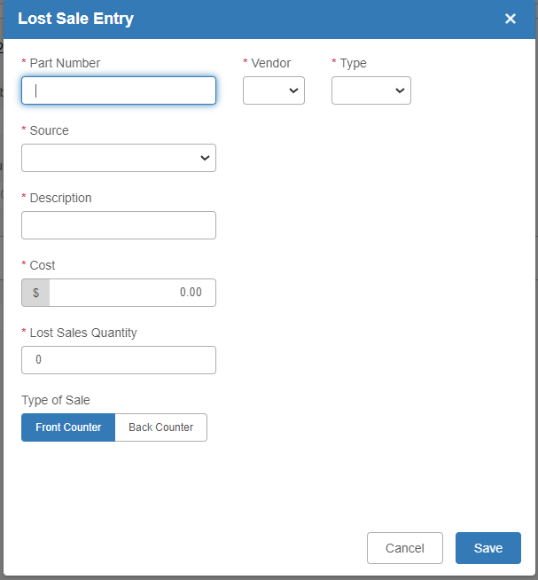

Identify the part number. The fields will automatically populate with the part’s information. Specify the quantity and type of the lost sale, then click “Save” to record it.

POS Screen Defaults (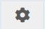): This screen allows the dealership to change POS settings. For more information, see the “POS Session Defaults” topic page.

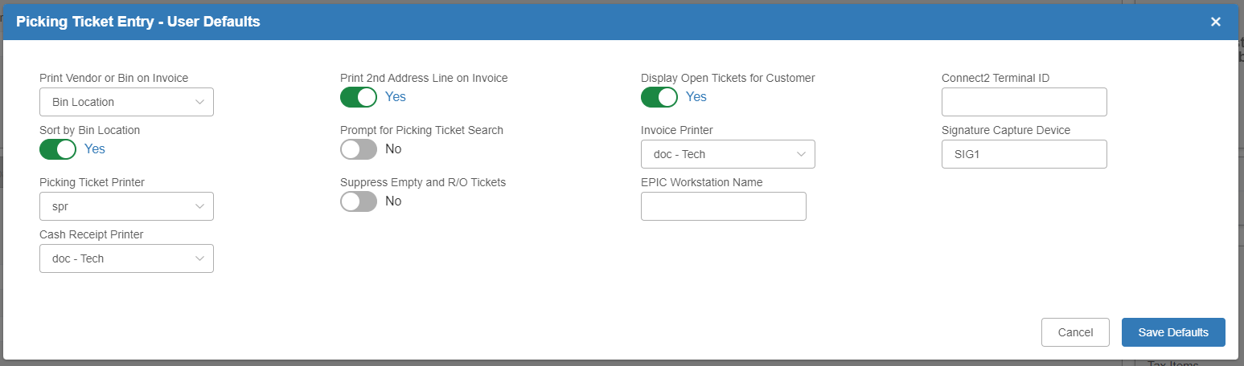

Void A Picking Ticket (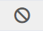): Click this button to void an open picking ticket. Enter the password at the prompt (if one is set in Password Verification Maintenance (PVM)) and press Submit.

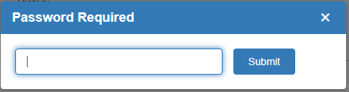

The following alert will appear:

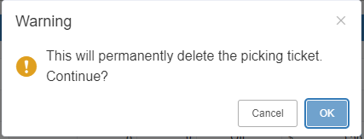

Click OK to void the ticket. Keep a record of voided picking tickets or invoices, as the number assigned will not be reused by the system.

POS History (): Click this button to open POS History (POSH). Search for invoices based on customer number, date invoice number, picking ticket number, invoice number, or purchase order. A specific month or year may also be chosen.

