Technician Maintenance (TM)

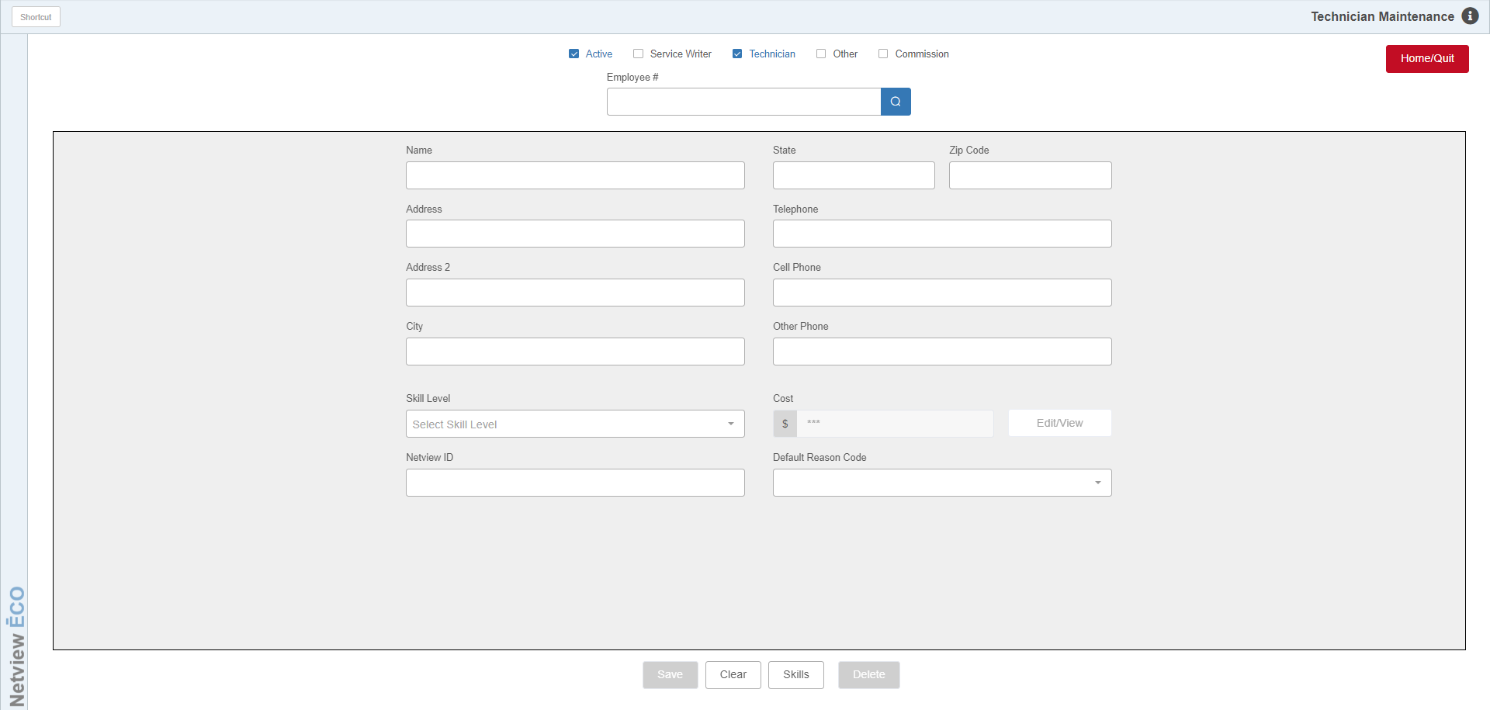

Technician Maintenance (TM) allows you to manage your service employees’ information on your NetView Service system.

To access this program, you can either:

- Select “Service” from the menu. Choose the “Time Slip Management” submenu and click “Technician Maintenance.
- Type in “TM” in the Shortcuts Bar.

Adding a Technician

Type: Check one or more Type boxes to indicate the employee’s status. The boxes are:

- Active
- Service Writer
- Technician
- Other
- Commission

Employee #: Enter the Employee Number.

- If you have the Payroll package, the technician must be added there first, and then added here with the same number.
- If you do not have the Payroll package, you may add a number of your choice here. You can also look up any existing technicians.

Name: Enter the Technician’s name as First Name, then Last Name. If the technician’s info is read from Payroll, the Name, Address and Telephone number fields will be pre-filled. We recommend that you change the Name to read First Name, then Last Name.

Address fields: You may fill in the address, city, state/province, and zip/postal code fields if desired.

Phone #’s: There are places for a regular phone, cell phone, and another phone number. All of these are optional, but this is a great place to keep a list of contact numbers for each technician.

Skill Level: This field is optional but can be used to choose a skill level for the technician from the dropdown menu. See the description of the Skills button below for more information on skill levels.

Cost: This field is optional but is used to provide costs for accounting entries and reports. It can only be edited with the Edit/View button, which is password-protected. The cost may be:

- The technician’s actual cost
- An average cost used for all technicians

NetView ID: This field shows the technician’s NetView login username, or ID.

Default Reason Code: This field is optional, but allows you to add a Default Reason Code per employee. This can be useful for a non-service employee who logs in via the Service System timeclock. Use the drop-down menu to select a code.

Save: Click this button to save your changes.

Clear: Click this button to clear the screen without saving.

Skills: Click this button to open the Skill Level Maintenance screen:

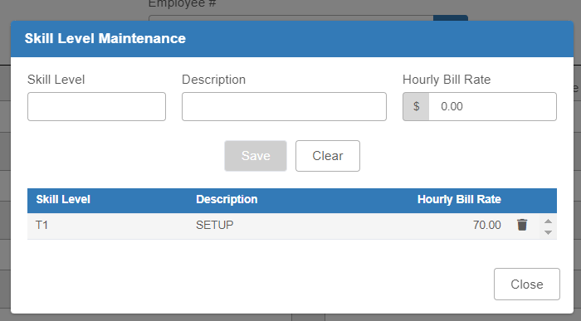

This screen allows you to create and maintain your dealership’s Skill Levels, which enable you to set up special billing rates to apply to your technicians. Each technician can be assigned one skill level, which represents one specialized billing rate. These rates, if applied to a technician, only apply on Customer-type RO conditions; all other conditions follow the rates set up in Manufacturer Control Table Maintenance (MCTM).

You can select an existing skill level in this screen in order to modify it, or add a skill level by typing in a unique Skill Level designation, as well as a description and the desired hourly bill rate. Click Save to store your changes. You can then use the “Skill Level” field (described above) to attach the rate to a technician.

Delete: Click this button to delete the current open employee record. Note that you can only delete a Service employee record that has no time slips recorded in the system. If you attempt to do so, you will receive this warning:

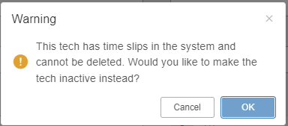

Clicking OK will remove the check in the “Active” status box at the top of the screen, allowing the technician to be hidden without being removed.

If the technician has no time slips and thus can be deleted, clicking the button will instead show this message:

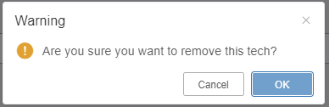

Click OK here to delete the employee.

