Technician Profitability Report (TPR)

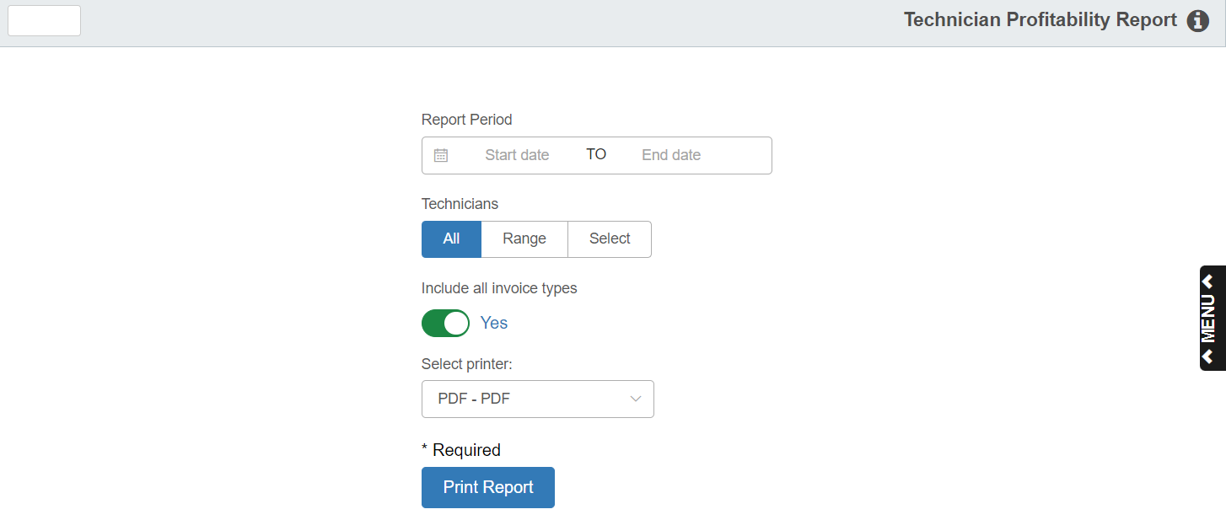

This report allows you to view and print the Technician Profitability Report.

To access this function, type “TPR” in the Shortcuts Bar.

Field Definitions:

Report Period: Select the starting and ending dates of your report period by typing the dates into the fields or selecting them from the calendar.

Technicians: Choose which technicians to include in your report. The options are:

All: Shows all technicians in the report.

Range: Allows you to set a range of technicians for the report using the following fields:

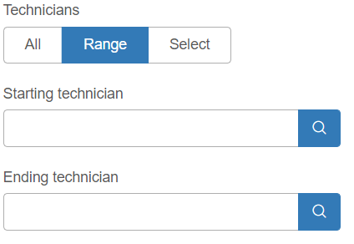

Either type the starting and ending technicians’ names in the fields, or use the Search icons to look them up.

Select: Allows you to select up to five individual technicians to include on the report using the following fields:

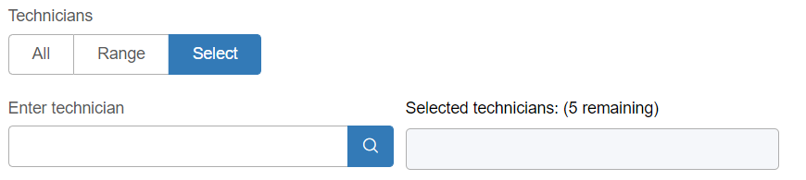

Either type technicians’ names to select them, or use the Search icons to look them up. The technicians will show in the second field once they are selected.

Include All Invoice Types: Set this option to “Yes” to include all invoice types on the report. Switch it to “No” to specify which types you want on the report, up to all four.

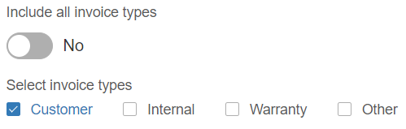

The types are:

- Customer
- Internal
- Warranty
- Other

Select Printer: Select a printer from the drop-down menu. Select the pdf printer to view a copy of the report.

Print Report: Click this button to print the report.

Sample Report

