Entering Trade-Ins Before Completing the Unit Sale

Many dealerships need to enter a trade-in into the system prior to processing the actual sale. In some cases, the shop must make immediate repairs because the trade-in is already promised to another customer and it needs to be sold.

Trade-ins are typically entered into Units as part of a sales transaction. When you create a Units Sales invoice, you take the trade-in as part of the deal. These steps provide a way for you to handle the trade before the actual sale is processed. In a nutshell, we will take in the trade and consider it a deposit on the upcoming sale. Two sets of steps for handling the pre-trade are included here: one for taxable transactions and one for nontaxable transactions.

Other Charge Maintenance (OCM): To make this work, be sure that Pre-Trade or Customer Deposits is an option for Other Charges in Unit Sales. To make sure, open Other Charge Maintenance by typing “OCM” in the Shortcuts Bar.

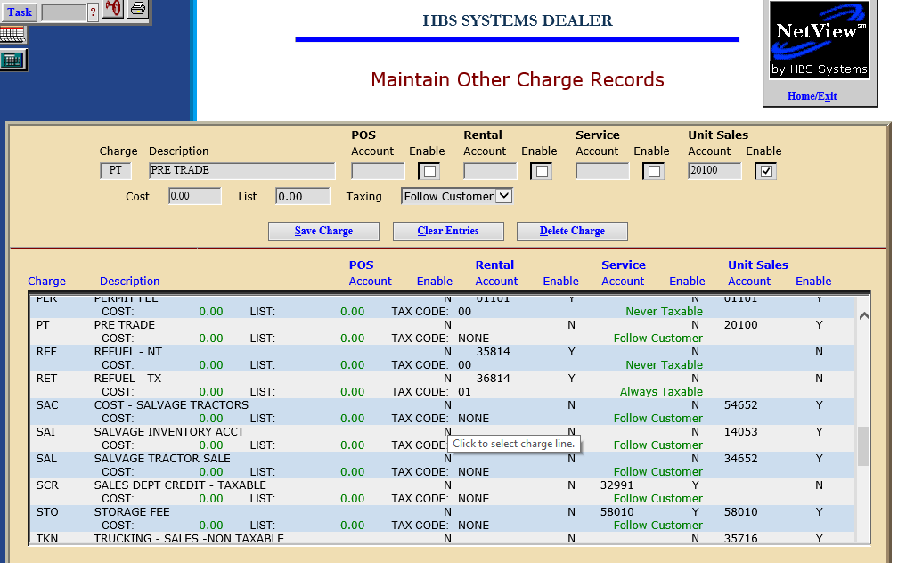

Make sure that “Pre-Trade” is one of the selections available for Unit Sale (US) in your choices. Typically, many dealerships use account number 20100 (Customer Deposits) for this. Double-check your Chart of Accounts (COA) before you add that entry here.

Processing a Pre-Trade for a nontaxable transaction:

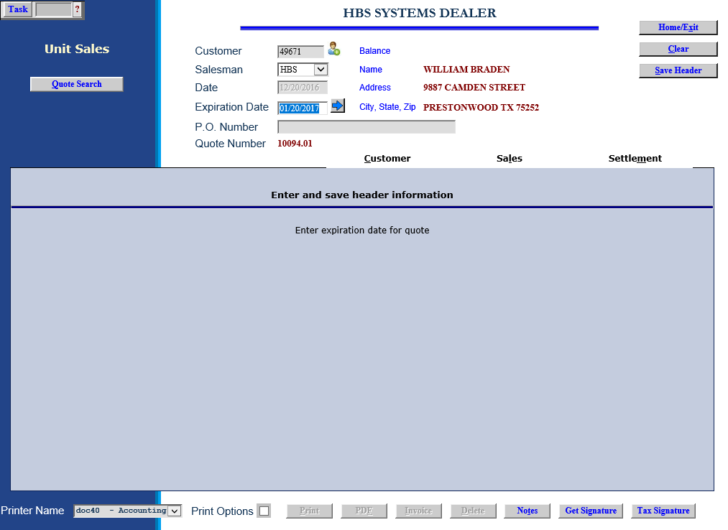

Now we will handle the trade-in, in this case a nontaxable unit, and bring it into inventory. We will use the Unit Sale (US) invoicing routine to process the trade-in.

To access this function, you can either:

- Select “Units” from the menu and choose the “Data Entry” submenu. Click on “Unit Sale.”
- Type “US” in the Shortcuts Bar.

Customer: Choose the customer who trading in the unit. Type the customer number or search for the number by typing in a few letters of the customer’s last name. Select the correct name from the results shown by clicking on it.

Salesman: Identify the salesperson here. Type in his/her initials or employee number, or choose it from the drop-down menu.

Expiration Date: Leave this field as it is for this transaction.

Save Header: Press the Save Header button to save the customer information and move on to the invoice.

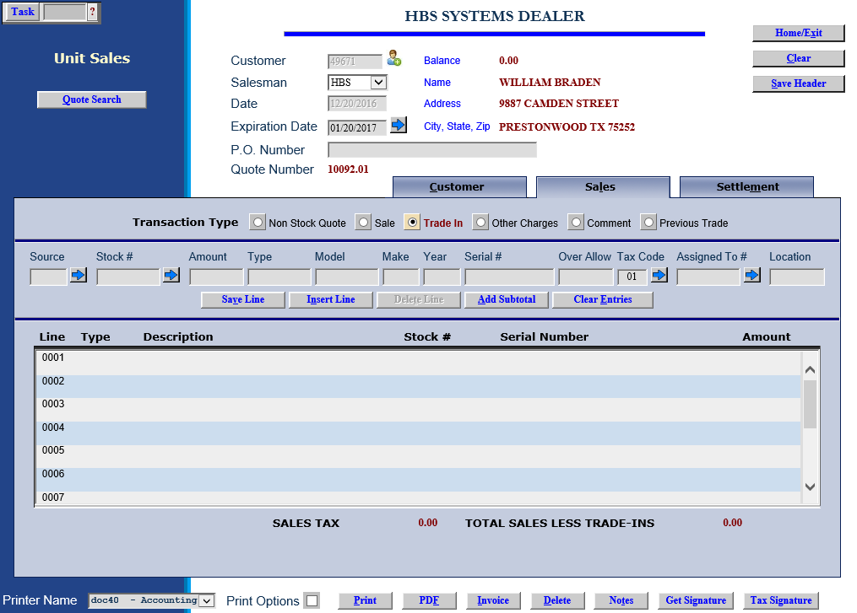

Click on Trade In:

- Source: Choose the Unit source for the trade-in or press the arrow to search for it.
- Stock#: Enter the stock number for trade or press “Enter” to have it assigned. You may also use the arrow to search for it if the customer’s unit is already in the system as a sold or historical unit. If the unit exists in the system, many of the following fields will be populated and will not require any entry from you.
- Amount: Enter the amount to be given for the trade-in.
- Type: Enter the type of equipment of the trade in.
- Model: Enter the model number of the trade-in.
- Make: Enter the make of the trade-in.
- Year: Type in the model year of the trade-in or use 0000 if it is unknown.
- Serial #: Enter the serial number of the trade-in unit here.
- Allowance: This field can hold the amount of the over-allowance of the trade-in.
- Tax Code: For a nontaxable transaction, be sure this tax code shows 00.
- Location: Enter the store location if applicable, or a physical location on your property where the trade-in will be housed.

Save Line: When you finish the line by pressing this button, the line appears in the general area in the lower part of the screen.

Comment: Add a comment line to indicate the unit is being taken in as a pre-trade.

Click on Other Charges: Here we will use the Other Charge you defined as Pre-Trade.

Enter the full 5-character customer number in the CNTL field on that line.

Enter the amount we are showing for the trade-in. Be sure it is the same figure you entered when you defined the trade-in itself.

For a nontaxable transaction, be sure this tax code shows 00.

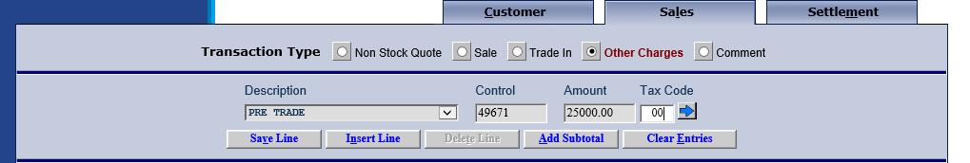

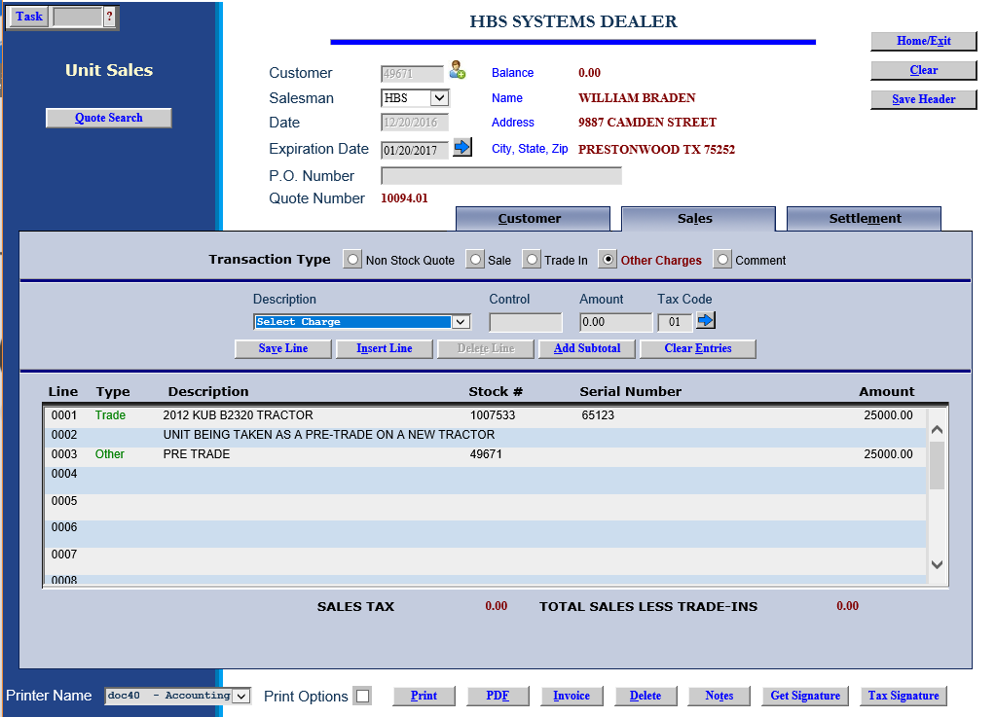

Save Line: When you finalize the line by pressing this button, the line appears in the general area in the lower part of the screen.

At this point you should notice that the Sales Tax Amount is zero (0) and the Total Sales Less Trade-Ins is zero (0).

Invoice: Now you are ready to print the invoice. Press the Invoice button to generate the invoice for the trade-in.

Nontaxable Unit Invoice Sample

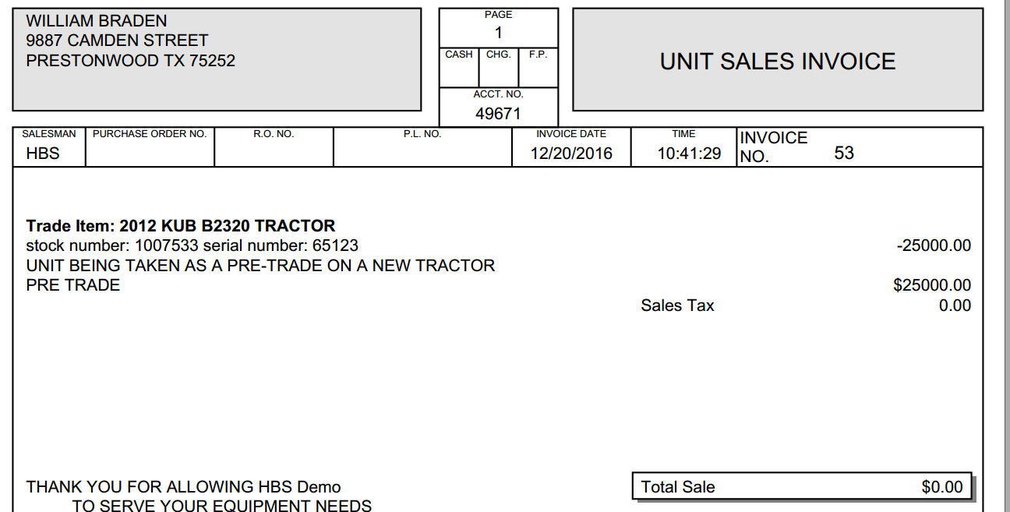

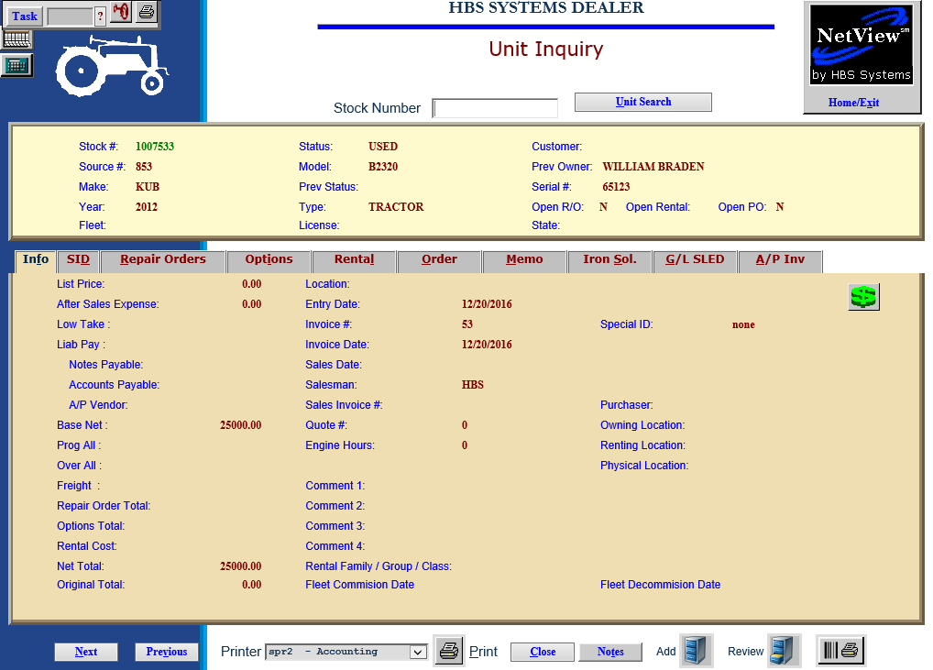

Unit Inquiry (UI): You can check out the trade-in via the Unit Inquiry screen. You’ll notice it shows all info you entered when you brought it in. The Net Total field shows the value of the unit after any over-allowances have been applied. The unit is now available for sale or for repair work in the shop.

Journaling the transaction: The “trade-in” transaction will be posted at the end of the day when you post the other Units transactions. The Journal may look similar to the following example:

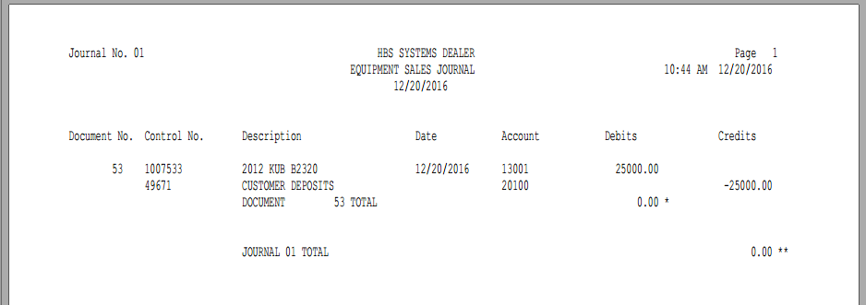

In this Journal entry, you will notice that there is now a “deposit” in the Customer Deposit account to be used when you process the sale to the customer. In that case, we will “use” the credit in the Deposits account as part of the sale when it occurs

Processing the actual sale (Nontaxable):

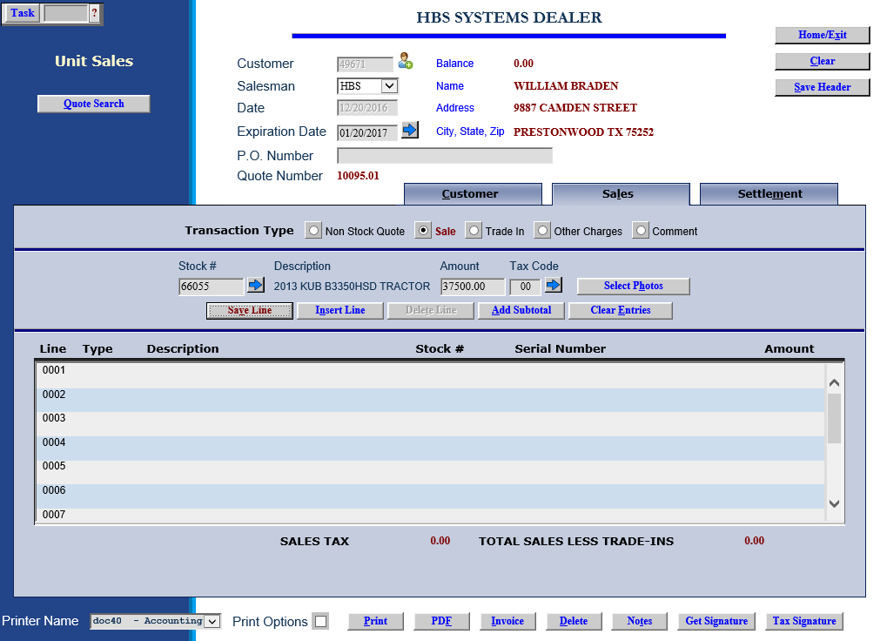

- In US, enter the header and the item to sell as usual. Be sure to use the correct tax code (00 in this case).
- Click on “Other Charges,” and choose “Pre-Trade.”
- Enter the 5-character customer number in the Control field exactly as it was done on the pre-trade.
- In the Amount field, enter a CREDIT for the amount of the trade-in as we are going to “use the credit” now in the sale.
- Make sure the correct taxable tax code (00) is in place on the Other Charge line.

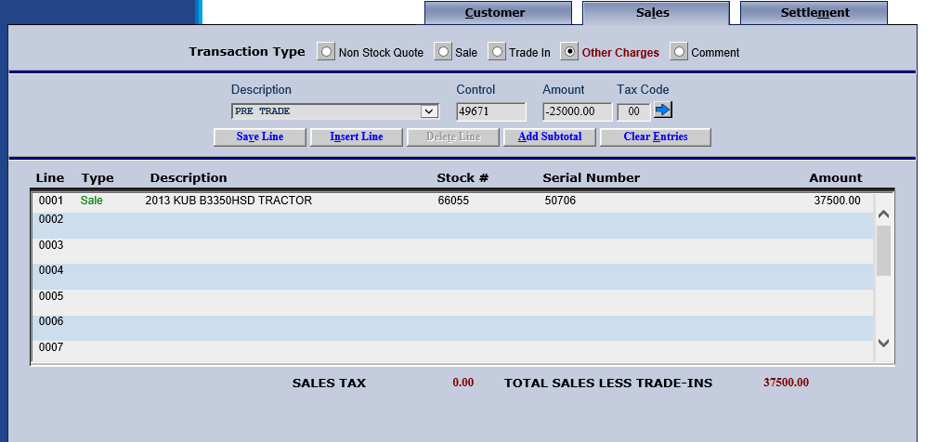

In this example below, notice how the tax is correct (none) as it is based on the tax codes for each part of the process (sale and other charge).

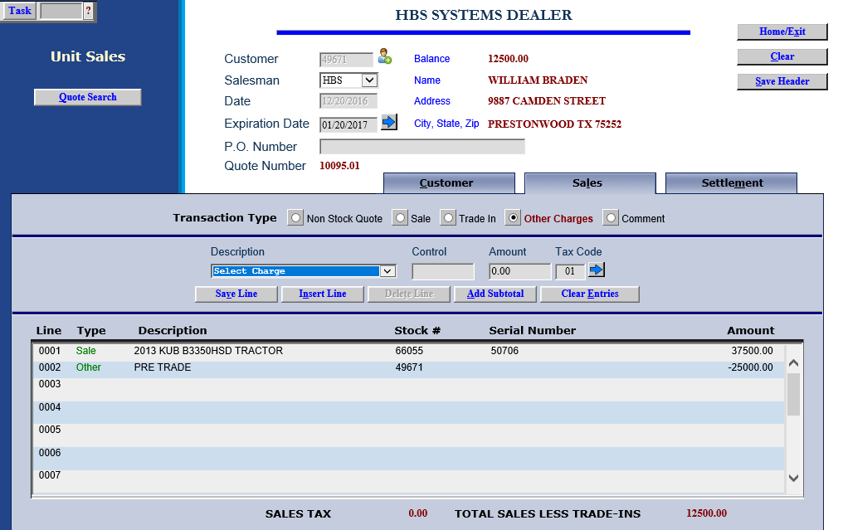

Processing a Pre-Trade for a taxable transaction:

Now we will handle a taxable trade-in and bring it into inventory. We will use the Unit Sale (US) invoicing routine to process the trade-in.

To access this function, you can either:

- Select “Units” from the menu and choose the “Data Entry” submenu. Click on “Unit Sale.”
- Type “US” in the Shortcuts Bar.

Customer: Choose the customer who trading in the unit. Type the customer number or search for the number by typing in a few letters of the customer’s last name. Select the correct name from the results shown by clicking on it.

Salesman: Identify the salesperson here. Type in his/her initials or employee number or choose it from the drop-down menu.

Expiration Date: Leave this field as it is for this transaction.

Save Header: Press the Save Header button to save the customer information and move on to the invoice.

Click on Trade In:

- Source: Choose the Unit source for the trade-in or press the arrow button to search for it.
- Stock#: Enter the stock number for the trade or press “Enter” to have it assigned. You may also use the arrow to search for it if the customer’s unit is already in the system as a sold or historical unit. If the unit exists in the system, many of the following fields will be populated and will not require any entry from you.
- Amount: Enter the amount to be given for the trade-in.
- Type: Enter the type of equipment of the trade in.
- Model: Enter the model number of the trade-in.
- Make: Enter the make of the trade-in.
- Year: Type in the model year of the trade-in or use 0000 if it is unknown.
- Serial #: Enter the serial number of the trade-in unit here.
- Allowance: This field can hold the amount of the over-allowance of the trade-in.
- Tax Code: For a taxable transaction, be sure this tax code shows 01 or select the desired tax code using the arrow on the right.

Location: Enter the store location if applicable, or a physical location on your property where the trade-in will be housed.

Save Line: When you finish the line by pressing this button, the line appears in the general area in the lower part of the screen.

Comment: Add a comment line to indicate the unit is being taken in as a pre-trade.

Click on Other Charges: Here we will use the Other Charge you defined as Pre-Trade.

Enter the full 5-character customer number in the CNTL field on that line.

Enter the amount we are showing for the trade-in. Be sure it is the same figure you entered when you defined the trade-in itself.

For a taxable transaction, be sure this tax code shows 01 or select the desired tax code using the arrow on the right.

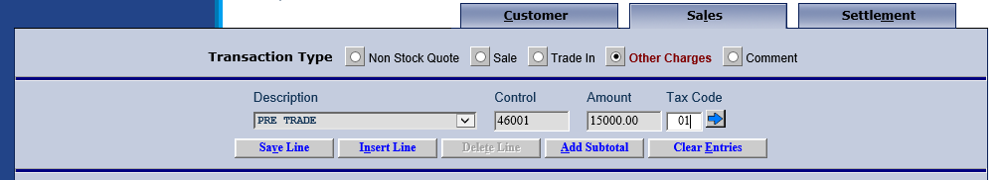

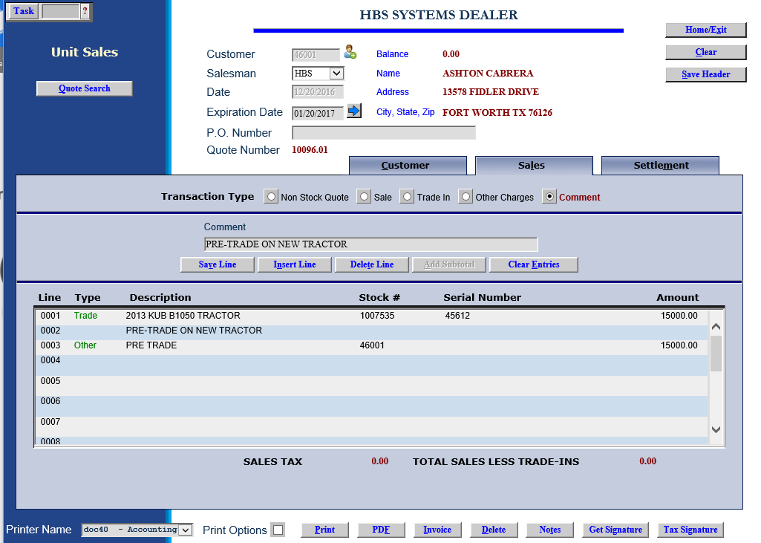

Save Line: When you finish the line by pressing this button, the line appears in the general area in the lower part of the screen.

At this point you should notice that the Sales Tax Amount is zero (0) and the Total Sales Less Trade-Ins is zero (0).

Invoice: Now you are ready to print the invoice. Click the Invoice button to generate the invoice for the trade-in.

Taxable Unit Invoice Sample

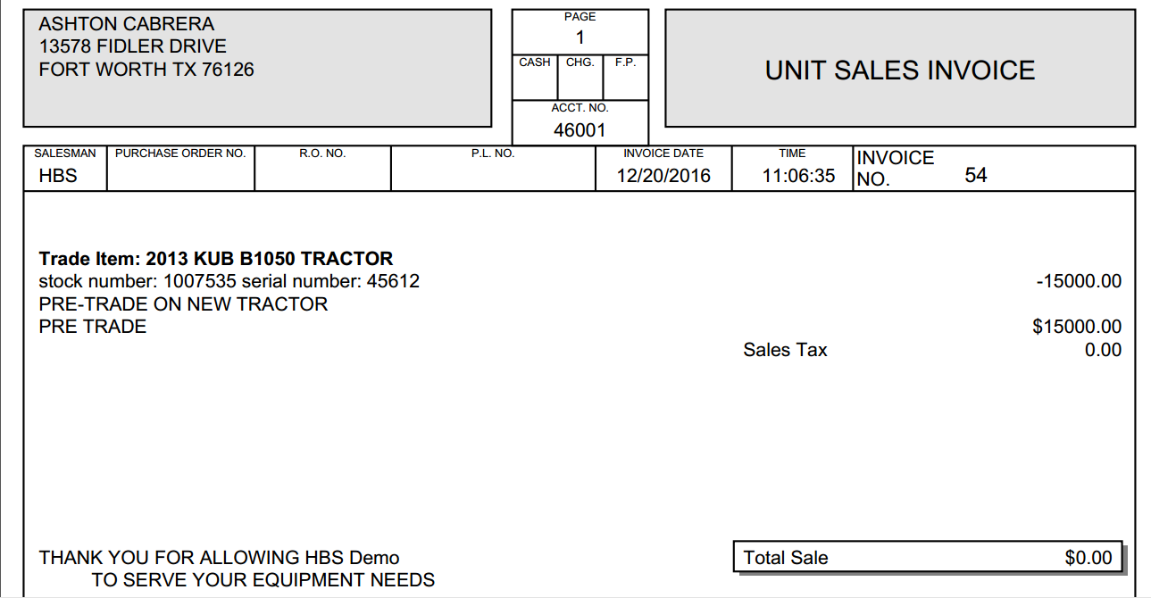

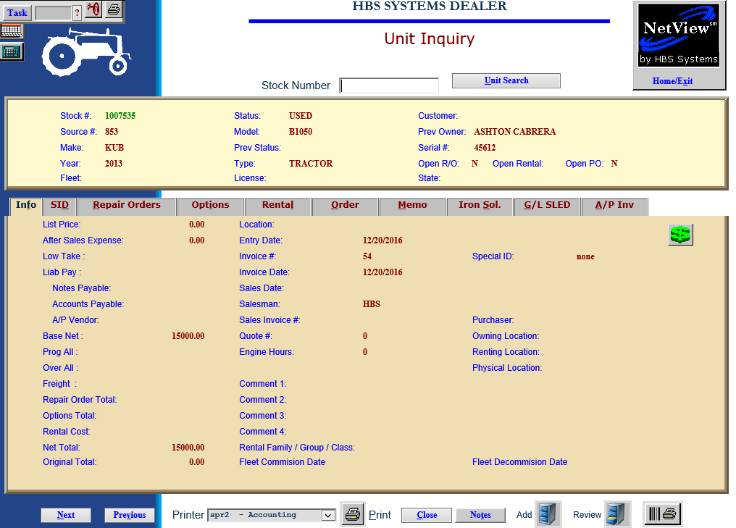

Unit Inquiry (UI): You can check out the trade-in via the Unit Inquiry screen. You’ll notice it shows all info you entered when you brought it in. The Net Total field shows the value of the unit after any over-allowances have been applied. The unit is now available for sale or for repair work in the shop.

Journaling the transaction: The “trade-in” transaction will be posted at the end of the day when you post the other Units transactions. The Journal may look similar to the following example:

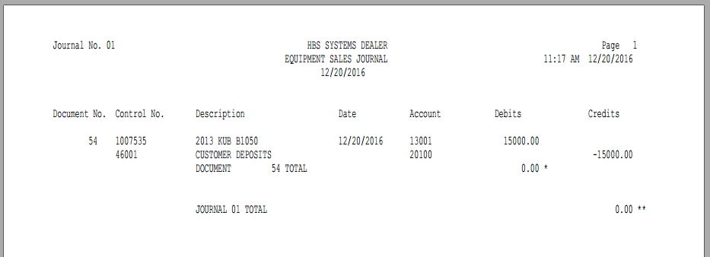

In this Journal entry, you will notice that there is now a “deposit” in the Customer Deposit account to be used when you process the sale to the customer. In that case, we will “use” the credit in the Deposits account as part of the sale when it occurs

Processing the actual sale (Taxable):

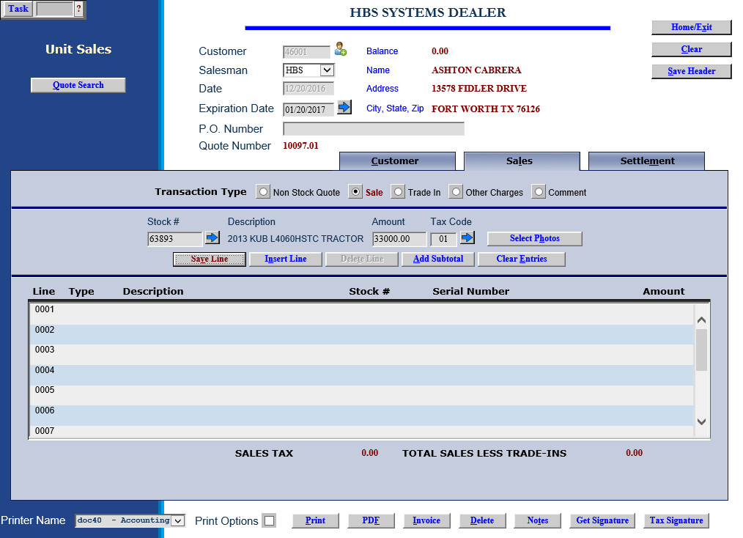

- In US, enter the header and the item to sell as usual. Be sure to use the correct tax code (taxable in this case).
- Click on “Other Charges,” and choose “Pre-Trade” or “Customer Deposit.”
- Enter the customer’s name or number in the Control field exactly as it was done on the Pre-Trade.
- In the Amount field, enter a CREDIT for the amount of the trade-in as we are going to “use the credit” now in the sale.
- Make sure the correct taxable tax code is in place on the Other Charge line.

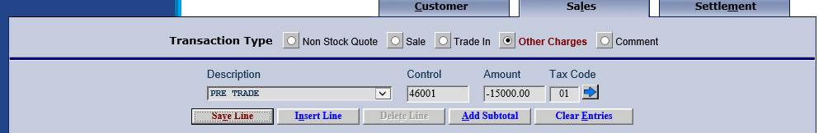

In this example below, notice how the tax is correct as it is based on the net of the sale after the Pre-Trade value is applies (33000 – 15000) x 6% tax rate = $1080 tax.

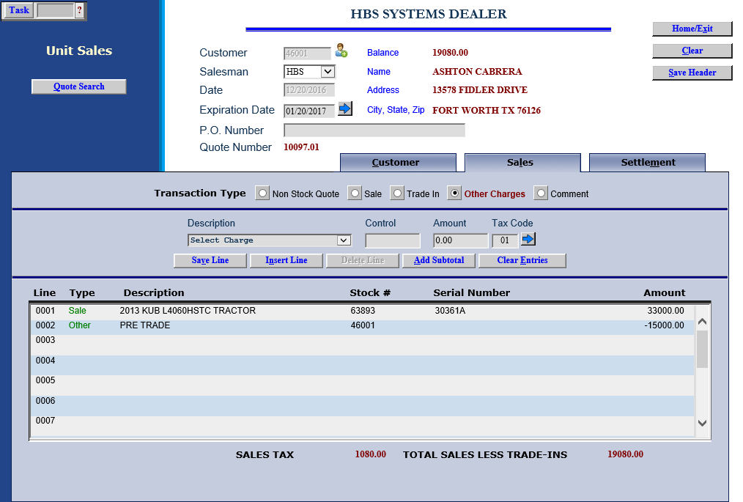

Sample Invoice

