Tax Rates and Messages (TRM)

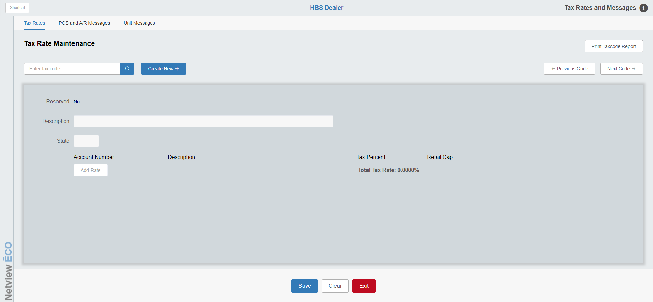

This screen in the Company File Defaults defines the sales tax rates used for Parts, Service, and Units. It offers further options for customer statement handling. You will also find the A/R Statement, Point of Sale (POS) Invoice, and Unit Invoice global messages kept here.

To access this function, you can either:

- Select “System Maintenance” from the menu, then choose the “Company File” submenu. Click on “Tax Rates Maintenance.”
- Type “TRM” in the Shortcuts Bar.

Tax Rates Tab: In a typical scenario where there is a simple tax situation—taxable and non-taxable—you will likely have just two records here. We usually suggest using 00 as the tax code for your non-taxable rate and 01 as the prevailing tax rate.

In the US, if you have multiple tax rates due to different county, city, or other state tax rates, these records can be added. NetView ECO now allows for alpha and alphanumeric tax codes, expanding our previously available codes for your use.

In Canada, typically 01 is defined as GST, and 02 is defined as PST or HST, if applicable in your province.

Tax Code: Type in the tax code you wish to review or use the “Search” button to look it up.

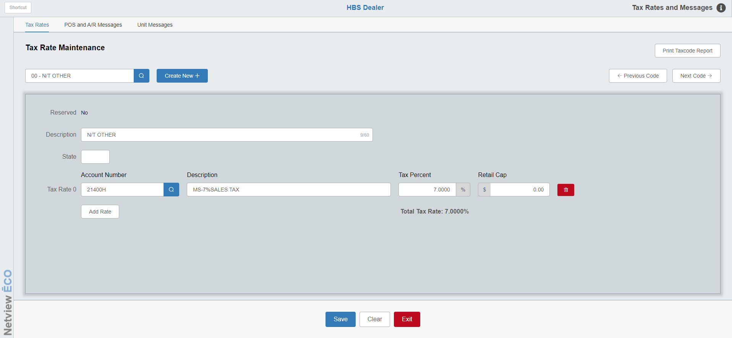

Reserved: This field indicates whether or not the tax code is “Reserved.” Making a tax code “Reserved” indicates that the system should not perform internal tax calculations on anything assigned that code under the assumption that the amount already had its tax calculated externally. For example, a dealer would reserve a tax code to handle amounts processed through our E-Commerce (ECOM) program, as TaxJar performs the tax calculations on those transactions rather than NetView itself. As a result, reserved tax codes do not have tax percents or retail caps assigned as they are unnecessary information, and are restricted to only having 1 G/L account assigned as a tax rate.

Description: This field should contain a descriptive name for this tax code (i.e. 5% Arkansas Sales Tax, State Sales Tax, Provincial Sales Tax, or Non-Taxable).

ST: This optional field allows you to add a state/province designation to the tax code to make looking it up in the Tax Code Search easier.

Tax Rate 0–9: This section of the record lets you define the tax rate in different components, if necessary. In some US states, the prevailing tax rate (i.e. 5%) is actually made up of a state tax (i.e. 3.5%), a county tax (i.e. 1%), and a city tax (i.e. .5%). If you want the tax rate to be split between the various components and have the system make separate entries based on the individual rates (potentially to different tax accrual accounts), you can use the “Add Rate” button to utilize the 10 levels provided. As most sales tax dollars are paid to the same place, many dealerships simply choose to only use the single rate provided by default (i.e. the full 5%). NOTE: If you set a tax code as Reserved, you will only be allowed one Tax Rate, which serves mostly to indicate where in the system any amounts assigned that tax code need to go.

Acct #: The system will place the sales tax dollars collected for this rate in the General Ledger account number shown here. Typical G/L sales tax account numbers are 21400 through 21490.

Description: This field should contain a name for this tax rate on THIS line of the record. If the record has only one rate specified, we recommend using the description used for the main record (i.e. 5% Arkansas Sales Tax, State Sales Tax, Provincial Sales Tax, or Non-Taxable). If the rate is being split into different levels, the description should identify the type of tax defined on THIS line of the record (i.e. 5% State Sales Tax or 1.5% Dunbar County Tax). NOTE: This field will not appear for the tax rate on a Reserved tax code, as a Reserved code does not need to have an assigned percentage.

Percent: This field holds the tax percentage for this level. The system supports rates that extend three positions to the right of the decimal point (i.e. 3.275). NOTE: This field will not appear for the tax rate on a Reserved tax code, as a Reserved code does not need to have an assigned percentage.

Retail Cap: This field applies if there is a cap to the sales tax rate. In the US, some states have a dollar limit on which sales tax is calculated (i.e. $2500). If this is true for the sales tax rate being defined, enter that amount in this field. In most cases, the field will be left blank. NOTE: This field will not appear for the tax rate on a Reserved tax code, as a Reserved code does not need to have a retail cap.

Delete Rate: Use the red trash can button on the end of each Rate line to remove the Rate from the tax code.

Total Tax %: This field displays the total tax percentage for the tax code selected, as distributed across the recorded tax rates.

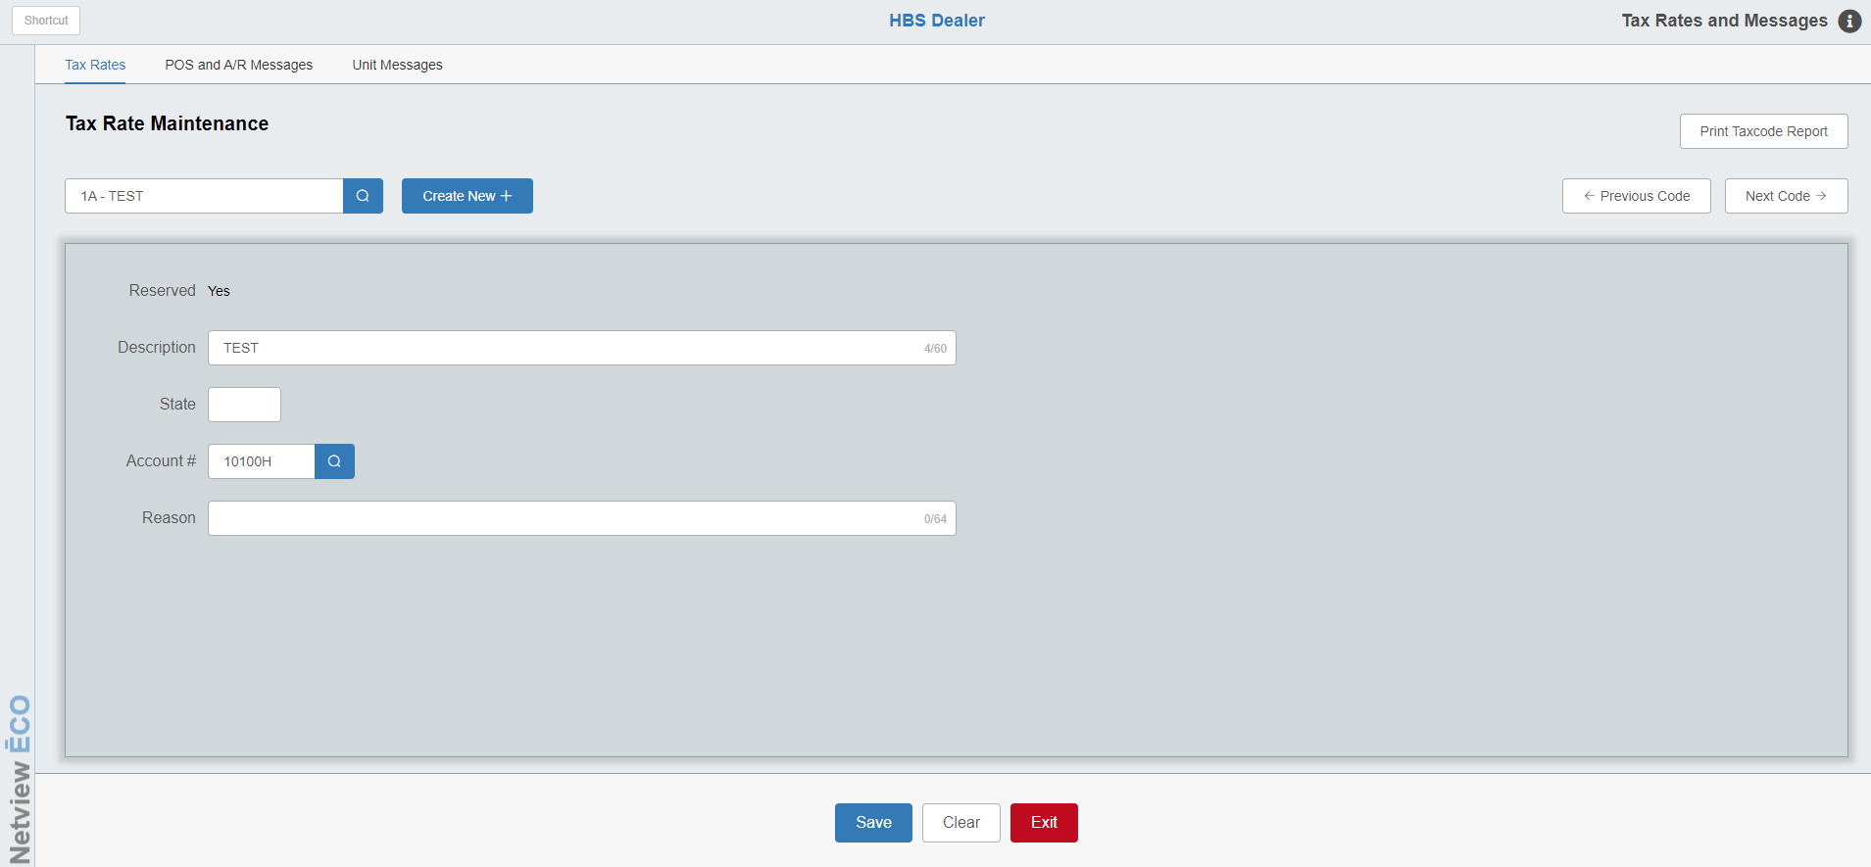

Reason: If the tax code is Reserved, most of the above fields will be replaced by this field, which can show a reason why the tax code was listed as “Reserved” (see image above).

Create New: To add a new tax code to the system, click this button to open the Create New Tax Code modal:

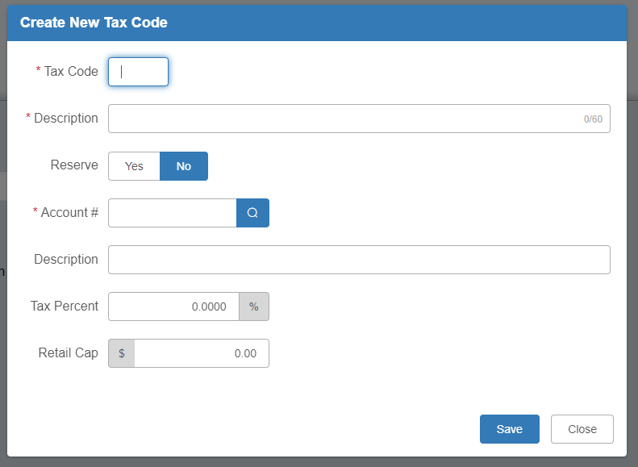

Tax Code: Enter the new code in this field. The 2-digit code can be comprised of only numbers, only letters, or a letter and a number.

Description: Enter the description for the code here.

Reserve: Use this field to mark whether or not the code should be considered “Reserved.” If you set the option to Yes, the available fields will change appropriately to match the requirements for a Reserved tax code:

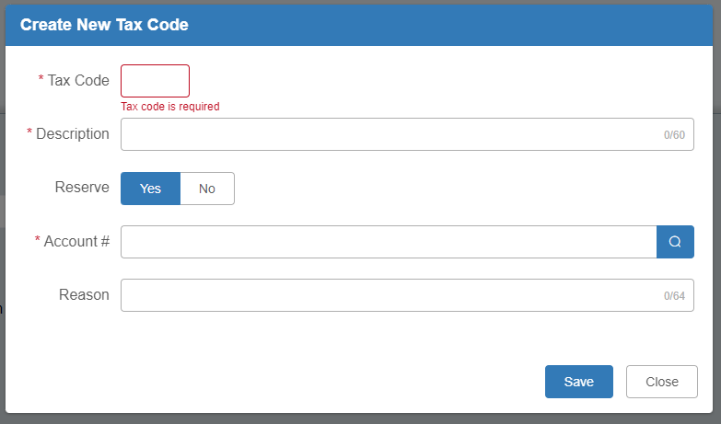

Account #: Enter the G/L account for the tax code’s initial tax rate here.

Description: If you left Reserve set to No, enter a description for the tax code’s initial tax rate here. Unlike the first “Description” field, this one is not required.

Tax Percent: If you left Reserve set to No, enter the tax percentage for the code’s initial tax rate here.

Retail Cap: If you left Reserve set to No, you can enter the retail cap for the code’s initial tax rate here (if desired).

Reason: If you set Reserve to Yes, you can use this field to explain why you “reserved” this particular code.

Click Save to create the new Tax Code record.

Previous Code/Next Code: Once you open a tax code record to examine, you can use these buttons to quickly move through the list of tax codes to look at their records without having to enter or look them up.

Print Taxcode Report: Click this button to select a printer and generate a printed list of all tax codes currently recorded in the program:

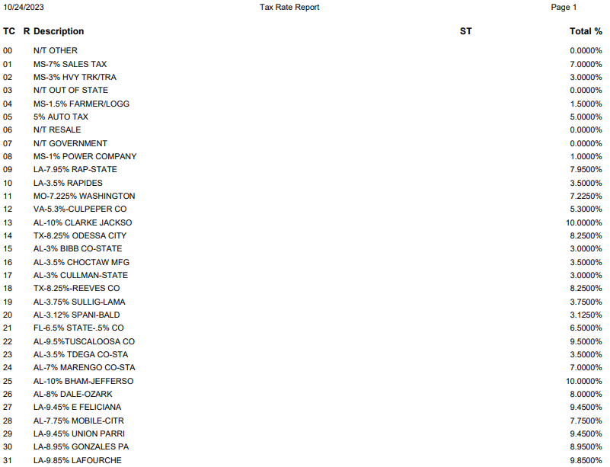

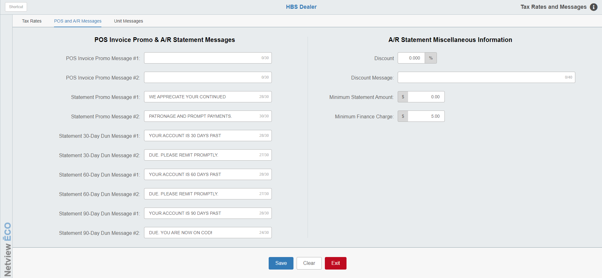

POS & A/R Messages Tab:

POS Invoice Promo Message #1 & 2: This is a set of two lines for a promotional message that appears on each POS invoice. The text entered remains here and prints on each invoice printed until it is changed. It is wise to review these periodically. Possible uses are to advertise specials (in Parts, Service, or Units), thank customers, give business hours, or promote special events.

Statement Promo Message #1 & 2: This is a set of two lines for a statement promotional message that appears on each A/R statement printed. The text entered remains here and prints on the statement for customers that are current on their account.

Statement 30 Day Dun Message #1 & 2: This is a set of two lines for a thirty-day past due message that appears on A/R statements that have invoices that are 30 days past due (as the oldest invoices). The text entered remains here and prints on the qualifying statements printed until it is changed. It is wise to review these periodically.

Statement 60 Day Dun Message #1 & 2: This is a set of two lines for a sixty-day past due message that appears on A/R statements that have invoices that are 60 days past due (as the oldest invoices). The text entered remains here and prints on qualifying statements printed until it is changed. It is wise to review these periodically.

Statement 90 Day Dun Message #1 & 2: This is a set of two lines for a ninety-day past due message that appears on A/R statements that have invoices that are 90 days past due (as the oldest invoices). The text entered remains here and prints on qualifying statements printed until it is changed. It is wise to review these periodically.

Discount: This is an optional area where you may enter a discount percentage offered to encourage on-time payments of Accounts Receivable balances. The percentage entered here is used to calculate and print a discounted balance if paid by a specific date on A/R statements.

Discount Message: This field works with the previous field. Here you might enter a message to print on the statement to accompany the discounted balance. You may also use this field independently. For example, you could advertise your website here.

Minimum Statement Amount: This specifies the minimum customer balance before A/R statements will print. If you do not want to print statements with balances under $1.00, you may enter that amount. If a zero is entered, it will print all statements regardless of the balance.

Minimum Finance Charge: Enter the minimum dollar amount that should be charged for a finance charge on customer statements. When A/R statements are run, the system will charge this amount as a minimum finance charge on all past due balances. For example, if you have $1.00 as the minimum and the finance charge is calculated as $0.17, the system will add a $1.00 finance charge on that account.

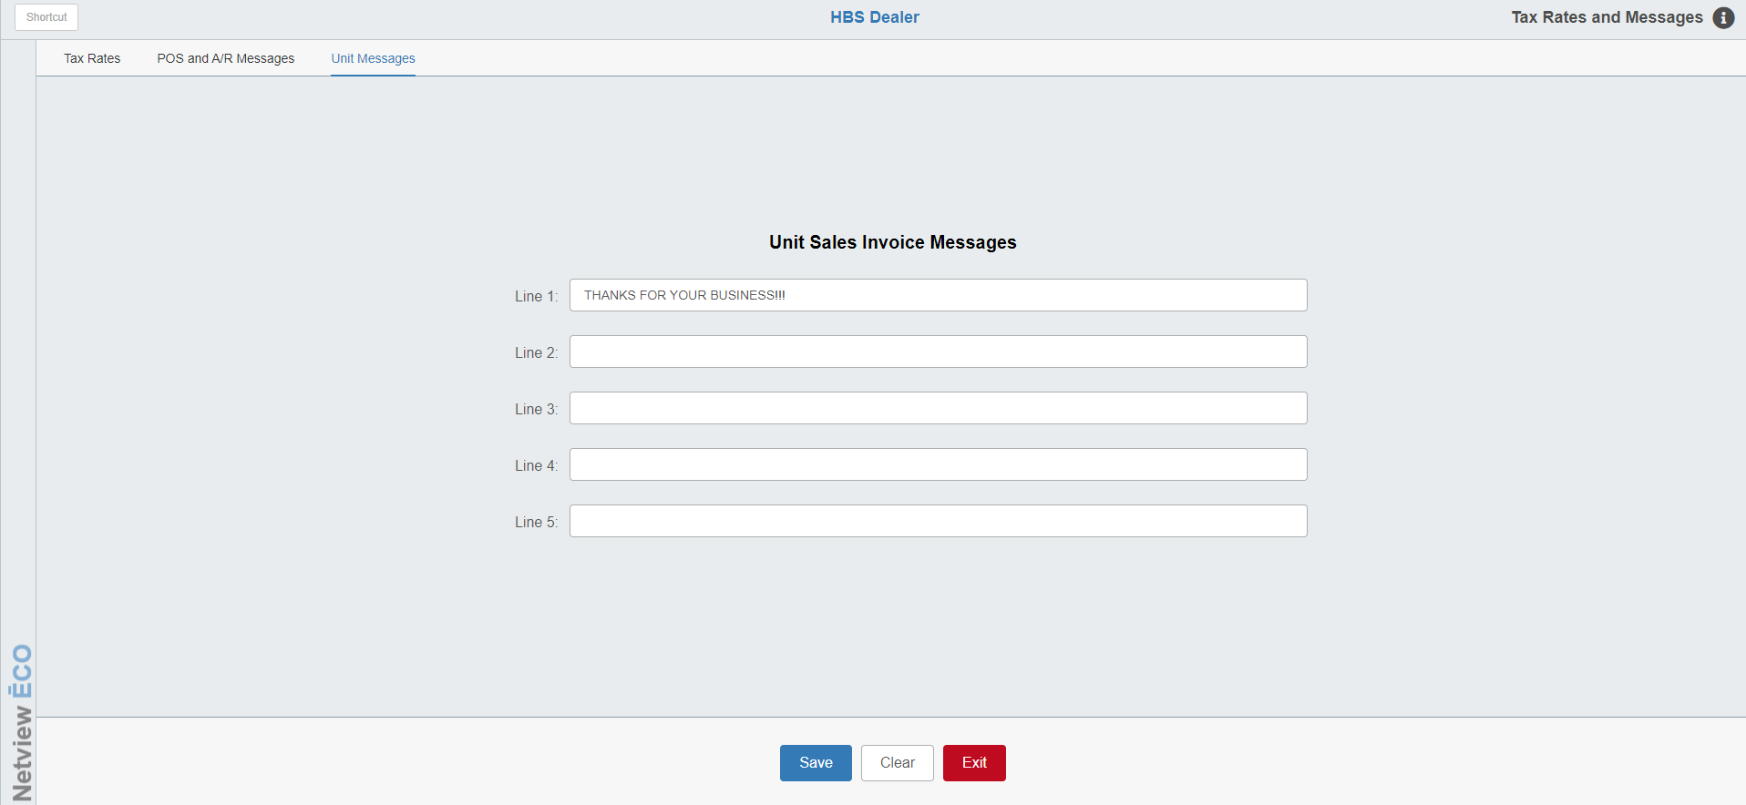

Unit Messages Tab: This area provides the option to include a message on all Unit Sales Invoices and Unit Quotes.

Lines 1 – 5: These five lines are available to enter the text of the message. The message prints toward the bottom of the invoice or quote.

