Technician Recap Report (TRR)

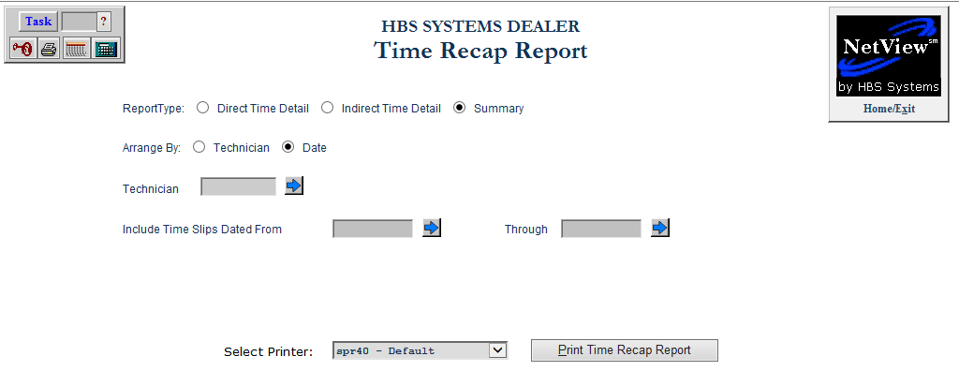

This program allows you to view and print the Time Recap Report.

To access this function, type “TRR” in the Shortcuts Bar.

Field Definitions:

Report Type: Choose one of the following types for your report:

- Direct Time Detail
- Indirect Time Detail
- Summary (default)

Arrange By: Choose whether to arrange the report by:

- Technician
- Date

Technician: If you want to run the report for a single technician, type the technician’s number in this field. You can also use the arrow button to look it up.

Include Time Slips Dated From/Through: To run the report for a specific range of dates, type the starting and ending dates in the fields. You can also use the arrow button to select the dates from a calendar.

Select Printer: Select a printer from the drop-down menu. Select either the see or pdf printers to view a copy of the report.

Print Time Recap Report: Click this button to print the report.

Sample Direct Time Detail Report (By Date)

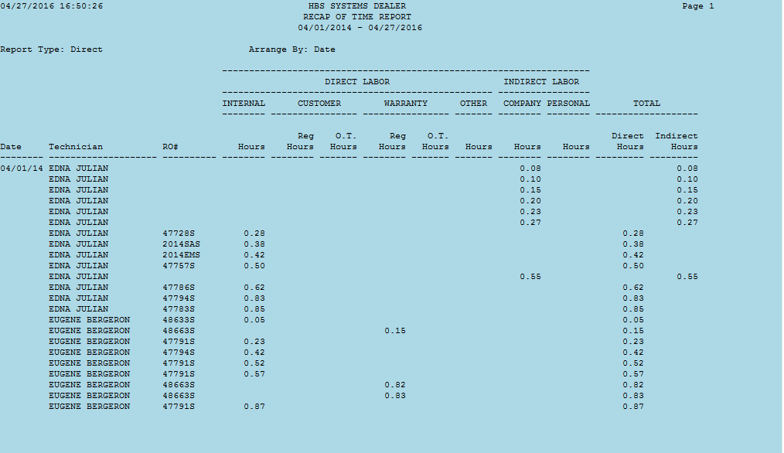

Sample Indirect Time Detail Report (By Date)

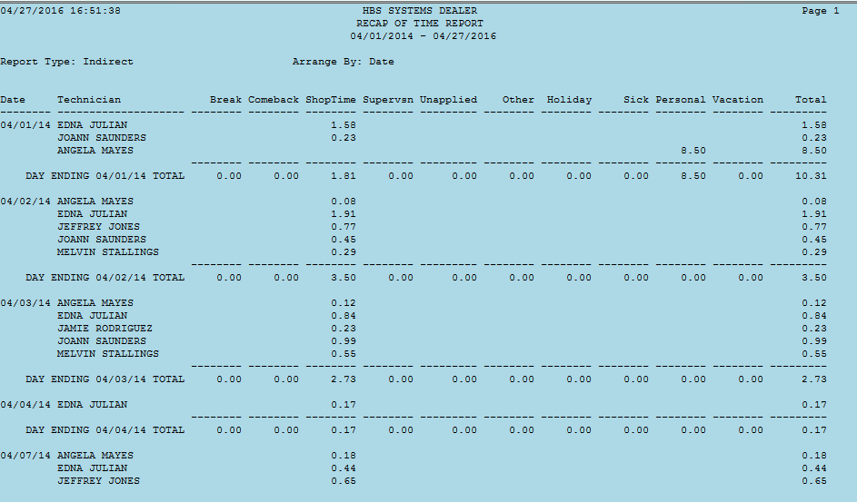

Sample Summary Report (By Technician)

