Time Slip Entry (TSE)

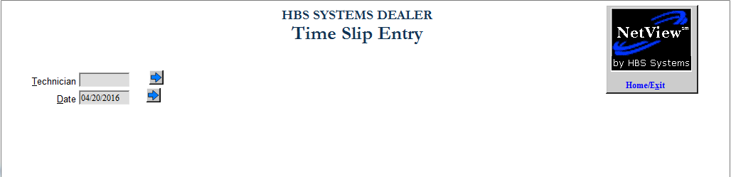

Time Slip Entry (TSE) allows you to maintain or add information from your service employees’ time slips.

To access this program, you can either:

- Select “Service” from the menu. Choose the “Time Slip Maintenance” submenu and click “Time Slip Entry.”
- Type in “TSE” in the Shortcuts Bar.

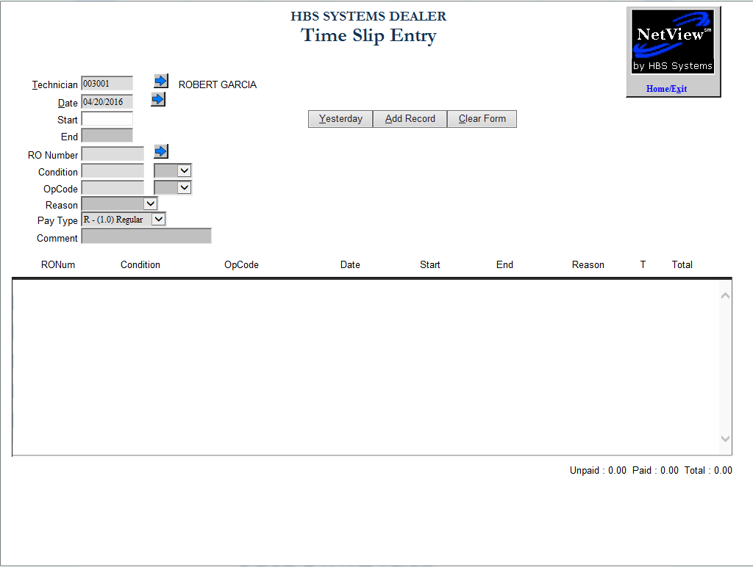

Entering Time from a Time Card

Technician: Enter the Technician Number whose time card you are holding. You can also use the Arrow to look it up. Click on the name to select it.

Date: Enter the Date. You can also use the Arrow to look at a calendar. Click on the date to select it.

Start: Enter the starting time from the time card.

- If your time card has hours and minutes: Enter 0830 for 8:30 a.m. or 1345 for 1:45 p.m.
- If your time card has the time in decimal format: Enter 8.50 for 8:30 a.m. or 13.75 for 1:45 p.m.

End: Enter the ending time from the time card.

RO Number: Enter the Repair Order Number. You can also use the Arrow to look it up. Click on the number to select it.

Condition:

- The condition will default if there is only one condition on the RO.
- Enter the Condition or use the drop-down menu to select it.

Op Code: Enter the Op Code or select it from the drop-down menu .

Reason: This selection box is only used when the entry is for unapplied time. Select it from the drop-down menu .

Pay Type: This selection box is only used when you need to specify a pay rate other than regular time. Select it from the drop-down menu .

Comment: This optional field allows you to enter comments about the entry.

Add Record: Click on Add Record or type “Alt A” to record the time slip.

Continuing with the 2nd and following entries on the time card:

Start: The End time from the previous time slip will be pre-filled in this field. Press “Enter” to use it or type the starting time from the time card.

- If your time card has hours and minutes: Enter 0830 for 8:30 a.m. or 1345 for 1:45 p.m.
- If your time card has the time in decimal format: Enter 8.50 for 8:30 a.m. or 13.75 for 1:45 p.m.

End: Enter the ending time from the time card.

RO Number: Enter the Repair Order Number. You can also use the Arrow to look it up. Click on the number to select it.

Condition:

- The condition will default if there is only one condition on the RO.
- Enter the Condition or use the drop-down menu to select it .

Op Code: Enter the Op Code or select it from the drop-down menu .

Reason: This selection box is only used when the entry is for unapplied time. Select it from the drop-down menu .

Pay Type: This selection box is only used when you need to specify a pay rate other than regular time. Select it from the drop-down menu .

Comment: This optional field allows you to enter comments about the entry.

Add Record: Click on Add Record or type “Alt A” to record the time slip.

Clear Record: Click on the Clear Record button to enter time for another employee.

Home Exit: Press the Home Exit button to leave the screen.

