Technician Slip Report (TSR)

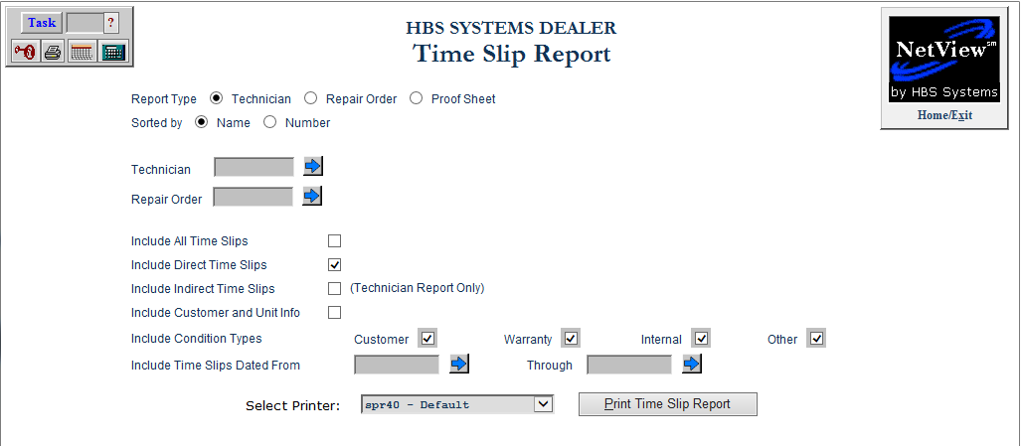

This program lets you view and print the Time Slip Report by Tech, RO, and/or Date.

To access this function, type “TSR” in the Shortcuts Bar.

Field Definitions:

Report Type: Choose the type of report you want to run:

- Technician
  - Sorted By: Choose whether you want to sort the report by Name or Number.
- Repair Order
- Proof Sheet
  - Sorted By: Choose whether you want to sort the report by Name or Number.

Technician: If you want to create a report for a single technician, type their technician number here. You can also use the arrow button to look up the technician.

Repair Order: If you want to create a report for a single repair order, type the RO number here. You can also use the arrow button to search for the RO.

Include All Time Slips: Check this box to include all time slips on the report.

Include Direct Time Slips: Check this box to include specifically Direct Time Slips on the report. This is checked by default when the program opens.

Include Indirect Time Slips (Technician Report Only): Check this box to include Indirect Time Slips on the Technician Report. Select the Indirect Types you specifically want to include using the checkboxes that appear when you check the box, as shown in the image below.

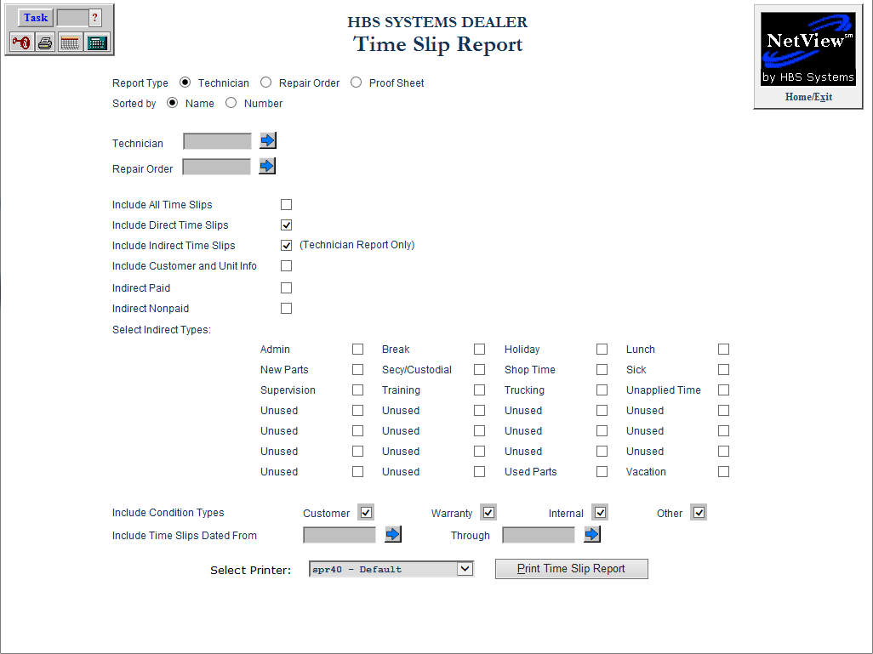

Include Customer and Unit Info: When this box is checked, the printout will now include the customer name from the repair order. NOTE: Not available for Repair Order report.

Include Condition Types: Select which condition types you want to include on the report:

- Customer
- Warranty
- Internal
- Other

Include Time Slips Dated From/Through: To have the report cover only time slips from a specific date range, type the starting and ending dates in these fields. You can also use the arrow buttons to select the dates from a calendar.

Select Printer: Select the printer to view/print the report. Use the see or pdf printer to view the report before printing it.

Print Time Slip Report: Click this button to print the Report.

Sample Technician Report

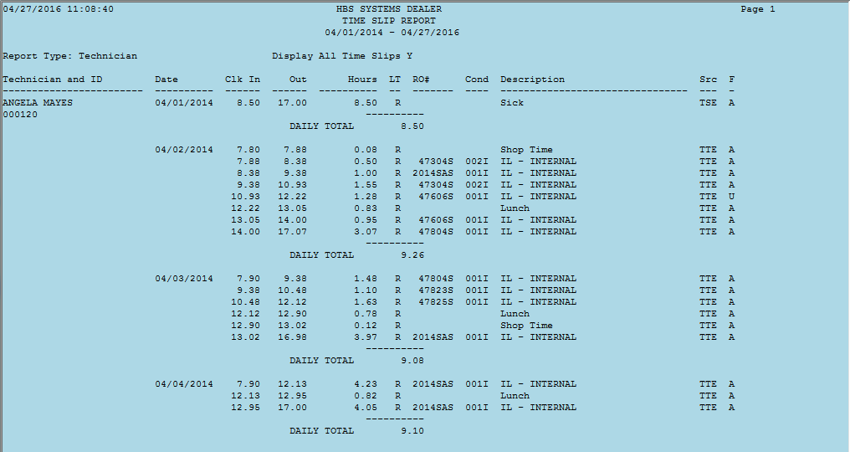

Sample Repair Order Report

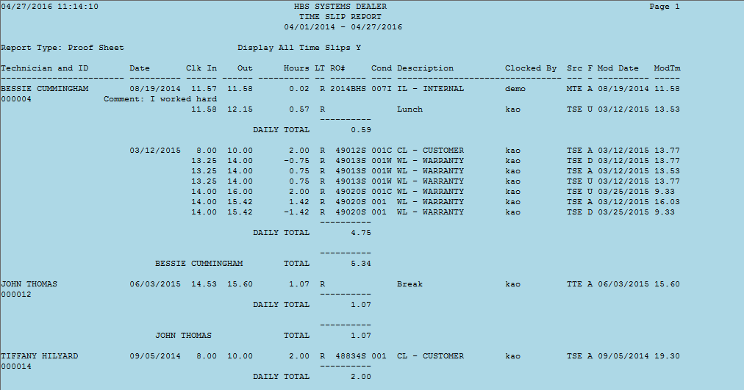

Sample Proof Sheet Report

