Time Utilization Report: The Time Utilziation Report in Rental Reports (RR) creates a report showing how the dealer fleet’s rental time is utilized over a period of time.

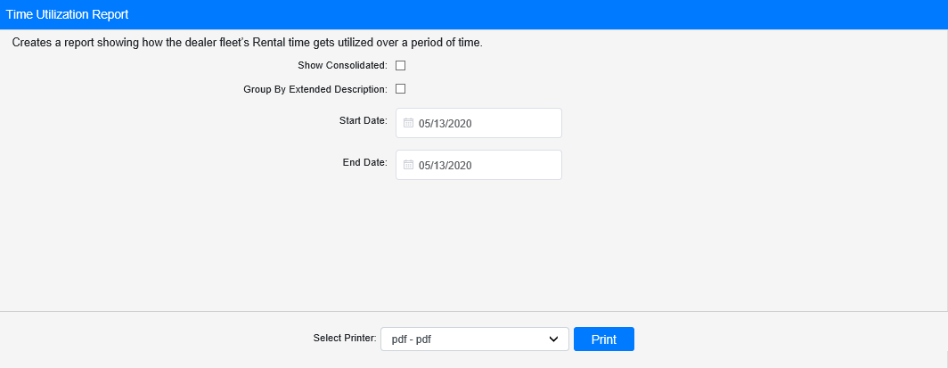

Field Definitions:

Show Consolidated: If you are a multi-location dealership with a Consolidated location, check this box to include the Consolidated location’s information on your report. Uncheck it to only print a report for your individual location. NOTE: If running the report in the Consolidated location, you must check this box to receive a report.

Group by Extended Description: Check this box to group the rental units on the report by their Rental Class’s extended description instead of by their Rental Group and Class.

Start Date/Time: Enter the start date/time for the report here.

End Date/Time: Enter the end date/time for the report here.

Select Printer: Select the printer to receive the report. Use the pdf printer to preview the report.

Click “Print” to print the report.

Sample Report:

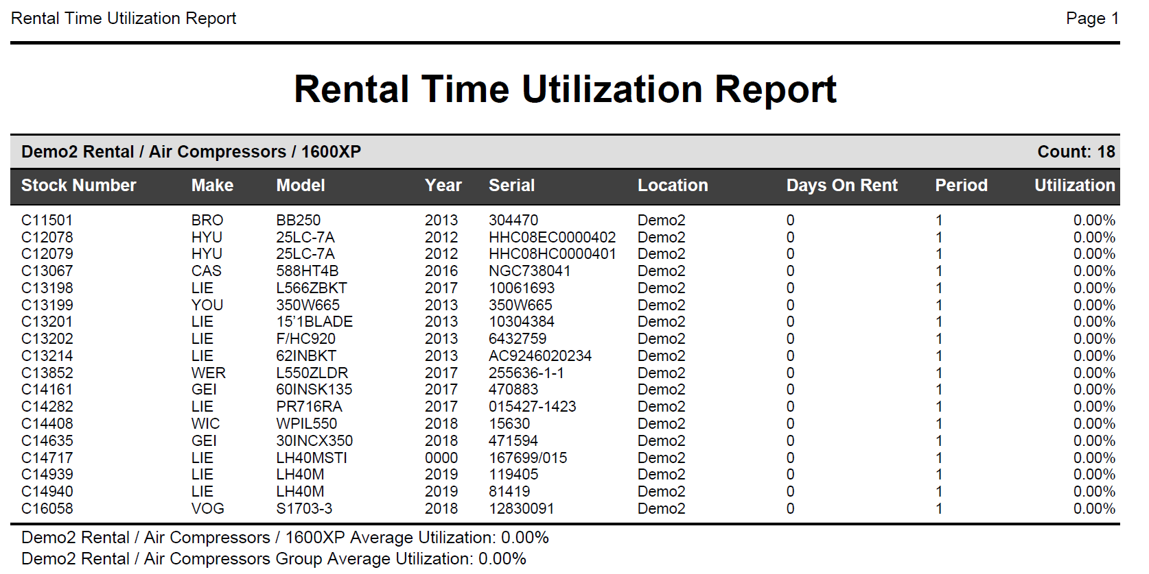

The report shows a list of all Rental units grouped by family/group/class. Each unit is listed by its stock number, along with the following information:

- Make
- Model
- Year
- Serial Number
- Location
- Days spent on rent during the report period
- Days available to rent during the report period
- Percent Rental Time Utilized

A total line at the bottom of the unit list shows the percent average utilization for the entire class. Another total will appear after the last class in the Rental group, showing the group’s percent average utilization.

Sample Report Grouped by Extended Description: If you check the Group By Extended Description box, the report will provide the same data for each unit. However, they will be organized by their Rental Class’s extended description, which will alter the Class Average Utilization Percentage depicted, and the report will not provide any average percentage for Groups as a result.

