Unit Accounting Reports (UAR)

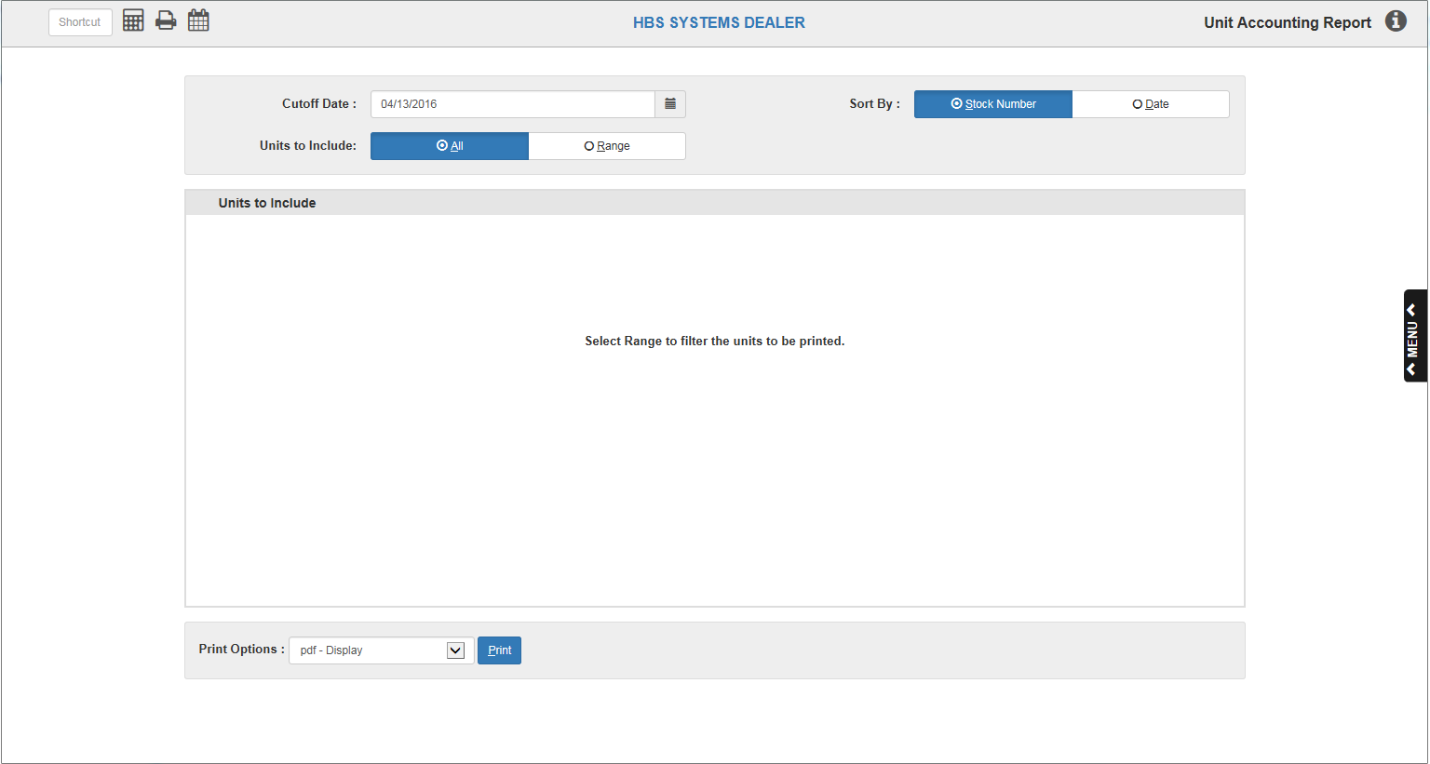

Unit Accounting Reports (UAR) focus only on items in your inventory or on order, and is organized by G/L account numbers. It can be used for accounting or sales purposes. Its single-spaced format makes it a concise way to get selective or complete information about your units inventory as of the chosen report date.

NOTE: The search parameters may change what units appear on the report based on the status and source of the unit on the date of the report, as the report is an “as-of” snapshot of the unit’s information on the chosen date.

To access this function, you can either:

- Select “Units” from the menu. Choose the “Reports” submenu and click “Unit Accounting Report.”
- Type “UAR” in the Shortcuts Bar.

Field Definitions

Cutoff Date: This field lets you select the “as of” date for the report, which means the report will only show the unit’s information as it was on the chosen date, including the unit’s status and source. The current date will prefill. While you can select any date within the open accounting periods, it may be wise to accept the provided date if you want a current look at your unit inventory. For example, in the event that some units have been sold after the date you select, they will NOT appear on the report as they are already flagged in the system as sold.

Sort by: There are two choices resulting from selecting this button. You may numerically sort by either option within the general ledger account number:

- Stock numbers
- Entry date

Units to Include: There are two options to choose from when making your unit selections. At the top of the button selection columns, you have choices of:

- All
- Range

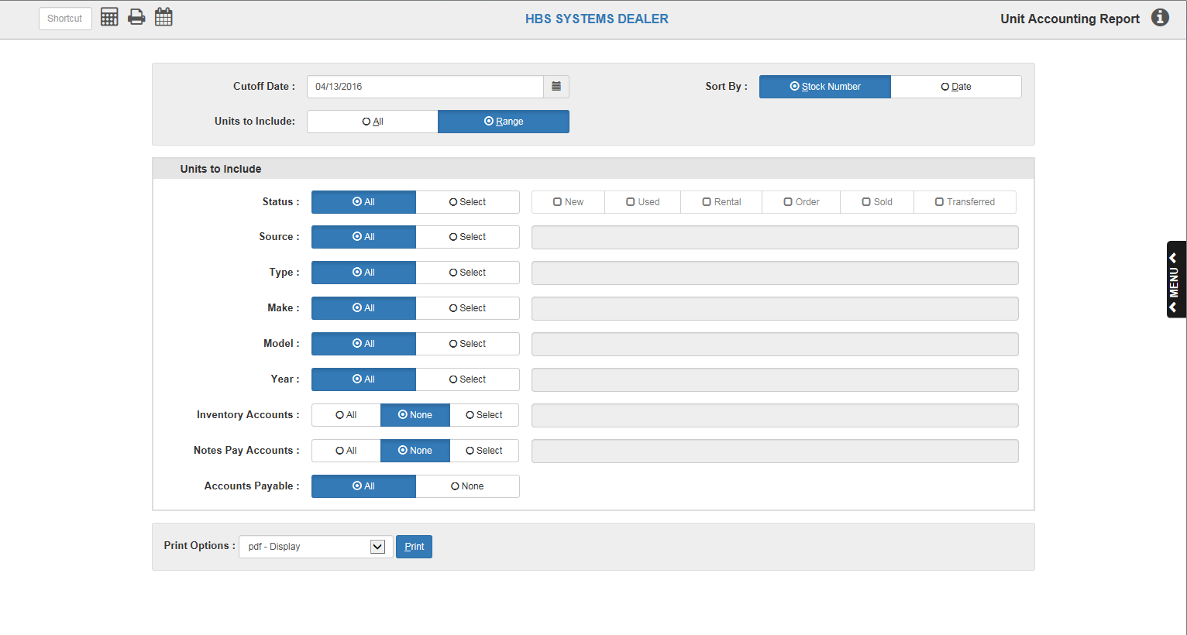

Status: Choose:

- All
- New
- Used
- Rental
- Order
- Sold
- Transferred

Type: Choose All or Select to input individual types.

Make: Choose All or Select to input individual makes.
Model: Choose All or Select to input individual models.

Year: Choose All or Select to input individual model years.

Inventory Accts: Choose:

- All
- None
- Select to input individual inventory accounts (G/L account numbers).

Notes Pay Accts: Choose:

- All
- None
- Select to input individual notes payable accounts (G/L account numbers).

Accounts Pay: Choose:

- All
- None

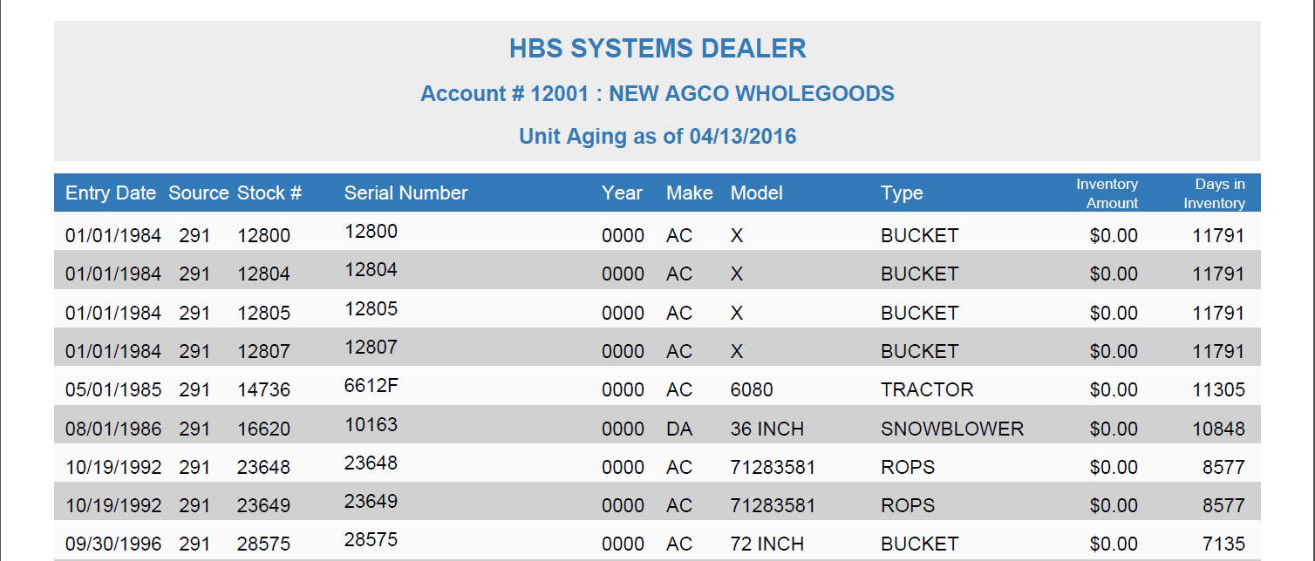

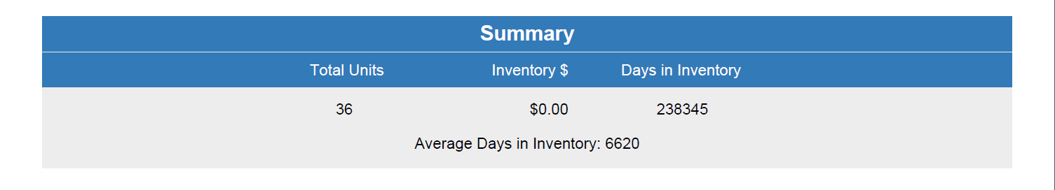

Inventory Account Report Description: The header for this report shows the description
and general ledger account number of the Units inventory account.

Entry Date: This field shows the invoice date for the unit.

Source: This field shows the units source that applies to this stock number.

Stock #: This field shows the stock number of the unit.

Serial Number: This field holds the unit’s main Serial Number.

Year: This field shows the unit's Model Year.

Make: This field shows the unit's Make.

Model: This field shows the unit's Model Number.

Type: This field shows the unit's Type.

Inventory Amount: This field shows the current inventory amount for this stock number.

Days in Inventory: This field compares the date of the report to the entry date and
calculates the number of days this unit has been in inventory.

Totals: Totals are provided for the following:

- # of Units
- Inventory Amount
- Days In Inventory (the average days in inventory is calculated by dividing the total days in inventory by the number of units)

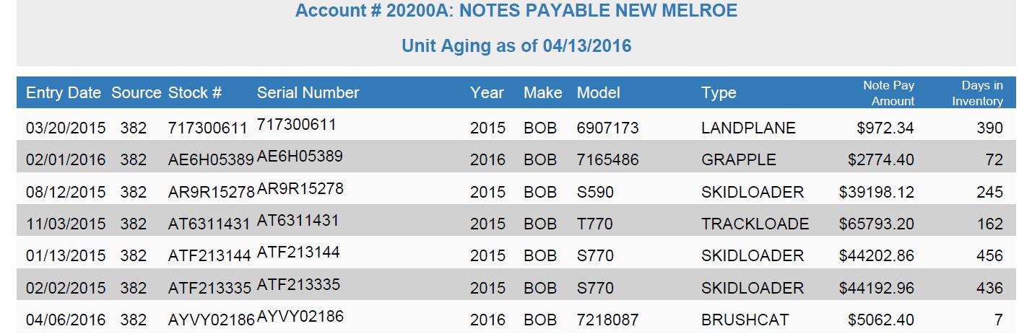
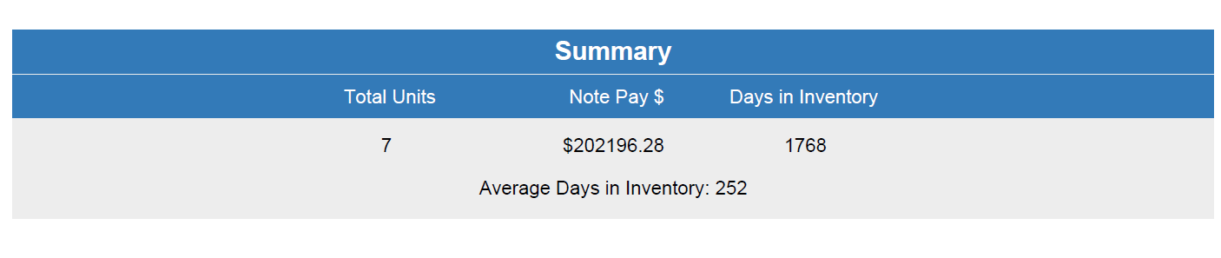

Notes Payable Account Report Description: The header for this report shows the description
and general ledger account number of the units notes payable account.

Entry Date: This field shows the invoice date for the unit.

Source: This field shows the units source that applies to this stock number.

Stock #: This field shows the stock number of the unit.

Serial Number: This field holds the unit’s main Serial Number.

Year: This field shows the unit's Model Year.

Make: This field shows the unit's Make.

Model: This field shows the unit's Model Number.

Type: This field shows the unit's Type.

Note Pay Amount: This field shows the current notes payable amount for this stock
number.

Days in Inventory: This field compares the date of the report to the entry date and
calculates the number of days this unit has been in inventory.

Totals: Totals are provided for the following columns:

- # of Units
- Note Pay Amount
- Days In Inventory (the average days in inventory is calculated by dividing the total days in inventory by the number of units)

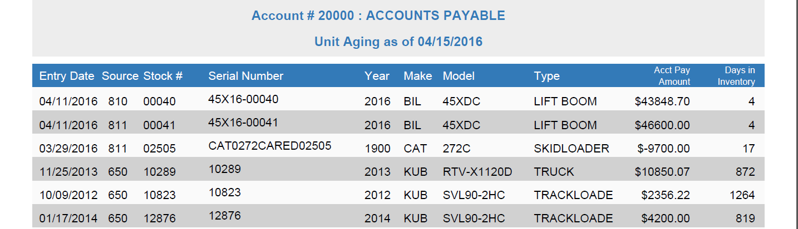

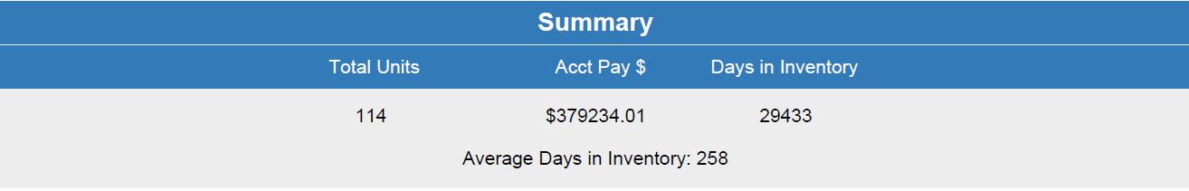

Accounts Payable Account Report Description: This report shows the following information:

Entry Date: This field shows the invoice date for the unit.

Source: This field shows the unit source that applies to this stock number.

Stock #: This field shows the stock number of the unit.

Serial Number: This field holds the unit’s main Serial Number.

Year: This field shows the unit’s Model Year.

Make: This field shows the unit’s Make.

Model: This field shows the unit’s Model Number.

Type: This field shows the unit’s Type.

Acct Pay Amount: This field shows the amount owed in accounts payable for this stock number.

Days in Inventory: This field compares the date of the report to the entry date and calculates the number of days the unit has been in inventory.

Totals: Totals are provided for the following columns:

Total Units

Acct Pay $

Days In Inventory (the average days in inventory equals the total days in inventory divided by the number of units)

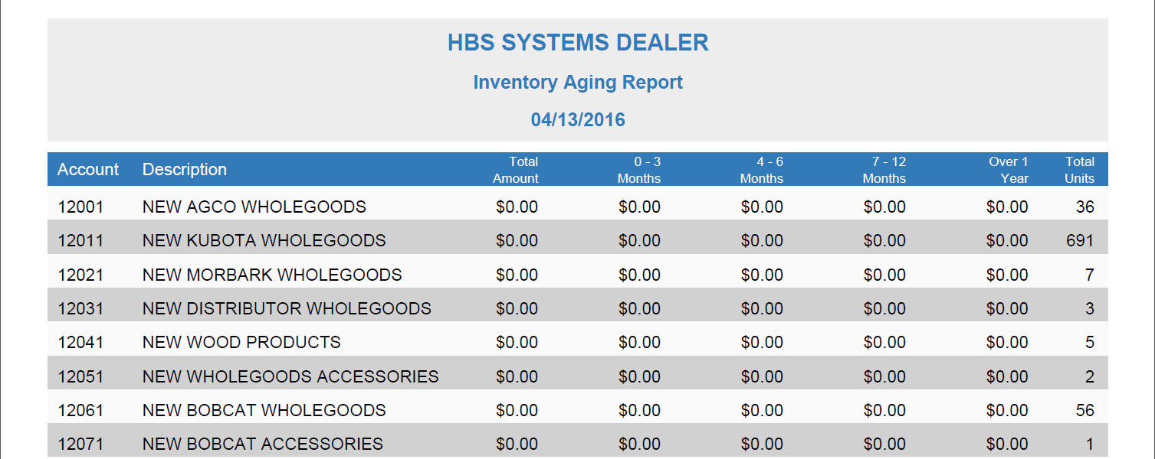
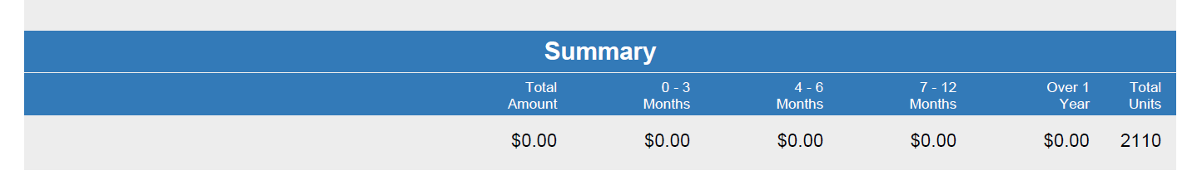

Inventory Aging Report: When inventory accounts are selected, you will also receive an aging report that summarizes all selected inventory accounts. Their account numbers and names are shown plus the total amount and total units of each. Aging is based on unit invoice date, and aging brackets for the following inventory periods are provided:

0–3 months

4–6 months

7–12 months

over a year

