Print Single Unit Barcode Label (UBL)

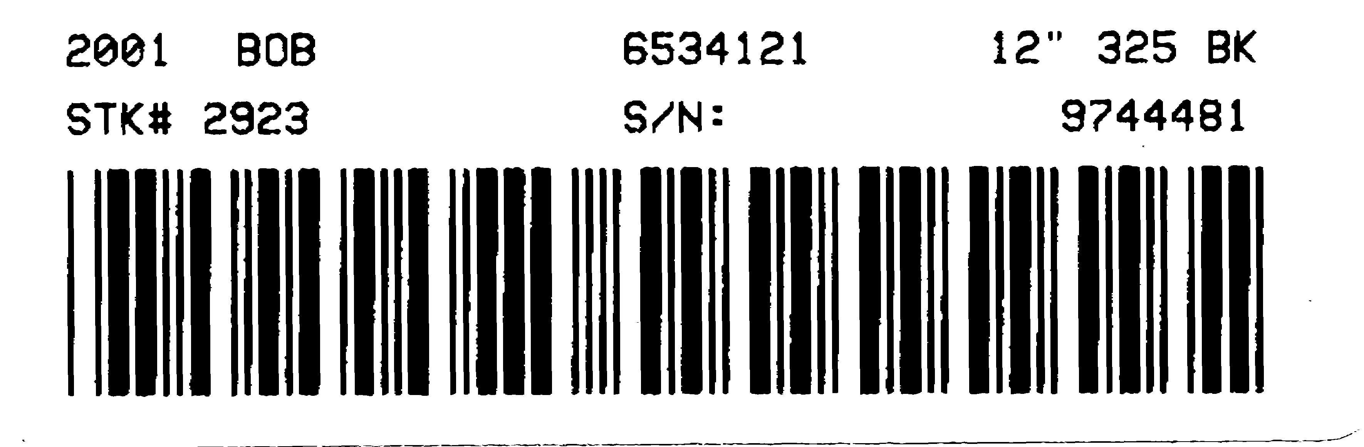Print Single Unit Barcode Labels (UBL) lets you print barcode labels for specific stock numbers (use of this function requires a specialty barcode printer). The information on a Units Barcode Label includes the following:

- Model year
- Make
- Model number
- Type
- Stock number
- Serial number

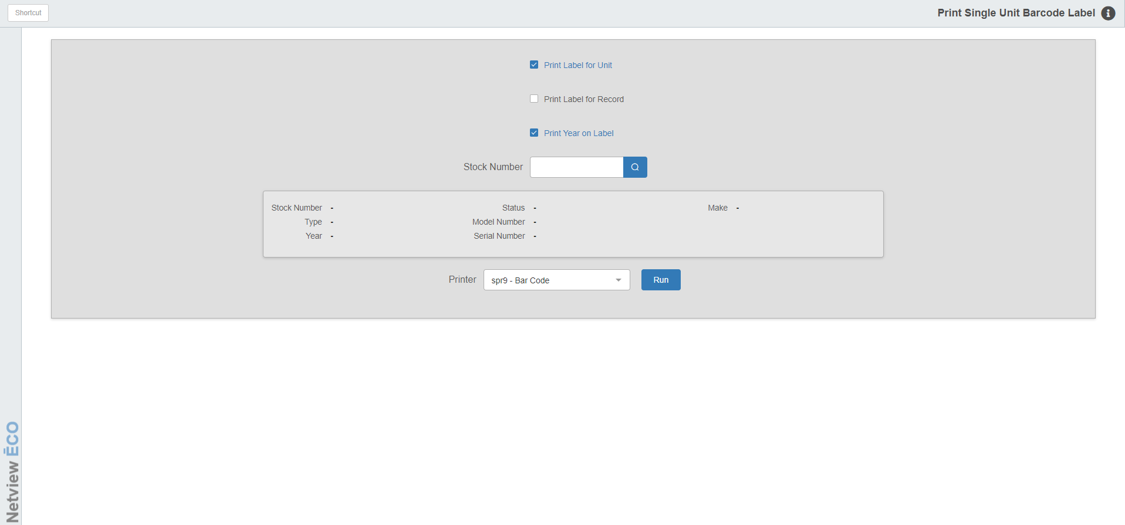

To access this function, you can either:

- Select “Units” from the menu. Choose the “Data Entry” submenu and click “Print Single Unit Barcode Label.”
- Type “UBL” in the Shortcuts Bar.

Field Definitions

Print Label for Unit:

- Check the box to print a label for the unit.
- Uncheck if you do not wish to have unit labels print.

Print Label for Record:

- Check the box to print a second label.
- Uncheck if you do not wish to have a second label copy.

Print Year on Label:

- Check the box to print the Model Year on the label.
- Uncheck if you do not wish to have the Model Year print.

Stock Number to Print: When you fill in this field with a valid stock number and press “Tab” or “Enter,” the information fields below will automatically fill in with the unit’s details. You can also access the Unit Search by clicking the field’s “Search” icon and use it to look up a stock number. NOTE: If you type in a partial stock number and press “Tab” or “Enter,” the Unit Search will trigger automatically, showing all stock numbers that match what you entered.

Printer: Make sure you have this field set to your correct barcode printer.

Run: Press this button to print your label.

