Unit Category Maintenance (UCM)

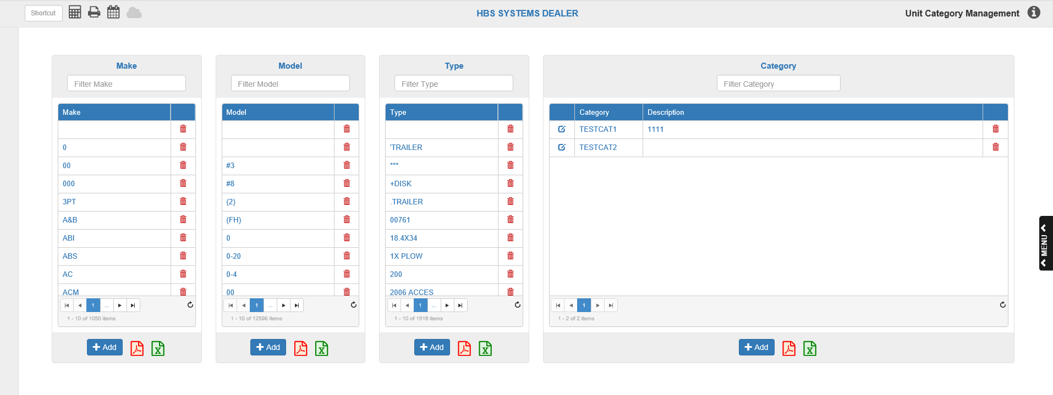

Unit Category Maintenance (UCM) allows you to view, create, and remove categories of information that you use to classify units within your dealership. This includes the Category classification, which is more personal to your dealership, as well as the more standard Make, Model, and Type classifications that all units possess.

To access this function, you can either:

- Select “Units” from the menu and choose the “Data Entry” submenu. Click “Unit Category Maintenance.”
- Type “UCM” in the Shortcuts Bar.

You can also access the program through Unit Maintenance (UM). The Category, Make, Model, and Type field titles in the Unit Info section all link to UCM. Click on the blue, underlined field title for any of the four fields to open the application.

Make Listing: The first section on the screen is the Make listing. This is a comprehensive list of all makes (three-character manufacturer IDs) currently entered in your Unit system. Grey text at the bottom of the list indicates how many makes are listed on the current page, as well as the total number of makes on the list.

Filter Make: This field allows you to filter the Make listing to see if you have a specific make in your system. Begin typing the letters and/or numbers of the make in the bar, and it will automatically sort through the list to find all makes that contain those characters. The search will return more specific results the more characters you enter.

TIP: Remember that makes are typically no longer than 3 characters.

Page Navigation: Use the buttons at the bottom of the list to move between the list pages.

- Page Indicator/More Pages: The number highlighted in blue indicates what page of the list you are currently on. Click the “…” buttons to the left and/or right of the Page Indicator to move forward or back one page, i.e. see more pages.
- Back/Forward Page: The buttons showing a single arrow serve the same function as the More Pages buttons—to move you back and forward a single page.
  - Use the left single arrow to go back one page.
  - Use the right single arrow to go forward one page.
- First/Last Page: The first and last buttons on the navigation row are the First and Last Page buttons. They show an arrow pointing at a vertical line, and allow you to jump to either the very first or very last page of the listing.
  - The left-pointing arrow button will take you to the first page.
  - The right-pointing arrow button will take you to the last page.

Refresh List: Click the circling arrow icon below the bottom right corner of the list to refresh the list’s contents. If any new makes have been added to the system since you opened UCM, the application will update the list to include those.

Add Make: To add a make, click the Add button below the list. This will open the following window.

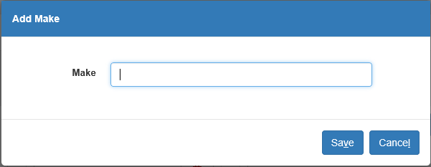

Enter the three-character make. Keep the format consistent for searching and sorting reasons. Click Save to add the make to the listing. Click Cancel to cancel the make’s creation and return to the main screen.

Delete Make: Click the red trash can icon next to a make’s entry on the list to delete the make from the system. A dialogue box will appear, asking if you are sure you want to delete the make.

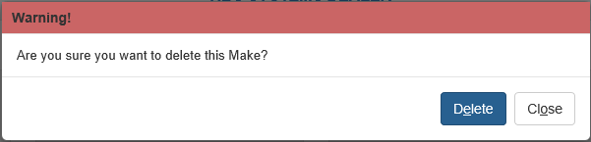

Click Delete to delete the make. If you change your mind, click Close to return to the main page. The make will remain in the system. NOTE: Do NOT delete any make assigned to at least 1 existing unit record.

Export to PDF: Click the red PDF icon at the bottom of the list to export the list to a PDF file.

Export to Excel: Click the green Microsoft Excel icon at the bottom of the list to export the list to an Excel file.

Model Listing: The next section is the Model listing. This is a comprehensive list of all models currently entered in your Unit system. Grey text at the bottom of the list indicates how many models are listed on the current page, as well as the total number of models on the list.

Filter Model: This field allows you to filter the Model listing to see if you have a specific model in your system. Begin typing the letters and/or numbers of the model in the bar, and it will automatically sort through the list to find all models that contain those characters. The search will return more specific results the more characters you enter.

Page Navigation: Use the buttons at the bottom of the list to move between the list pages.

- Page Indicator/More Pages: The number highlighted in blue indicates what page of the list you are currently on. Click the “…” buttons to the left and/or right of the Page Indicator to move forward or back one page, i.e. see more pages.
- Back/Forward Page: The buttons showing a single arrow serve the same function as the More Pages buttons—to move you back and forward a single page.
  - Use the left single arrow to go back one page.
  - Use the right single arrow to go forward one page.
- First/Last Page: The first and last buttons on the navigation row are the First and Last Page buttons. They show an arrow pointing at a vertical line, and allow you to jump to either the very first or very last page of the listing.
  - The left-pointing arrow button will take you to the first page.
  - The right-pointing arrow button will take you to the last page.

Refresh List: Click the circling arrow icon below the bottom right corner of the list to refresh the list’s contents. If any new models have been added to the system since you opened UCM, the application will update the list to include those.

Add Model: To add a model, click the Add button below the list. This will open the following window

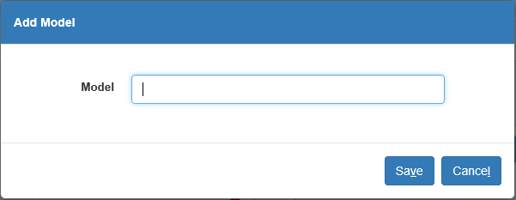

Enter the model number. We recommend you keep the format consistent for searching and sorting reasons. Click Save to add the model to the listing. Click Cancel to cancel the model’s creation and return to the main screen.

Delete Model: Click the red trash can icon next to a model’s entry on the list to delete the model from the system. A dialogue box will appear, asking if you are sure you want to delete the model.

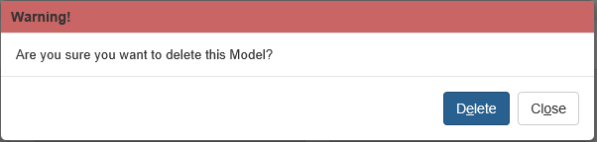

Click Delete to delete the model. If you change your mind, click Close to return to the main page. The model will remain in the system. NOTE: Do NOT delete any model assigned to at least 1 existing unit record.

Export to PDF: Click the red PDF icon at the bottom of the list to export the list to a PDF file.

Export to Excel: Click the green Microsoft Excel icon at the bottom of the list to export the list to an Excel file.

Type Listing: The next section is the Type listing. This is a comprehensive list of all types currently entered in your Unit system. The Type tells you about the piece of equipment: Tractor, Snowplow, Mower, Chain saw, etc. Grey text at the bottom of the list indicates how many types are listed on the current page, as well as the total number of types on the list.

Filter Type: This field allows you to filter the Type listing to see if you have a specific type in your system. Begin typing the letters and/or numbers of the type in the bar, and it will automatically sort through the list to find all types that contain those characters. The search will return more specific results the more characters you enter.

Page Navigation: Use the buttons at the bottom of the list to move between the list pages.

- Page Indicator/More Pages: The number highlighted in blue indicates what page of the list you are currently on. Click the “…” buttons to the left and/or right of the Page Indicator to move forward or back one page, i.e. see more pages.
- Back/Forward Page: The buttons showing a single arrow serve the same function as the More Pages buttons—to move you back and forward a single page.
  - Use the left single arrow to go back one page.
  - Use the right single arrow to go forward one page.
- First/Last Page: The first and last buttons on the navigation row are the First and Last Page buttons. They show an arrow pointing at a vertical line, and allow you to jump to either the very first or very last page of the listing.
  - The left-pointing arrow button will take you to the first page.
  - The right-pointing arrow button will take you to the last page.

Refresh List: Click the circling arrow icon below the bottom right corner of the list to refresh the list’s contents. If any new types have been added to the system since you opened UCM, the application will update the list to include those.

Add Type: To add a type, click the Add button below the list. This will open the following window.

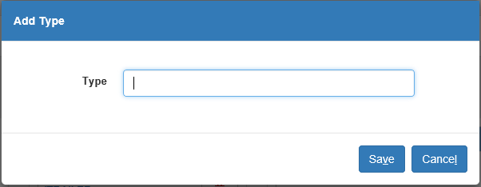

Enter the type. The equipment types can be as detailed or as generic as you like. We suggest that you keep them consistent for searching and reporting purposes. Click Save to add the type to the listing. Click Cancel to cancel the type’s creation and return to the main screen.

Delete Type: Click the red trash can icon next to a type’s entry on the list to delete the type from the system. A dialogue box will appear, asking if you are sure you want to delete the type.

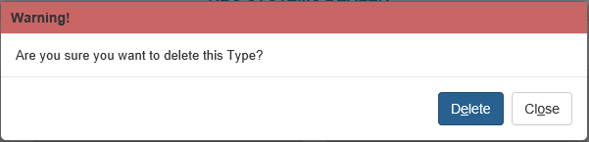

Click Delete to delete the type. If you change your mind, click Close to return to the main page. The type will remain in the system. NOTE: Do NOT delete any type assigned to at least 1 existing unit record.

Export to PDF: Click the red PDF icon at the bottom of the list to export the list to a PDF file.

Export to Excel: Click the green Microsoft Excel icon at the bottom of the list to export the list to an Excel file.

Category Listing: The final section is the Category listing. Grey text at the bottom of the list indicates how many categories are listed on the current page, as well as the total number of types on the list. Categories are user-created and can be used to more easily identify groups of units for dealership purposes. For example, you could mark all units available for rent as belonging to a “Rental” category, or all units currently undergoing repairs as “Internal Service.” The category thus provides an identification tag which can indicate a commonality between the units that may not be conveyed by their make, model, or type. UCM is the primary program for the creation and maintenance of your system categories.

Filter Category: This field allows you to filter the Category listing to find a specific category. Begin typing the letters and/or numbers of the category in the bar, and it will automatically sort through the list to find all categories that contain those characters. The search will return more specific results the more characters you enter.

Page Navigation: Use the buttons at the bottom of the list to move between the list pages.

- Page Indicator/More Pages: The number highlighted in blue indicates what page of the list you are currently on. Click the “…” buttons to the left and/or right of the Page Indicator to move forward or back one page, i.e. see more pages.
- Back/Forward Page: The buttons showing a single arrow serve the same function as the More Pages buttons—to move you back and forward a single page.
  - Use the left single arrow to go back one page.
  - Use the right single arrow to go forward one page.
- First/Last Page: The first and last buttons on the navigation row are the First and Last Page buttons. They show an arrow pointing at a vertical line, and allow you to jump to either the very first or very last page of the listing.
  - The left-pointing arrow button will take you to the first page.
  - The right-pointing arrow button will take you to the last page.

Refresh List: Click the circling arrow icon below the bottom right corner of the list to refresh the list’s contents. If any new categories have been added to the system since you opened UCM, the application will update the list to include those.

Add Type: To add a category, click the Add button below the list. This will open the following window.

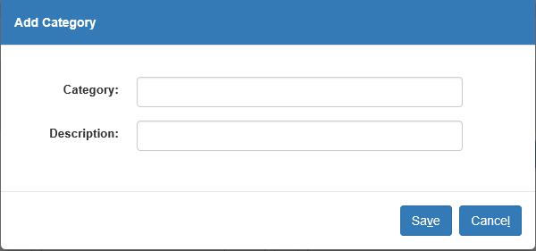

Enter the category’s name and description. Click Save. The category will now appear in the listing. Click Cancel to cancel the category’s creation and return to the main screen.

Edit Category: To edit an existing category, click the icon next to the category. This will open the following window.

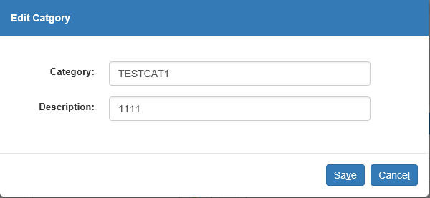

Make the desired changes and click Save. Click Cancel to cancel your changes before saving and return to the main screen.

Delete Category: Click the red trash can icon next to a category’s entry on the list to delete the category from the system. A dialogue box will appear, asking if you are sure you want to delete the category.

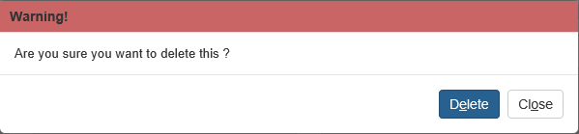

Click Delete to delete the category. If you change your mind, click Close to return to the main page. The category will remain in the system. NOTE: Do NOT delete any category assigned to at least 1 existing unit record.

Export to PDF: Click the red PDF icon at the bottom of the list to export the list to a PDF file.

Export to Excel: Click the green Microsoft Excel icon at the bottom of the list to export the list to an Excel file.

