Unit Financial History Maintenance (UFHM)

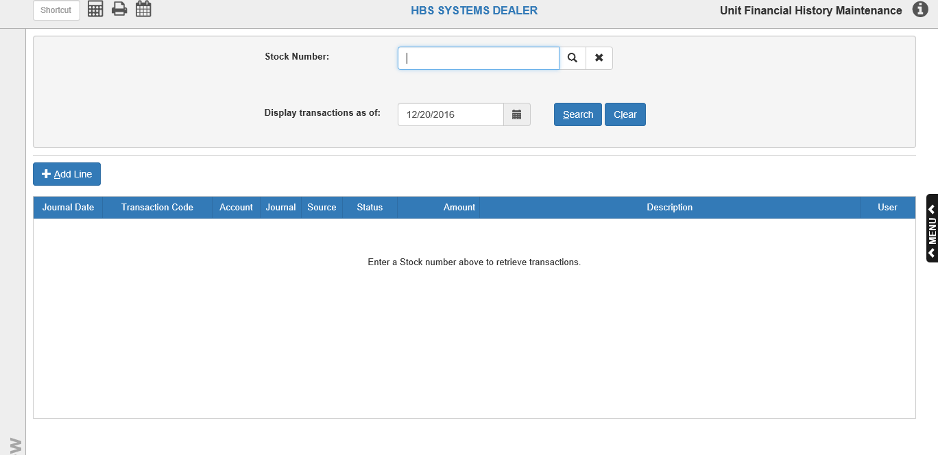

The Unit Financial History Maintenance screen is FOR SPECIAL USE ONLY, such as to reconcile differences in the G/L Reconciliation report (GLRR). It makes entries that will align the UAR column of the GLRR with the rest of the amounts for a particular G/L account. DO NOT USE THIS PROGRAM UNLESS INSTRUCTED BY HBS.

To access this function, you can either:

- Select “Units” from the menu and choose the “Data Entry” submenu. Click on “Unit Financial History Maintenance.”
- Type “UFHM” in the Shortcuts Bar.

Stock Number: To view the unit’s current financial information, enter or look up the stock number to examine, then click Search. The information will populate the screen. Click Clear at any point to clear the screen of all information.

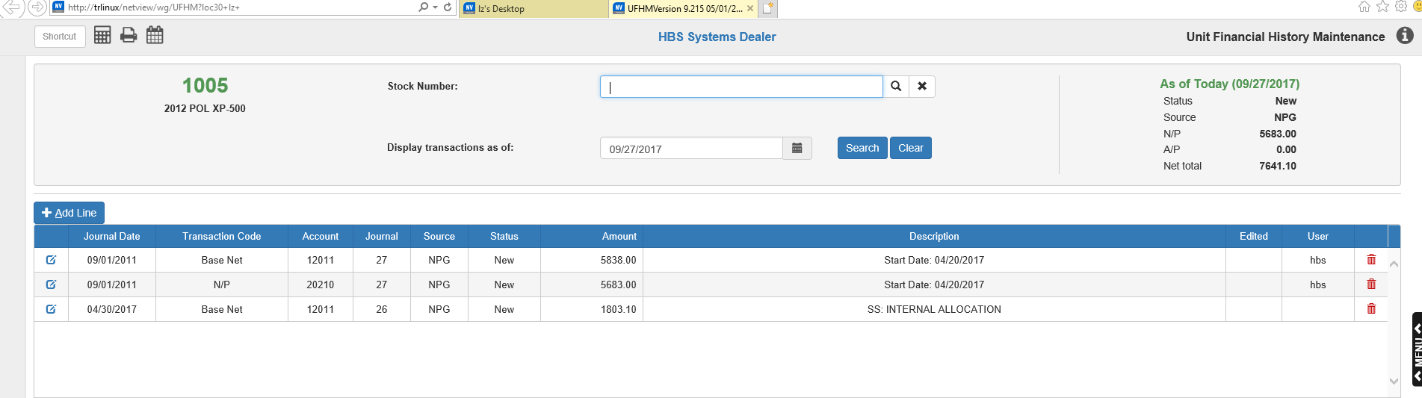

As of Today (Date): Note the figures in the upper right-hand corner with the current date. This shows the unit’s financial figures as of the current date.

Status: This field shows the unit’s current status (New, Used, Sold, etc.).

Source: This field shows the Unit source as of the current date.

N/P: This field shows the unit’s Notes Payable balance as of the current date.

A/P: This field shows the unit’s Accounts Payable balance as of the current date.

Net total: This field shows the unit’s net total balance as of the current date.

Display transactions as of: This field defaults to the current date. It affects the amount of transaction detail shown on the screen. If you use the current date, you will see all transactions that affect the stock number entered through the last Journal posting for today. If you change the date, you will see an additional line about the full amounts with the values of the unit at the point in time. Changing the date here also sets the dates for any lines added to the stock number to match the new Display Transactions date.

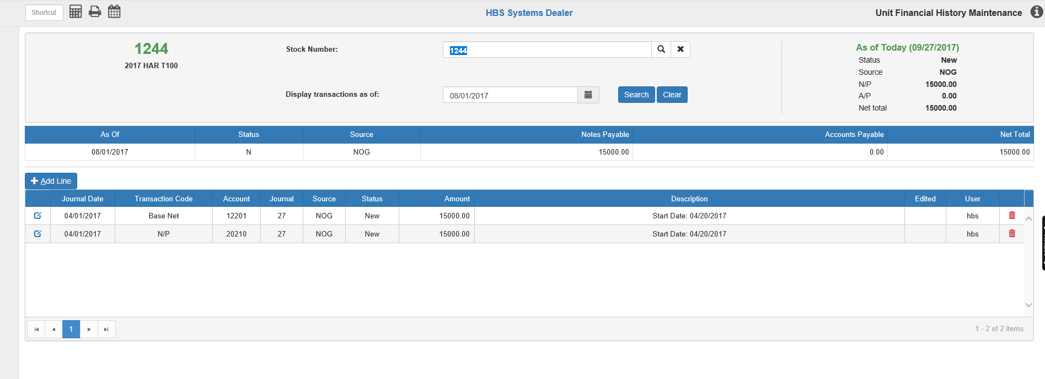

Notice the difference in the detail in the lower portion of the screen and the additional recap line shown above the detail. For reference, the amounts in the upper right-hand corner show the unit as of the current date.

As Of: This field shows the changed date shown in the Display transactions as of field.

Status: This field shows the unit’s status (N/U/S/etc.).

Source: This field shows the Unit source on the As Of date.

Notes Payable: This field shows the unit’s Notes Payable balance on the As Of date.

Accounts Payable: This field shows the unit’s Accounts Payable balance on the As Of date.

Net Total: This field shows the unit’s net total balance on the As Of date.

Financial History Grid: This grid shows the unit’s financial history from when the program was first installed up to the current date. Each line represents an addition or reduction of value to one component of the unit’s financial values (Net, A/P, or N/P). You can resort the entries by clicking on the column headers—once to sort in ascending order by the column data or twice to sort in descending order by the column data. For ease of viewing, we recommend sorting by the Transaction Code column in order to group all entries with the same type of code together.

Journal Date: This column shows the Journal date for transaction line shown.

Transaction Code: This column shows the portion of the unit value that was affected by the transaction line:

- Base Net
- Option
- Repair Order
- Accounts Payable
- Notes Payable

Account: This column shows the G/L account affected by the transaction line.

Journal: This column shows the Journal where the transaction line occurred. If the column shows 27, it indicates the line is the initial balance entry for the unit in UFHM, or a subsequent entry that has been made in UFHM.

Source: This is the Unit source in place when the transaction line was created (and the “source” of the G/L accounts used for the transaction line).

Amount: This column shows the amount brought in (+) or taken out (-) by the transaction (either a line initial balance entry or subsequent transaction details).

Description: This field may contain a description like “Start Date XX/XX/XXXX,” which indicates this is the initial balance entry made in the file. This start date is also the oldest date you may use when backdating the Unit Accounting Report (UAR). It may also show familiar transaction descriptions like “Option” or “SS Internal Allocation” for daily transactions made to the stock number.

User: This column identifies the user who created the transaction line.

Edit: Click the icon in this column to edit a particular line. The following window will appear:

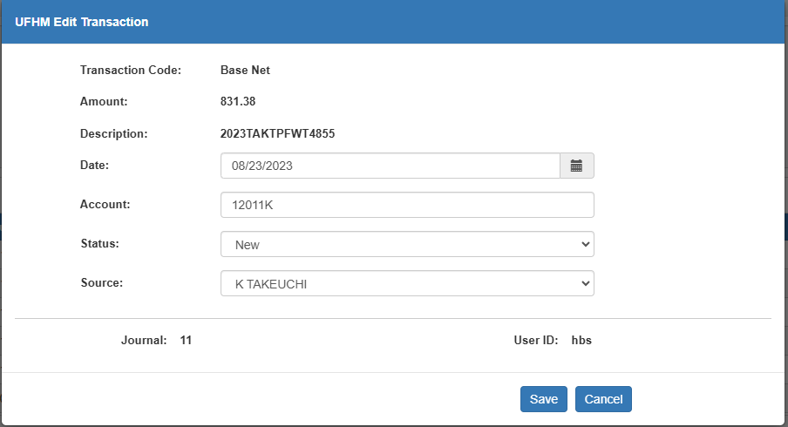

Make changes to the line’s information as desired and click Save to update the line.

Delete: If you ever need to delete a transaction line, use the icon in this column. The following alert will appear:

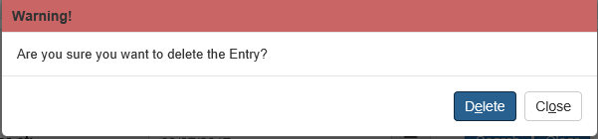

Click Delete to delete the line.

Add Line: If you determine you need to add a line to a unit financial history for a stock number to bring the GLRR back into balance, be sure that Display transactions as of field contains the date you want the line to add on. Then click the Add Line button.

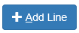

The following window will appear:

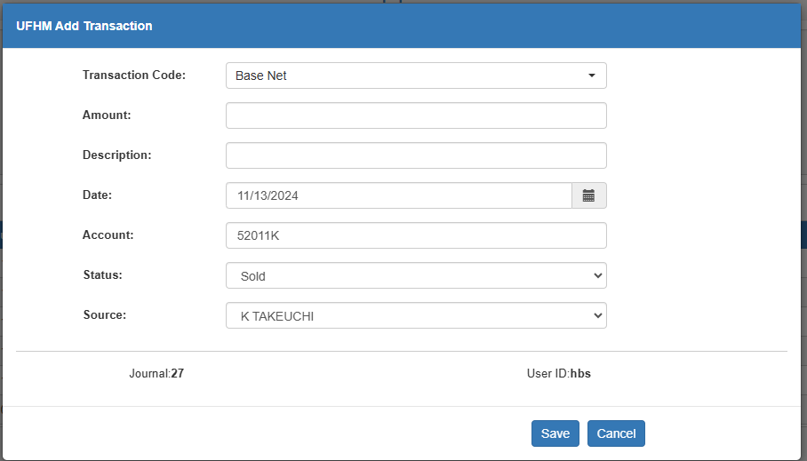

Transaction Code: Choose a Transaction Code from the list provided:

- Base Net
- Option
- Repair Order
- Accounts Payable
- Notes Payable

Amount: Enter the transaction amount here. Enter a debit or “+” amount to INCREASE the current unit value. Enter a credit or “-“ amount to DECREASE the value.

Example of an added transaction to decrease the item value.

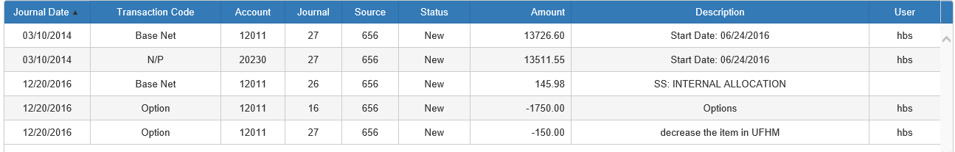

Example of an added transaction to increase the item value.

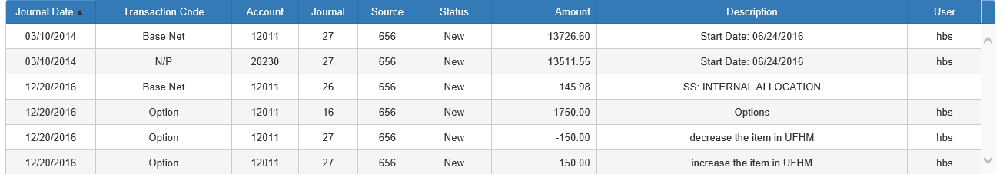

Description: Enter a description to be used for the transaction line.

Date: Make sure the date in this field is the correct date for the transaction. The field will default to whatever date is currently entered in the Display transactions as of field on the main screen.

Account: Make sure the correct G/L account for the transaction appears in this field. There will be a default account, but it can be changed as necessary.

Status: Set the unit’s status at the time of the transaction using this dropdown menu. The available statuses are:

- New
- Used
- Rental
- Ordered
- Sold
- Historical
- Transferred

Source: Set the unit’s Source at the time of the transaction using this dropdown menu. There will be a default Source, but it can be changed as necessary.

Click Save to save the new transaction and add it to the unit’s financial history.

