Update General Ledger Entries (UGLE)

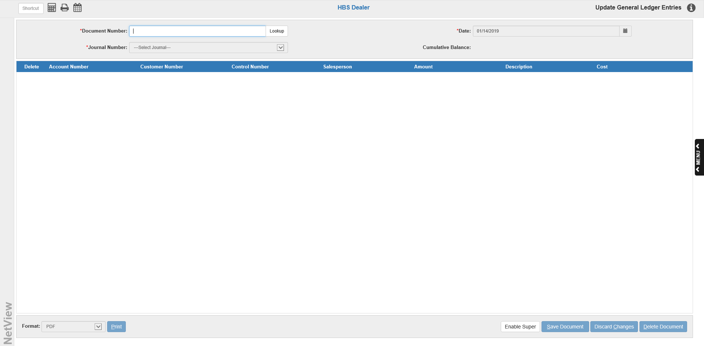

Update General Ledger Entries lets you manually update documents entered in the General Ledger by uploading new versions of the document. To access this function, type UGLE in the Shortcuts Bar. DO NOT USE UNLESS INSTRUCTED TO BY HBS.

Active Keys:

Save Document: This button saves a new document or any changes made to an existing document. It is only active when there is an active document on the screen.

Discard Changes: This button discards any changes made to the document on the screen that have yet to be saved. It is only active when there is an active document on the screen.

Delete Document: This button permanently deletes the document on the screen. It is only active when there is an active document on the screen.

Print: This button generates a proof sheet of additions, changes, and deletions in the format you have selected. Select the type of printout you want from the Format drop-down menu next to the button. A default format name is pre-filled, but can be changed as necessary using the drop-down menu. Click the button to print out your proof sheet.

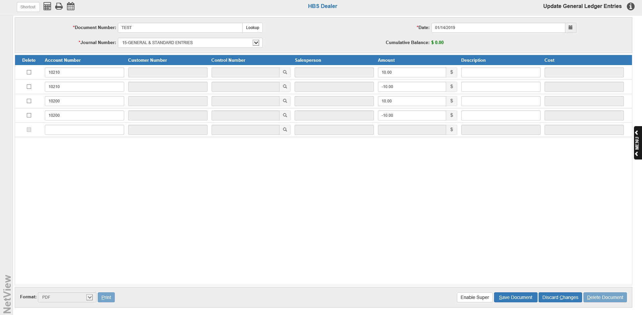

Field Definitions:

Document Number: To create a new document, type the document number for the transaction in here. Examples: check number, invoice number, receipt id, or other reference.

Date: Enter the document date here or select it using the calendar. The current date appears by default.

Journal Number: Type in the number of the Journal to receive the transaction, or select the Journal from the drop-down menu. Valid Journal Numbers are 01 through 27. Journals 03, 09, 12, and 27 are used exclusively by the system and are not available for manual entries.

TYPICAL JOURNAL NAMES

1 UNITS SALES JOURNAL 15 GENERAL & STANDARD ENTRIES
2 16 UNIT TRANSFERS AND ADJUSTMENTS
3 PARTS SALES JOURNAL 17
4 18 YEAR END ADJUSTMENTS
5 19
6 20
7 21
8 BANK & CREDIT CARD DEPOSITS 22
9 CASH RECEIPTS JOURNAL 23 INTER STORE PARTS TRANSFERS
10 CASH DISBURSEMENT JOURNAL 24 FIXED ASSET DEPRECIATION
11 UNIT PURCHASES JOURNAL 25 RENTAL MANAGEMENT ENTRIES
12 AP PURCHASES JOURNAL 26 SERVICE MANAGEMENT ENTRIES
13 PAYROLL JOURNAL 27 COMPUTER GENERATED ENTRIES
14

Account #: Enter the General Ledger Account Number for this line of the document. You may do a search by typing in the first number or two of the account number, or by typing in the name or part of the name on the account. The Account Number Lookup Screen (see below) will appear to provide the account numbers and descriptions, which you can scroll through and find the account number you want.

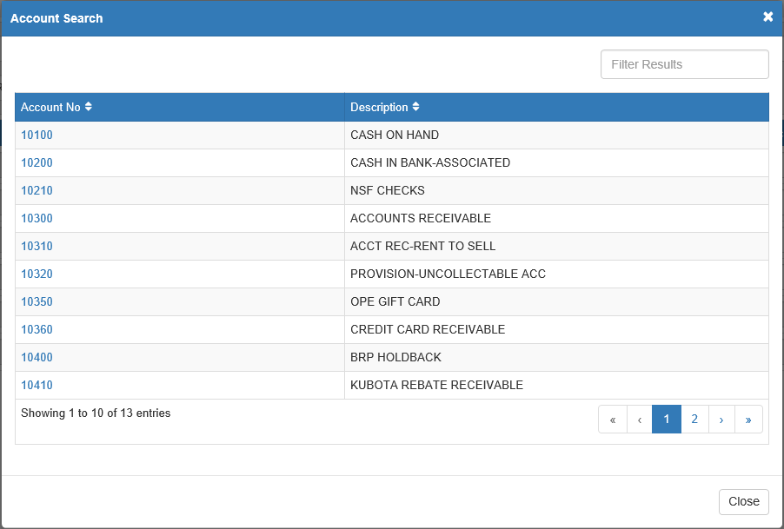

Additionally, if you type in part of the account number and there is only one account that contains that combination of numbers, the application will automatically fill the field with that account number.

Customer #: This field is only active for 10300 (Accounts Receivable, which requires a customer account number) and possibly 10100 (Cash on Hand, may be optional). Type the customer number or search for it by typing in the first few letters of the customer's last name.

Control #: If the account number has a subledger code, you will need to enter the appropriate control number here. This can be a stock number, vendor number, reference number, or customer name, depending on the type of account.
Common Subledger Codes
Type of Account Code Control Number
Unit Inventory 5 Stock #
Notes Payable 5 Stock #
Warranty Receivables 5 Invoice #/Document #
Contracts in Transit 5 Customer # or Customer Name
Customer Deposits 5 Customer # or Customer Name
Checking Account 8 Check # or Deposit #

Salesperson: An entry in the Salesperson field (initials or employee number) is only required if the account number is a sales account (examples: 32001, 34003).

Amount: Enter the amount to pass to the line entry’s account number in this field. If you need to enter a credit amount, type the “-” before or after the amount. You may type the amount with or without the decimal point (type in 2537 or 25.37 to enter $25.37).

Description: Type a brief description of this transaction. The description should be unique for this document. For example, typing PARTS for your parts inventory account number 14003 does not tell you much since you probably know that 14003 is the Parts Inventory account. However, a description of PARTS-AGCO or PARTS-AUTOZONE would give you a better idea of what you bought and where it came from

Cost: When you make an entry to a sales account, you may enter the cost of the sale in this field (if the cost and inventory accounts are referenced to it in Account Number Maintenance (ANM)). It will make two automatic entries: a debit (+) to the Cost of Sales account and a credit (-) to the Inventory account. Type the amount of the cost in this field. If you are reversing a sales entry, you would enter a credit amount here. You can also make your own Cost of Sales and Inventory entries by entering the appropriate account numbers on following lines and ignore the Cost field. The use of this field would probably be limited to entry of manual sales and should be used with caution.

Cumulative Balance: This field on the left side of the screen shows a running balance for the transaction. The entry is balanced when this field shows a zero. If you attempt to save the document when the cumulative balance is not zero, you will require a password to continue (see image).

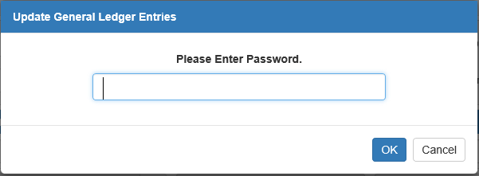

Do NOT enter the password unless you are trying to create an out of balance document.

Editing Existing Documents: You can edit any documents created here until you post them to the General Ledger. Recall them on this screen by entering the document number in the Document Number field or use the Lookup button to the right of the field to search for a document (see image below).

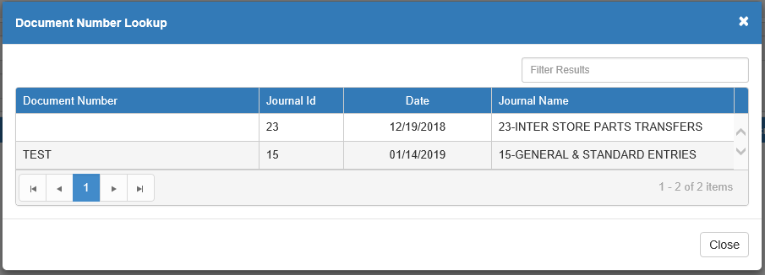

You may change ALL aspects of the document except the document number. Make your changes and press Save Document.

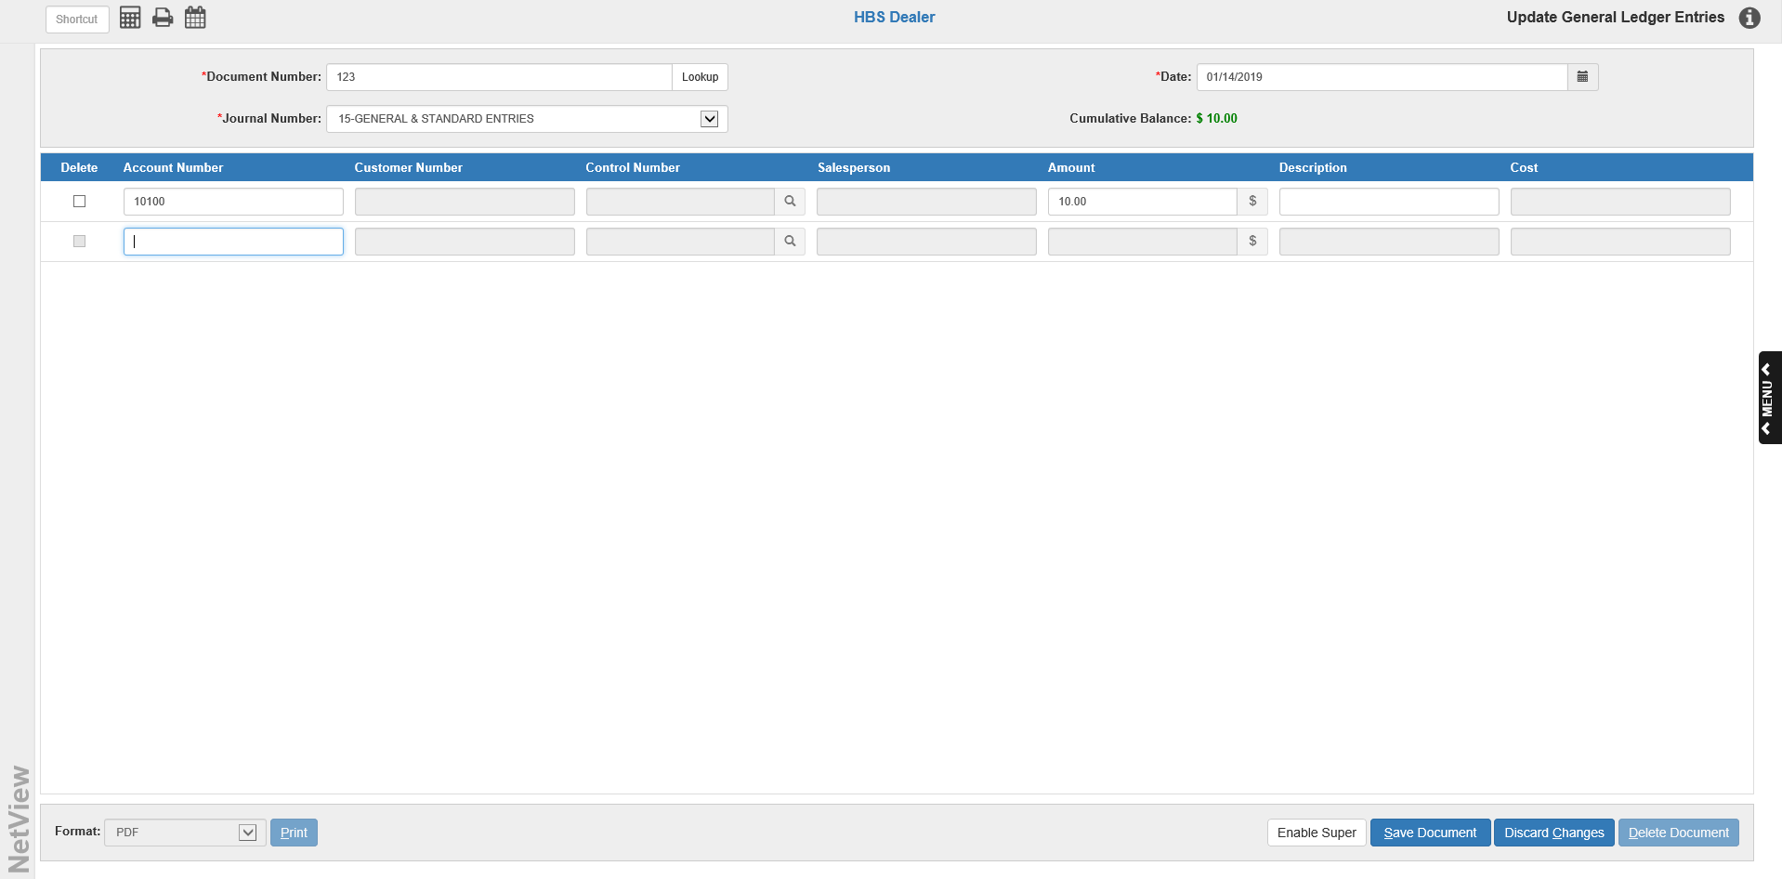

Correcting Out of Balance Documents: If you try to save a document that has a cumulative balance other than 0.00, you will be asked for a password in order to continue. If you are not trying to create an out of balance transaction, you DO NOT want to record this transaction. Press the Cancel button on the message box (see below) and you will return to the document where you can make the necessary adjustments to create a balanced transaction.

Adding a One-Sided General Ledger Document: Occasionally there is a need to create a one-sided Journal entry (perhaps to correct an out of balance in the Trial Balance). Please check with HBS Support before making this entry to verify that it is needed for your situation.

- Enter the Document Number, the Journal Number, and the Document Date. The one-sided document often contains only one account number line entry which will leave a balance in the Cumulative Balance field (see above image).
- Press Save Document. You will be asked for a password.

- Type in the appropriate password and press OK to record your out-of-balance document.
- Press the Print button to receive the proof sheet.
- Post the single-sided document through Post Journals (GLPJ). Notice that the Journal Total does not equal 0.00.
- Print a Trial Balance (TB) and a G/L Reconciliation Report (GLRR) to verify that the accounting system is now in balance.

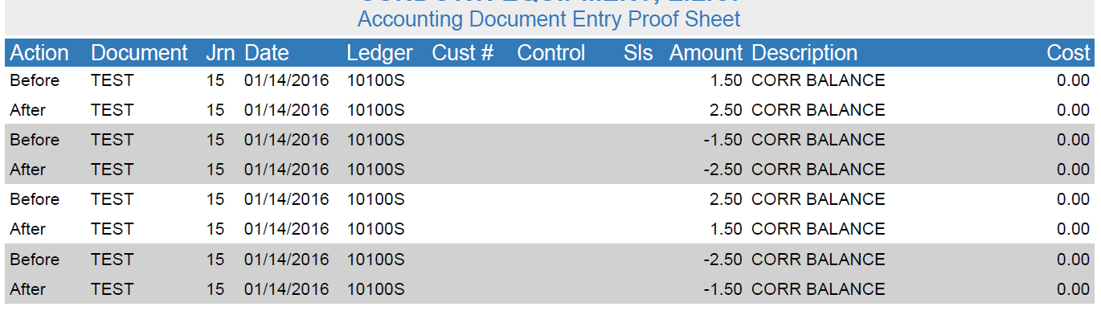

UGLE Proof Sheet:

Action: This field shows the final status of the entry lines. For an initial entry, all lines will show after to indicate the final version of the entry. If you edit the entry before it is posted, the proof sheet will show before in this field on any line you changed and after on the revised line. You may also see deleted to show the lines you removed from the entry.

Document: This field shows the document number for this line.

Jrn: The Journal Number (01 through 27) will show here.

Date: This field shows the document date entered.

Ledger: This is the General Ledger account number for this line of the transaction.

Cust#: If a customer number was used on this line, it will appear in this space. Most transactions will not have an entry in this field.

Control: If the account number entered in the Ledger field has a subledger code, you will see the control number here (Stock Number, Vendor Number, Reference Number, or Customer Name).

Sls: If the salesperson’s initials were entered, they will show in this field.

Amount: The dollar amount for this line of the entry will be shown here.

Description: The description for this line of the transaction will display in this field.

Cost: If a cost entry was made, you will see the amount entered in the cost field here. This amount also will be credited to the appropriate inventory account.

