Unit Inquiry (UI)

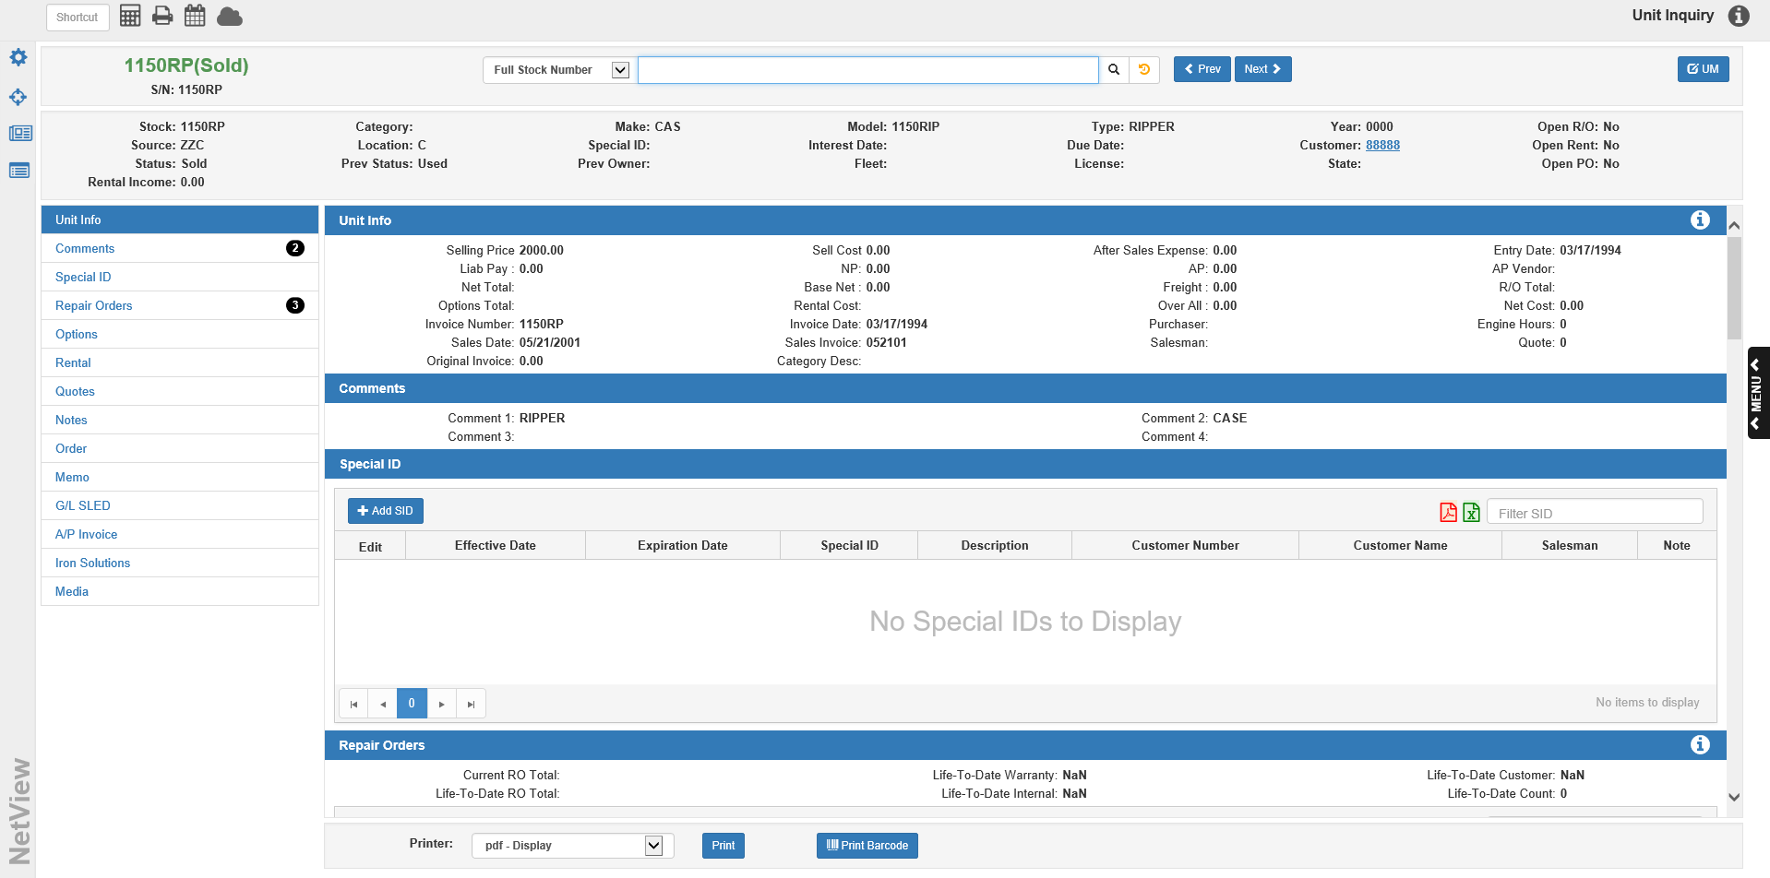

Unit Inquiry displays all the available information about a particular stock number. It accesses any unit, regardless of status, and provides up to the moment figures about its current or past value.

To access this function, you can either:

- Select “Units” from the menu and click “Unit Inquiry.”
- Type “UI” in the Shortcuts Bar.

Search: Use this field at the top of the screen to search for a unit record. When clicked, the field will display the last 5 units viewed in this screen.

Select Search Type: Use this drop-down menu to the left of the Search field to select whether you want to search for the unit by stock number or customer.

Full Stock Number: Choose this option to search for a unit by its full stock number.

Partial Stock Number: Choose this option to search for a unit by part of its stock number. Use this choice if you don’t know the full number.

Search by Customer: If the unit you’re looking for was sold to a particular customer and you can’t remember the stock number, use this option to search for the customer by their number or name. You will then be able to look at a full list of units marked in your system as belonging to this customer.

Starting the Search: Click the 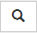 icon to begin your search.

Full Stock Number Search: If you have entered the full stock number, the unit information will automatically populate the screen. However, if there is no unit with that stock number, the application will ask if you want to use it for a partial search. Click the words “partial search” to initiate the new search

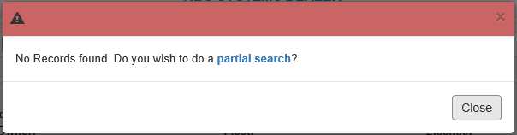

Partial Stock Number Search: For the partial search, the search results will appear in a separate window.

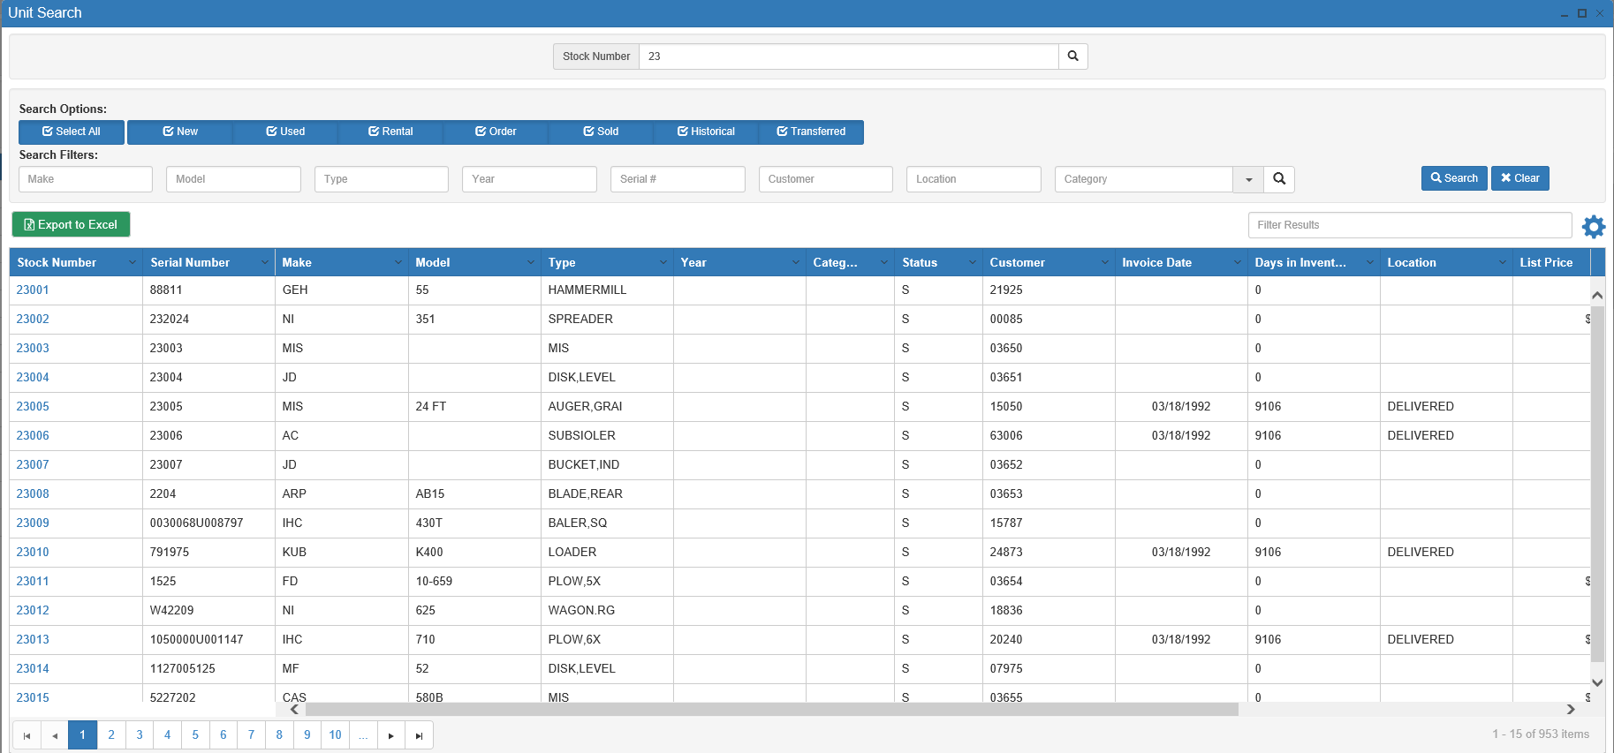

Locate the unit you want and click on it to open the record.

Search Options: If you want to look for a unit with a particular status, use these search options to select what status(es) you want to look for. You can choose up to all available statuses. The options are:

- Select All (auto-selects all 7 statuses)
- New
- Used
- Rental
- Order
- Sold
- Historical
- Transferred

Search Filters: The search filters let you enter further unit specifications to narrow down your search. You can enter a search filter in up to all eight fields. These fields are different from the Filter Results field in that they let you filter your results before you make the search, while the Filter Results field only works once you’ve generated search results. The fields let you filter for the following information:

- Make
- Model
- Type
- Year
- Serial Number
- Customer
- Location
- Category

Sort Features: These features attached to the results listing grid let you sort through your results to find the entry you want.

Page Numbers: Use the page numbers at the bottom of the window to jump between pages.

Sortable Headers : Click on the arrow on the right side of the column headers to view further sort options.

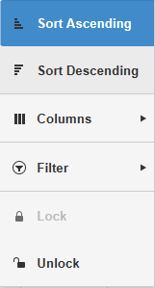

- Sort Ascending: Click this option to sort the results in ascending order by the column’s content. For example, if you click “Sort Ascending” under the Stock Number header, then the results will sort in ascending order by stock number. You can also perform this sort by clicking the column header once.
- Sort Descending: Click this option to sort the results in descending order by the column’s content. For example, if you click “Sort Descending” under the Stock Number header, then the results will sort in descending order by stock number. You can also perform this sort by clicking the column header.
  - Click the header twice from when the search window first opens or if the results have been sorted by a different column.
  - Click the header once if the results are already sorted in ascending order by that column’s content.
- Columns: Use this checklist to determine which columns you want to view.
  - Removing the check from a box will automatically remove the column from the results grid.
  - Checking an empty box will automatically add the column to the grid.
- Filter: This option allows you to filter your search results in greater detail using the data in that specific column. Use the drop-down menus to set how you want the results to filter.
- Lock: Clicking “Lock” fixes the column in its location. NOTE: This feature does not appear for all columns.
- Unlock: Clicking “Unlock” allows you to switch the column’s position in the grid order. NOTE: This feature does not appear for all columns.

Filter Bar: Use the Filter Bar in the upper right-hand corner to further narrow down the results. Type in further search criteria, and the results will update to reflect it.

Export to Excel: Click this button to export the search results into Microsoft Excel.

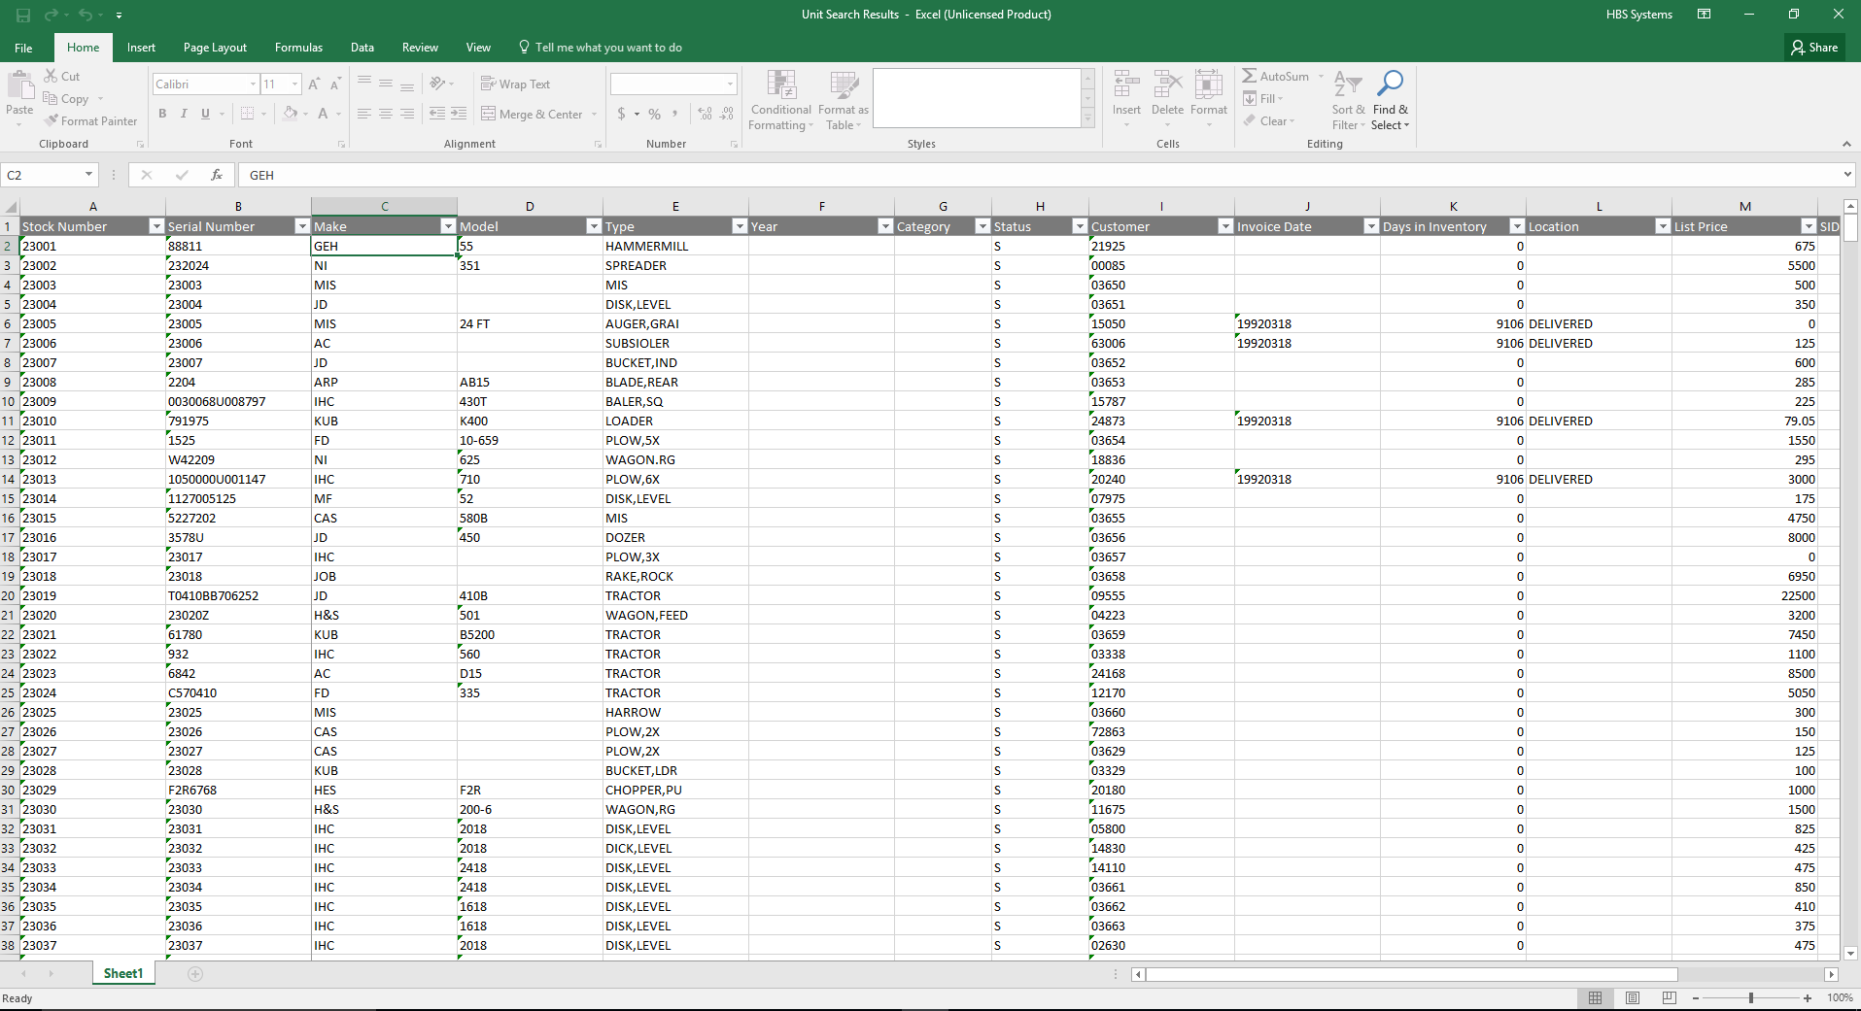

Search By Customer: If you search by customer number or name instead of by stock number, the Customer Search window will initially open.

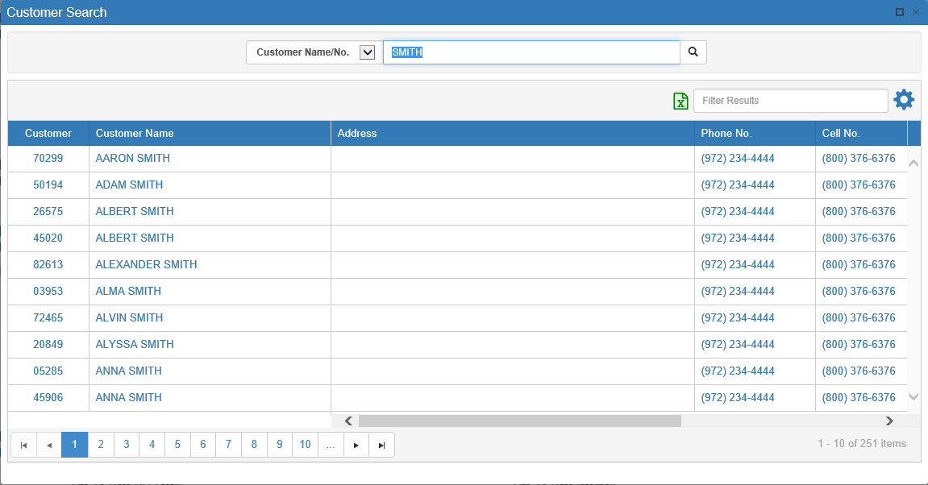

Locate the customer who owns the unit you wish to examine.

Once you click on the customer entry, the program will open the Unit Search window. The results, however, will consist only of units belonging to that particular customer.

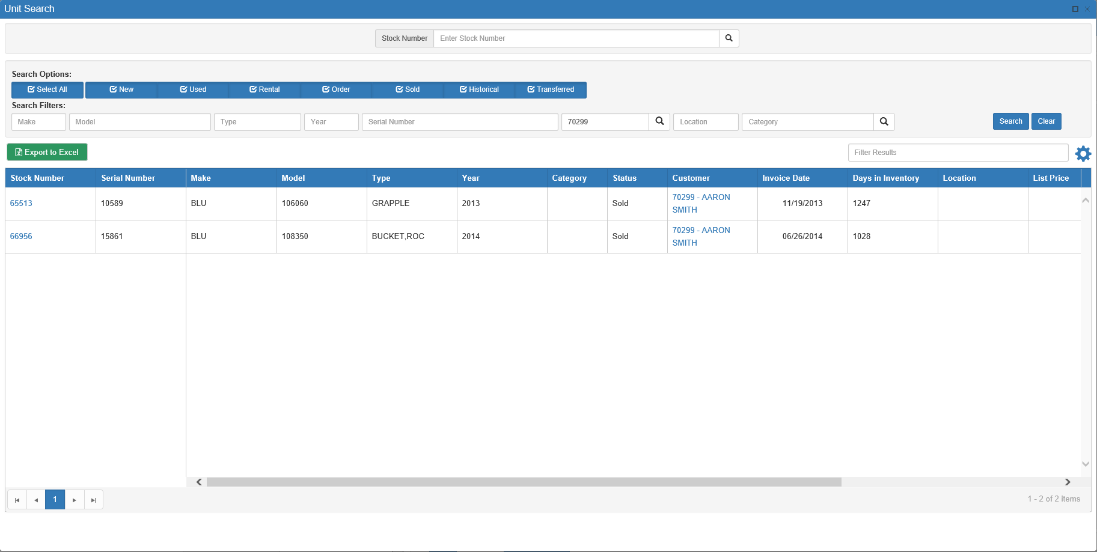

Locate the unit you want and click on it to open the record.

Search Recall: This button 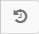 appears next to the Search button. After you have made a search and selected a unit, the button will turn gold 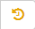. Clicking it will re-open the search window and display the results of your last search, allowing you to pick up exactly where you left off before selecting a record.

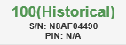

Stock Number Display: After you have selected a unit, the unit’s stock number will appear to the left of the Stock Number Search fields, along with the following information:

- The unit’s current status
- The unit’s serial number
- The unit’s pin number (if applicable—not all units will have one)
- How many days the unit has been in inventory, if applicable (view by hovering cursor over display)

Base Unit Info: The unit record’s grey header holds the basic unit information. See “Focus Basic Unit Info” for a list of additional field options that can show here.

Stock: This field shows the unit’s stock number again.

Source: The source number ties the stock number to the General Ledger accounts used for purchase and sales transactions.

Status: This field holds the current status of the unit. The choices are:

- New: This status is for new units in inventory.
- Used: This status identifies used units in inventory. You might use this status when purchasing a used unit or when you take a trade-in from a customer.
- Rental: This status identifies the units used for rental or part of a rental fleet. It is used by the Rental system.
- Order: This status identifies units on order, but not yet received.
- Sold: This status identifies sold units.
- Historical: This status is used for records entered to provide information about the customer’s equipment.

Transferred: This status identifies the units you have transferred out of the dealership to other dealers.

Category: This field shows the unit’s category. Categories are user-created labels that can help classify groups of units outside of the standard make/model/type identifiers. For example, a “Service” category could contain all units currently undergoing repairs.

Location: The location field can hold the physical location of the unit (i.e. back lot, side yard, front field, showroom). In a multi-store environment, it can provide the branch location of the unit. Units on order show ON ORDER in this field.

Previous Status: This field shows what the previous status of the unit was. For example, if the unit’s status is “Sold,” you might see “New” or “Used” in this field.

Make: This 3-character field holds the manufacturer or “make” of the unit.

Special ID: This field is user-defined and can be used to tag the unit with a secondary status. It is just a note, and can be removed from a unit at will. You may define any letter or number as a Special ID.

Previous Owner: This field identifies the company or person who previously owned the equipment if it was “used.”

It can show a manufacturer’s name or a customer name.

Some dealers reference the manufacturer or supplier name here for new equipment.

When trade-ins are entered, the previous owner’s name is automatically placed here.

Model: This field holds the equipment’s model number.

Interest Date: This field shows the date on which interest will start charging on the unit if it has not been paid off by then.

Fleet: This field can be used on a customer’s unit to hold the fleet number or the customer’s number for that unit.

Type: The Type field tells you about the piece of equipment: Tractor, Snowplow, Mower, Chainsaw, etc.

Due Date: This field holds the due date for the unit’s invoice, which is the date that the invoice needs to be fully paid-off. This is related to, but not necessarily the same as, the interest date.

License: If the unit has a license plate, that number can be entered here.

Year: This field holds the 4-digit model year of the unit.

Customer: When the unit is sold or transferred, the system records the number of the purchaser or customer in this field. The number should be blue. Clicking it will open the customer’s NetView Insight page (see the “NetView Insight Detail” topic page for more information).

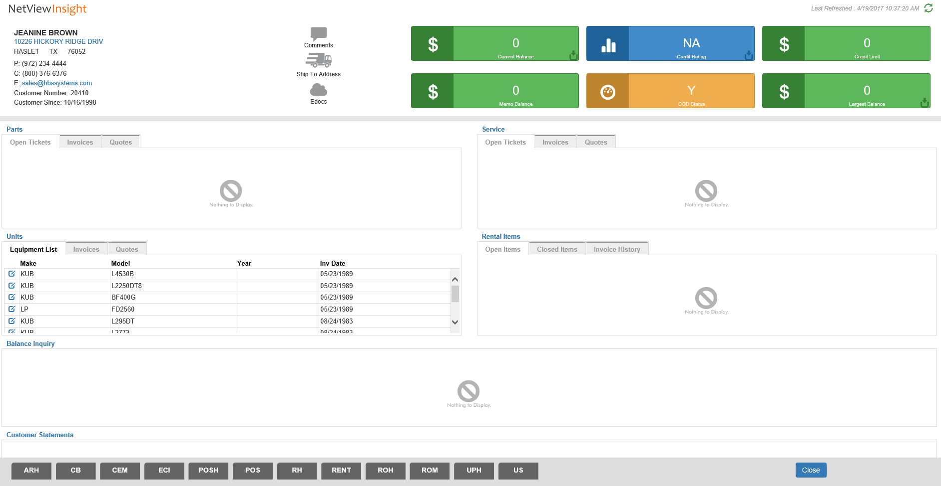

State: If the unit has a license plate, the state of that number can be entered here.

Open R/O: This field indicates if there is currently an open repair order on this unit.

Open Rental: This field indicates if there is currently an open rental contract on this unit (Rental Package ONLY).

Open PO: This field indicates if there is currently an open purchase order on this unit (Purchase Order Package ONLY).

Other Buttons:

Previous/Next: When you use the partial search to look up a record, these two buttons will become active. They allow you to move between the records contained in your results list.

- Click Previous to go to the record listed before the one currently on the screen.
- Click Next to go to the next record in the list.

UM: Click this button to edit the unit’s information in Unit Maintenance (UM). See the “Unit Maintenance (UM)” topic page for more information.

Save Configuration/Restore Search: Click the  icon on the left-hand side of the screen to access the option to either save the current search configuration or reset the search to its default settings.

Focus Base Part Info: Click the icon on the left-hand side of the screen to select additional information fields for the Base Unit Info section from the “Choose header fields” window:

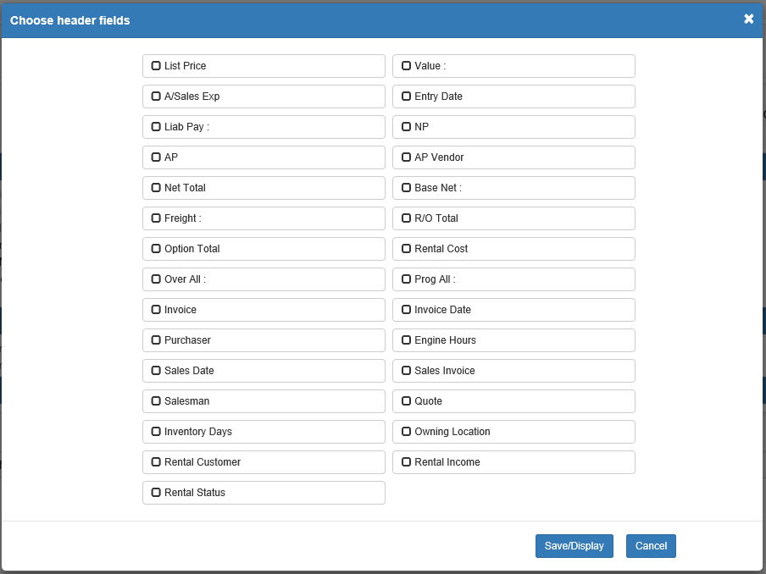

Click an option to select it. Click Save/Display to save your selections, or click Cancel to close the window without saving any selections. Your selections are custom to your specific login, and will always display automatically when you open UI.

You can choose up to 7 additional fields from the options presented, as listed below:

List Price: While the unit is in inventory, this is your suggested selling price for it. Once a unit is sold, the field name changes to Sell Price and records the actual selling price of the unit.

A/Sales Exp: This is an accumulation of expenses/costs for this stock number after it has been sold. All internal repair orders add to this field after the unit is sold. It can include the following:

Amounts from POS or ROM

Options amounts from Transfers & Adjustments (ETA)

Invoices from A/P

Liab Pay: Here you see the amount owed or the liability for this unit. It represents the total amount owed and could be:

The amount owed on a note (floorplan)

The amount owed in Accounts Payable

A combination of both

AP: This field the amount owed for this unit in Accounts Payable.

Net Total: This field provides the total cost of the inventory unit. Typically, it includes the following amounts:

Base Net

Freight

R/O Total

Options Total

Freight: This field can hold the freight charges for the unit.

Option Total: This field totals the amount of options applied to this unit. In the case of an inventory unit, the options are added into the net total. The system automatically updates this field whenever an option is applied to a particular stock number. Options added after the unit is sold will be directed to the A/Sales Exp field.

Over All: Over-allowance is the difference between what you gave the customer on a trade-in and the value you want the unit “on the books.” Unit Sale (US) can place an amount here when the trade is being brought in. If you “over-allowed” for a trade-in, that difference becomes the over-allowance in this field.

Invoice: This is the manufacturer’s invoice number.

Purchaser: This field shows the login of the person who entered the unit into the system.

Sales Date: When the unit is sold, or transferred, the system records that transaction date as the Sales Date.

Salesman: When the unit is sold, or transferred, the system records the salesperson’s number or initials here.

Inventory Days: This field shows how many days the unit has been in inventory.

Rental Customer: If the unit is out on rental, this field shows the name of the renting customer.

Rental Status: This field shows the unit’s rental status (On Rent, Available, Off Rent, etc.).

Low Take/Value/Sell Cost: This field is a free-form field that can show alternate pricing information for the unit.

If it reads Low Take, then it shows an alternate selling price while the unit is in inventory.

If it reads Value, then it shows the replacement cost of a rental unit.

When the unit is sold, the field name will always change to Sell Cost and hold the cost of the unit when it was sold. This value combined with the after-sales expense provides the cost of the sold unit.

Entry Date: This field shows the actual date the unit was added to the system.

NP: This field the amount owed for this unit on Notes Payable.

AP Vendor: If there is an Accounts Payable amount owed, this field will show the vendor number associated with that amount.

Base Net: This is the base cost or the original invoice cost of the unit itself, excluding the following:

Options

Freight

Repair orders

R/O Total: This field totals the amount of repair orders applied to this unit. In the case of an inventory unit, the repairs are added into the net total. The system automatically updates this field whenever a repair order is applied to a particular stock number. When a unit is sold, this field accumulates the amount for internal repair orders attached after the unit was sold.

Rental Cost: If you have set up a cost percentage for this rental unit, the system records the cost amount in this field (Rental Package ONLY).

Prog All: This field can hold the amount of program allowance or incentive discount for the unit. It is a reference field only, and is not used in the calculation of either the cost or selling price.

Invoice Date: This field goes hand–in-hand with the Invoice field. It holds the date for the invoice.

Engine Hours: Here you will find the number of engine hours that the equipment has accumulated. This field is updated from POS and ROM when current hours on the unit are entered.

Sales Invoice: This field holds the invoice number when a unit is sold or transferred.

Quote: If the unit is currently on a quote, the assigned number will be displayed here.

Owning Location: If the unit’s status is Rental, this field shows a number designation for the dealership location that owns the unit. Note: This applies to single-location dealerships as well as multi-location.

Rental Income: This field shows the cumulative total of rental income for this unit since it was added to the rental fleet.

Unit Summary: Click the icon on the left-hand side of the screen to view a brief snapshot of the unit’s financial information:

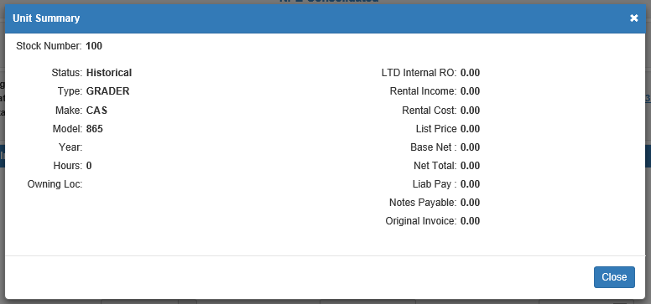

Inspections: The icon on the left-hand side of the screen links to the Record360 login page. You can enter your Record360 credentials in order to then view the unit’s inspections information on Record360’s site.

Print Barcode: Click this button next to the print options at the bottom of the screen to print a bar code label for the unit.

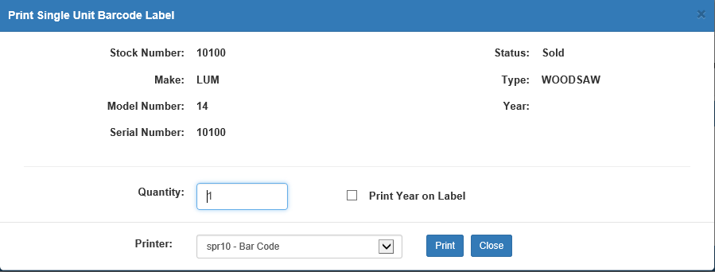

- Enter the quantity.
- Choose whether or not to print the year on the label.
- Select the printer name.
- Click Print to receive the label(s).

Sidebar Shortcuts: On the left side of the screen is a list of the different tabs that comprise a Unit Master record. Click on any tab name to jump to that section of the entry.

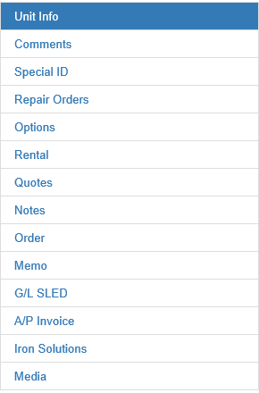

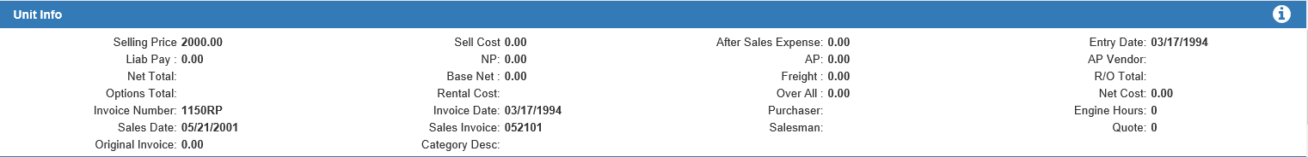

Unit Info Tab:

Hide/Reveal Values: If you have the required setting(s) turned on in Unit Defaults (WGDF), certain dollar amount fields in this section of the screen will automatically hide their values. To view those hidden values, click the white “i” icon in the upper right-hand corner of the tab. Note: if you have not set any available field in this tab to hide its values, clicking this icon will not affect the tab display.

List Price: While the unit is in inventory, this is your suggested selling price for it. Once a unit is sold, the field name changes to Sell Price and records the actual selling price of the unit.

Low Take/Value/Sell Cost: This field is a free-form field that can show alternate pricing information for the unit.

If it reads Low Take, then it shows an alternate selling price while the unit is in inventory.

If it reads Value, then it shows the replacement cost of a rental unit.

When the unit is sold, the field name will always change to Sell Cost and hold the cost of the unit when it was sold. This value combined with the after-sales expense provides the cost of the sold unit.

After Sales Expense: This is an accumulation of expenses/costs for this stock number after it has been sold. All internal repair orders add to this field after the unit is sold. It can include the following:

Amounts from POS or ROM

Options amounts from Transfers & Adjustments (ETA)

Invoices from A/P

Entry Date: This field shows the actual date the unit was added to the system.

Liab Pay: Here you see the amount owed or the liability for this unit. It represents the total amount owed and could be:

The amount owed on a note (floorplan)

The amount owed in Accounts Payable

A combination of both

NP: This field the amount owed for this unit on Notes Payable.

AP: This field the amount owed for this unit in Accounts Payable.

AP Vendor: If there is an Accounts Payable amount owed, this field will show the vendor number associated with that amount.

Net Total: This field provides the total cost of the inventory unit. Typically, it includes the following amounts:

Base Net

Freight

R/O Total

Options Total

Base Net: This is the base cost or the original invoice cost of the unit itself, excluding the following:

Options

Freight

Repair orders

Freight: This field can hold the freight charges for the unit.

R/O Total: This field totals the amount of repair orders applied to this unit. In the case of an inventory unit, the repairs are added into the net total. The system automatically updates this field whenever a repair order is applied to a particular stock number. When a unit is sold, this field accumulates the amount for internal repair orders attached after the unit was sold.

Options Total: This field totals the amount of options applied to this unit. In the case of an inventory unit, the options are added into the net total. The system automatically updates this field whenever an option is applied to a particular stock number. Options added after the unit is sold will be directed to the After Sales Expense field.

Rental Cost: If you have set up a cost percentage for this rental unit, the system records the cost amount in this field (Rental Package ONLY).

Over All: Over-allowance is the difference between what you gave the customer on a trade-in and the value you want the unit “on the books.” Unit Sale (US) can place an amount here when the trade is being brought in. If you “over-allowed” for a trade-in, that difference becomes the over-allowance in this field.

Prog All: This field can hold the amount of program allowance or incentive discount for the unit. It is a reference field only, and is not used in the calculation of either the cost or selling price.

Invoice: This is the manufacturer’s invoice number.

Invoice Date: This field goes hand–in-hand with the invoice number field. It holds the date for the invoice.

Purchaser: This field shows the login of the person who entered the unit into the system.

Engine Hours: Here you will find the number of engine hours that the equipment has accumulated. This field is updated from POS and ROM when current hours on the unit are entered.

Sales Date: When the unit is sold or transferred, the system records that transaction date as the Sales Date.

Sales Invoice: This field holds the invoice number when a unit is sold or transferred.

Salesman: When the unit is sold, or transferred, the system records the salesperson’s number or initials here.

Quote: If the unit is currently on a quote, the assigned number will be displayed here.

Original Invoice: This field shows the unit’s original invoice cost, if applicable.

Category: This field shows the unit’s category. Categories are user-created labels, and can be used to more easily identify groups of units for dealership purposes. For example, you could mark all units available for rent as belonging to a “Rental” category, or all units currently undergoing repairs as “Internal Service.” The category thus provides an identification tag which can indicate a commonality between units that may not be conveyed by their make, model, or type.

Comments Tab:

Comment 1 – 4: These 4 freeform comment lines are used for additional information about the stock number. They can be used for additional descriptions, details of programs/incentives discounts, additional serial numbers, etc.

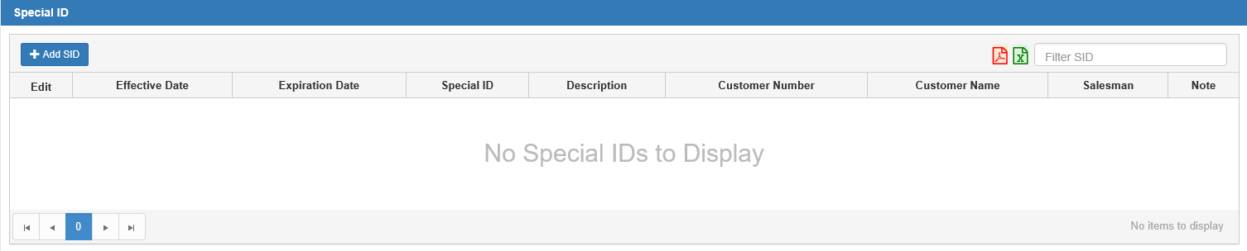

Special ID (SID) Tab:

Add SID: Click this button to add a Special ID. The window below will appear:

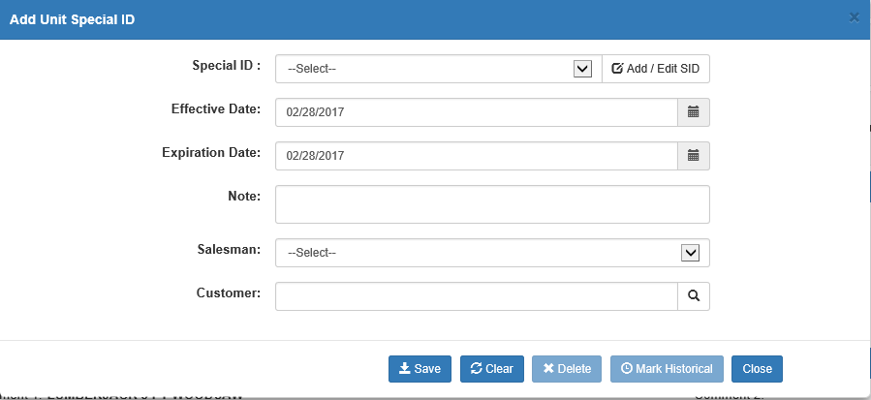

Special ID: Choose the desired Special ID from the drop-down menu.

Add/Edit SID: Click this button to add or edit a Special ID. NOTE: There can only be 35 SIDs in the system at a time.

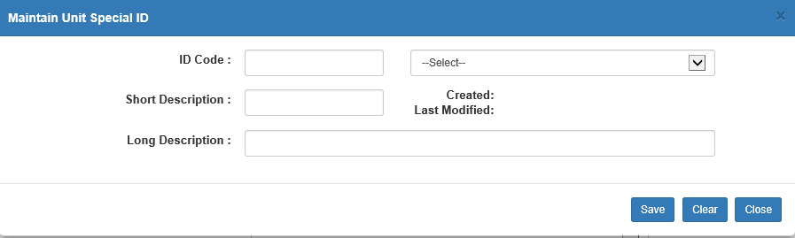

- ID code: Fill in the new ID code or select a preexisting one from the drop-down menu.
- Short Description: Enter a brief description of the SID here.
- Created: This field will show the date the SID was created.
- Last Modified: This field will show the date the SID was last modified by a user.
- Long Description: Enter a detailed description in the place provided.
- Save/Clear/Close
  - Click Save to save the ID code.
  - Click Clear to clear all information from the fields.
  - Click Close to return to the main screen.

Effective Date: Fill in the effective date or choose it from a calendar.

Expiration Date: Fill in the expiration date or choose it from a calendar.

Notes: Fill in any details for the reason you are adding the Special ID to this unit.

Salesman: Choose the Salesman ID or initials from the drop-down menu.

Customer: Fill in the customer number or look it up. This is not a required field.

Save: Click on Save to add the Special ID to this unit.

Clear: Click on Clear to clear the fields of information.

Close: Click Close to close the window and return to the main UI screen.

Export to PDF: Click this red icon to export your list of Special IDs to a PDF file.

Export to Excel: Click this green icon to export your list of Special IDs to a Microsoft Excel spreadsheet.

Sorting Special IDs: Use the following features to look through and reorder your Special ID list.

Filter SID: Filter your SIDs by entering the filtering information in this field. For example, if you type in “2,” only SID entries containing the number 2 in one of their columns will appear.

Page Numbers: Use the page number buttons to switch between pages of SIDs, provided you have enough SIDs to take up more than one page of results.

Sortable Headers: Aside from the Edit column, you can use the column headers to reorder your SID list. Click the header to sort the results based on that column’s contents, and click it a second time to perform a reverse-sort of the results by the column contents. For example, clicking the Effective Date header will reorder the results in chronological order by Effective Date. Clicking the header a second time will reorder the results in reverse-chronological order by Effective Date.

SID Columns: The SID tab’s grid view organizes the Special IDs into an easily-understood listing, with the columns separating out important information about each ID.

Edit: To edit an SID on the list, click the blue icon in the Edit column. The following window will open:

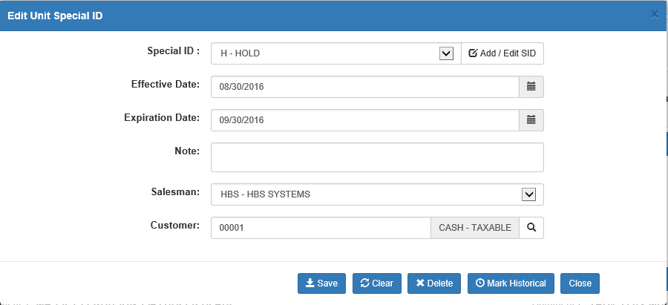

- Special ID: This field holds the Special ID. To edit a preexisting code, you can either enter it or select it from the drop-down menu to the right of the field.
- Add/Edit SID: Click this button to add or edit a Special ID. The window detailed under the Add SID section will appear. Make your changes and save them.
- Effective Date: This field shows the SID’s effective date. You can manually edit this field or select a new date from the calendar.
- Expiration Date: This field shows the SID’s expiration date. You can manually edit this field or select a new date from the calendar.
- Notes: This field shows any notes made on this SID. Add or edit the notes as desired.
- Salesman: Change the Salesman ID or initials by choosing a new ID from the drop-down menu.
- Customer: This field shows the customer number. This is not a required field. You can edit it manually or use the search feature to find a new customer number.
- Save: Click this button to add the Special ID to this unit.
- Clear: Click this button to clear the fields of information.
- Delete: Click this button to delete the Special ID. The Delete capability is tied to a setting on each user’s login, and must be turned on in order to activate this button. This button is also only active in the “Edit” version of this window.
- Mark Historical: An SID entry can be marked as Historical while its dates are still active, at which point this button will be active. As long as any entry or entries are in force based on the effective and expiration dates, that SID will show in UI. This button is only active in the “Edit” version of this window.
- Close: Click this button to close the window and return to the main UI screen.

Effective Date: This column holds the SID’s effective date.

Expiration Date: This column holds the SID’s expiration date.

Special ID: The actual Special ID shows in this column. It is user-defined and can be used to tag the unit with a secondary status. You may define any letter or number as a Special ID.

Description: This column holds the Special ID’s short description, as recorded in the system.

Customer Number: This column holds the customer number connected with this specific Special ID on this particular unit.

Customer Name: This column shows the name of the customer whose number appears in the Customer Number column.

Salesman: This column shows the Salesman ID connected with this specific Special ID on this particular unit.

Note: This column shows any notes entered for this Special ID on this unit.

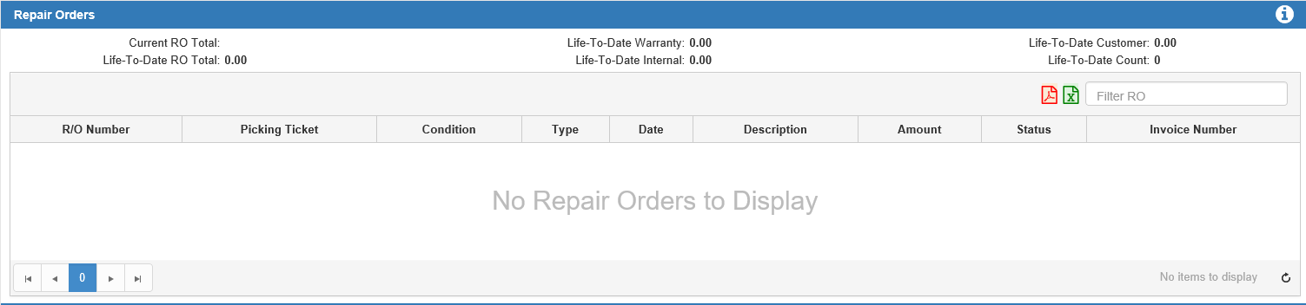

Repair Orders Tab:

Hide/Reveal Values: If you have the required setting(s) turned on in Unit Defaults (WGDF), certain dollar amount fields in this section of the screen will automatically hide their values. To view those hidden values, click the white “i” icon in the upper right-hand corner of the tab. Note: if you have not set any available field in this tab to hide its values, clicking this icon will not affect the tab display.

Current RO Total: This field shows the total amount of all current repair orders on this unit.

Life-To-Date RO Total: This field shows the lifetime-to-date total for all repair orders posted to the unit. This includes the following RO types:

Customer

Internal

Warranty

Life-To-Date Internal: This field shows the lifetime-to-date total for Internal repair orders posted to the unit.

Life-To-Date Warranty: This field shows the lifetime-to-date total for Warranty repair orders posted to the unit.

Life-To-Date Customer: This field shows the lifetime-to-date total for customer-paid repair orders posted to the unit.

Life-To-Date Count: This field shows the lifetime-to-date count for all closed repair orders. Note: once an RO is classified as historical it is not included in the count.

Export to PDF: Click this red icon to export your list of repair orders to a PDF file.

Export to Excel: Click this green icon to export your list of repair orders to a Microsoft Excel spreadsheet.

Sorting Repair Orders: Use the following features to look through and reorder your repair order list.

Filter RO: Filter your ROs by entering the filtering information in this field. For example, if you type in “2,” only RO entries containing the number 2 in one of their columns will appear.

Page Numbers: Use the page number buttons to switch between pages of ROs, provided you have enough ROs to take up more than one page of results.

Sortable Headers: You can use the column headers to reorder your RO list. Click the header to sort the results based on that column’s contents, and click it a second time to perform a reverse-sort of the results by the column contents. For example, clicking the Date header will reorder the results in chronological order by the dates in the column. Clicking the header a second time will reorder the results in reverse-chronological order by the dates.

Repair Order Columns: The Repair Order tab’s grid view organizes the ROs into an easily-understood listing, with the columns separating out important information about each RO.

R/O Number: This column stores the RO number(s) attached to the unit shown. If the number is blue, then you can click on it to view or print the repair order.

Picking Ticket: If the repair order was opened in Point-of-Sale (POS), the picking ticket number will appear here in place of an RO number. If the ticket number is blue, then you can click on it to view or print the picking ticket.

Condition: This column shows the condition number for a repair order opened in Repair Order Maintenance (ROM). Repair orders opened in POS do not have condition numbers.

Type: This column displays the type of repair order being shown. The valid types are:

Customer

Internal

Warranty

Date:

- While the repair order is open, the date shown here is the date it was opened.
- When the repair order is closed, it changes to the date the repair order was closed.

Description: This column holds a brief description of the repair order or condition referenced. The description reads from the program where the repair order was opened:

POS

ROM

Amount: This column holds the dollar amount of the repair order or condition when it is closed.

Status: This field shows the status of the repair order or condition shown.

- Warranty Repair Orders: The status of a warranty repair order will be:
  - Open while it is open.
  - Historical when it is closed.
- Customer Repair Orders: The status of a customer repair order will be:
  - Open while it is open.
  - Historical when it is closed.

Internal Repair Orders:
  - When an internal repair is opened on any unit, the status will be:
    - Open while it is open.
    - Closed when it is closed.
  - When a unit that has been in inventory is sold (Sold status and previously New, Used, Rental, or Ordered), the status on all attached and closed repair orders will change to Historical.
  - When a unit is traded in (previous status of Sold or Historical), the status of all attached repair orders that were run after the unit was sold change to Historical.

Invoice Number: When the repair order is closed in POS or ROM, the invoice number is placed here. If the number is blue, then you can click on it to view or print the invoice.

Refresh Repair Order Tab: Click the Refresh button at the bottom right-hand corner of the tab to refresh the Repair Order list. If any new repair orders have been created for this unit since you opened UI, they will be added to the list.

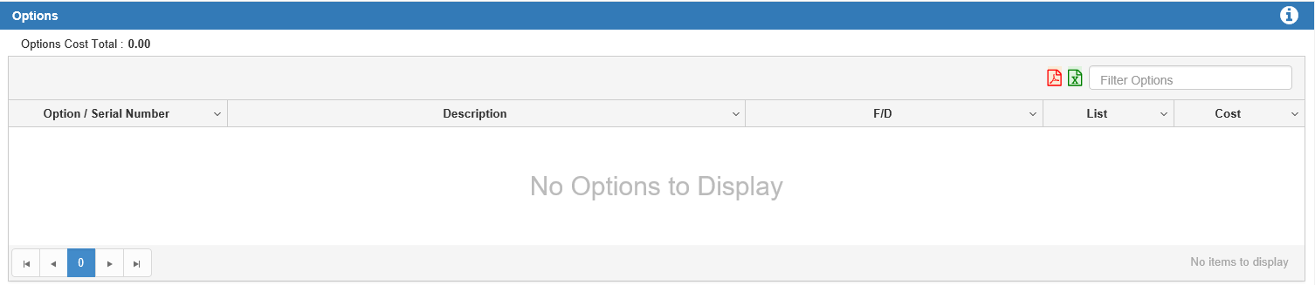

Options Tab:

Hide/Reveal Values: If you have the required setting(s) turned on in Unit Defaults (WGDF), certain dollar amount fields in this section of the screen will automatically hide their values. To view those hidden values, click the white “i” icon in the upper right-hand corner of the tab. Note: if you have not set any available field in this tab to hide its values, clicking this icon will not affect the tab display.

Options Cost Total: This field shows the total cost of all options listed for this unit.

Export to PDF: Click this red icon to export your list of options to a PDF file.

Export to Excel: Click this green icon to export your list of options to a Microsoft Excel spreadsheet.

Sorting Options: Use the following features to look through and reorder your options list.

Filter Options: Filter your options by entering the filtering information in this field. For example, if you type in “2,” only option entries containing the number 2 in one of their columns will appear.

Page Numbers: Use the page number buttons to switch between pages of options, provided you have enough options to take up more than one page of results.

Sortable Headers: You can use the column headers to reorder your options list. Click the header to sort the results based on that column’s contents, and click it a second time to perform a reverse-sort of the results by the column contents. For example, clicking the Description header will reorder the results in alphabetical order by the first letter of the description. Clicking the header a second time will reorder the results in reverse-alphabetical order. You can also click the drop-down arrow on the right side of the header to view further sort-by-header options (see below image).

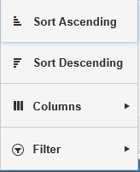

Options Columns: The Options tab’s grid view organizes the options into an easily-understood listing, with the columns separating out important information about each option.

Option/Serial Number: This column holds an option number or serial number for this item. For a unit on order, this field shows ON ORDER until the unit is received. At that point, the field then shows the factory option number or ordered option number. If the number is colored blue, then you can click it to view further details about the option in a new window (see image below).

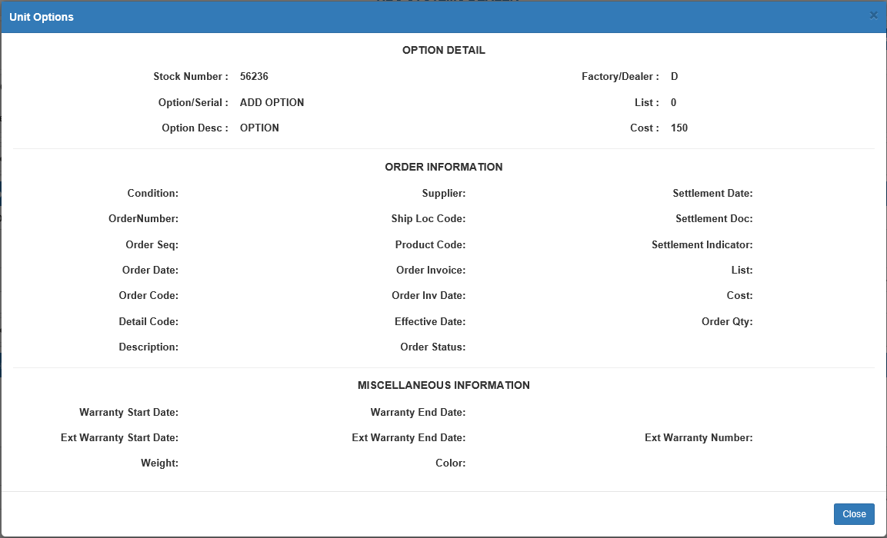

Description: This area provides the details of what the option really is, like the size of the optional tires, the characteristics of the wheel weights, or the dimensions of the attached bucket.

F/D: This flag shows if the option was:

Factory-installed (F)

Dealer-installed (D)

List: This field can hold the selling price of the option. It is a memo-only field and does not add into the values of ANY other field.

Cost: This field can hold the cost of the option. It is a live field, so any value entered here adds to the Option net total of the unit and ultimately becomes part of the cost of the item.

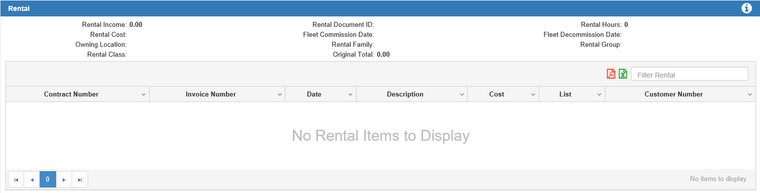

Rental Tab: Note that this tab will only hold data if you have the RENTAL PACKAGE installed.

Hide/Reveal Values: If you have the required setting(s) turned on in Unit Defaults (WGDF), certain dollar amount fields in this section of the screen will automatically hide their values. To view those hidden values, click the white “i” icon in the upper right-hand corner of the tab. Note: if you have not set any available field in this tab to hide its values, clicking this icon will not affect the tab display.

Rental Income: This is the cumulative total of rental income for this unit since it was added to the rental fleet.

Rental Document ID: If the unit is currently listed on an open rental contract, this field shows the contract number.

Rental Hours: This is the cumulative total of rental hours for this unit since it was added to the rental fleet.

Rental Cost: This is the cumulative total of rental cost for this unit since it was added to the rental fleet.

Fleet Commission Date: This is the date the unit was added to the Rental Fleet.

Fleet Decommission Date: This is the date the unit was removed from the Rental Fleet.

Owning Location: This field should show the location that currently owns the unit.

Rental Family: If this unit is part of the Rental Fleet, the field shows the Family it belongs to.

Rental Group: If this unit is part of the Rental Fleet, the field shows the Group it belongs to.

Rental Class: If this unit is part of the Rental Fleet, the field shows the Class it belongs to.

Original Total: This field holds the original Net Total of the unit before it was transferred into Rental.

Export to PDF: Click this red icon to export your list of rentals to a PDF file.

Export to Excel: Click this green icon to export your list of rentals to a Microsoft Excel spreadsheet.

Sorting Rentals: Use the following features to look through and reorder your rentals list.

Filter Rentals: Filter your rentals by entering the filtering information in this field. For example, if you type in “2,” only rental entries containing the number 2 in one of their columns will appear.

Page Numbers: Use the page number buttons to switch between pages of rentals, provided you have enough rentals to take up more than one page of results.

Sortable Headers: You can use the column headers to reorder your rentals list. Click the header to sort the results based on that column’s contents, and click it a second time to perform a reverse-sort of the results by the column contents. For example, clicking the Date header will reorder the results in chronological order by date. Clicking the header a second time will reorder the results in reverse-chronological order. You can also click the drop-down arrow on the right side of the header to view further sorting options (see below image).

Rental Columns: The Rental tab’s grid view organizes the rentals into an easily-understood listing, with the columns separating out important information about each rental.

Contract Number: This column holds the rental contract number(s).

Invoice Number: Here you will see the individual invoice numbers for rental activity. If “CNTRCT” (Contract) displays in this field, this line entry is the original contract entry. It is possible to have closed rental invoices and an open contract line.

Date: This is the date of the Rental activity in the system.

Description: This column’s data is updated through the Rental program. It describes the following:

Type of rental

Duration of rental

Whether the rental rate is based upon Real or Metered time.

Cost: If you have set up a “cost” percentage for this rental unit, the system records the cost amount in this field.

List: This field shows the amount or selling price of the rental transaction.

Customer Number: This field shows the renting customer number listed on the rental contract.

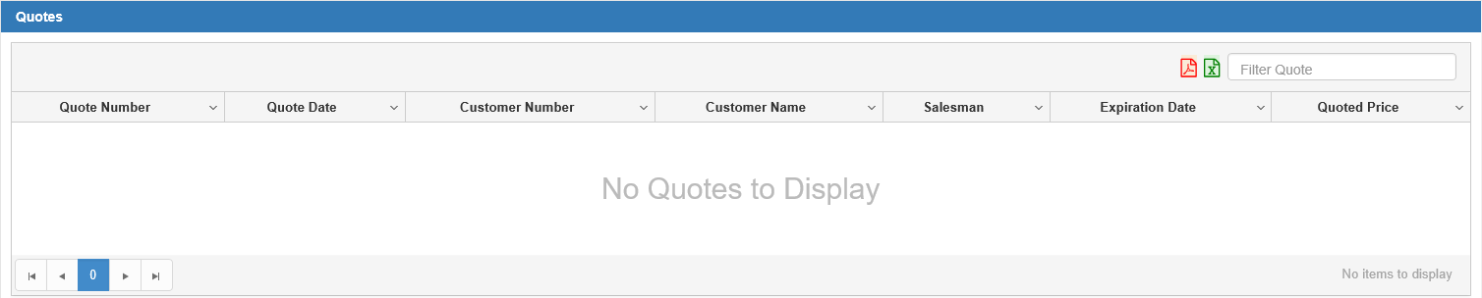

Quotes Tab:

Export to PDF: Click this red icon to export your list of quotes to a PDF file.

Export to Excel: Click this green icon to export your list of quotes to a Microsoft Excel spreadsheet.

Sorting Quotes: Use the following features to look through and reorder your quotes list.

Filter Quotes: Filter your quotes by entering the filtering information in this field. For example, if you type in “2,” only quote entries containing the number 2 in one of their columns will appear.

Page Numbers: Use the page number buttons to switch between pages of quotes, provided you have enough quotes to take up more than one page of results.

Sortable Headers: You can use the column headers to reorder your quotes list. Click the header to sort the results based on that column’s contents, and click it a second time to perform a reverse-sort of the results by the column contents. For example, clicking the Expiration Date header will reorder the results in chronological order by expiration date. Clicking the header a second time will reorder the results in reverse-chronological order. You can also click the drop-down arrow on the right side of the header to view further sort-by-header options (see below image).

Quote Columns: The Quote tab’s grid view organizes the quotes into an easily-understood listing, with the columns separating out important information about each quote.

Quote Number: The quote number shows in this column.

Quote Date: This column shows the date the quote was made.

Customer Number: This column shows the number of the customer who received the quote.

Customer Name: This column shows the name assigned to the customer number.

Salesman: This column shows the ID of the salesperson who made the quote.

Expiration Date: This column shows the quote’s expiration date.

Quoted Price: This is the unit’s price as listed on the quote.

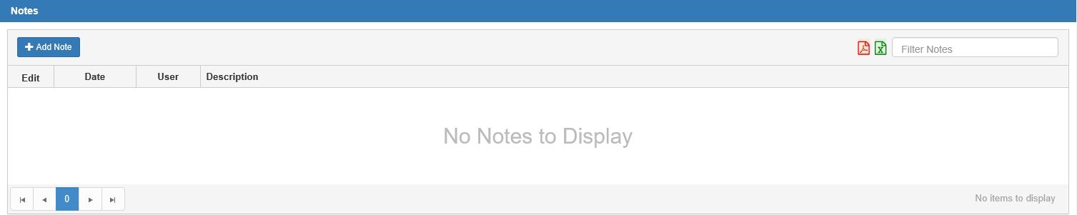

Notes Tab:

Add Note: Click this button to add a note to the unit. The following window will open:

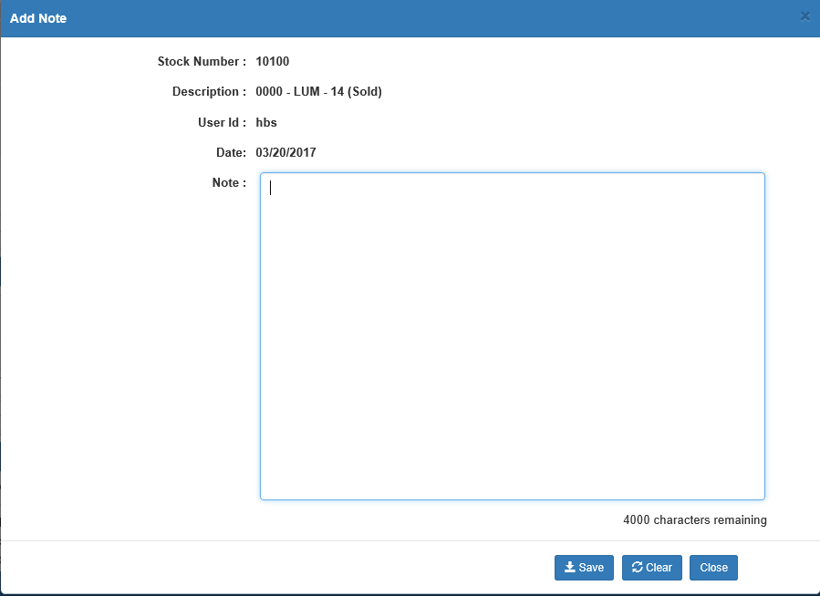

Stock Number: The unit’s stock number shows here.

Description: The unit’s description here can include the following information about the unit:

- Make
- Model
- Year
- Status

User Id: This is the NetView ID for the user creating the note.

Date: This shows the current date, as you are adding a new note.

Note: Enter the desired note in this field. The script below the bottom right-hand corner of the field indicates how many characters you have remaining. The maximum character limit for a note is 4,000.

Save: Click this button to save the note.

Clear: Click this button to clear the note field.

Close: Click this button to close the window and return to the main screen.

Export to PDF: Click this red icon to export your notes to a PDF file.

Export to Excel: Click this green icon to export your notes to a Microsoft Excel spreadsheet.

Sorting Notes: Use the following features to look through and reorder your notes.

Filter Notes: Filter your notes by entering the filtering information in this field. For example, if you type in “2,” only note entries containing the number 2 in one of their columns will appear.

Page Numbers: Use the page number buttons to switch between pages of notes, provided you have enough notes to take up more than one page of results.

Sortable Headers: You can use the column headers to reorder your notes. Click the header to sort the results based on that column’s contents, and click it a second time to perform a reverse-sort of the results by the column contents. For example, clicking the Date header will reorder the results in chronological order by the date the note was added. Clicking the header a second time will reorder the results in reverse-chronological order.

Note Columns: The Note tab’s grid view organizes the notes into an easily-understood listing, with the columns separating out important information about each note.

Edit: Click on the blue icon in this column to edit the note. The following window will open:

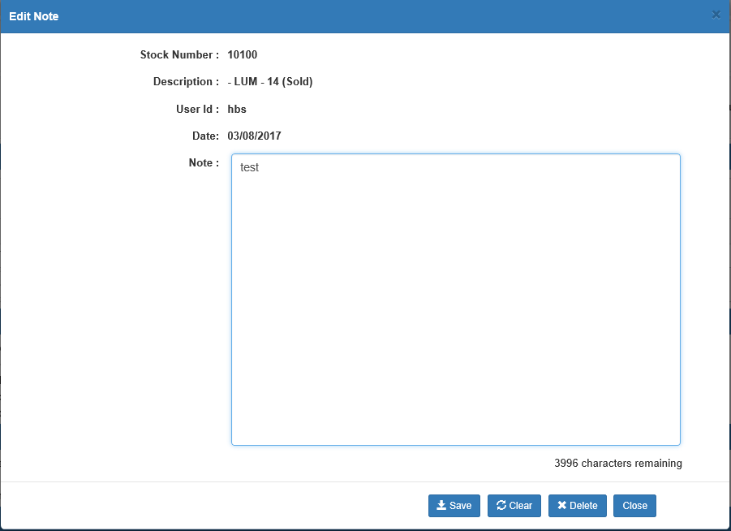

- Change the note as desired, then click Save.
- Click Delete to permanently delete the note.

Date: This column shows the date the note was added to the unit.

User: This column shows the ID of the user who added the note.

Description: This column shows the actual note.

Order Tab:

Condition: This field shows the status of the ordered item:

New

Used

Order Number: This field shows the number of the order for this unit.

Order Sequence Num: This field can optionally show an order sequence number.

Order Date: This field shows the date the unit was ordered.

Order Code: This field shows the order code for John Deere automated orders. It can be used to record other order information for manual orders.

Detail Code: This field shows the detail machine order code for John Deere automated orders. It can record other order information for manual orders.

Order Quantity: This memo field can be used to store the number of units ordered.

Order Status: This memo field can be used to track the status of the order.

Order Invoice: This memo field can hold the order invoice number, if supplied.

Order Invoice Date: This memo field can hold the order invoice date, if supplied.

Supplier: This field shows the supply location for John Deere automated orders. It can record other order information for manual orders.

Ship Location Code: If the order includes a shipping location code, it can be stored in this field.

Product Code: This field shows the product type code for John Deere automated orders. It can record other order information for manual orders.

List: This field shows the list price of the ordered item. The amount entered in this field is for information until the item is received. When the unit is received, the list amount here becomes the list price of the base unit.

Cost: This field shows the order cost (dealer price) for the ordered item. The amount entered in this field is for information until the item is received. When the unit is received, the cost becomes the base net for the unit.

Effective Date: This field shows the date the ordered prices were locked in for John Deere automated orders. It can hold the effective date of the pricing for manual orders.

Description: This field can hold info about the order or the customer who ordered it.

Settlement Date: This field shows the settlement date for John Deere automated orders. We use this field to hold the Due Date/Interest Date for the Floorplan amount.

Settlement Document: This field shows the settlement document number for John Deere automated orders. It can record other order information for manual orders.

Settlement Indicator: This field shows the settlement indicator code for John Deere automated orders. It can record other order information for manual orders.

Memo Tab:

Engine Serial: This field provides the engine serial number.

Transmission Serial: This field provides the transmission serial number.

Cab Serial: This field provides the cab serial number.

Other Serial: This field can store the serial number for any component of the unit.

Color: This field can identify the color of the unit or the equipment color code.

Weight: This field can store the weight of the unit.

Warranty Start: This field can hold the warranty start date.

Warranty End: This field provides a place to enter the warranty expiration date.

Ext Warranty End: This field shows the extended warranty expiration date.

Ext Warranty Code: This field can store an extended warranty type code, if appropriate.

Ext Warranty Number: This field provides a place for an extended warranty contract number.

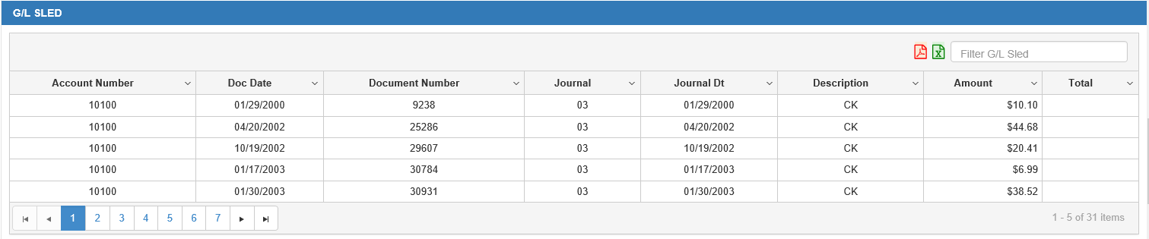

G/L SLED Tab: The G/L SLED tab shows activity for the stock number from the subledgers. The activity shown can be for a unit in inventory as well as historical information for sold units.

Export to PDF: Click this red icon to export the G/L SLED list to a PDF file.

Export to Excel: Click this green icon to export the G/L SLED list to a Microsoft Excel spreadsheet.

Sorting G/L SLED: Use the following features to look through and reorder the G/L SLED list.

Filter G/L SLED: Filter the G/L SLED list by entering the filtering information in this field. For example, if you type in “2,” only entries containing the number 2 in one of their columns will appear.

Page Numbers: Use the page number buttons to switch between the pages of the list, provided you have enough entries to take up more than one page of results.

Sortable Headers: You can use the column headers to reorder the G/L SLED list. Click the header to sort the results based on that column’s contents, and click it a second time to perform a reverse-sort of the results by the column contents. For example, clicking the Doc Date header will reorder the results in chronological order by the document date. Clicking the header a second time will reorder the results in reverse-chronological order. You can also click the drop-down arrow on the right side of the header to view further sort-by-header options (see below image).

G/L SLED Columns: The G/L SLED tab’s grid view organizes the entries into an easily-understood listing, with the columns separating out important information about each entry.

Account Number: This field shows the G/L account number for the activity.

Doc Date: This is the document date of the activity shown.

Document Number: This is the document number used on the transaction shown.

Journal: This is the Journal number for the transaction.

Journal Dt: This is the Journal date for the transaction.

Description: This is the description pulled from the G/L Detail Inquiry file (GLDI).

Amount: This is the amount of the transaction.

Total: This is the running total of the transactions for the G/L account shown. There will only be an entry in this column if the row represents a Total entry.

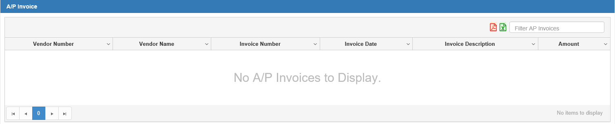

A/P Invoice Tab: This tab shows activity for the stock number selected that originated in A/P.

Export to PDF: Click this red icon to export the invoice list to a PDF file.

Export to Excel: Click this green icon to export the invoice list to a Microsoft Excel spreadsheet.

Sorting A/P Invoices: Use the following features to look through and reorder the invoices.

Filter A/P Invoices: Filter the invoices by entering the filtering information in this field. For example, if you type in “2,” only entries containing the number 2 in one of their columns will appear.

Page Numbers: Use the page number buttons to switch between the pages of invoices, provided you have enough invoices to take up more than one page of results.

Sortable Headers: You can use the column headers to reorder the invoices. Click the header to sort the results based on that column’s contents, and click it a second time to perform a reverse-sort of the results by the column contents. For example, clicking the Invoice Date header will reorder the results in chronological order by the invoice date. Clicking the header a second time will reorder the results in reverse-chronological order. You can also click the drop-down arrow on the right side of the header to view further sort-by-header options (see below image).

A/P Invoice Columns: The A/P Invoice tab’s grid view organizes the entries into an easily-understood listing, with the columns separating out important information about each entry.

Vendor Number: This is the vendor number for this activity

Vendor Name: This is the vendor name for the activity.

Invoice Number: This shows the invoice number for this transaction. If colored blue, you can click the number to display the invoice detail from A/P History (VH).

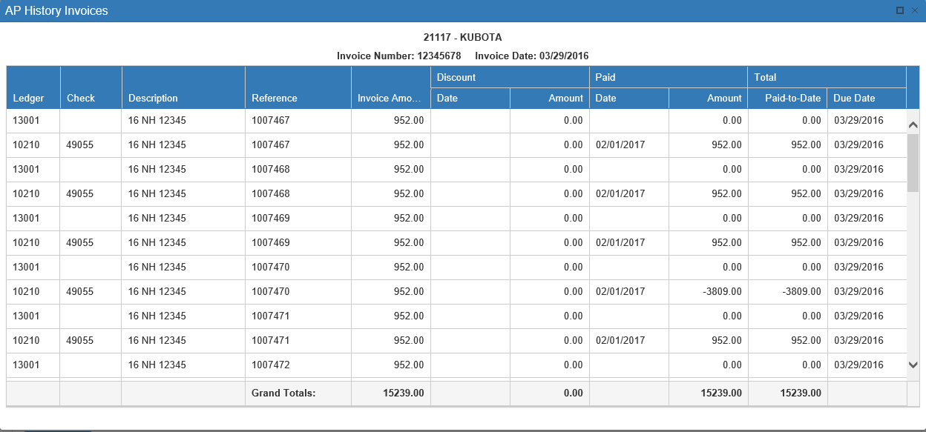

Invoice Date: This is invoice date for this transaction.

Invoice Description: This is the description entered for the transactions.

Amount: This is the amount of the transaction.

Iron Solutions Tab:

Iron Solutions Make: This field shows the make selected in the mapping process.

Iron Solutions Type: This field shows the type selected in the mapping process.

Size Specifications: This field can show more detailed information about the unit’s “size,” and can display up to 2 data sets.

Meter Specifications: This field can show more detailed information about the unit’s “size,” and can display up to 2 data sets.

Unit Condition: This describes the overall condition on a scale of 1-10.

Condition Comments: This shows any additional comments about the unit’s condition.

Publicly Display on Iron Solutions: A note at the bottom of this tab indicates whether or not this unit is publicly displayed on Iron Solutions.

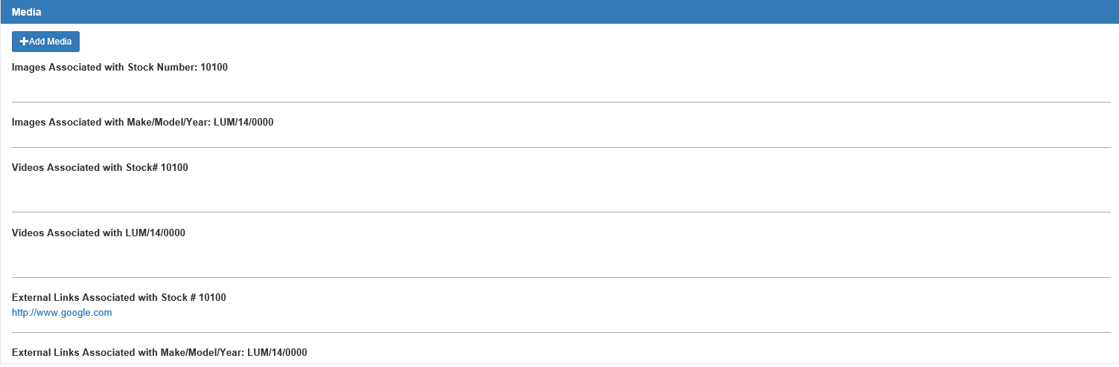

Media Tab: If there are any images, videos, or hyperlinks attached to the stock number, they will show in this tab. NOTE: The system will save any additions or changes made to this tab automatically. You DO NOT have to click the Save button at the bottom of the screen to put any changes into effect.

Add Media: Click this button to attach a new media file to the unit. The following window will open:

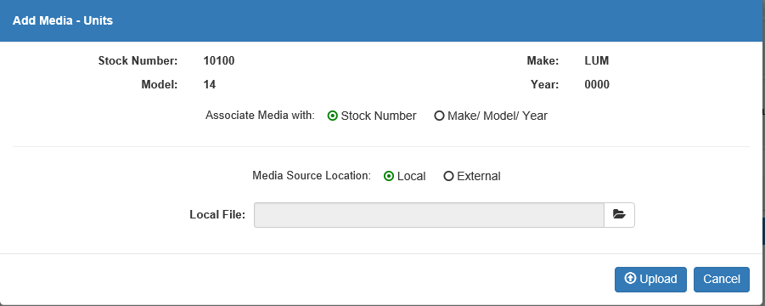

Stock Number: The unit’s stock number shows here

Make: The unit’s make shows here.

Model: The unit’s model shows here.

Year: The unit’s model year shows here.

Associate Media with: Choose what you want to associate the media with:

- The specific stock number
- All units with the same make/model/year as this unit

Media Source Location: Indicate the media’s source location here. It can be:

- Local: Media from a local source would come from a file saved on your computer’s hard drive.
- External: Media from an external source would come from a file or website located through the Internet.

Local File: If you selected Local as your source location, this field will appear.

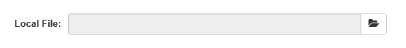

Click the Browse icon on the right side of the field to find the desired media file on your computer.

Url: If you selected External as your source location, this field will appear.

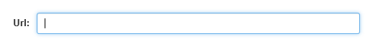

Enter the website address of the desired media (for example, a YouTube video or the main Google page) here.

Upload: Once you have entered your chosen media file, click this button to upload it to NetView Desktop and attach it to the unit record. The file or hyperlink will appear in the Media tab.

Cancel: Click this button to cancel the file upload and return to the main UI screen.

Media Tab Sections: The Media tab display is divided into 6 sections by the type of media uploaded and whether it is attached to the individual stock number or to all units of that particular make/model/year.

Images Associated with Stock Number: [number]: All image files attached to the specific unit’s stock number will appear in this section. Click on an image to view it.

Images Associated with Make/Model/Year: [configuration]: All images files attached to the unit’s make/model/year will appear in this section. Click on an image to view it. Note: all images added to this section will appear in the Media tab for every unit with this make/model/year configuration.

Videos Associated with Stock# [number]: All video files attached to the specific unit’s stock number will appear in this section. Click on a video to play it.

Videos Associated with [Make/Model/Year]: All video files attached to the unit’s make/model/year will appear in this section. Click on a video to play it. Note: all videos added to this section will appear in the Media tab for every unit with this make/model/year configuration.

External Links Associated with Stock # [number]: All external hyperlinks attached to the specific unit’s stock number will appear in this section. Click on a link to open its associated webpage.

External Links Associated with Make/Model/Year: [configuration]: All external hyperlinks attached to the unit’s make/model/year will appear in this section. Click on a link to open its associated webpage. Note: all hyperlinks added to this section will appear in the Media tab for every unit with this make/model/year configuration.

Unit Inquiry Printout: Click on the Print button and generate a report of the details for the selected unit.

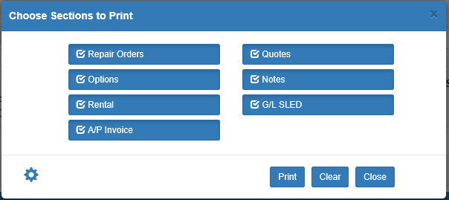

Printable Sections: The Unit Info and Comments sections will always print. You will be prompted to choose which remaining printable sections of the unit record you want on the report. The optionally printable sections are:

- Repair Orders
- Options
- Rental
- A/P Invoice
- Quotes
- Notes
- G/L SLED

Save Configuration: You can save your printing selections or restore the default settings by clicking the Save Configuration icon in the bottom left-hand corner.

Clear: Use this button to deselect all options.

Close: Click this button to cancel the printing process and return to the main UI screen.

Print: Once you have made your selections, click Print to receive your printout.

Sample Printout with G/L SLED

