Print Unit Inventory Barcode Labels (UIBL)

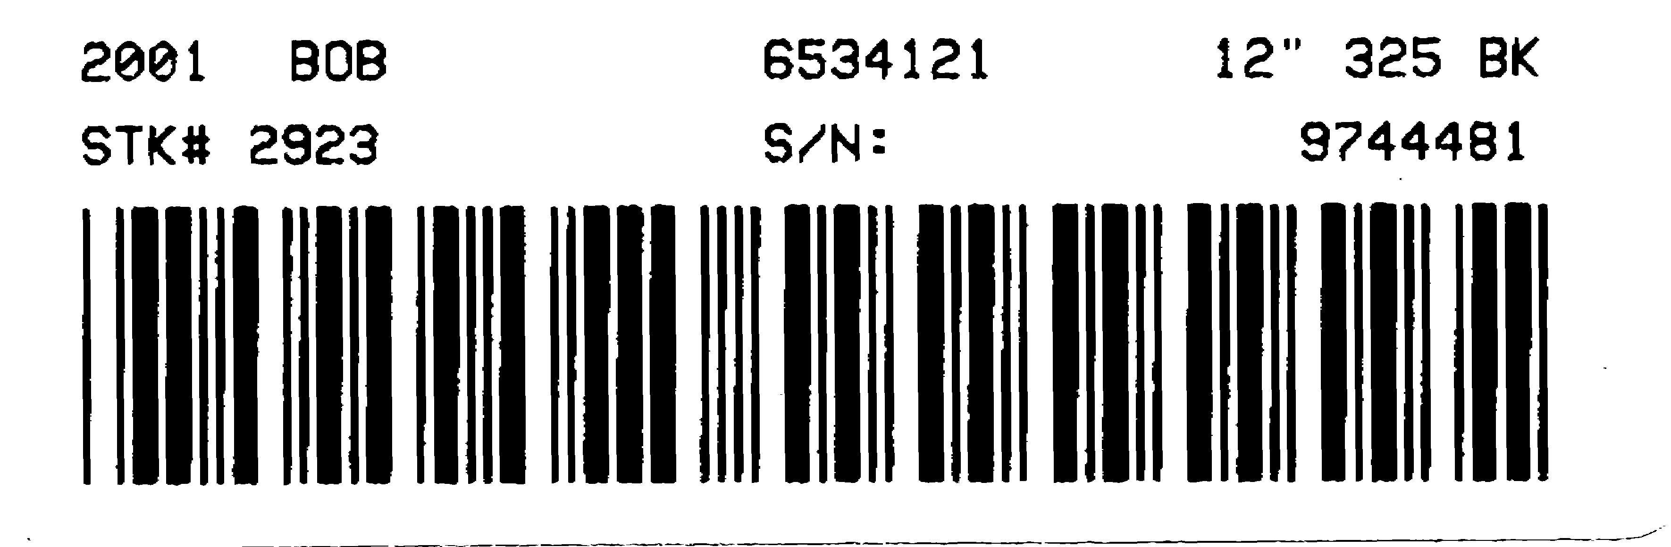Print Units Inventory Barcode Labels (UIBL) lets you print barcode labels for units and record labels for selected units or for all units (use of this function requires a specialty barcode printer). The information on a Units Barcode Label includes the following:

- Model year
- Make
- Model
- Type
- Stock number
- Serial number

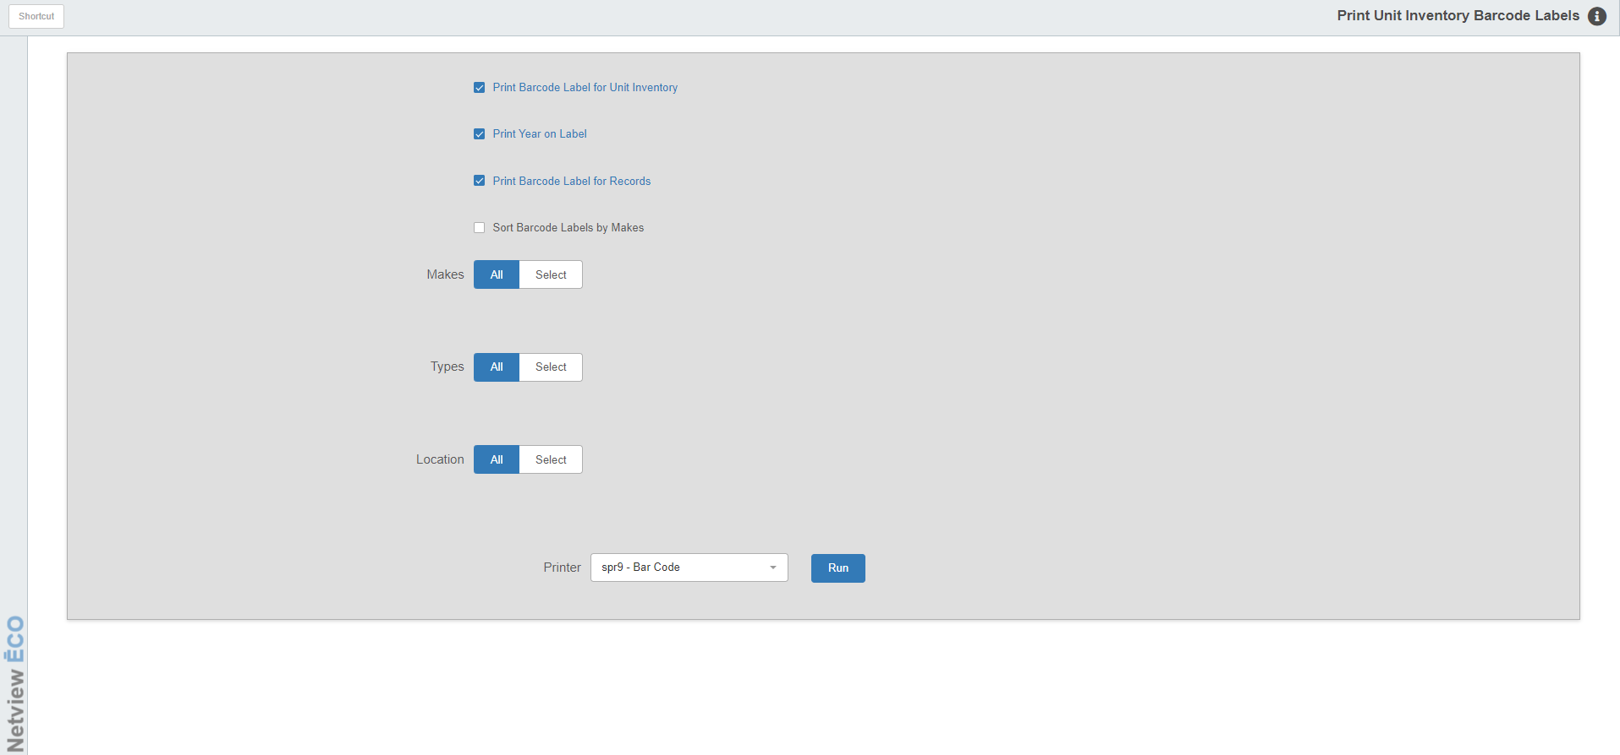

To access this function, you can either:

- Select “Units” from the menu. Choose the “Data Entry” submenu and click “Print Units Inventory Barcode Labels.”

Type “UIBL” in the Shortcuts Bar.

Field Definitions

Print Barcode Label for Unit Inventory: This option lets you print a barcode label for each unit you select on this screen.

Print Year on Label: Click this box if you want the Model Year to print on the label.

Print Barcode Label for Records: Click this box to print an extra label for each unit.

Sort Barcode Labels by Makes:

- Click this box to sort your labels by make/manufacturer.
- If you do not click it, the labels will sort by stock number.

Makes Fields:

- To print labels for all makes of units in your system, choose All.
- If you only want to print labels for specific makes, choose Select and enter up to 10 makes for label generation.

Types Fields:

- To print labels for all types of units in your system, choose All.
- If you only want to print labels for specific types, choose Select and enter up to 10 types for label generation.

Location Fields:

- To print labels for all locations in your system, choose All.
- If you only want to print labels for specific locations, choose Select and enter up to 10 locations for label generation.

