Unit Liability Report (ULR)

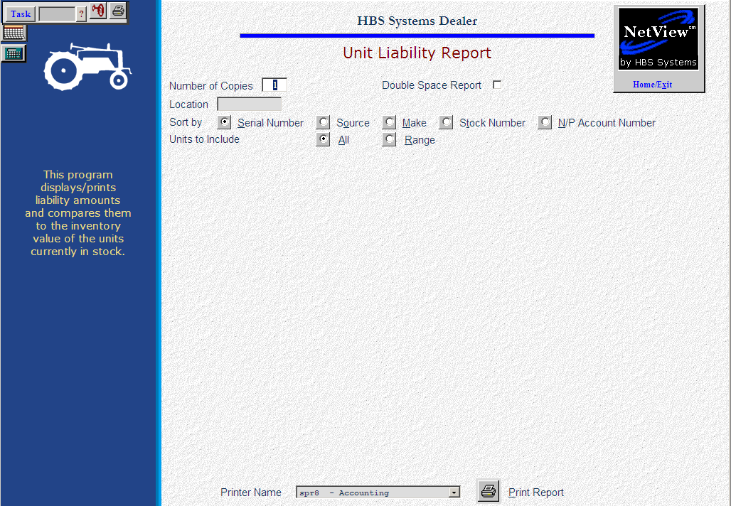

The Unit Liability Report explores the liability portion of the Units picture and its relationship to the inventory value of the units.

- To access this function, you can either:
  - Select “Units” from the menu. Choose the “Reports” submenu and click “Unit Liability Reports.”
  - Type “ULR” in the Shortcuts Bar.

Field Definitions

Number of Copies: This field is used to specify how many copies of the report you wish to print.

Double Space Report: Selection of this option puts a space between each line of the report.

Location: You may specify the location to include on the report (location field in UM).

Sort by: This field allows you to choose which field you would like to sort by, and includes:

Serial number (Alt S)

Source (Alt O)

Make (Alt M)

Stock number (Alt T)

Units to Include: You may include all units (New, Used, Rental, Ordered, and Sold) or a range of units.

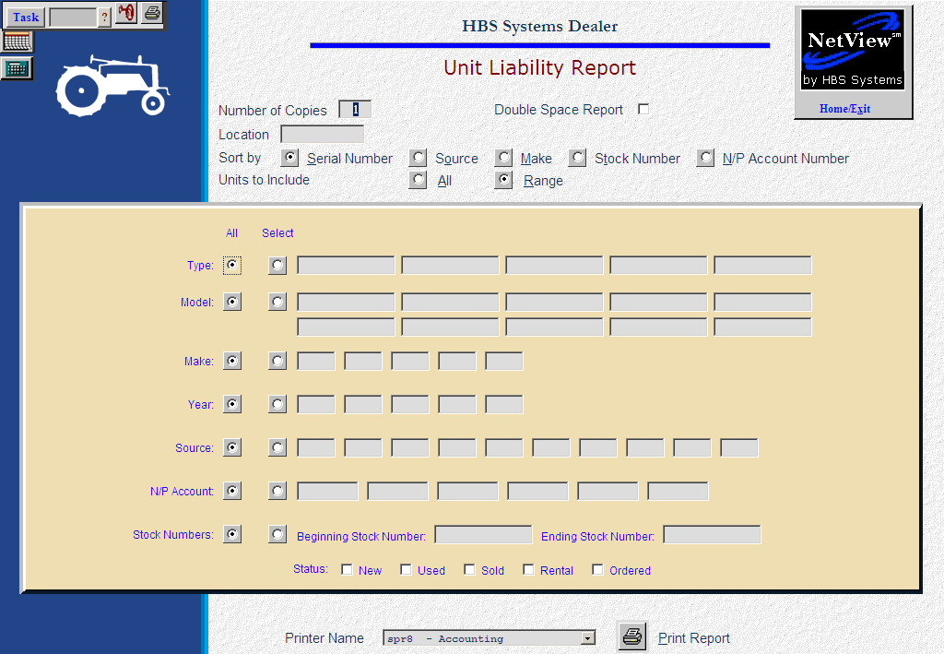

Type: Choose All or Select to enter up to 5 types.

Model: Choose All or Select to enter up to 10 models.

Make: Choose All or Select to enter up to 5 makes.

Year: Choose All or Select to enter up to 5 model years.

Source: Choose All or Select to enter up to 10 sources.

Stock #: Choose All or enter a Beginning and Ending stock number.

Status: Click and choose the ones you want to include:

New

Used

Rental

Ordered

Sold

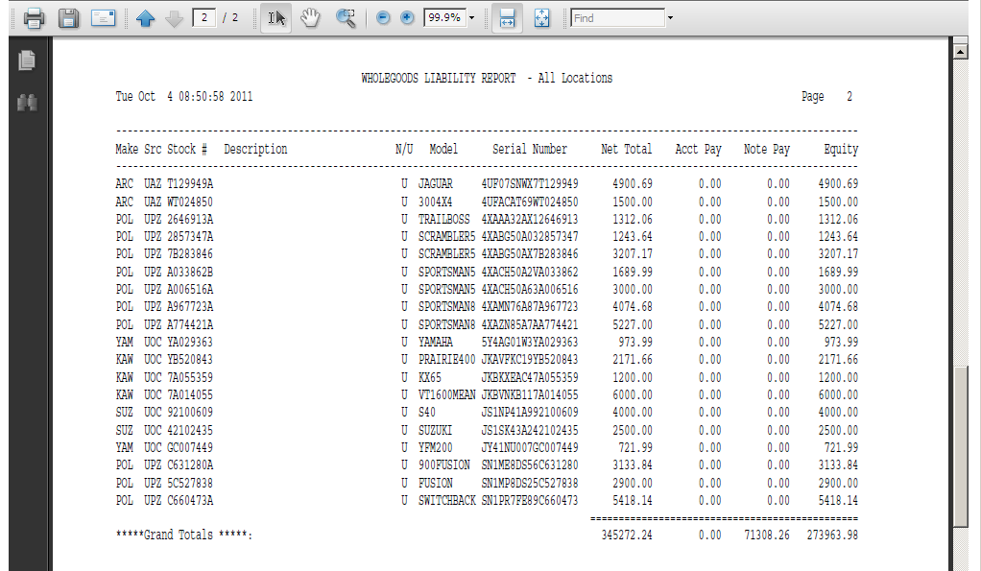

Report Description

Make: This field shows the make of the unit.

Src #: This field shows the unit source that applies to this stock number.

Stock #: This field shows the stock number of the unit.

Description: This field shows the information from the comment 1 field.

N/U: This field shows the status of the unit:

- N=new
- U=used
- S=sold
- O=ordered
- R=rental
- T=transferred
- H=history

Model #: This field holds the model number of the unit.

Serial #: This field holds the unit’s main Serial Number.

Net Total: This field holds the asking price for the unit.

Acct Pay: This field shows the amount owed in Accounts Payable for this stock number.

Note Pay: This field shows the amount owed in Notes Payable for this stock number.

Equity: This field is calculated by subtracting the Accounts Payable and Notes Payable amounts from the Base Net of this stock number.

