Unit Make Field Maintenance (UMM)

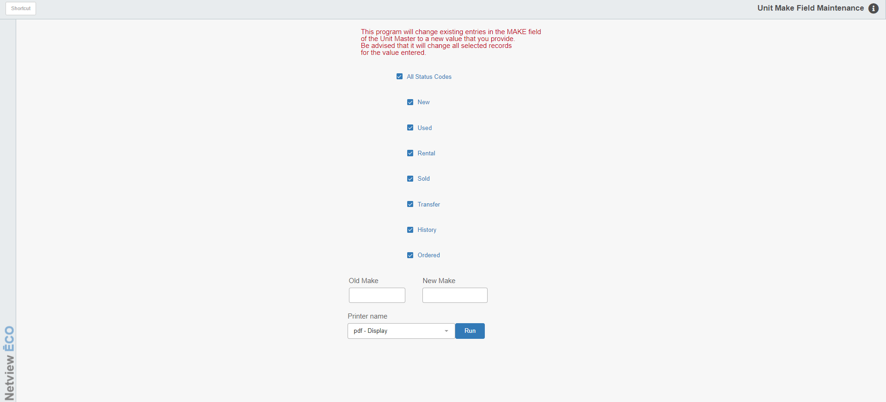

Units Make Field Maintenance (UMM) lets you make your Units Master Make field values consistent.

To access this function, you can either:

- Select “Units” from the menu and choose the “Data Entry” submenu. Click on “Unit Make Field Maintenance.”
- Type “UMM” in the Shorcuts Bar.

Field Definitions:

All Status Codes: Click in the box for the Status codes you want to update. Choose any of the following:

- All
- New
- Used
- Rental
- Sold
- Transferred
- History
- Ordered

NOTE: If you choose All, all the subsequent boxes will be automatically checked. If you remove a check from any of those boxes, All will automatically uncheck.

Old Make: Enter the OLD value you want to change. For example, if you are changing the units with MAS to MF, enter “MAS” in this field.

New Make: Enter the NEW value you want to have. For example, if you are changing the units with MAS to MF, enter “MF” in this field.

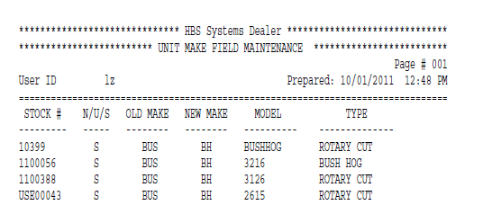

Report Fields: The report that is generated from your changes includes the following information:

Stock #: This column shows the stock numbers of the units.

N/U/S: This column shows the actual status of the units. They include:

N (New)

U (Used)

O (ordered)

S (Sold)

H (Historical)

T (Transfer)

R (Rental)

OLD Make: This column shows the original values in the Make field of the units.

NEW Make: This column shows the NEW values now in the Make field of the units.

Model: This column shows the model numbers of the units.

Type: This column shows the units’ types.

