Unit Model Field Maintenance

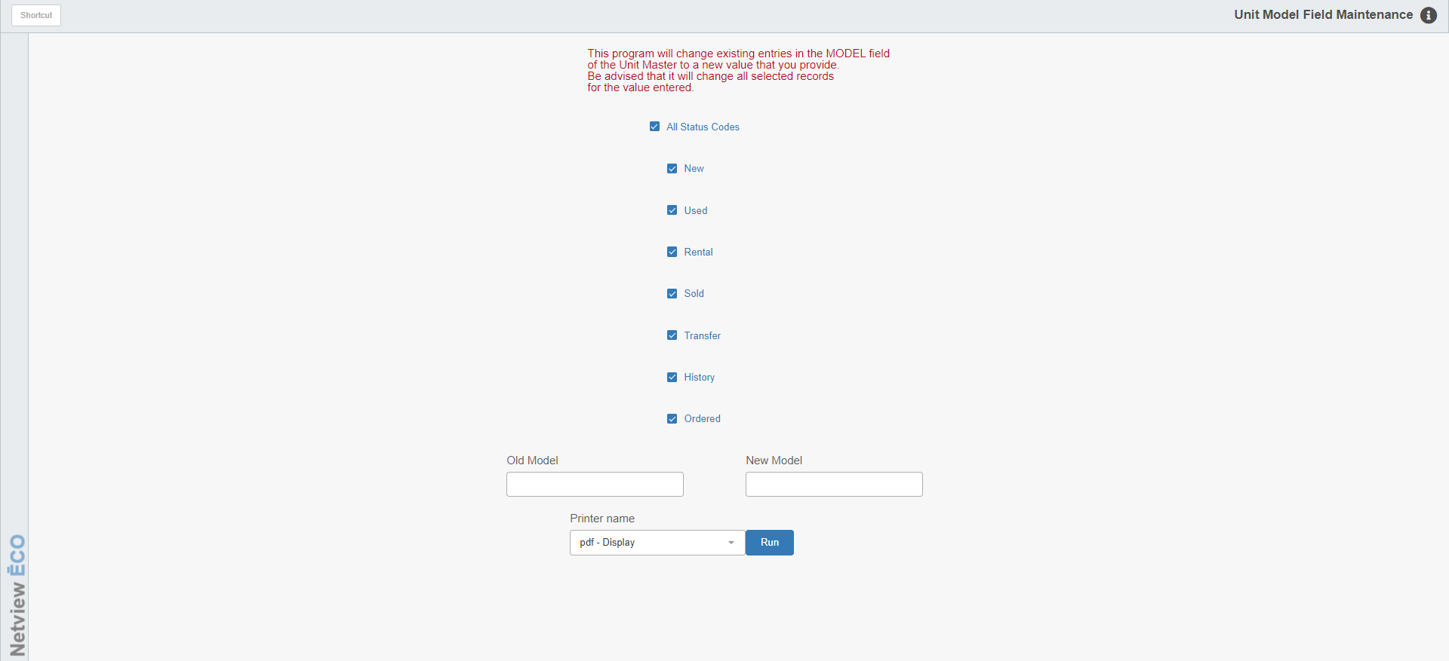

Units Model Field Maintenance (UMODM) lets you make your Units Model field values consistent.

To access this function, you can either:

- Select “Units” from the menu and choose the “Data Entry” submenu. Click on “Unit Model Field Maintenance.”
- Type “UMODM” in the Shortcuts Bar.

Field Definitions:

Status Codes: You can process the changes for ALL status settings or select them individually by checking the ones you want to include.

Old Model: Enter the OLD value of the Model field you want to change. For example, if you are changing the units with 125 to 125V, enter “125” in this field.

New Model: Enter the NEW value you want to show in the Model field. For example, if you are changing the units with 125 to 125V, enter “125V” in this field.

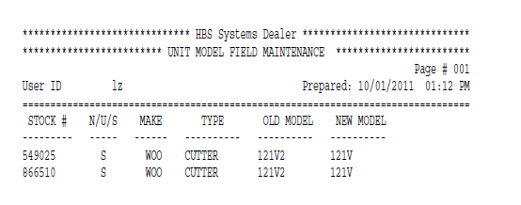

Report Fields: The report generated from your changes includes the following information:

Stock #: This column shows the units’ stock numbers.

N/U/S: This column shows the actual status of the units. This includes:

New

Used

Ordered

Sold

Historical

Transferred

Rental

Make: This column shows the units’ makes.

Type: This column shows the units’ types.

OLD Model: This column shows the original values in the Model Number field of the units.

NEW Model: This column shows the NEW values now in the Model Number field of the units.

