Receiving an Ordered Unit with UM

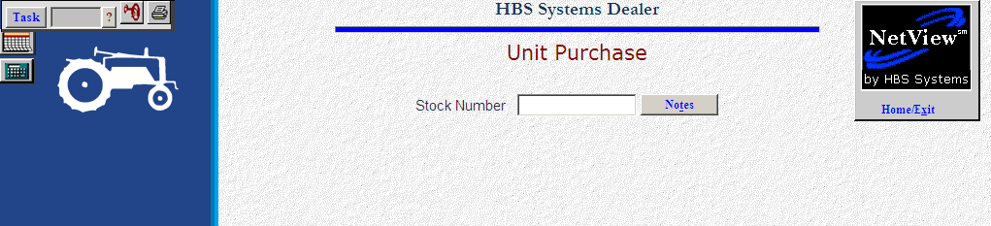

When an ordered unit arrives at your dealership, process the receipt, and it can automatically create the accounting transactions for the receipt/purchase.

- To access this function, you can either:
  - Select “Units” from the menu. Choose the “Data Entry” submenu and click “Unit Maintenance.”
  - Type “UM” in the Shortcuts Bar.

By entering the stock number of the received/ordered item, a second screen opens allowing you to enter additional information about the order. The tabs can be accessed and fields on those screens can be completed as well. Note that the Receive button is now visible.

Critical fields to validate BEFORE finishing the receipt of an ordered unit:

- Serial Number
- Order Cost
- List
- Invoice Number
- Invoice Date

**Press the Receive Button (Alt v) to receive the unit**

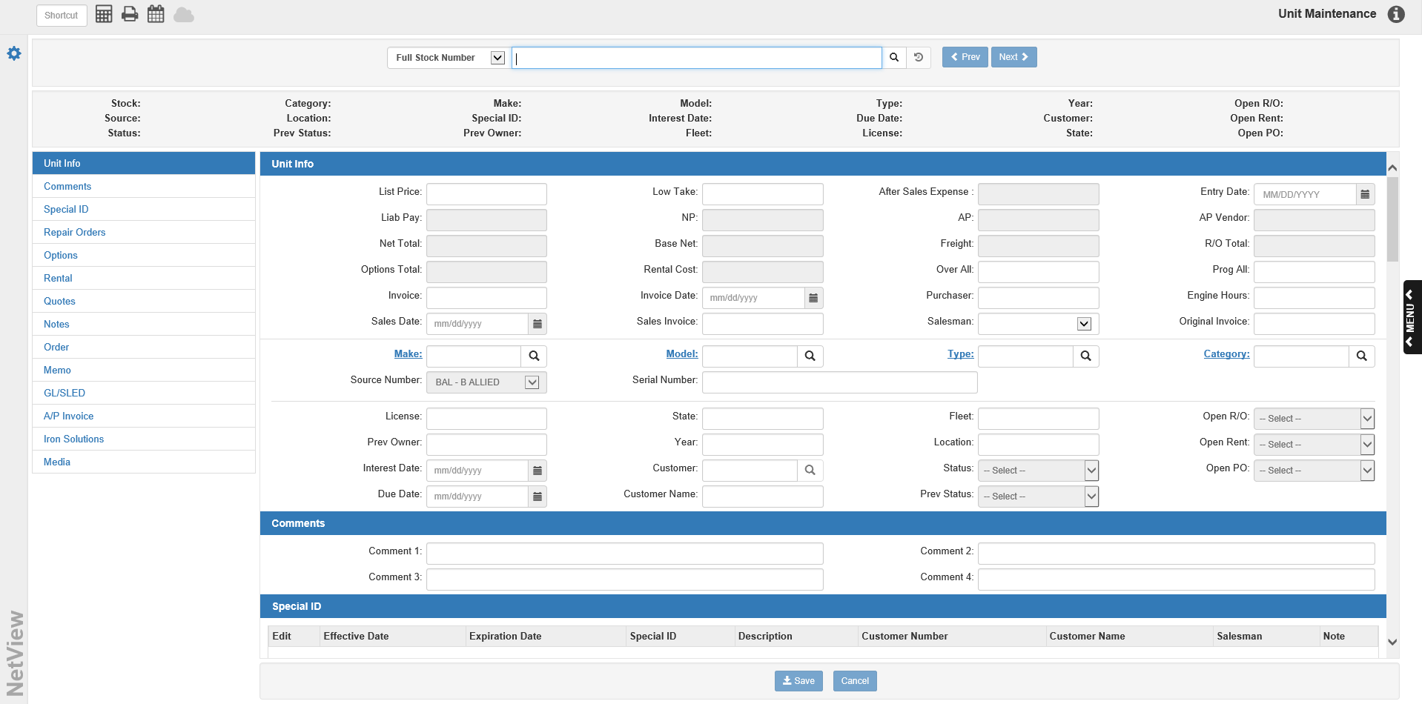

Additional Info needed upon receipt

Serial Number: Enter the unit’s serial number.

Invoice Number: Enter the unit’s invoice number if known at this time.

Invoice Date: Enter the Invoice Date if know at this time.

List Price: This field can hold an optional Selling Price.

Low Take: You may also enter an alternate selling price.

Base Net: We recommend adding the Base Net, Freight, and Liability for the unit in ETA.

Freight: We recommend adding the Base Net, Freight, and Liability for the unit in ETA.

Location: Enter the location if appropriate.

Previous Owner: You may enter the manufacturer’s name in this field.

Engine Hours: Here you will find the number of engine hours that the equipment has accumulated. This field is updated from POS and Netview Service when the current hours on the unit are entered.

Comments (Alt C): Fill in as needed.

Options (Alt t): Fill in as needed.

Memo Tab (Alt M): Fill in as needed.

Accounting Tab (Alt A): When all information for the unit receipted is entered, click the Finish Purchase button to complete the Accounting screen.

