Unit Purchase (UP/BIP)

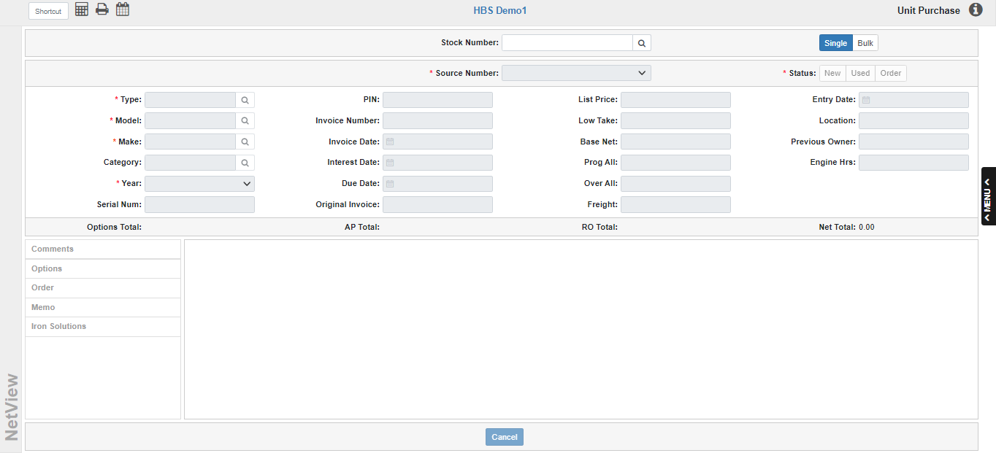

It is best to enter Units into your system as soon as they arrive at your dealership. When initially entering a unit, you may or may not have the invoice for it. Either way, use Unit Purchase (UP) to create the record. Purchase processes using invoices and using packing slips are shown on the following pages, as is how to handle bulk purchases. If your dealership accepts consignment units from your customers, you can use the Consignment process shown to handle these units.

To access this function, you can either:

- Select “Units” from the menu and choose the “Data Entry” submenu. Click either “Unit Purchase” or “Bulk Items Purchase.”
- Type “UP” or “BIP” in the Shortcuts Bar.

The program is divided into two purchase modes: Single and Bulk.

Single Mode: Single Mode is the program’s default purchase mode when opened with the UP shortcut, though you can always select it in the header if you open the program using the “BIP” shortcut. This mode allows you to purchase a single unit at a time.

Stock Number: Enter a stock number for the unit being purchased, or simply press “Enter” while your cursor is in the field to use the next available system-assigned stock number. NOTE: If you manually enter a stock number, the system will validate the number to make sure another unit does not already have it assigned so as to prevent duplicates.

Assigning the stock number will activate the rest of the screen, allowing you to begin creating the unit record. NOTE: Once you set the stock number, it cannot be changed. You would have to click the Cancel button to clear the screen and start over.

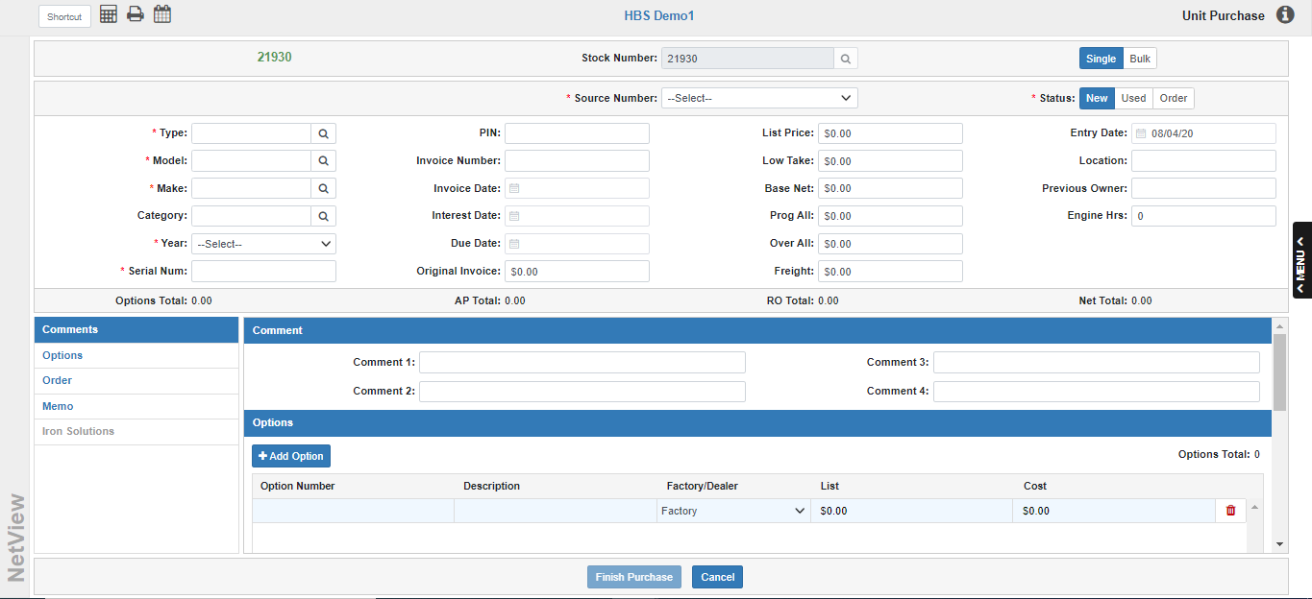

Source Number: Select the Unit Source from the drop-down menu. The Source Number ties the Stock Number record to the set of General Ledger accounts used for purchase and sales transactions. This is a required field.

Status: Choose the unit’s status (this is a required field):

- New: This status is for new units in inventory, and will be selected by default.
- Used: This status identifies used units in inventory. You might use this status when purchasing a used unit.
- Order: This status identifies units on order, but not yet received.

Type: This is a required field. Enter the unit’s type in this field or use the search to look it up:

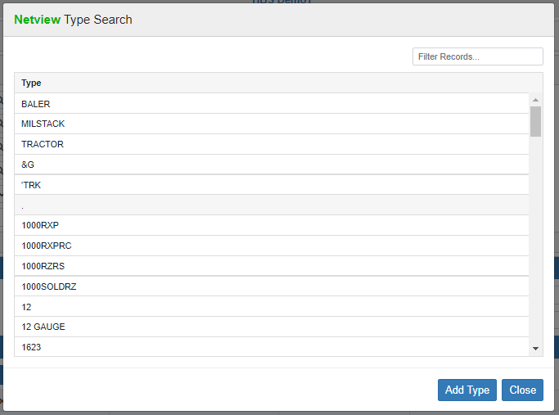

If the type you wish to use does not exist in the system, use the Add Type button in the Search to open Unit Category Maintenance (UCM) and add the type to the system.

Model: This is a required field. Enter the equipment’s model number in this field or use the search to look it up:

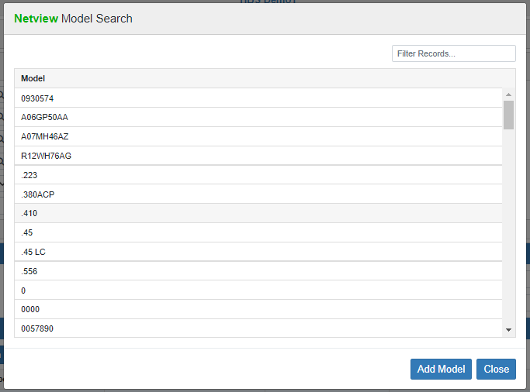

If the model number you wish to use does not exist in the system, use the Add Model button in the Search to open UCM and add the model to the system.

Make: This is a required field. Enter the unit’s three-character make in this field or use the search to look it up:

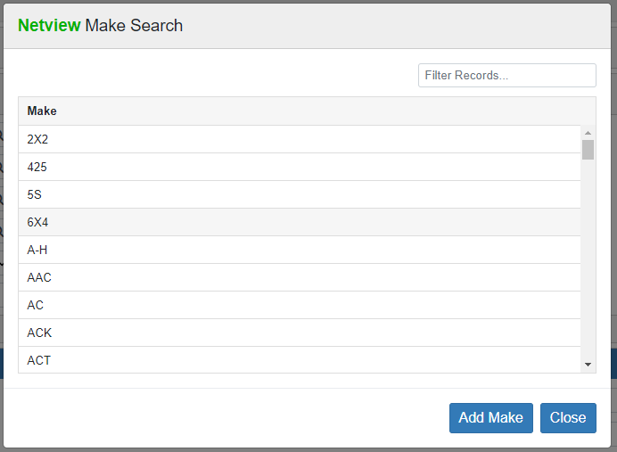

If the make you wish to use does not exist in the system, use the Add Make button in the Search to open UCM and add the make to the system.

Category: This field can hold a category for the unit. Enter a category or use the search to look one up:

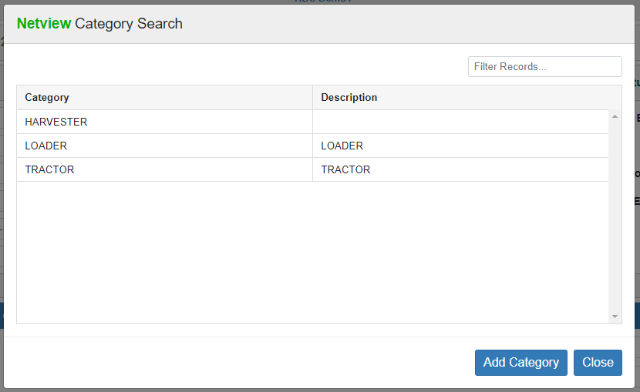

If the category you wish to use does not exist in the system, use the Add Category button in the Search to open UCM and add the category to the system. NOTE: See Unit Category Maintenance (UCM) for more information on categories.

Year: This is a required field. Select the four-digit model year from the drop-down menu. We strongly recommend that you enter a model year for every unit. If the year is not known or inappropriate for this unit, you could use a consistent year to mean it is unimportant. For instance, use “0000” for those dates that are unknown or for the units that do not have a model year.

Serial Number: This 30-character required field holds the unit’s main Serial Number. In the absence of a serial number for a given unit, we often suggest using the stock number, as it is most likely to be a unique number for the unit. In that case you could use “STK” and the stock number (i.e. STK123456).

PIN: This 30-character field can hold a pin number for the unit if one is required by the manufacturer. As both CNH and Kubota require pin numbers for their units, this field is required if you select either manufacturer as the Unit Source.

Invoice Number: This is where the manufacturer’s invoice number is kept. When purchasing a unit with the actual invoice in hand, the invoice number can be filled in at that time. However, if the purchase is entered from a packing slip, the invoice number field may be left blank until the invoice is received. At that point, you may attach the inventory value and liability, and reference the original invoice number. This field is required if you entered a value in the Base Net field.

Invoice Date: This field goes hand-in-hand with the Invoice Number field, and is also required if you enter a value in the Base Net field. It holds the date for the invoice. It can be filled in when you are entering the purchase from a manufacturer’s invoice. Enter the date or select it using the calendar. The date determines which accounting period will be used for the transaction, so make sure the date is within the open accounting periods on your system.

Interest Date: This field shows the interest date/due date for any Floorplan amount the unit might have. Enter the date or select it using the calendar.

Due Date: This field holds the due date for the unit invoice. Enter the date or select it using the calendar.

Original Invoice: This optional field can hold the amount of the original unit invoice. This amount will likely be the same as the Base Net value, but may vary depending on the nature of each purchase.

List Price: This field can hold an optional Selling Price. It shows on most of the unit reports and in the unit sales invoicing routine. Once a unit is sold, the field name changes and records the actual selling price of the unit.

Low Take: While the unit is in inventory, this is the lowest price you would take for a unit or perhaps the cash price for the stock number. It is not a required field. When the unit is sold, the field name changes to “Sell Cst” and holds the cost of the unit when it was sold. This value combined with the Sell Cadj provides the cost of the sold unit.

Base Net: Enter the base cost of the unit itself, excluding options, freight, and repair orders. This will usually be the unit’s original invoice cost, though it may vary depending on the nature of the purchase. This field is required in order to access the Accounting screen, and once you enter the value, the Finish Purchase button will be deactivated until you fill in all the required fields.

Prog All: This is not likely to be used on a purchase. This field can hold the amount of program allowance or incentive discount for the unit. It is a reference field only, and is not used in the calculation of either the cost or selling price. Since program discounts and incentives change often before a unit is sold, we recommend leaving this field blank.

Over All: This is not likely to be used on a purchase. Over-allowance is the difference between what you gave the customer on a trade-in and the value you want the unit “on the books.” Unit Sales (US) can place an amount here when the trade is being brought in. If you “over-allowed” for a trade-in, that difference becomes the over-allowance in this field.

Freight: If the unit you are purchasing has its freight itemized on the invoice, you may enter it in this field. Doing so will cause it to appear as an itemized portion of the inventory value of the unit. Some manufacturer’s invoices do not show freight as a separate line item. If that is the case, it is likely to have been included in the base cost entered earlier.

Entry Date: This field will be skipped in the purchase routine. The system will place the physical date the unit was entered in this field. It defaults to the current date.

Location: Enter a location, if desired. You could reference where the unit is to be placed or, in the case of multiple locations, the store name where the unit is located.

Previous Owner: This is an optional field that identifies the company or person who previously owned the equipment.

Engine Hours: If the unit being purchased has an hour meter and the hours are known, you may fill them in here.

Options Total: If options have been entered for the item, the total will be displayed here.

A/P Total: This field reflects the amount entered for A/P when performing the unit accounting. It will recalculate as the unit is paid off.

R/O Total: This field shows the total value of all the unit’s repair orders, as it is possible for a unit to have repair orders assigned before the purchase routine is completed.

Net Total: This field keeps a “running total” of all the costs of this unit here. Typically, it includes the Base Net, Freight, R/O Total, and Options Net Total.

Sidebar Shortcuts: On the lower left side of the screen is a list of the different tabs that can hold additional information depending on the nature of the unit purchase. Click on any tab name to jump to that section of the entry.

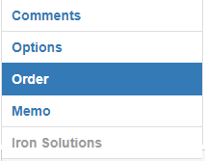

NOTE: The Iron Solutions tab is not available at this time.

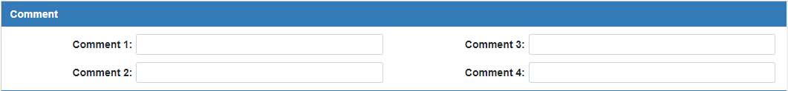

Comment 1-4: These four freeform comment lines are used for additional information about the stock number. They can be used for additional descriptions, details of programs/incentive discounts, additional serial numbers, etc.

TIP—Comment Lines: These four fields can provide some additional key information for each unit. While there are no rules that govern the use of these fields, determine what information will help you the most. It is a good idea to use these fields consistently. For instance, you could use Line 1 to provide a nicely worded description or enhanced description for the unit. Line 2 could hold additional information about the unit. An example of this scheme might look like this:
Comments
1: 2011 T1460 KUBOTA RIDING MOWER
2: 52” DECK
3:
4:
Using each comment line for a consistent purpose provides the ability to always know where to look for specific information. You may also select specific comment lines to include on some of the unit reports.

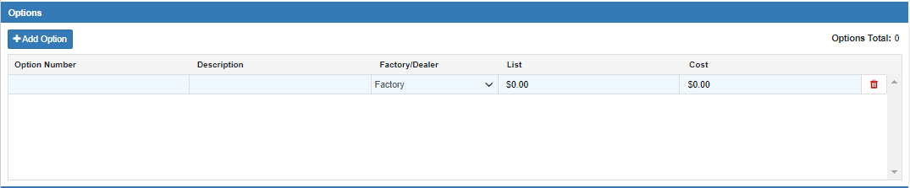

Options Tab: If you have options that will be added to this equipment, details about them can be entered here. The Options Total will also show again in the right-hand corner of the tab. If you need to add a new Option line to the grid, just click the Add Option button.

Option Number: This field holds a description or serial number for this option or attachment.

Description: This is the place to fully describe the option or attachment being entered.

Factory /Dealer: Type F for factory-installed options. Type D for dealer-installed options.

List: Enter the selling price of the option in this field, if desired.

Cost: Enter the cost to the dealership in this field. This number is added into the Options Total and thus the Net Total.

Delete: If you need to remove the option from the purchase at any time, click the icon of a red trash can on the far right side of the Option line. This will delete the option.

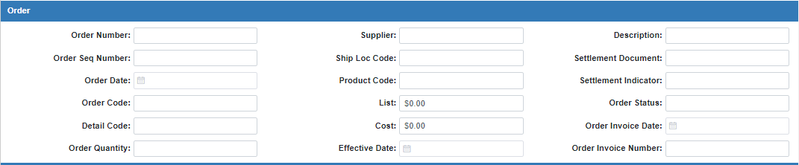

Order Tab: If you are entering the purchase of a unit you have placed on order, you must record information about the original order. To enter order information, select this tab. NOTE: For more information about ordering units in UP, please see “Orders in Unit Purchase (UP).”

Order Number: This 10-character field shows the order number for this unit.

Order Seq Number: This field can be used to hold the order sequence number, if supplied.

Order Date: This field shows the date the unit was ordered.

Order Code: This 12-character field shows the order code for John Deere automated orders. It can be used to record other order information for manual orders.

Detail Code: This 12-character field shows the detail machine order code for John Deere automated orders. It can record other order information for manual orders.

Order Quantity: This memo field can be used to store the number of units ordered. This is more likely to be used for bulk orders than single units.

Supplier: This 10-character field shows the supply location for John Deere automated orders. It can record other order information for manual orders.

Ship Loc Code: If the order includes a shipping location code, it can be stored in this field.

Product Code: This 10-character field shows the product type code for John Deere automated orders. It can record other order information for manual orders.

List: This field shows the list price of the ordered item. The amount entered in this field is for information only. You will have to enter the list price manually when you receive the unit.

Cost: This field shows the order cost (dealer price) for the ordered item. The amount entered in this field is for information only. You will have to enter the cost manually when you receive the unit.

Effective Date: This field shows the date the ordered prices were locked in for John Deere automated orders. It can hold the effective date of the pricing for manual orders.

Description: This field can hold info about the order or the customer who ordered it.

Settlement Document: This 16-character field shows the settlement document number for John Deere automated orders. It can record other order information for manual orders.

Settlement Indicator: This 2-character field shows the settlement indicator code for John Deere automated orders. It can record other order information for manual orders.

Order Status: This memo field can be used to track the status of the order.

Order Invoice Date: This memo field can hold the order invoice date, if supplied.

Order Invoice Number: This memo field can hold the order invoice number, if supplied.

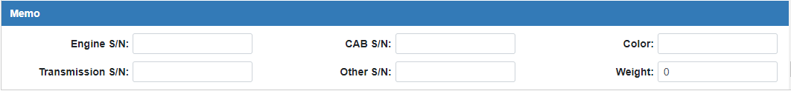

Memo Tab:

Engine S/N: This field provides a place to store the engine serial number.

Transmission S/N: This field provides a place to store the transmission serial number.

Cab S/N: This field provides a place to store the cab serial number.

Other S/N: This field provides a place to store the serial number for any other component of the unit.

Color: This field can identify the color of the unit or the equipment color code.

Weight: This field can store the weight of the unit.



Cancel: Click this button at any time to clear the screen without saving. NOTE: If you chose to use a system-generated stock number, and leave the screen without saving or using “Cancel” to clear it, the system will not reuse that stock number.

Finish Purchase: When all information for the unit being purchased is entered, click “Finish Purchase” to access the Accounting screen. Here you show how the unit’s liability will be handled.

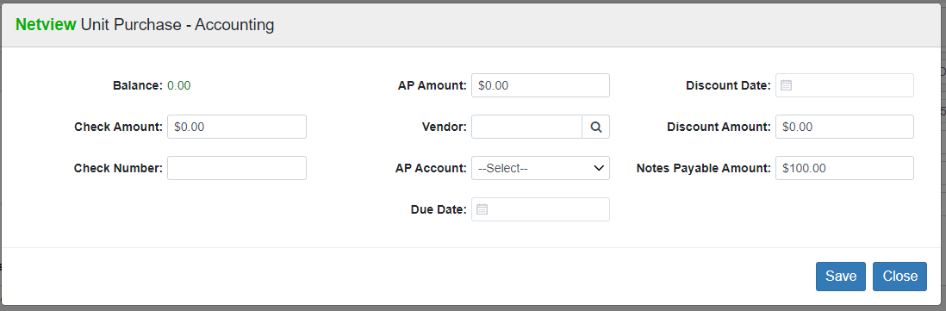

Balance: This field shows the amount of the unit’s Base Net that still needs to be allocated for payment. You will be able to save and complete the accounting once the Balance is “0.00.” NOTE: The Balance will generally start at this value as the total Base Net will automatically appear as the Notes Payable Amount.

Check Amount: If the unit is being paid for or will be paid for at the time of purchase, enter the amount in this field. The system will use this information to credit your checking account for the amount. Entry of this amount does NOT create and print a check for the transaction. It does, however, make the journal entry for a manual check written or one that will be written.

Check Number: This field holds the check number for the payment of this item.

AP Amount: If you want all or part of the liability to go to A/P, enter the amount here. NOTE: For Canadian dealers, all Canadian tax payments must be handled through A/P—the program will pop a warning otherwise.

Vendor: Type in the A/P vendor number or use the Vendor Search to look it up.

AP Account: Select the A/P account to take the liability. Unless you have multiple A/P accounts set up in your system, this drop-down should only let you choose your default A/P account (normally 20000). If you do have more than one account, they will all appear here as options, though the field will still default to your default A/P account.

Due Date: This field holds the due date of the A/P invoice.

Discount Date: This field can hold the discount date, if any, for the A/P invoice.

Discount Amount: This is the discount dollar amount for the A/P invoice.

Notes Payable: Enter the amount to go to Notes Payable in this field. The field will automatically prefill with the full Base Net value, and will recalculate if you choose to redistribute the value to the other payment fields. The system will pass any amount entered in the Notes Payable field to the General Ledger account identified in the Unit Source.

Press the “Save” button when finished to complete the purchase and save the unit record.

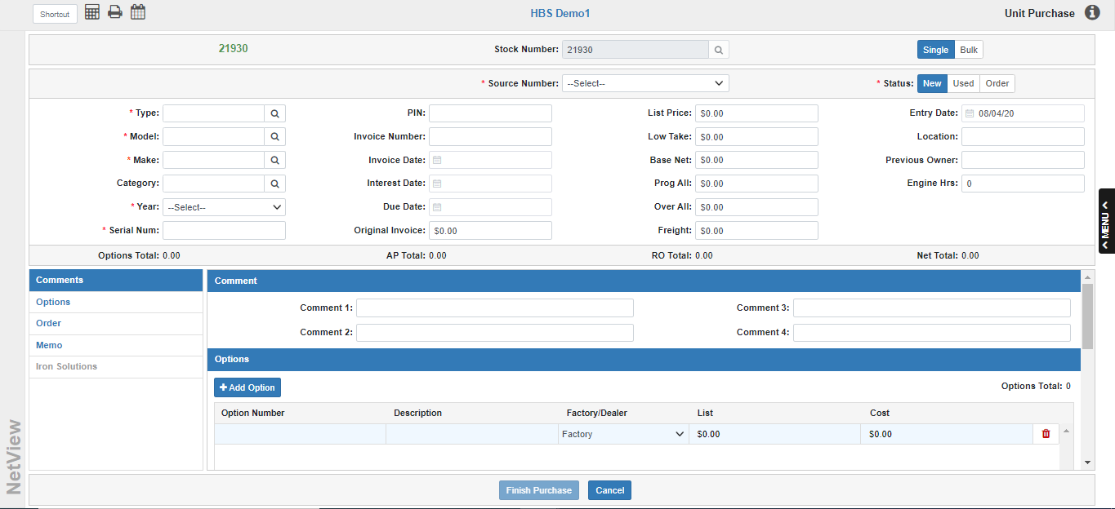

Entering Single Unit Purchase From a Packing Slip – No Invoice (Zero Purchase Method): In many instances, units arrive at a dealership before their invoices. We strongly recommend that you enter a unit upon its arrival at your dealership. However, you can use Single Mode in UP to easily add a unit record to the system without invoice amounts or date. This “early” entry process gets the unit into your system when it arrives and makes it available immediately for sale or for work in your Service department. When the invoice arrives, you can painlessly add the invoice information to the record.

Stock Number: Type in a stock number or accept the system-generated stock number.

Source Number: Select the source number for the vendor.

Status: Select the status:

- New
- Used
- Order

Type: Enter the equipment type here or look it up.

Model: Enter the model number of the unit here or look it up.

Make: Enter the unit make (manufacturer) here or look it up.

Category: This field is optional for the Zero Purchase Method. Enter a unit category or look one up.

Year: Select the model year of the item.

Serial Number: Enter the serial number in this field.

Invoice Number: Since you do not have an invoice at this time, do NOT enter any information in this field now.

Invoice Date: Since you do not have an invoice date at this time, do NOT enter any information in this field now.

Interest Date: Enter a date in this field only if you have a Floorplan amount against the unit.

Due Date: Since you do not have an invoice due date at this time, do NOT enter any information in this field now.

Original Invoice: Since you do not have an invoice at this time, do NOT enter any information in this field now.

List Price: Here you may enter the suggested selling price for this unit, if known.

Low Take: Here you may enter the lowest price you would take for the unit or perhaps the cash price for the stock number. This is an optional field.

Base Net: Since you do not have an invoice at this point, enter “0” in this field. The invoice cost and other costs can be entered when you become aware of them.

Prog All: Skip this field.

Over All: Skip this field.

Freight: Skip this field.

Entry Date: This field will be skipped in the purchase routine. The system will place the physical date the unit was entered in this field. It defaults to the current date.

Location: Enter a location, if desired. You could reference where on your premises the unit is to be placed or in the case of multiple locations, the store name where the unit is located.

Previous Owner: This is an optional field that identifies the company or person who previously owned the equipment.

Engine Hours: If the unit being purchased has an hour meter and the hours are known, you may fill them in now.

Comments Tab: Enter any comments about the unit here as you would on a normal purchase. These fields can hold any additional information that might help identify it when the invoice comes in, such as the packing slip number.

Finish Purchase: Press this button to finish the purchase. This will trigger the Accounting Screen.

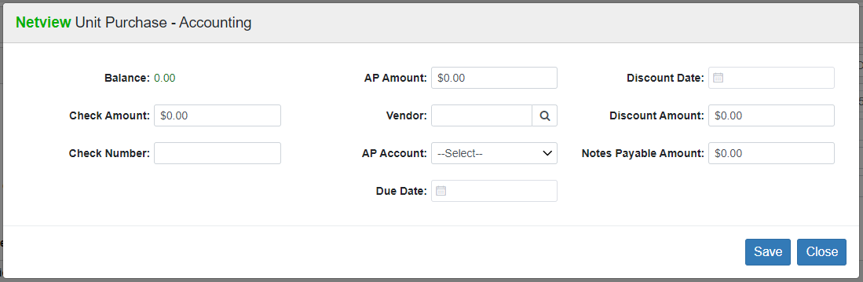

Note that the screen will be in balance without any accounting entries, due to the Base Net having been entered as “0.00.” Click Save to finish the purchase. The screen will return to the Unit Purchase screen where you may enter additional units.

You will find a minimal record for the unit has been added to the system. It is now available to print on any of the Unit inventory reports and a repair order can be opened against it. When the invoice actually arrives, you will be able to enter the information in the Unit record using Unit Maintenance (UM).

Purchasing Single Consignment Unit (Zero Purchase Method): You can also handle consignment equipment using the Zero Purchase method. The consignment units will then be eligible to have repair orders run against them, plus they will show on all lists of equipment for sale. The following steps offer guidelines for adding a consignment unit to your system using Single Mode in UP. NOTE: You may want to use every opportunity indicate that it is a consignment unit.

Stock Number: Type in the stock number or accept the system-generated number.

Source Number: Choose the unit source appropriate for the unit.

Status: Select the status, in this case typically New or Used.

Type: Enter the unit type or look it up.

Model: Enter the model number of the unit here or look it up.

Make: Identify the make (manufacturer) of the unit or look it up.

Category: This field is optional for the Zero Purchase Method. Enter a unit category or look one up.

Year: Select the unit’s model year.

Serial Number: Identify the unit’s main serial number in this field. If there is no serial number for this type of unit, we suggest using the stock number in this format: STK123456.

PIN: Enter a pin number in this field if you chose CNH or Kubota as your unit source.

Invoice Number: Since you do not have an invoice at this time, do NOT enter any information in this field now.

Invoice Date: Since you do not have an invoice at this time, do NOT enter any information in this field now.

Interest Date: Only enter a date in this field if you have a Floorplan amount against the unit.

Due Date: Since you do not have an invoice due date at this time, do NOT enter any information in this field now.

Original Invoice: Since you do not have an invoice at this time, do NOT enter any information in this field now.

List Price: Here you enter the suggested selling price for this unit, if known.

Low Take: Here may you enter the lowest price the owner of the unit will take for the consigned unit.

Base Net: We do not want to enter a value for the unit at this time. Enter “0” in this field.

Prog All: Leave this field blank.

Over All: Leave this field blank.

Freight: There wouldn’t likely be a number to enter in this field for a consignment. Enter “0” in this field.

Entry Date: This field will be skipped in the purchase routine. The system will place the physical date the unit was entered in this field. It defaults to the current date.

Location: This is a good field to reference that the unit is on consignment. The abbreviation “CONSIGNMNT” fits in this field.

Previous Owner: Put the name of the actual owner of the unit here.

Engine Hours: If the unit being purchased has an hour meter and the hours are known, you may fill them in now.

Comments Tab: You may use the comment lines to enter additional information about the consignment unit. You may want to reference the price/cost of the unit somewhere. Since there is no coding routine that codes the dollar amounts entered in the comment lines, you may devise some way to hide any amounts entered here. For example, you could “hide” the amount the owner wants for the piece on the line for the engine serial number. You could use an “A” as a code for asking price and reverse the dollar amount (A00010).

Options Tab: This area can be used to show the details of the consignment unit.

Memo Tab: This area can be used to show additional details of the consignment unit.

Finish Purchase: Press this button to open the Accounting Screen.

Note that the screen will be in balance without any accounting entries, due to the Base Net having been entered as “0.00.” Click Save to finish the purchase. The screen will return to the Unit Purchase screen where you may enter additional units.

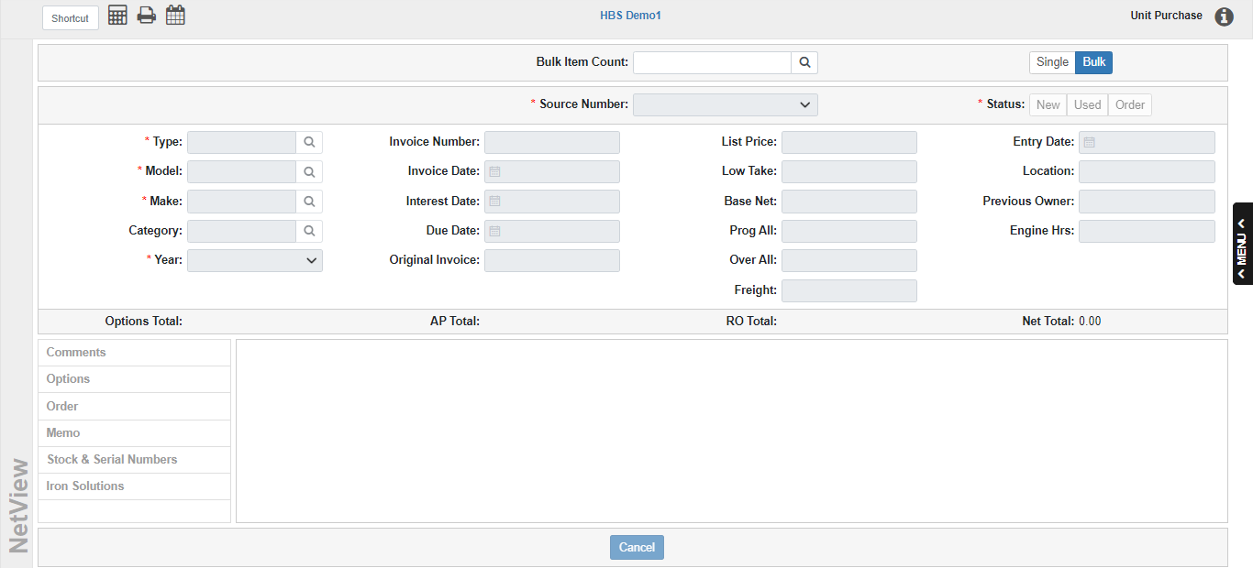

Bulk Mode: UP’s Bulk Mode is the result of merging UP and Bulk Items Purchase (BIP) into a single program. You can still use the “BIP” shortcut to automatically open the program in Bulk Mode. This mode provides a fast way to enter units into the system that are virtually the same except for their serial numbers. Bulk purchasing is often used for smaller units like lawnmowers, leaf blowers, chain saws, and so on.

Bulk Item Count: Enter the bulk quantity in this field in order to activate the rest of the purchase screen. NOTE: Like the stock number, once you set the item count, you cannot change it. You will have to use the Cancel button to clear the screen and start over.

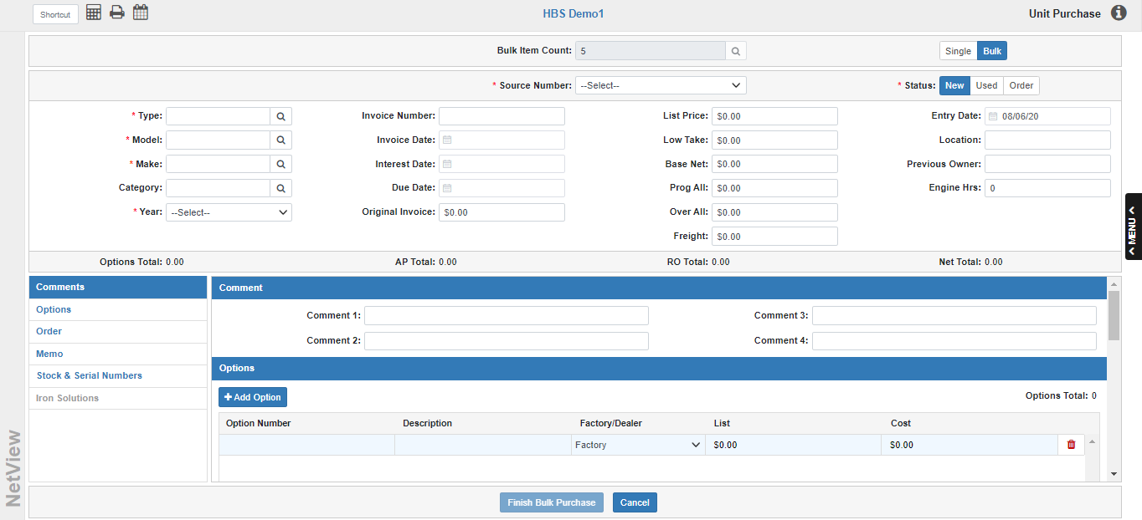

Source Number: Choose the Unit Source appropriate for the units being purchased. This is a required field.

Status: When purchasing units in bulk, typically you would choose New or Order.

Type: Enter the type of unit being purchased or use the search to look it up. This is a required field.

Model Number: Enter the model number of the units here or use the search to look it up. This is a required field.

Make: Enter the make (manufacturer) of the units or use the search to look it up. This is a required field.

Category: Enter a category for the units or use the search to look one up.

Year: Select the units’ model year. This is a required field.

Invoice Number: Enter the invoice number for these units. This field is required if you entered a value in the Base Net field.

Invoice Date: Enter the date from the manufacturer’s invoice. The date determines which accounting period will be used for the transaction, so make sure the date is within the open accounting periods on your system. This field is required if you entered a value in the Base Net field.

Interest Date: If the bulk order has a Floorplan amount against it, enter the interest date in this field or use the calendar to select it.

Due Date: Enter the invoice due date in this field or use the calendar to select it.

Original Invoice: This optional field can hold the amount of the original unit invoice. This amount will likely be the same as the Base Net value, but may vary depending on the nature of each purchase.

List Price: Here you may enter the suggested selling price for EACH unit. This is the individual selling price, not the amount for the whole shipment being entered.

Low Take: This field can hold the lowest price you would take for an individual unit from this order, or perhaps the cash price for the stock number. It is not a required field.

Base Net: Here you enter the total value for all the units combined (excluding freight, options, and repair orders). The system will divide it up amongst the stock numbers created in the purchase process. This field is required in order to complete the bulk purchase’s accounting.

Prog All: This is not likely to be used on a purchase. This field can hold the amount of program allowance or incentive discount for the units. It is a reference field only, and is not used in the calculation of either the cost or selling price. Since program discounts and incentives change often before a unit is sold, we recommend leaving this field blank.

Over All: This is not likely to be used on a purchase. Over-allowance is the difference between what you gave the customer on a trade-in and the value you want the unit “on the books.” Unit Sales (US) can place an amount here when the trade is being brought in. If you “over-allowed” for a trade-in, that difference becomes the over-allowance in this field.

Freight: Here you enter the ENTIRE freight amount for all the units combined. The system will divide it up between the stock numbers created in the purchase process.

Entry Date: This field will be skipped in the purchase routine. The system will place the physical date the units were entered in this field. It defaults to the current date.

Location: Enter a location, if desired. You could reference where the units will be placed or, in the case of multiple locations, the store name where the units are located. We recommend you not use this field if the units will not all remain in the same location.

Previous Owner: This is an optional field that identifies the company or person who previously owned the equipment, assuming all the units originally came from the same entity.

Engine Hours: This field will likely remain at “0.00,” as the units in a bulk order will not generally have engine hours recorded.

Options Total: If options have been entered for the units, the total will be displayed here. This value will be distributed evenly between the units, as each unit will have all entered options added.

A/P Total: This field reflects the amount entered for A/P when performing the unit accounting. It will recalculate as the units are paid off.

R/O Total: This field will almost always show “0.00” for bulk purchases, as repair orders can only be created for individual stock numbers, and the units in a bulk purchase do not have in-system stock numbers until after the purchase is finished.

Net Total: This field keeps a “running total” of all the bulk purchase’s costs here. Typically, it includes the Base Net, Freight, R/O Total, and Options Net Total.

Sidebar Shortcuts: On the lower left side of the screen is a list of the different tabs that can hold additional information depending on the nature of the unit purchase. Click on any tab name to jump to that section of the entry.

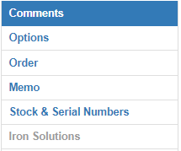

NOTE: The Iron Solutions tab is not available at this time.

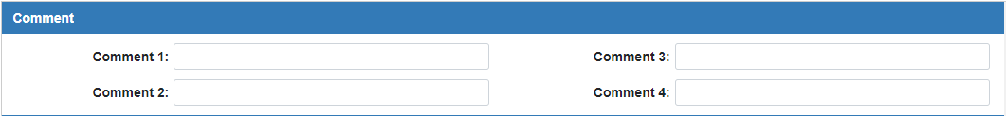

Comment 1-4: Enter any additional desired information in the provided comment lines. Be sure to use a consistent pattern for the information and their placement on the lines. Comments entered will appear on each unit entered.

Options Tab: If you have options that will be added to this equipment, details about them can be entered here. Each option will be added to every unit. The Options Total will also show again in the right-hand corner of the tab. If you need to add a new Option line to the grid, just click the Add Option button.

Option Number: This field holds a description or serial number for this option or attachment.

Description: This is the place to fully describe the option or attachment being entered.

Factory /Dealer: Type F for factory-installed options. Type D for dealer-installed options.

List: Enter the unit selling price of the option in this field, if desired.

Cost: Enter the cost to the dealership for attaching the option to all units on the purchase in this field. This value should be the total number of units multiplied by the option’s unit price. This number is added into the Options Total and thus the Net Total.

Delete: If you need to remove the option from the purchase at any time, click the icon of a red trash can on the far right side of the Option line. This will delete the option.

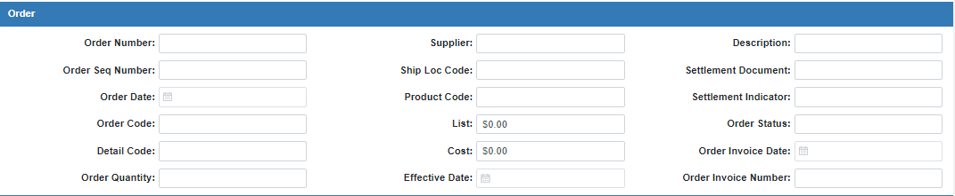

Order Tab: For more information about ordering units in UP, please see “Orders in Unit Purchase (UP).”

Order Number: This 10-character field shows the Order Number of the bulk order.

Order Seq Number: This field can optionally show an order sequence number.

Order Date: This field shows the date the units were ordered.

Order Code: This 12-character field shows the order code for John Deere automated orders. It can be used to record other order information for manual orders.

Detail Code: This 12-character field shows the detail machine order code for John Deere automated orders. It can record other order information for manual orders.

Order Quantity: This memo field can be used to store the number of units ordered.

Supplier: This 8-character field shows the supply location for John Deere automated orders. It can record other order information for manual orders.

Ship Loc Code: If the order includes a shipping location code, it can be stored in this field.

Product Code: This 10-character field shows the product type code for John Deere automated orders. It can record other order information for manual orders.

List: This 10-digit field shows the list price of the ordered items. The amount entered in this field is for information only. You will have to manually fill in the actual unit list price when you receive the individual units.

Cost: This 10-digit field shows the order cost (dealer price) for the ordered items. The amount entered in this field is for information only. You will have to manually fill in the actual unit cost when you receive the individual units.

Effective Date: This field shows the date the ordered prices were locked in for John Deere automated orders. It can hold the effective date of the pricing for manual orders.

Description: This field can hold info about the order or the customer who ordered it.

Settlement Document: This 16-character field shows the settlement document number for John Deere automated orders. It can record other order information for manual orders.

Settlement Indicator: This 2-character field shows the settlement indicator code for John Deere automated orders. It can record other order information for manual orders.

Order Status: This memo field can be used to track the status of the order.

Order Invoice Number: This memo field can hold the order invoice number, if supplied.

Order Invoice Date: This memo field can hold the order invoice date, if supplied.

Memo Tab:

Engine S/N: We recommend you leave this field blank, as it can only hold 1 unique engine serial number and a bulk order by nature consists of multiple units.

Transmission S/N: We recommend you leave this field blank, as it can only hold 1 unique transmission serial number and a bulk order by nature consists of multiple units.

Cab S/N: We recommend you leave this field blank, as it can only hold 1 unique cab serial number and a bulk order by nature consists of multiple units.

Other S/N: We recommend you leave this field blank, as it can only hold 1 unique serial number and a bulk order by nature consists of multiple units.

Color: This field can identify the color of the units or the equipment color code. We recommend only using this field if all the units will be the same color.

Weight: This field can store the weight of an individual unit. We recommend not recording the total weight of all the units put together, as this will then be copied on each unit’s individual record, resulting in an incorrect weight value.

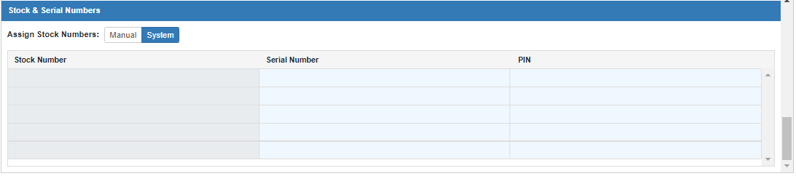

Stock & Serial Numbers Tab: This tab is required for Bulk Mode. The grid in this tab is created using the Bulk Item Count, so that the number of entry lines exactly matches the purchase quantity. Use the grid to enter all the stock, serial, and pin numbers necessary to create the individual unit records.

Assign Stock Numbers: Choose Manual to enter the stock numbers yourself, or choose System to have the system generate the stock numbers. If you choose “System,” the Stock Number fields will all show the word “Generated” and be disabled for editing.

Serial Number: Enter the serial number for each unit in the Serial Number column.

PIN: If the chosen unit source is CNH or Kubota, you will be required to enter a pin number for each unit using this column.

Finish Bulk Purchase: After you have filled in all the required fields as well as the Stock & Serial Numbers tab, click the Finish Bulk Purchase button at the bottom of the screen to access the Accounting screen:

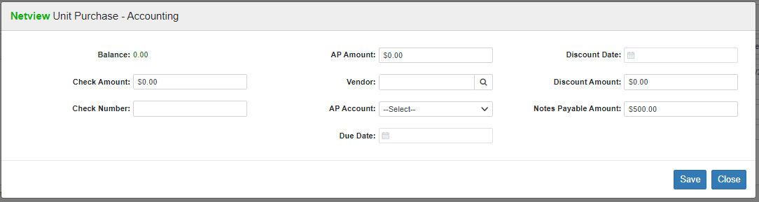

NOTE: All values entered will be evenly distributed among the purchased units.

Balance: This field shows the amount of the bulk purchase’s Base Net that still needs to be allocated for payment. You will be able to save and complete the accounting once the Balance is “0.00.” NOTE: The Balance will generally start at this value as the total Base Net will automatically appear as the Notes Payable Amount.

Check Amount: If any part of the bulk purchase is being paid for or will be paid for at the time of purchase, enter the amount in this field. The system will use this information to credit your checking account for the amount. Entry of this amount does NOT create and print a check for the transaction. It does, however, make the journal entry for a manual check written or one that will be written. NOTE: Remember that the check amount will be evenly distributed between all the purchased units.

Check Number: This field holds the check number for the payment of this item.

AP Amount: If you want all or part of the liability for the bulk purchase to go to A/P, enter the amount here. NOTE: Remember that the A/P amount will be evenly distributed between all the purchased units, and that Canadian dealers must allocate their tax amount through A/P.

Vendor: Type in the A/P vendor number or use the Vendor Search to look it up.

AP Account: Select the A/P account to take the liability. Unless you have multiple A/P accounts set up in your system, this drop-down should only let you choose your default A/P account (normally 20000). If you do have more than one account, they will all appear here as options, though the field will still default to your default A/P account.

Due Date: This field holds the due date of the A/P invoice.

Discount Date: This field can hold the discount date, if any, for the A/P invoice.

Discount Amount: This is the discount dollar amount for the A/P invoice.

Notes Payable: Enter the amount to go to Notes Payable in this field. The field will automatically prefill with the full Base Net value, and will recalculate if you choose to redistribute the value to the other payment fields. The system will pass any amount entered in the Notes Payable field to the General Ledger account identified in the Unit Source.

Save: Press this button when finished to complete the purchase and save the unit records.

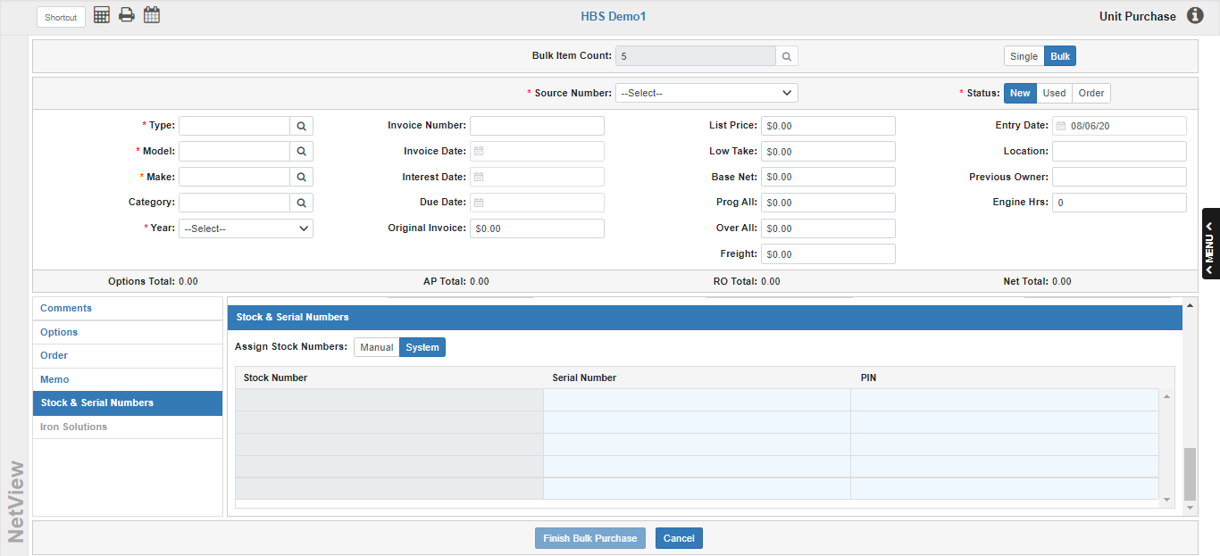

Enter Bulk Unit Purchase From a Packing Slip—No Invoice (Zero Purchase Method): In many instances, units arrive at a dealership before their invoices. We strongly recommend that you enter the units upon their arrival at your dealership. You can easily add Unit records for these items without invoice amounts or date. This “early entry” process gets the units into your system when they arrive and makes it available immediately for sale or for work in your Service Department. When the invoice arrives, you can painlessly add the invoice information to the individual Unit records.

Purchase Screen Fields: To begin the Zero Purchase Method process, enter the following information from the packing slip, or from the equipment itself, as with an invoice:

Source Number | Model
Status | Make
Type | Year

Enter values in the remaining fields according to the following guidelines:

Invoice Number: Since you do not have an invoice at this time, do NOT enter any information in this field now!

Invoice Date: Since you do not have an invoice at this time, do NOT enter any information in this field now!

Due Date: Since you do not have an invoice at this time, do NOT enter any information in this field now!

Original Invoice: Since you do not have an invoice at this time, do NOT enter any information in this field now!

List Price: Here you may enter the suggested selling price for EACH unit. This is the individual selling price, not the amount for the whole shipment being entered.

Base Net: Since you do not have an invoice at this point, enter “0” in this field. The invoice cost and other costs can be entered when you become aware of them.

Freight: If you have a freight bill for the bulk purchase even though the invoice has not come in, you may enter the amount here. Doing so will cause it to be evenly distributed between the stock numbers created in the purchase process.

Entry Date: This field will be skipped in the purchase routine. The system will place the physical date the units were entered in this field. It defaults to the current date.

Comments Tab: Enter any additional desired information in the provided comment lines. Be sure to use a consistent pattern for the information and their placement on the lines.

Stock & Serial Numbers Tab: Enter the stock, serial, and pin numbers as you would on a normal purchase.

Finish Purchase: Press this button to finish the purchase. This will trigger the Accounting Screen:

Note that the screen will be in balance without any accounting entries, due to the Base Net having been entered as “0.00.” Click Save to finish the purchase. The screen will return to the Unit Purchase screen.
You will find minimal records for each purchased unit have been added to the system. The units are now available to print on any of the Unit inventory reports, and a repair order can be opened against any one of them. When the invoice actually arrives, you can enter the information in the individual Unit records using Unit Maintenance (UM). NOTE: You will not be able to enter the invoice information for all the units in one place; you will have to enter the information separately for each ordered stock number.

