UPC Code File Maintenance (UPCM)

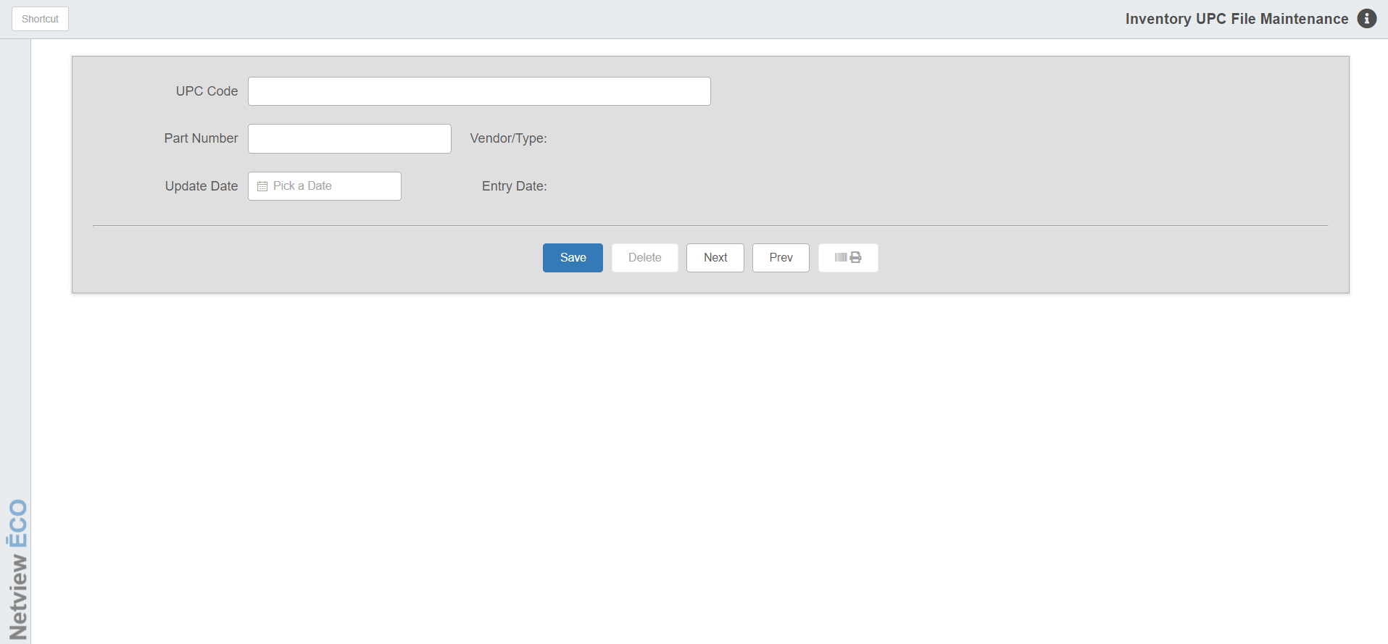

The UPC Code File Maintenance (UPCM) program is designed to let you add, modify, or delete relationships between UPC/bar codes and part numbers.

Manufacturers sometimes use UPC codes that do not match the part number. These codes may need to be maintained in this program in order to link the UPC code to the part number it represents. If you scan an UPC/bar code at a part number field and the screen displays “Part not on File,” you may need to setup the part number this code represents. This could be an actual part number that needs to be added to your inventory records before the scanned code can access it.

If the bar code or SKU# that you scan automatically calls up the actual part number, you do not need to maintain them with this program.

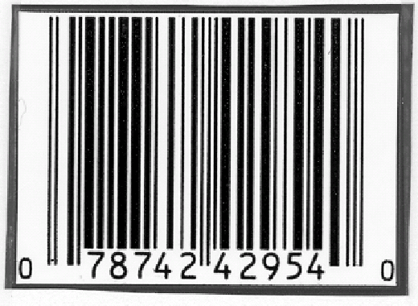

- To access the UPC Code File Maintenance program, either:
  - Select “Inventory” from the menu. Choose the “Barcodes and UPCs” submenu and click “UPC File Maintenance.”
  - Type “UPCM” in the Shortcuts Bar.

Field Definitions

UPC Code: Use your scanner to enter the UPC/bar code or type in the code. The program validates the entry with the UPC file.

Part Number: Type the part number that is associated with the UPC/bar code. The Vendor Number and Part Type for this part will display.

Update Date: This pre-fills with the current date for a new record or the date the entry was added for an existing entry.

Entry Date: This field shows the date the record was added.

Save: Click this button to save any changes made.

Delete: Click this button to delete a code.

Next/Previous: Use these buttons to move between records in the program.

Print Barcode: Use the  button to print out the barcode label the entry represents.

