Unit POS History (UPH)

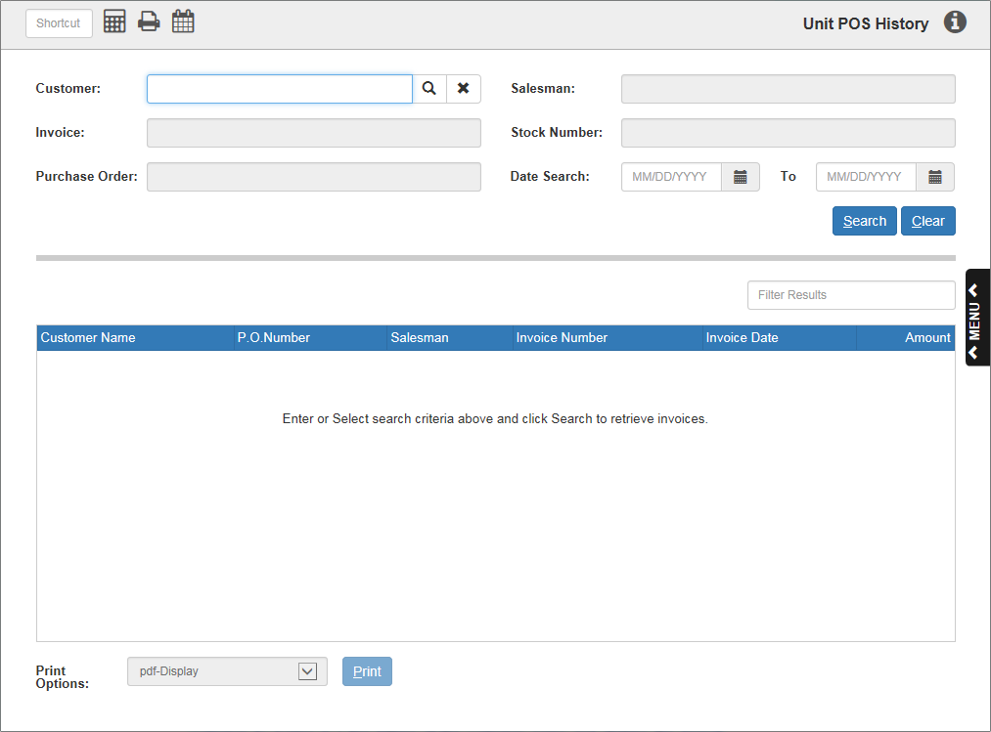

Units POS History (UPH) retains the details of unit sales invoices. UPH lets you call up a Units invoice, even if the invoice was written several years ago. You can choose to display the invoice or print it. You can even search through past invoices by:

- Customer name
- Salesman
- Date
- Invoice number
- Purchase order number
- Stock number

To recall unit sales generated using POS, use POS History (POSH or Hotkey X).

To access this function, either:

- Select “Units” from the menu and click “Unit POS History.”
- Type “UPH” in the Shortcuts Bar

Field Definitions

Customer: Click on this field and type in the customer number to view their units invoices. You can also search for a customer by typing in the first five letters of the customer name and clicking the Search icon to the right of the field. The customer’s name will then appear in this field while their invoice information populates the box below.

Click the black “x” next to the Search icon to clear the customer’s name from the field.

Salesman: Click on this field and type in the salesman number or initials to search for the desired invoice.

Invoice: Click on this field and type in the desired invoice number to search for the invoice.

Stock Number: Click on this field and type in a stock number to search for invoices containing that specific number. NOTE: The Stock Number will only display in the results box below when you search for a Stock Number.

Purchase Order: Click on this field and type in a purchase order number to find the invoice(s) with that order number.

Date Search: Specify a date range in these fields to bring up a list of all units invoices dated in that time period. Either type in the dates or use the calendar icons to the right of each field to located the dates.

- TIP—Searching for Invoices from a Specific Year: To look for invoices in a specific year, type the number of the year into the first field and hit “Enter,” then do the same in the second field. The first field will fill with the first date of the year (01/01) and the second field will fill with the last (12/31). Hit “Search” to see all the invoices from that year.
  - Another way to perform this search is to type the desired year in the first field, then the following year in the second field. This will fill the first field with the first date of the desired year and the second with the first date of the following year, allowing you to search for all invoices in that year including those dated the first of the next year.

Search: Click this button to start your searches after typing the information into the fields. You can also initiate a search by hitting the “Enter” key.

Clear: Click this button to clear any search fields on the page containing information.

Results Box: The results of the search, i.e. the units invoice information, will display here. You will see:

- The customer’s name
- The purchase order (P.O.) number of the invoice
- The initials of the salesman who created the invoice
- The invoice number
- The date of the invoice
- The amount listed on the invoice.
- If you found the invoice by searching for a stock number, that number will be listed as well.

Filter Results: Use this field to narrow down your results by imputing more information. The information can be anything visible in the Results Box, such as:

- The customer’s name
- The purchase order (P.O.) number
- The salesman’s initials
- The invoice number
- The date of the invoice
- The amount listed on the invoice.
- NOTE: Attempting to narrow down your results by stock number will not work, as the stock number will only appear after you have searched for a specific number, meaning all your results will have the same number.

Print Options/Print: Once you have located your desired invoice, click on it to activate the “Print” button. Use the drop-down menu in the field next to the button to select the type of printer you want, then click the button to print a copy of the invoice. See the image below for a sample reprinted invoice

