Unit Post Journals (UPJ)

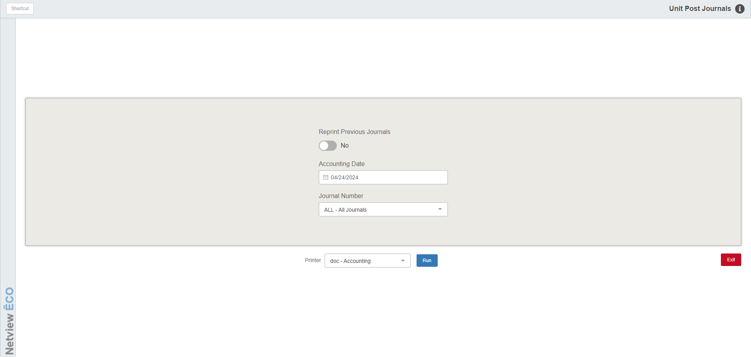

Unit Post Journals (UPJ) is the final step in the Units transaction process. UPJ posts all Units entries to the General Ledger. The account numbers and their respective amounts in the invoice document are posted. Transactions may include:

- Purchases
- Sales
- Activity from transfers and adjustments

To access this function, you can either:

- Select “Units” from the menu and click “Post Journals.”
- Type “UPJ” in the Shortcuts Bar.

Field Definitions

Reprint Previous Journals: This switch provides the option to reprint the last Units Journal posted if set to “Yes.” This is handy if the printer jammed while printing it. In most cases, this field will be set to “No.”

Accounting Date: The current date will pre-fill this field, but you may change it as needed. Using the current date will post all unposted transactions up to and including that date in the month. If you are posting entries from a previous month, we suggest that you use the last day of that month as it will post all unposted transactions for that period. NOTE: This field will be disabled if you set “Reprint Previous Journals” to “Yes.”

Journal Number:

- To post an individual Journal, select it from the menu.
- To post all open Units entries, choose “ALL.”

Printer Name: The default printer is shown, but you may select another printer from the drop-down menu, if needed.

Run: Clicking this button processes the Journal and prints the associated report.

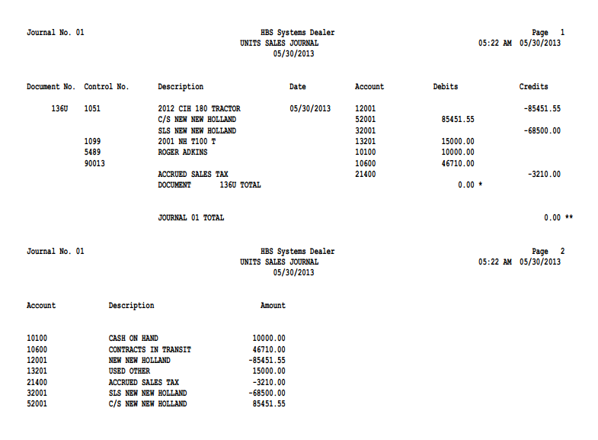

Journal Report Fields: The Journal printouts consist of at least two sections:

The detail of the entries posted per Journal Number

The Account Activity Summary

If the posting process affects more than one journal number, a set of these printouts will be printed for each journal posted.

Journal Number Detail Section: The header of this printout includes:

The date and time the journal was posted

The journal number

The description of the journal itself

Document No.: This field shows the document number for this transaction, which could be:

Check number

Invoice number

Receipt number

Other reference

Control No.: If the account number entered in the Account field is one that has a subledger code, you will see the control number you entered here, which could be one of the following:

Stock Number

Vendor Number

Reference Number

Customer Name

Description: The entered description for this line of the transaction will display in this field.

Date: This field shows the document date entered.

Accounts: The General Ledger Account Number referenced on each line of the transaction will be shown here.

Debits: If the amount for this individual line was a debit amount, it will appear in this column.

Credits: If the amount for this individual line was a credit amount, it will appear in this column.

Document Total: For each transaction posted, a document total will be printed.

- If the transaction posted was in balance, the document total will be 0.00.
- If an amount other than 0.00 shows for the document total, the document was posted out of balance and probably should be reviewed.

Journal Total: For each journal posted, a journal total will be printed.

- If the journal posted was in balance, the journal total will be 0.00.
- If an amount other than 0.00 shows for the journal total, the journal was posted out of balance and probably should be reviewed.

Account Activity Summary: The final page of each journal printout shows the Account Activity Summary. This section simply summarizes the net dollar amount passed to various account numbers when the journal was posted. The following will be shown for each affected account number:

Account number

Description

Net amount posted

TIP—When to Post & Print Journals: Develop the habit of posting all the unit documents on a daily basis. A good time to do this is at the end of day when you run other End of Day routines.

During month-end preparation, you may need to run Post & Print Journals (UPJ) more frequently than just once a day. For example, if you are still making entries for a prior month that has not been closed, post them first and then do the entries for the current month.

Exception Report: Sometimes, after running the Journal, the application will generate
an Exception Report after the Journal is run. This occurs if there are documents
unable to be journalized when the Journal ran. The following information will show
on the report:

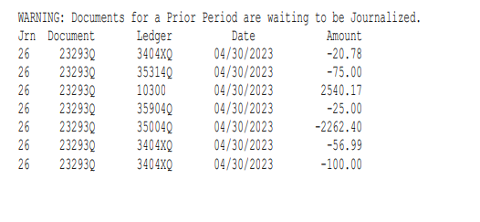

Jrn: This is the Journal number where the exception error occurred.

Document: This is the document number of the unjournalized document.

Ledger: This is the General Ledger account number associated with the document.

Date: This is the document date.

Amount: This is the dollar amount (debit or credit) of the document.

