Orders in Unit Purchase (UP): You can order units for future delivery and use Unit Purchase (UP/BIP) to enter the ordered units into your system in much the same way as you enter purchased units without an invoice (Zero Purchase Method). Once entered, ordered units are available immediately for sale or transfer. This allows you to order units for your customers and to receive payments for the units before they are received. You can also use UP to receive the items in once they arrive.

If you place a units order with John Deere, your HBS Business System can automatically create units records for ordered items using information received from John Deere. This record can also be automatically updated with option additions and deletions, invoice receipts, and settlement details as the information is received from John Deere.

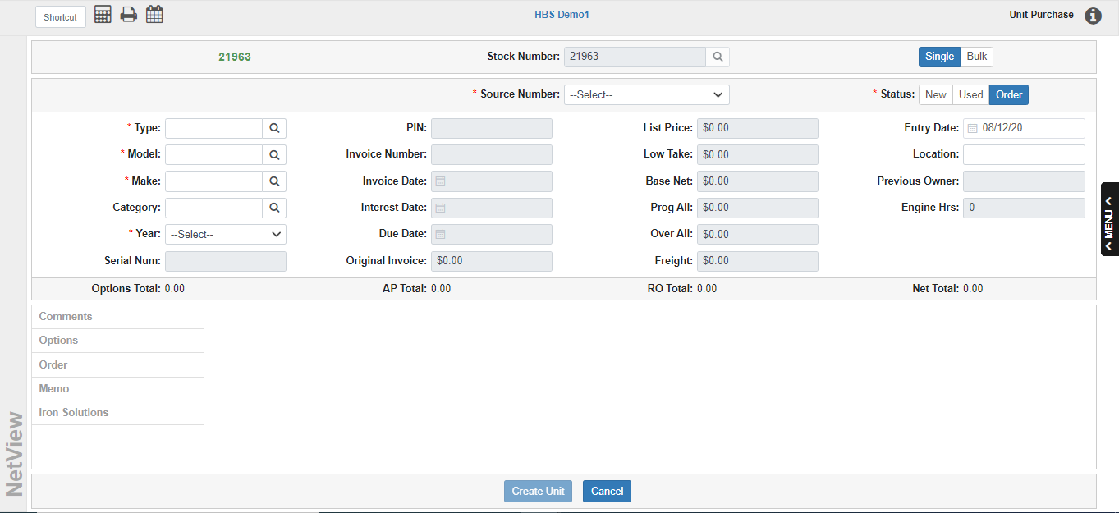

To access this function, you can either:

- Select “Units” from the menu and choose the “Data Entry” submenu. Click either “Unit Purchase” or “Bulk Items Purchase.”
- Type “UP” or “BIP” in the Shortcuts Bar.

The program is divided into two purchase modes: Single and Bulk. The topic will explain how to create and receive Order-status units in both modes.

Ordering Units in Single Mode:

Stock Number: Enter the stock number being ordered or press “Enter” to let the system assign it.

Source Number: Choose the Unit Source for the ordered unit.

Status: Select Order.

Type: Enter the type of unit being ordered or use the search to look it up.

Model: Enter the model number of the unit here or use the search to look it up.

Make: Identify the unit’s make (manufacturer) or use the search to look it up.

Category: Enter a category for the unit or use the search to look one up. This field is optional for orders.

Year: Select the unit’s model year in this field.

At this point the cursor jumps to the now-active Comment Tab. Fill in any comments and move to the Order Tab.

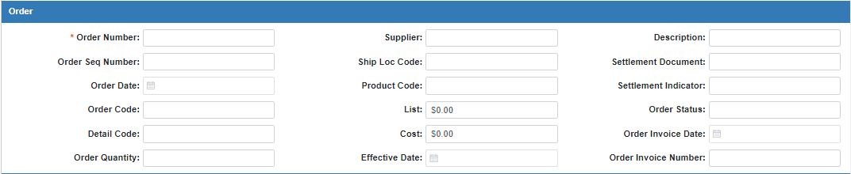

Order Tab:

Order Number: This field is very important in the order process, and is thus required. It must contain a unique order number, which will be used to create a temporary serial number.

NOTE: For orders placed with John Deere, DO NOT change the pre-filled value in the SN field. Changing the value will prevent the system from automatically updating this record with information imported from John Deere.

Order Sequence Number: If you have an order sequence number, you may enter it here.

Order Date: This field shows the date the unit was ordered.

Order Code: This 12-character field shows the Order Code for John Deere automated orders. It can be used to record other order information for manual orders.

Detail Code: This 12-character field shows the detail machine order code for John Deere automated orders. It can be used to record other order information for manual orders.

Order Quantity: This field shows the number of the units ordered.

Supplier: This 10-character field shows the supplying location for John Deere automated orders. It can be used to record other order information for manual orders.

Ship Loc Code: You may enter a ship location code here.

Product Code: This 10-character field shows the product type code for John Deere automated orders. It can be used to record other order information for manual orders.

List: This field shows the list price of the ordered item. The amount entered in this field is for information only. You will have to enter the list price manually when you receive the unit.

Cost: This field shows the order cost (dealer price) for the ordered item. We do not recommend entering a cost on an ordered unit.

Effective Date: This field shows the date the ordered prices were locked in for John Deere automated orders. It can be used to record other order information for manual orders.

Description: This field shows the order code description.

Settlement Document: This field shows the settlement document number for John Deere automated orders. It can be used to record other order information for manual orders.

Settlement Indicator: This 2-character field shows the settlement indicator code for John Deere automated orders. It can be used to record other order information for manual orders.

Order Status: If there is an order status for this order, you may enter it here.

Order Invoice Date: This field holds the order invoice date, if known.

Order Invoice Number: This field holds the invoice number for this order, if known.

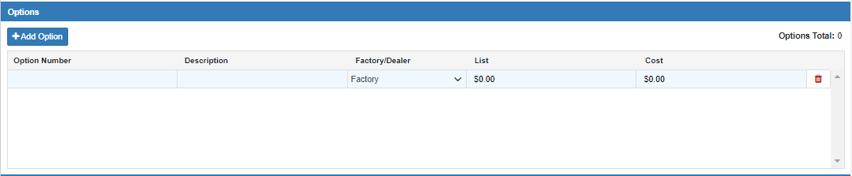

Options Tab: The following option fields act as memo fields until you receive this unit. The Options Total will show in the right-hand corner of the tab. If you need to add a new Option line to the grid, just click the Add Option button. NOTE: At this time, you will not be able to add the List price or Cost for the options, similarly to the unit itself. You will be able to add in the values once you receive the unit.

Option Number: Enter an option number or serial number for this item. Many use the factory option number or a short descriptive word that relates to the option itself.

Description: This optional field shows details of what the option really is, such as the size of the optional tires, the characteristics of the wheel weights, or the dimensions of the attached bucket.

Factory/Dealer: Since you are ordering these options on the unit initially, use F for Factory-installed.

Delete: If you need to remove the option from the purchase at any time, click the icon of a red trash can on the far-right side of the Option line. This will delete the option.



Create Units: This button replaces Finish Purchase and will activate when all the required information about the ordered unit has been entered. Click it to create the Ordered unit record.

The unit remains in Order status until it is later received. It now will show on any of the unit inventory printouts, can have a repair order run against it, and even be sold.

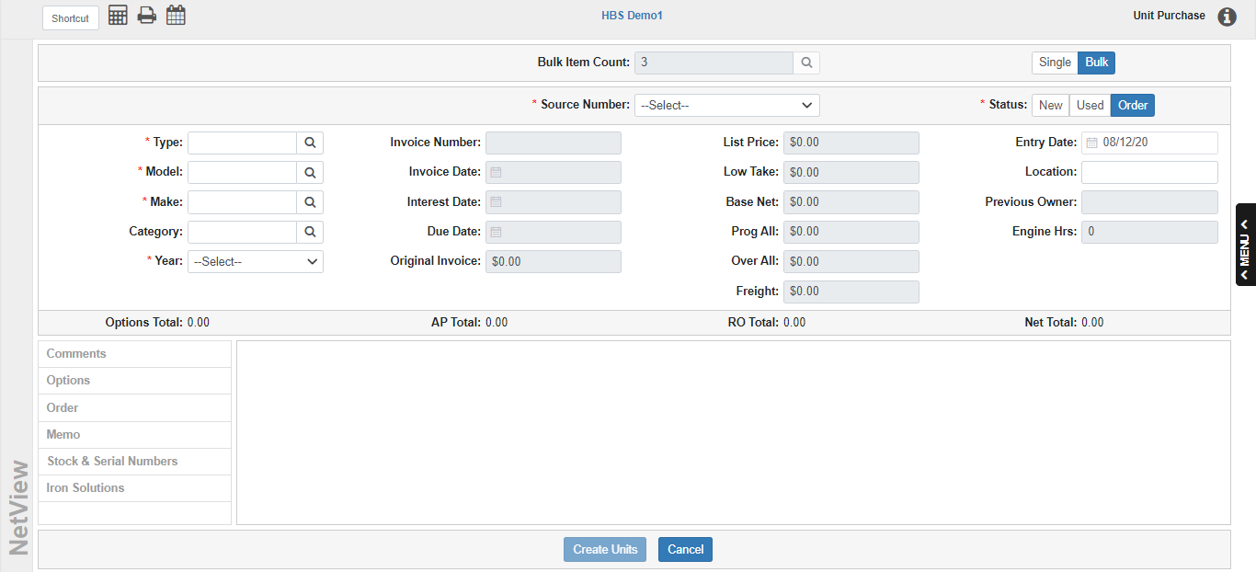

Ordering Units in Bulk Mode: This process is largely the same as in Single Mode, with a few key differences.

Bulk Item Count: Enter the bulk quantity for the order here.

Source Number: Choose the Unit Source for the ordered unit.

Status: Select Order.

Type: Enter the type of unit being ordered or use the search to look it up.

Model: Enter the model number of the unit here or use the search to look it up.

Make: Identify the unit’s make (manufacturer) or use the search to look it up.

Category: Enter a category for the unit or use the search to look one up. This field is optional for orders.

Year: Select the unit’s model year in this field.

At this point the cursor jumps to the now-active Comment Tab. Fill in any comments and move to the Order Tab.

Order Tab:

Order Number: This field is very important in the order process, and is thus required. It must contain a unique order number, which will be used to create a temporary serial number.

NOTE: For orders placed with John Deere, DO NOT change the pre-filled value in the SN field. Changing the value will prevent the system from automatically updating this record with information imported from John Deere.

Order Sequence Number: If you have an order sequence number, you may enter it here.

Order Date: This field shows the date the unit was ordered.

Order Code: This 12-character field shows the Order Code for John Deere automated orders. It can be used to record other order information for manual orders.

Detail Code: This 12-character field shows the detail machine order code for John Deere automated orders. It can be used to record other order information for manual orders.

Order Quantity: This field shows the number of the units ordered.

Supplier: This 10-character field shows the supplying location for John Deere automated orders. It can be used to record other order information for manual orders.

Ship Loc Code: You may enter a ship location code here.

Product Code: This 10-character field shows the product type code for John Deere automated orders. It can be used to record other order information for manual orders.

List: This field shows the list price of the ordered item. The amount entered in this field is for information only. You will have to enter the list price manually when you receive the unit.

Cost: This field shows the order cost (dealer price) for the ordered item. We do not recommend entering a cost on an ordered unit.

Effective Date: This field shows the date the ordered prices were locked in for John Deere automated orders. It can be used to record other order information for manual orders.

Description: This field shows the order code description.

Settlement Document: This field shows the settlement document number for John Deere automated orders. It can be used to record other order information for manual orders.

Settlement Indicator: This 2-character field shows the settlement indicator code for John Deere automated orders. It can be used to record other order information for manual orders.

Order Status: If there is an order status for this order, you may enter it here.

Order Invoice Date: This field holds the order invoice date, if known.

Order Invoice Number: This field holds the invoice number for this order, if known.

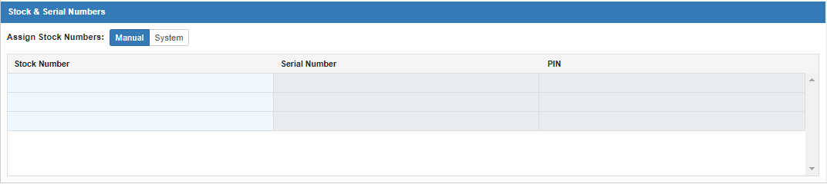

Stock & Serial Numbers Tab: This tab is required for bulk purchases. Choose Manual to manually input the stock numbers for the ordered units, or System to have the system automatically generate the numbers. Note that you cannot put in serial or PIN numbers at this time, as you do not know exactly what units you will receive.

Options Tab: The following option fields act as memo fields until you receive the units. Each option will be added to each unit. The Options Total will show in the right-hand corner. If you need to add a new Option to the grid, click the Add Option button. NOTE: At this time, you will not be able to add the List price or Cost for the options. You will be able to add in the values to the individual units once you receive them separately.

Option Number: Enter an option number or serial number for this item.

Description: Enter an optional description of the item in this field.

Factory/Dealer: Since you are ordering these options on the unit initially, use F for Factory-installed.

Delete: If you need to remove the option from the purchase at any time, click the icon of a red trash can on the far-right side of the Option line. This will delete the option.

Create Units: This button will activate when all the required information about the ordered units have been entered. Click it to create the Ordered unit records.

The units remain in Order status until they are individually received. They will now show on any of the unit inventory printouts, can have repair order run against them, and even be sold.

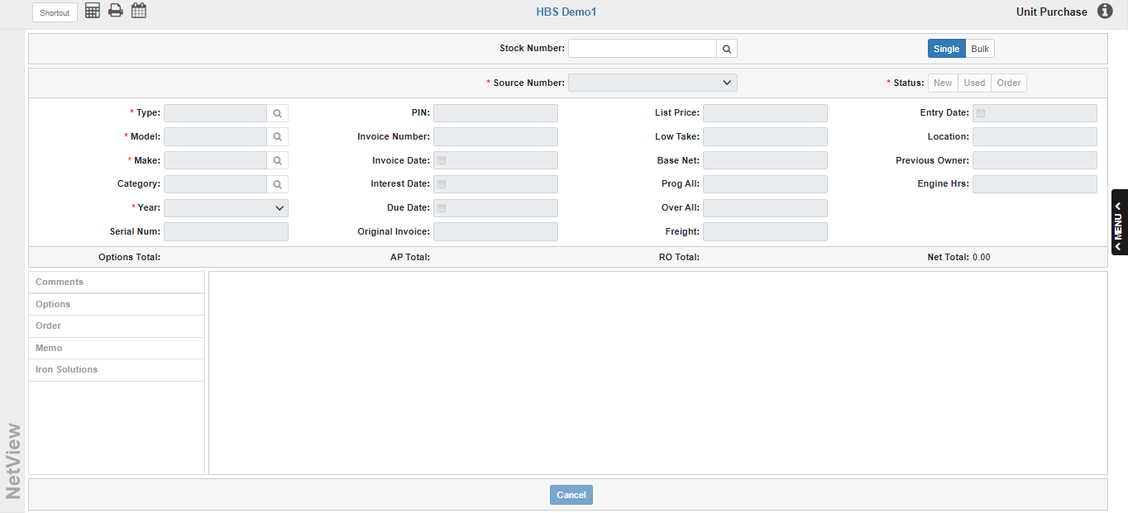

Receiving an Ordered Unit in Unit Purchase (Single Mode): Unit Purchase allows you to receive an Ordered unit into the system as you can in Unit Maintenance (UM). However, the process only works in Single Mode, as it is dependent upon the unit’s individual stock number.

Stock Number: Enter the full stock number of the ordered unit and click the Search icon. You can also hit the “Enter” key on your keyboard. If you don’t know the full stock number, you can enter a partial number and click the Search icon to view a list of existing Ordered units that contain matching characters.

Once you’ve selected the unit, the information from the unit record will populate the screen:

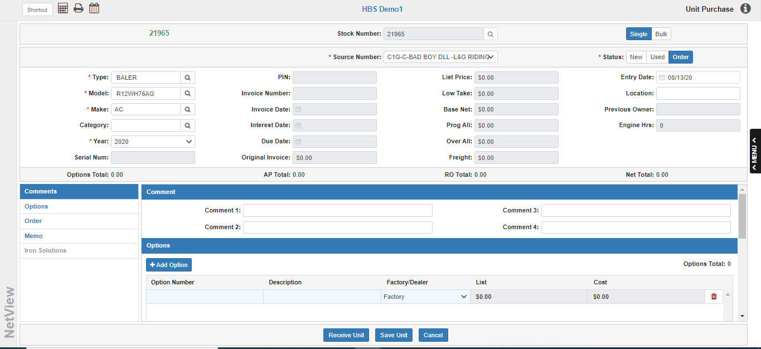

Save Unit: If you are not ready to receive the unit at this time, but need to make some changes to the record, make your edits as desired and then click Save Unit.

Receive Unit: Click this button when you are ready to receive the unit. The screen will change to allow you to finish the purchase:

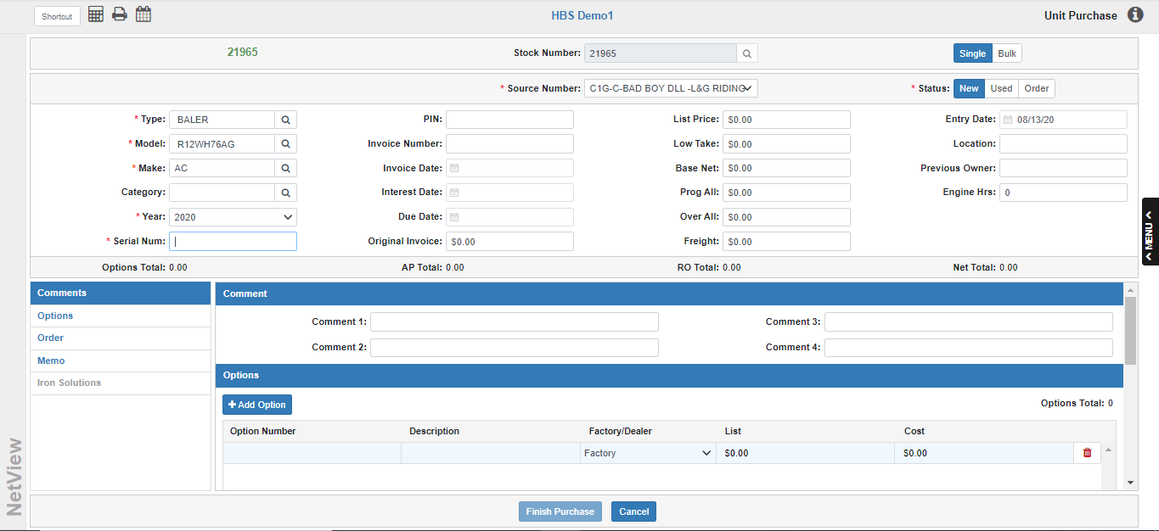

- The unit’s status will change from Order to New.
- All the fields previously disabled when the unit was in Order status are now enabled, so you can fill in the information needed to complete the purchase, like the Serial Number, Base Net, Invoice Number, and Invoice Date.
  - NOTE: The Serial Number field will be pre-filled with a temporary number generated by the system when it created the Ordered Unit. This is intended to be a placeholder until you enter the actual serial number from the received unit.
    - However, for orders placed with John Deere, DO NOT change the pre-filled value in the SN field. Changing the value will prevent the system from automatically updating this record with information imported from John Deere.

Fill in the screen as you would when purchasing a New unit.

Finish Purchase: Once you have filled in all the required fields, the Finish Purchase button will activate. Click it to access the Accounting screen:

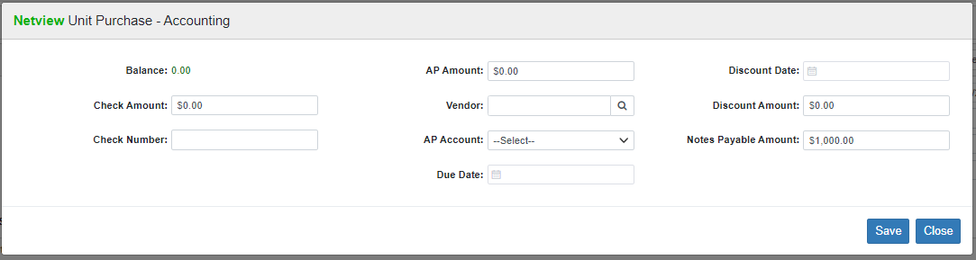

Complete the accounting as you would on any other unit purchase. When you’re done and the accounting is in balance (Balance=0.00), click Save to finish receiving the unit. The unit’s record in Unit Inquiry (UI) will automatically update to show its new status and add the information you inputted.

