Unit Sale (US)

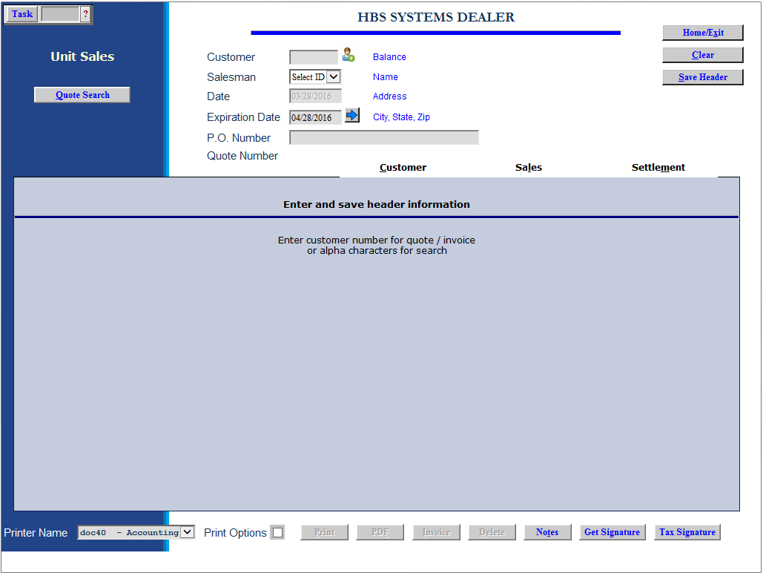

Unit Sales Invoicing can be used as a point-of-sale function since it produces a professional invoice. However, it can also be used to complete a unit sales transaction after the fact.

- To access this function, you can either:
  - Select “Units” from the menu. Choose the “Data Entry” submenu and click “Unit Sale.”
  - Type “US” in the Shortcuts Bar.

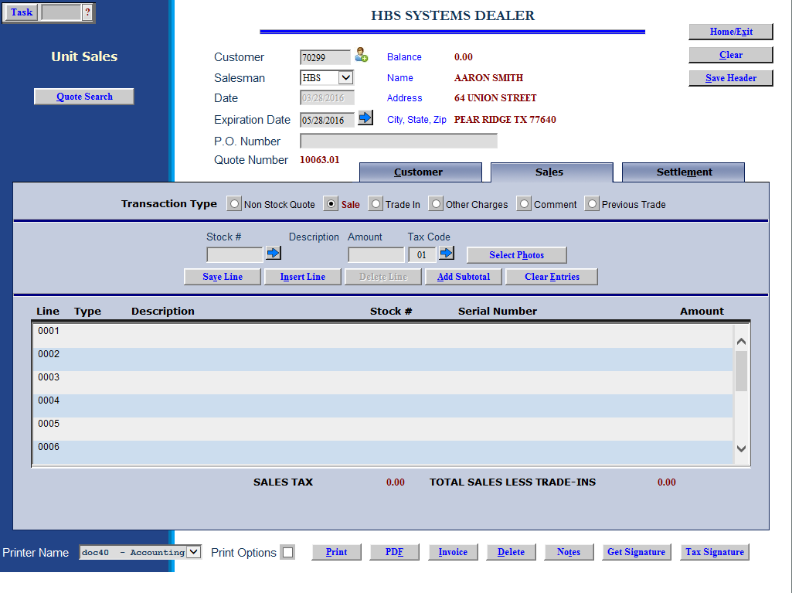

Field Definitions - Header

Customer #: Type in the customer number or use the search feature to find the customer’s number. You can also add a new customer by clicking on the icon of a person to the right of the field.

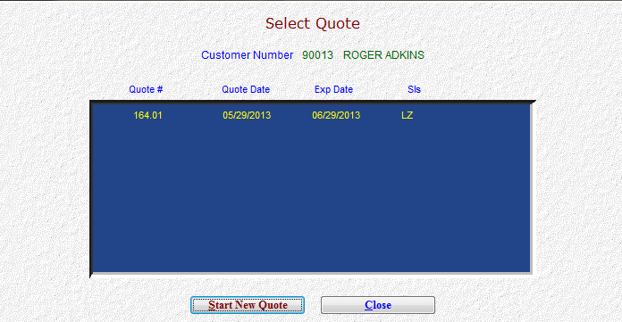

If there are quotes already available for this customer, a window will open showing the quote numbers. You are also offered the choice of “Start New Quote.”

Salesman: Identify the salesperson here. Type in his/her initials or employee number in the field shown. If you use initials, we recommend using all three initials to avoid possible duplicate initials.

Date: The system will pre-fill the current date in this space.

Expiration Date: The default date of one month from the current date is displayed. You may type in another date as needed or click on the arrow to the right for a calendar.

PO Number: You can enter the customer’s PO number here, if any.

Quote Number: The system provides the quote number for this transaction, which can be carried directly into a sales invoice.

Save Header (Alt S): Press the Save Header button to save the customer information and move on to the invoice.

Sales Tab (Alt l)—Transaction Types

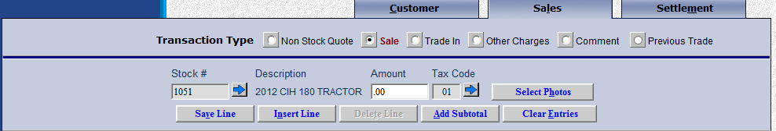

Sale: Use this transaction type to sell a unit you have in inventory to a customer.

- Stock #: Enter the stock number of the item or use the blue arrow to look it up.
- Description: The year, make, model, and type of the unit selected appear
- Amount: Here you enter the amount you are charging the customer for this unit.
- Tax Code: The customer’s typical tax code pre-fills here, but can be changed as necessary. Press the arrow to the right to look up available tax codes.
- Select Photos: This button is used for quotes only.
- Save Line (Alt V): When you finalize the line and press the “Save Line” button, the line appears in the general area in the lower part of the screen.

Non Stock Quote: This option is not applicable on a sales transaction as all units must be in-stock.

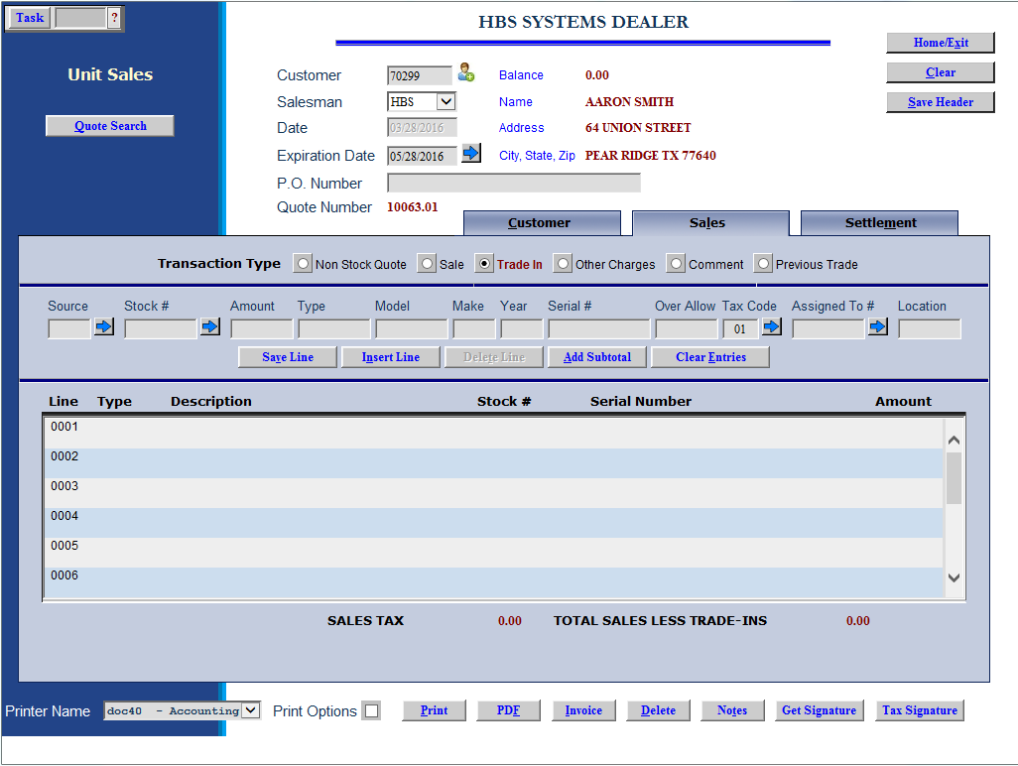

Trade In of unit not sold through the dealership: This line type shows a trade in item on the sale.

- Source: Choose the Unit source for the trade-in or search for it.
- Stock#: Enter the stock number for trade-in or press “Enter” to have the system assign it.
- Amount: Enter the amount to be given for the trade-in.
- Type: Enter the type of equipment being traded in.
- Model: Enter the model number of the trade-in.
- Make: Enter the make of the trade-in.
- Year: Type in the model year of the trade-in or use “1950” if it is unknown.
- Serial #: Enter the serial number of the trade-in unit here.
- Allowance: This field can hold the amount of the over-allowance of the trade-in. This means that the amount entered here will be subtracted from the Amount given for the trade and will net to the difference when in inventory.
- Tax Code: The customer’s typical tax code pre-fills here, but can be changed as necessary.
- Location: Enter the location where the trade has occurred.

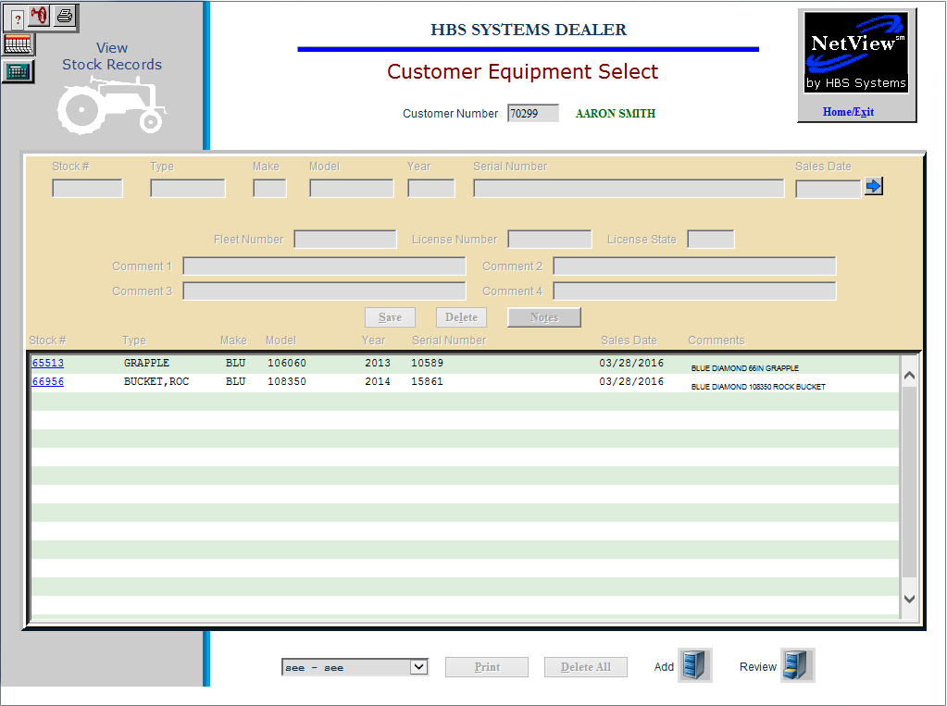

Trade In of unit previous sold to the customer or one owned by the customer: Click on the blue arrow to the right of the stock number to see those units.

- Source: Choose the Unit source for the trade-in or search for it.
- Stock#: Re-use the stock number already assigned to the unit.
- Amount: Enter the amount to be given for the trade-in.
- Type: Enter the type of equipment being traded in.
- Model: Enter the model number of the trade-in.
- Make: Enter the make of the trade-in.
- Year: Type in the model year of the trade-in or use “1950” if it is unknown.
- Serial #: Enter the serial number of the trade-in unit here.
- Allowance: This field can hold the amount of the over-allowance of the trade-in. This means that the amount entered here will be subtracted from the Amount given for the trade and will net to the difference when in inventory.
- Tax Code: The customer’s typical tax code pre-fills here, but can be changed as necessary.
- Location: Enter the location where the trade has occurred.

Trade In of unit when the washout feature is present: This feature enables another field when taking a trade-in: Assigned To #.

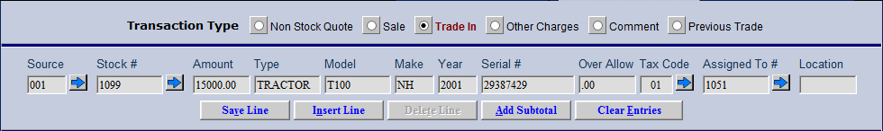

In this field you indicate the stock number that this trade in is to be applied against. For example, if you are selling a tractor and taking one on a trade, you would enter the stock number of the tractor being sold. If there are several units being sold and you are taking one or more trades, you will enter the stock number of one of the units being sold to tie the trade in the sale in the washout chain.

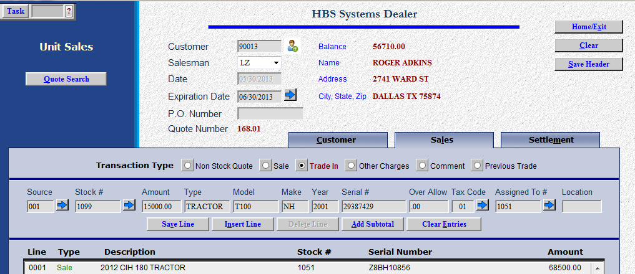

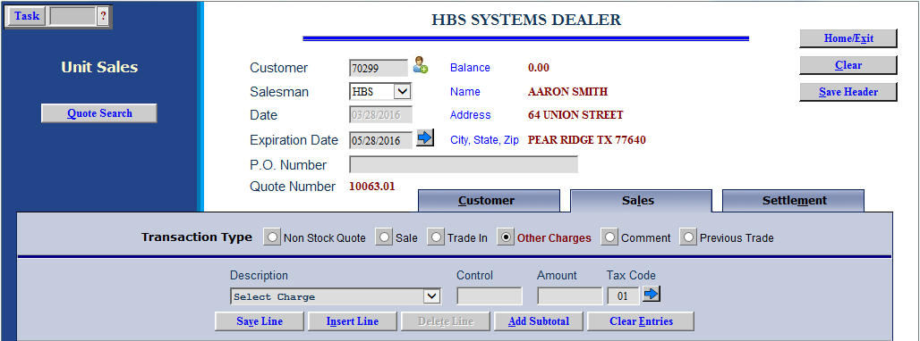

Other Charges: Select this button to add other charges related to the quote, i.e. fuel, delivery charges, extended warranty, etc.

- Select Charge: Choose the other charge from the drop-down menu.
- Control #: Enter a control if needed.
- Amount: Enter the amount of the charge in this field.
- Tax Code: The customer’s typical tax code pre-fills here, but can be changed as necessary.

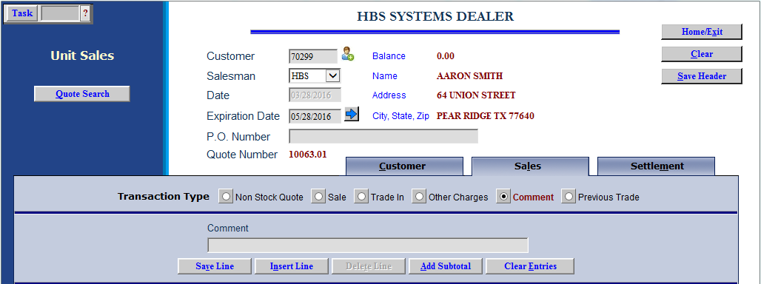

Comment: Type in additional information on comment lines. You can include as many as needed.

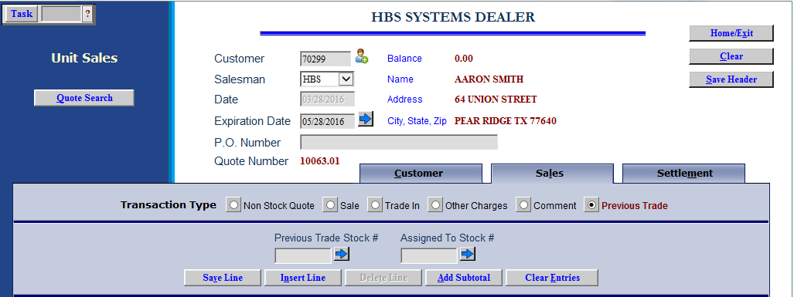

Previous Trade: In cases when a customer has made a trade-in when you do not have the purchased unit in inventory at the time of the trade, this option allows you to access the information on the traded-in unit at the time of the actual unit sale.

- Previous Trade Stock #: Enter the previous trade stock number or use the blue arrow button to look it up.
- Assigned To Stock #: Enter the stock number that you have assigned to the traded-in unit or use the arrow button to look it up.

Sales Tab (Alt l)—Buttons

Insert Line (Alt N): You may select this button on any new line or one that you re-select to edit.

Choose the exact place for the selected line:

After Last Line

As the First Line

After a Line Number of your choice

Press the Close button to position the line.

Delete Line (Alt D): You may select this button to delete the line in the editing area at the center of the screen.

Add Subtotal (Alt A): You may add a subtotal to the quote.

- Click this button and choose the position:
  - After Last Line
  - As the First Line
  - After a Line Number of your choice
- Press the Close button to position the subtotal.

Clear Entries (Alt E): Use this button to clear the line in the editing area in the center of the screen.

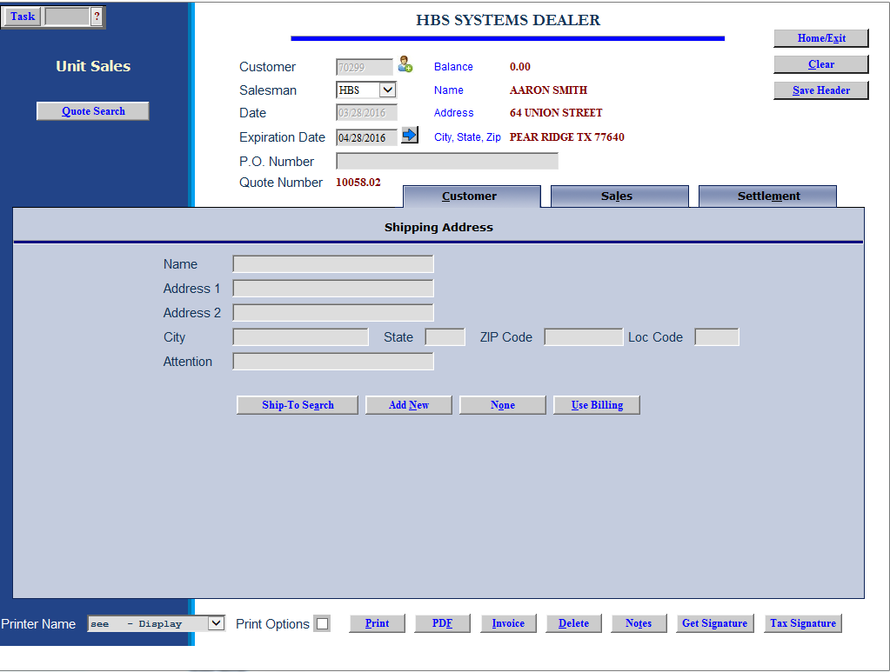

Customer Tab: This tab is only used when the unit is being delivered or shipped to the customer. In that case it is required to apply the correct sales tax rate to this transaction. This is helpful when the tax rate of the customer is different than the one at the dealership.

You may manually fill in the information on this panel. If you do that it is important to use the full zip-plus-four zip code to ensure proper sales tax calculation.

The Loc Code to the right of the zip code field is for Washington state dealerships using the SST tables to manually override the pre-selected tax rate with an entered one. You must enter the Fips code or location code in this field, not the tax rate.

Ship to Search: Use this button to search the ship to addresses for the customer.

Add New: Use this button to add a new ship address for the customer.

None: Use this button to close the tab and discard any entries made.

Use Billing: This button will copy the customer’s address from ECI in here to use for sales tax calculation.

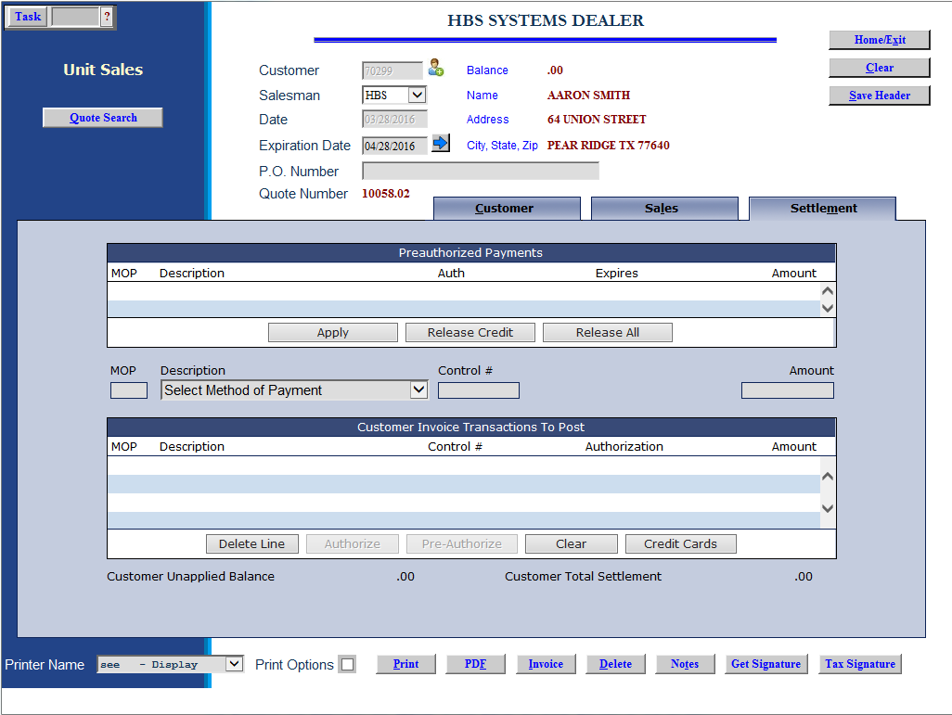

Settlement Tab (Alt m): Proceed to the settlement tab to record the customer’s payment. Press “Enter” to advance from field to field across the selected form of payment. As you move past the amount, the payment will appear in the panel on lower portion of the screen.

Description: Choose the form of payment from the drop-down menu or enter the MOP code.

Control: Enter a control number if necessary (probably needed for Financing, Customer Deposits, and possibly others).

Amount: Type in the amount for this form of payment.

Save Line (Alt V): When you finalize the line and press the Save Line button, the line appears in the general area in the lower part of the screen.

Delete Line (Alt t): You may select this button to delete the line in the editing area at the center of the screen.

Add as many forms of payment as needed. When done, the balance at the top of the screen must be 0.

Paying with Credit Card: If the desired method of payment is credit card, choose the appropriate card name from the drop-down menu. When you press “Enter,” the credit card screen appears.

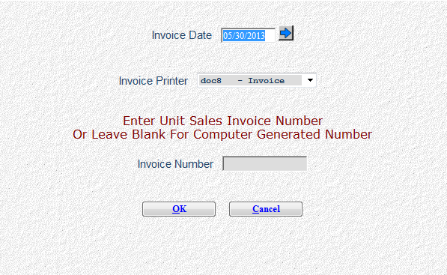

Invoice Date: The current date is pre-filled but can be changed as necessary.

Invoice Printer: A default printer is supplied but can be changed as needed.

Invoice Number: You may enter an invoice number in this field or press “Enter” to have the system generate the number.

Press OK (Alt O) to open EdgePay (EPIN) and proceed with the transaction.

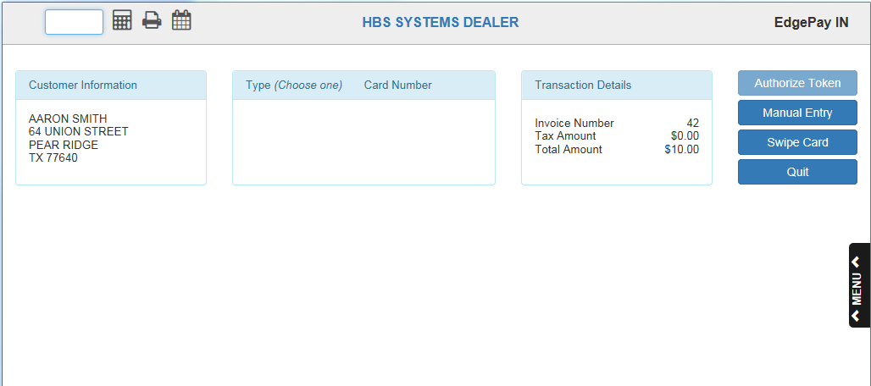

EdgePay (EPIN) Automated Credit Card System: At the credit card screen, if you have one of the credit card interfaces, you can:

Swipe the customer’s credit card

Use a token

Use a stored card number

Manually enter the credit card number

The authorization number is returned from the Clearing House and prints on the invoice. When the purchase clears, the screen displays a “Successful transaction” message and prints the sales invoice. If the transaction was not successful, a message will appear stating as much and informing you of what exactly went wrong. For more information, see the section on “EdgePay” in the documentation for “Customer Credit Card Maintenance (ECCR).”

Pre-authorized Payments: This allows you to “reserve” an amount on the customer’s credit card for the upcoming final billing. It works similar to credit card transactions, but you press the “Pre-Authorize” button at the bottom of the screen instead of the “Write Invoice” button. The Pre-Authorize request is then sent to credit card clearing house for processing. When it comes back, it appears in the upper portion of the screen as an available pre-authorize to use in the final billing of the invoice.

In that case, when the final billing is ready you would click on the line for the pre-authorization, and the press the Apply button to use the pre-authorization as part or all of the final payment. You may also press the Release button to release the pre-authorized funding from the customer’s credit card.

Enhanced Credit Card Security: Credit card information displayed in any of the settlement screens is encoded in the standard XXXX-XXX-1234 format (only showing the last 4 digits). Payment Card Industry (PCI) compliance standards have gone into effect for all merchants and many states have enacted laws to further protect sensitive credit card information. This release provides more changes to meet these new requirements.

What is PCI Compliance?: Payment Card Industry Data Security Standards (PCI DSS) are network security and business practice guidelines adopted by Visa, Mastercard, American Express, Discover Card, and JCB to establish a “minimum security standard” to protect customer’s payment card information. It’s a requirement for all merchants that store, transmit, or process payment card information.

Bottom Screen Options: Once the balance (top center) has been cleared to zero, you have several options at the bottom of the screen.

Print Options: Click this selection to print the Options detail for the unit on the invoice.

Print: This is a selection for quotes only.

PDF: This is a selection for quotes only.

Invoice: This generates a sales invoice for the details entered. When you click it, the following screen will appear:

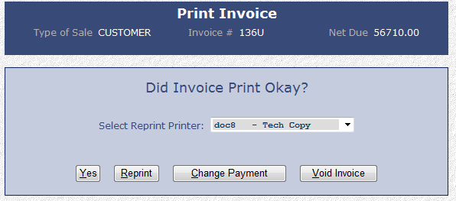

Yes: Choose “Yes” if the invoice has printed successfully.

Reprint: Click this button to get another copy of the invoice.

Change Payment: Choose this to change the payment type on the invoice. You will be taken back to the Settlement tab to make the changes. NOTE: This will result in the invoice number changing from the one chosen or generated.

Void Invoice: This button abandons the sales process and leaves the information open as a quote.

Delete: This discards the sales transaction (not recommended if the credit approval has already been received).

Notes: This gives you access to the Notes on the units of the invoice.

Get Signature: This button is available for capturing the customer’s signature on the invoice.

Tax Signature: This button attaches the valid tax exemption signature to the document. This is currently required only for Texas-based dealers.

Sample Unit Invoice

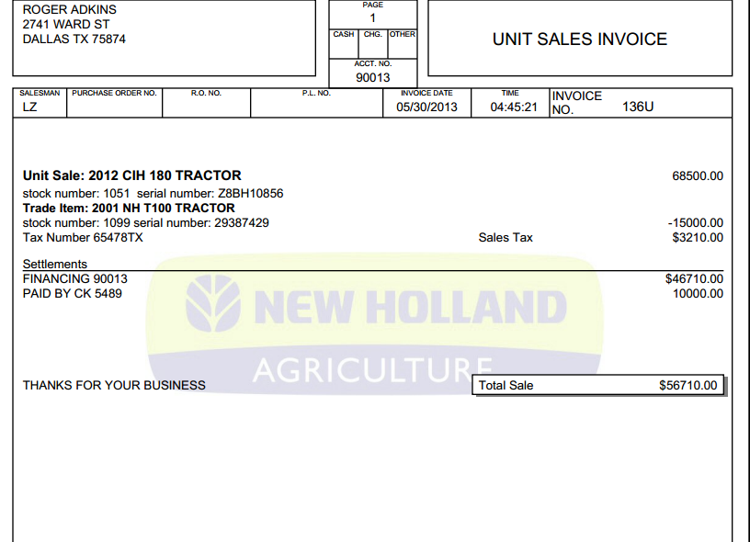

Preparing A Quote

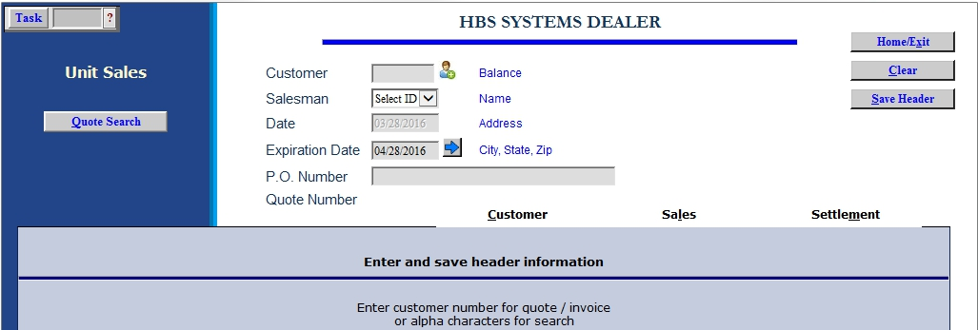

US lets you prepare quotes that include inventory items, non stock items, trade ins, and related charges The quotes can be retreived and turned into sales invoices as needed.

Field Definitions - Header

Customer #: Type in the customer number or use the search feature to find the customer’s number. You can also add a new customer by clicking on the icon of a person to the right of the field.

If there are quotes already available for this customer, a window will open showing the quote numbers. You are also offered the choice of “Start New Quote.”

Salesman: Identify the salesperson here.

Type in his/her initials or employee number in the field shown. If you use initials, we recommend using all three initials to avoid possible duplicate initials.

If you have CRM installed, you will choose the initials from a drop-down menu.

Date: The system will pre-fill the current date in this space.

Expiration Date: The default date of one month from the current date is displayed. You may change it as needed.

PO Number: You can enter the customer’s PO number here, if any.

Quote Number: The system provides the quote number for this transaction.

Save Header (Alt S): Press this button to save the customer information and move on to the quote.

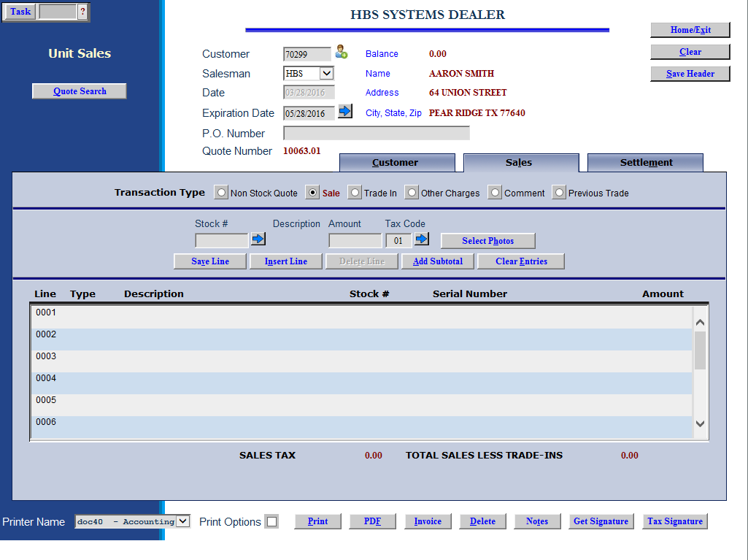

Sales Tab—Transaction Types

Sale (quote!): Use this transaction type to quote a unit you have in inventory to a customer.

- Stock #: Enter the stock number of the item the customer is interested in or use the arrow to the right of the field to look it up.
- Description: The year, make, model, and type of the unit selected appear.
- Amount: Enter the amount you are quoting the customer for this unit.
- Tax Code: The customer’s typical tax code pre-fills here, but can be changed as necessary.
- Select Photos: Click this button to add pictures to the quote. You can either use images saved in the unit record (UI/UM) or add new images from outside the system. You can add a maximum of 4 images to the quote (as the printout can only hold that many).
- Save Line: When you finalize the line and press the “Save Line” button, the line appears in the general area in the lower part of the screen.

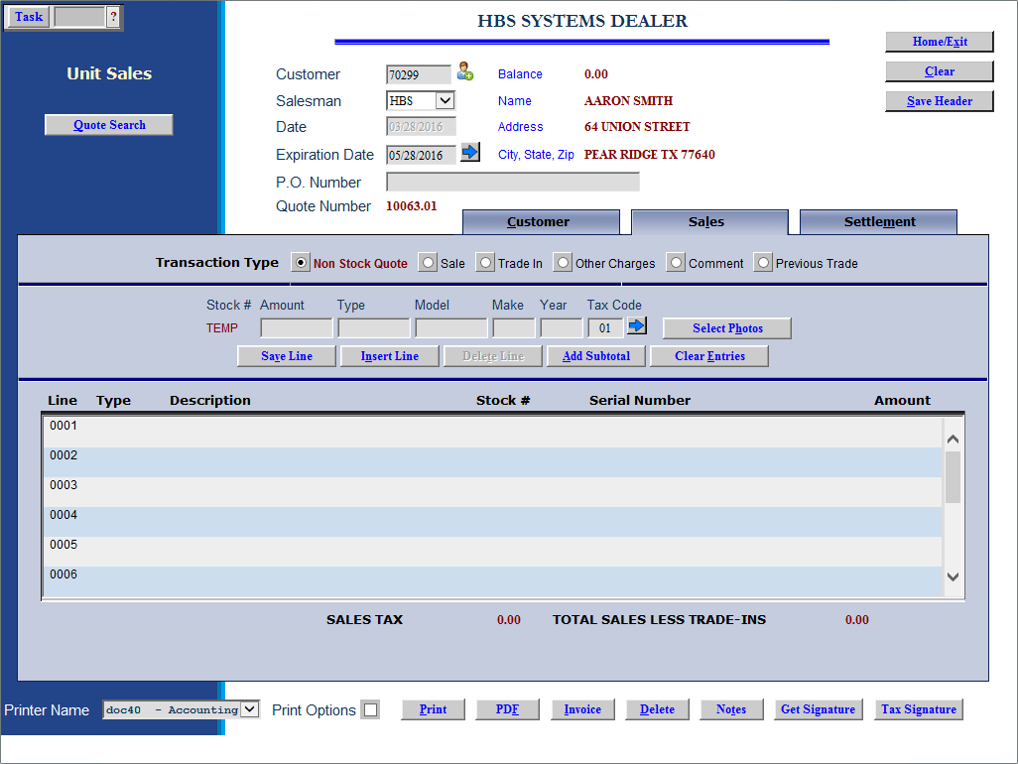

Non Stock Quote: Use this option to enter the information about a unit you do not have in inventory. The system assigns stock # TEMP to these items on the quote. Complete the fields on this line.

- Amount: Enter the amount you are quoting to the customer.
- Type: Enter the type of unit being quoted, i.e., tractor, bailer, loader, etc.
- Model: Enter the model number here.
- Make: Type in the manufacturer or make of the unit.
- Year: Enter the model year in this field.
- Tax Code: The customer’s typical tax code pre-fills here, but can be changed as necessary.
- Save Line (Alt V): When you finalize the line and press the Save Line button, the line appears in the general area in the lower part of the screen.

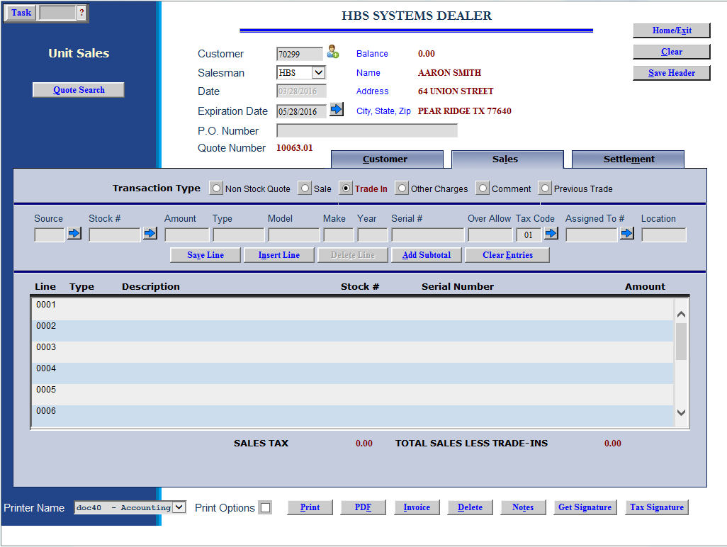

Trade In of unit not sold through the dealership: This line type shows a trade in item on the quote.

- Source: Choose the Unit source for the trade-in or search for it.
- Stock#: Enter the stock number for trade-in or press “Enter” to have the system assign it.
- Amount: Enter the amount to be given for the trade-in.
- Type: Enter the type of equipment being traded in.
- Model: Enter the model number of the trade-in.
- Make: Enter the make of the trade-in.
- Year: Type in the model year of the trade-in or use “0000” if it is unknown.
- Serial #: Enter the serial number of the trade-in unit here.
- Allowance: This field can hold the amount of the over-allowance of the trade-in. This means that the amount entered here will be subtracted from the Amount given for the trade and will net to the difference when in inventory.
- Tax Code: The customer’s typical tax code pre-fills here, but can be changed as necessary.
- Location: Enter the location where the trade has occurred.

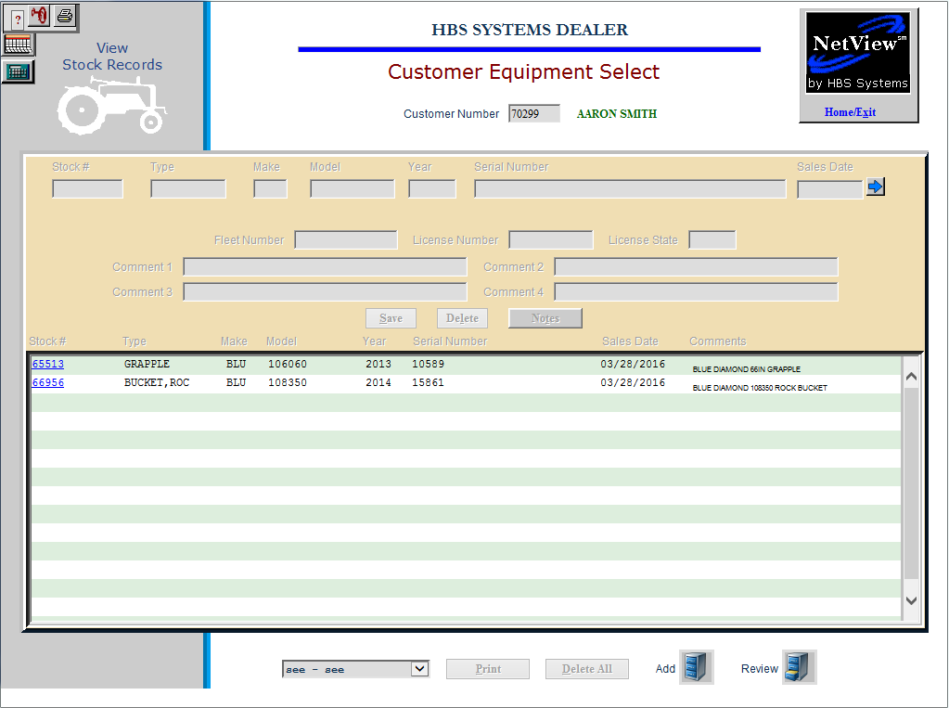

Trade In of unit previous sold to the customer or one owned by the customer: Click on the blue arrow to the right of the stock number to see those units.

- Source: Choose the Unit source for the trade-in or search for it.
- Stock#: Re-use the stock number already assigned to the unit.
- Amount: Enter the amount to be given for the trade-in.
- Type: Enter the type of equipment being traded in.
- Model: Enter the model number of the trade-in.
- Make: Enter the make of the trade-in.
- Year: Type in the model year of the trade-in or use “1950” if it is unknown.
- Serial #: Enter the serial number of the trade-in unit here.
- Allowance: This field can hold the amount of the over-allowance of the trade-in. This means that the amount entered here will be subtracted from the Amount given for the trade and will net to the difference when in inventory.
- Tax Code: The customer’s typical tax code pre-fills here, but can be changed as necessary.

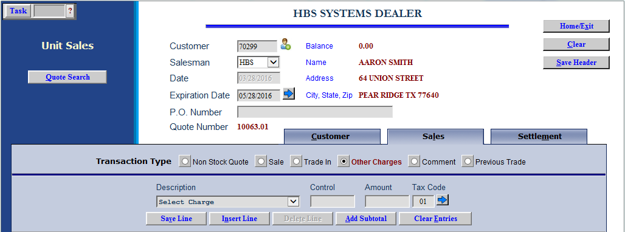

Other Charges: Select this button to add other charges related to the quote, i.e., fuel, delivery charges, extended warranty, etc.

- Select Charge: Choose the other charge from the drop-down menu.
- Control #: Enter a control if needed.
- Amount: Enter the amount of the charge in this field.
- Tax Code: The customer’s typical tax code pre-fills here, but can be changed as necessary.

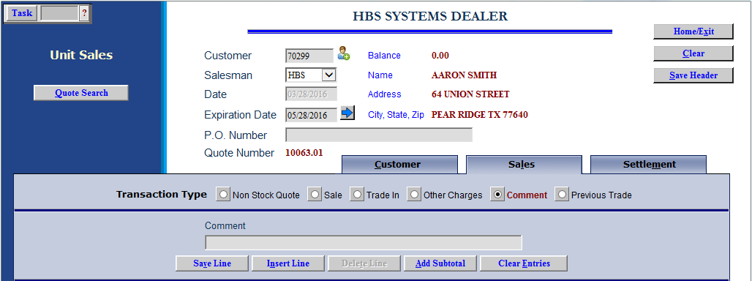

Comment: Type in additional information on comment lines. You can include as many as needed.

Previous Trade: In cases when a customer has made a trade-in when you do not have the purchased unit in inventory at the time of the trade, this option allows you to access the information on the traded-in unit at the time of the actual unit sale.

- Previous Trade Stock #: Enter the previous trade stock number or use the blue arrow button to look it up.
- Assigned To Stock #: Enter the stock number that you have assigned to the traded-in unit or use the arrow button to look it up.

Sales Tab—Buttons

Insert Line (Alt N): You may select this button on any new line or one that you re-select to edit.

Choose the exact place for the selected line:

After Last Line

As the First Line

After a Line Number of your choice

Press the Close button to position the line.

Delete Line (Alt D): You may select this button to delete the line in the editing area at the center of the screen.

Add Subtotal (Alt A): You may add a subtotal to the quote.

- Click this button and choose the position:
  - After Last Line
  - As the First Line
  - After a Line Number of your choice
- Press the Close button to position the subtotal.

Clear Entries (Alt E): Use this button to clear the line in the editing area in the center of the screen.

Print Options for Quotes

Printer Name: A default printer name is shown, but you may change it as necessary.

Print (Alt P): Press this button to generate a quote that will print on pre-printed forms in your printer (pre-printed Unit Sales Invoice form). The quote is automatically saved for later retrieval.

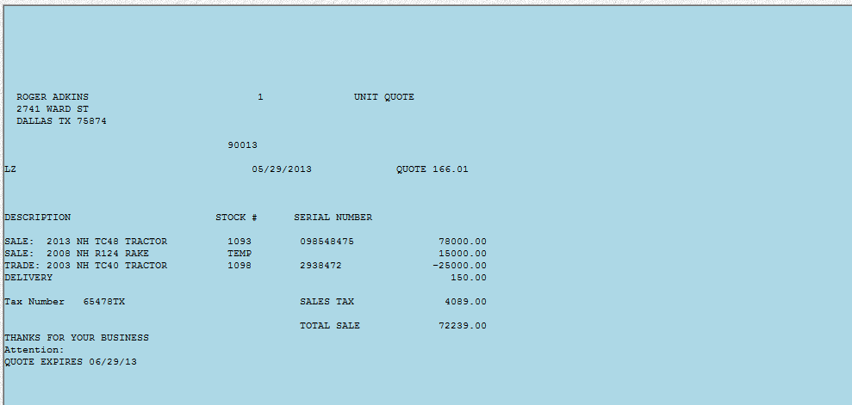

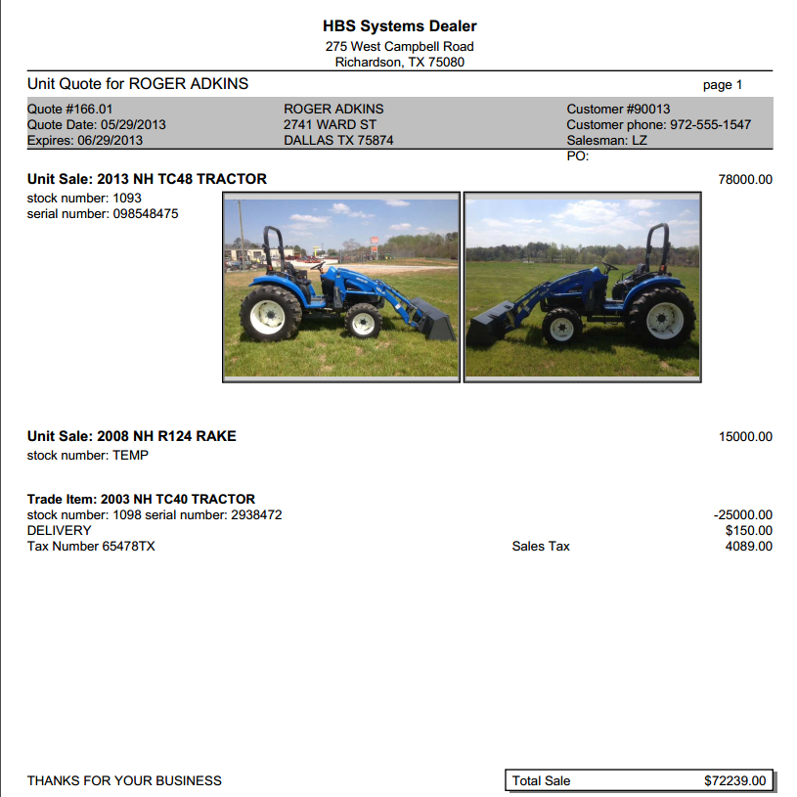

PDF (Alt F): Press the PDF button to produce a full-color quote that includes any attached pictures. Once the PDF file is generated, you can print it on any laser or inkjet printer or email it. The quote is automatically saved for later retrieval.

The Sale from a Quote

A previously prepared quote can be retrieved to convert to a Unit Sales Invoice.

There are two ways to retrieve the quote:

- Type in the customer’s number or search (Alt u) for it. Active quotes for that customer will appear in a new window(see image below). You can select the quote and convert it to a sale.

- Press the Quote Search button (Alt Q) at the left. This provides the ability to search for the quote via customers, dates, salesmen, quote numbers, or even stock numbers. You can look at active or expired quotes or both.

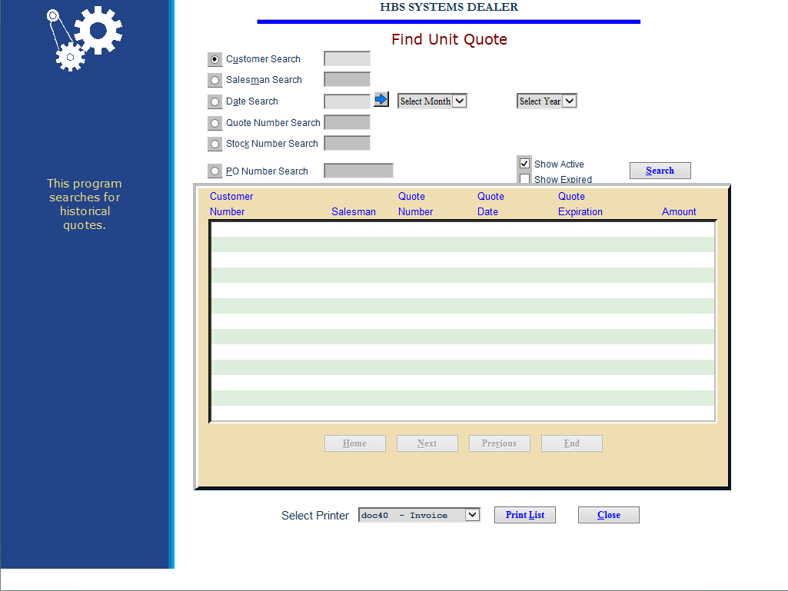

Quote Search:

- Select the quote to convert and it will draw it into Unit Sales. Then press the Save Header (Alt V) button.
- Verify the information about the units on the sales tab.

Sales Tab—Transaction Types

Sale: Use this transaction type to sell a unit you have in inventory to a customer.

- Stock #: Enter the stock number of the item or use the blue arrow to look it up.
- Description: The year, make, model, and type of the unit selected appear
- Amount: Here you enter the amount you are charging the customer for this unit.
- Tax Code: The customer’s typical tax code pre-fills here, but can be changed as necessary. Press the arrow to the right to look up available tax codes.
- Select Photos: This button is used for quotes only.
- Save Line (Alt V): When you finalize the line and press the Save Line button, the line appears in the general area in the lower part of the screen.

Non Stock Quote: This option is not applicable on a sales transaction as all units must be in-stock. If your quote had one of these items, it will need to be removed and replaced with an in-stock unit.

Trade In of unit not sold through the dealership: This line type shows a trade in item on the sale.

- Source: Choose the Unit source for the trade-in or search for it.
- Stock#: Enter the stock number for trade-in or press “Enter” to have the system assign it.
- Amount: Enter the amount to be given for the trade-in.
- Type: Enter the type of equipment being traded in.
- Model: Enter the model number of the trade-in.
- Make: Enter the make of the trade-in.
- Year: Type in the model year of the trade-in or use “1950” if it is unknown.
- Serial #: Enter the serial number of the trade-in unit here.
- Allowance: This field can hold the amount of the over-allowance of the trade-in. This means that the amount entered here will be subtracted from the Amount given for the trade and will net to the difference when in inventory.
- Tax Code: The customer’s typical tax code pre-fills here but can be changed as necessary.
- Location: Enter the location where the trade has occurred.

Trade In of unit previous sold to the customer or one owned by the customer: Click on the blue arrow to the right of the stock number to see those units.

- Source: Choose the Unit source for the trade-in or search for it.
- Stock#: Re-use the stock number already assigned to the unit.
- Amount: Enter the amount to be given for the trade-in.
- Type: Enter the type of equipment being traded in.
- Model: Enter the model number of the trade-in.
- Make: Enter the make of the trade-in.
- Year: Type in the model year of the trade-in or use “1950” if it is unknown.
- Serial #: Enter the serial number of the trade-in unit here.
- Allowance: This field can hold the amount of the over-allowance of the trade-in. This means that the amount entered here will be subtracted from the Amount given for the trade and will net to the difference when in inventory.
- Tax Code: The customer’s typical tax code pre-fills here, but can be changed as necessary.
- Location: Enter the location where the trade has occurred.

Trade In of unit when the washout feature is present: This feature enables another field when taking a trade-in: Assigned To #

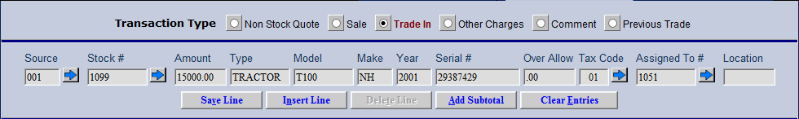

In this field you indicate the stock number that this trade in is to be applied against. For example, if you are selling a tractor and taking one on a trade, you would enter the stock number of the tractor being sold. If there are several units being sold and you are taking one or more trades, you will enter the stock number of one of the units being sold to tie the trade in the sale in the washout chain.

Other Charges: Select this button to add other charges related to the quote, i.e. fuel, delivery charges, extended warranty, etc.

- Select Charge: Choose the other charge from the drop-down menu.
- Control #: Enter a control if needed.
- Amount: Enter the amount of the charge in this field.
- Tax Code: The customer’s typical tax code pre-fills here, but can be changed as necessary.

Comment: Type in additional information on comment lines. You can include as many as needed.

Previous Trade: In cases when a customer has made a trade-in when you do not have the purchased unit in inventory at the time of the trade, this option allows you to access the information on the traded-in unit at the time of the actual unit sale.

- Previous Trade Stock #: Enter the previous trade stock number or use the blue arrow button to look it up.
- Assigned To Stock #: Enter the stock number that you have assigned to the traded-in unit or use the arrow button to look it up.

Sales Tab—Buttons

Insert Line (Alt N): You may select this button on any new line or one that you re-select to edit.

- Choose the exact place for the selected line:
  - After Last Line
  - As the First Line
  - After a Line Number of your choice
- Press the Close button to position the line.

Delete Line (Alt D): You may select this button to delete the line in the editing area at the center of the screen.

Add Subtotal (Alt A): You may add a subtotal to the quote.

- Click this button and choose the position:
  - After Last Line
  - As the First Line
  - After a Line Number of your choice
- Press the Close button to position the subtotal.

Clear Entries (Alt E): Use this button to clear the line in the editing area in the center of the screen.

Customer Tab: This tab is only used when the unit is being delivered or shipped to the customer. In that case it is required to apply the correct sales tax rate to this transaction. This is helpful when the tax rate of the customer is different than the one at the dealership.

You may manually fill in the information on this panel. If you do that it is important to use the full zip-plus-four zip code to ensure proper sales tax calculation.

The Loc Code to the right of the zip code field is for Washington state dealerships using the SST tables to manually override the pre-selected tax rate with an entered one. You must enter the Fips code or location code in this field, not the tax rate.

Ship to Search: Use this button to search the ship to addresses for the customer.

Add New: Use this button to add a new ship address for the customer.

None: Use this button to close the tab and discard any entries made.

Use Billing: This button will copy the customer’s address from ECI in here to use for sales tax calculation.

Settlement Tab (Alt m): Proceed to the settlement tab to record the customer’s payment. Press “Enter” to advance from field to field across the selected form of payment. As you enter past the amount, the payment will appear in the panel on lower portion of the screen.

Description: Choose the form of payment from the drop-down menu or enter the MOP code.

Control: Enter a control number if necessary (probably needed for Financing, Customer Deposits, and possibly others).

Amount: Type in the amount for this form of payment.

Save Line (Alt V): When you finalize the line and press the “Save Line” button, the line appears in the general area in the lower part of the screen.

Delete Line (Alt t): You may select this button to delete the line in the editing area at the center of the screen.

Add as many forms of payment as needed. When done, the balance at the top of the screen must be 0.

Paying with Credit Card: If the desired method of payment is credit card, choose the appropriate card name from the drop-down menu. When you press “Enter,” the credit card screen appears.

Invoice Date: The current date is pre-filled but can be changed as necessary.

Invoice Printer: A default printer is supplied but can be changed as needed.

Invoice Number: You may enter an invoice number in this field or press “Enter” to have the system generate the number.

Press OK (Alt O) to open EdgePay (EPIN) and proceed with the transaction.

EdgePay (EPIN) Automated Credit Card System: At the credit card screen, if you have one of the credit card interfaces, you can:

swipe the customer’s credit card

use a token

use a stored card number

manually enter the credit card number

The authorization number is returned from the Clearing House and prints on the invoice. When the purchase clears, the screen displays a “Successful transaction” message and prints the sales invoice. If the transaction was not successful, a message will appear stating as much and informing you of what exactly went wrong. For more information, see the section on “EdgePay” in the documentation for “Customer Credit Card Maintenance (ECCR).”

Pre-authorized Payments: This allows you to “reserve” an amount on the customer’s credit card for the upcoming final billing. It works similar to credit card transactions, but you press the “Pre-Authorize” button at the bottom of the screen instead of the “Write Invoice” button. The Pre-Authorize request is then is sent to credit card clearing house for processing. When it comes back, it appears in the upper portion of the screen as an available pre-authorize to use in the final billing of the invoice.

In that case, when the final billing is ready you would click on the line for the pre-authorization, and the press the Apply button to use the pre-authorization as part or all of the final payment. You may also press the Release button to release the pre-authorized funding from the customer’s credit card.

Enhanced Credit Card Security: Credit card information displayed in any of the settlement screens is encoded in the standard XXXX-XXX-1234 format (only showing the last 4 digits). Payment Card Industry (PCI) compliance standards have gone into effect for all merchants and many states have enacted laws to further protect sensitive credit card information. This release provides more changes to meet these new requirements.

What is PCI Compliance?: Payment Card Industry Data Security Standards (PCI DSS) are network security and business practice guidelines adopted by Visa, Mastercard, American Express, Discover Card, and JCB to establish a “minimum security standard” to protect customer’s payment card information. It’s a requirement for all merchants that store, transmit or process payment card information.

Bottom Screen Options: Once the balance (top center) has been cleared to zero, you have several options at the bottom of the screen.

Print Options: Click this selection to print the Options detail for the unit on the invoice.

Print: This is a selection for quotes only.

PDF: This is a selection for quotes only.

Invoice: This generates a sales invoice for the details entered. When you click it, the following screen will appear:

Yes: Choose Yes if the invoice has printed successfully.

Reprint: Click this button to get another copy of the invoice.

Change Payment: Choose this to change the payment type on the invoice. You will be taken back to the Settlement tab to make the changes. NOTE: This will result in the invoice number changing from the one chosen or generated.

Void Invoice: This button abandons the sales process and leaves the information open as a quote.

Delete: This discards the sales transaction (not recommended if the credit approval has already been received).

Notes: This gives you access to the Notes on the units of the invoice.

Get Signature: This button is available for capturing the customer’s signature on the invoice.

Tax Signature: This button attaches the valid tax exemption signature to the document. This is currently required only for Texas-based dealers.

Sample Unit Invoice

