Unit Source Maintenance (USM)

Unit Sources are the way the HBS System categorizes the different kinds of equipment in your inventory. The definition of a “source” will vary from dealership to dealership and is dependent on two key factors:

- The manufacturers you carry
- Sources of financing for your dealership

These characteristics are determined by a definition of General Ledger accounts, which are created in Unit Source Maintenance (USM).

WARNING!!!: DO NOT LEAVE ANY FIELDS IN A SOURCE RECORD BLANK.

Since Unit Source Codes are alphanumeric, how you choose them is really a matter of personal preference. Often the Vendor Price File numbers are used as the source codes. An abbreviation of the vendor is also acceptable (such as “KUB” for Kubota or “MAS” for Massey Ferguson).

For example, if your dealership carries Kubota, Massey Ferguson, Bush Hog, and a number of smaller short lines AND you as a dealership only finance the equipment through the manufacturers, your sources might look like this:

- KUB (Kubota)
- MAS (Massey Ferguson)
- BUS (Bush Hog)
- MIS (Miscellaneous Other Equipment)

However, if your dealership finances its inventory through the manufacturer or a bank or a finance company, they might look like this:

- KUK (Kubota financed through Kubota)
- KUC (Kubota financed through the Canbury Bank)
- KUF (Kubota financed through a Finance Co.)
- MFA (Massey financed through Agco)
- MFC (Massey financed through the Canbury Bank)
- MFF (Massey financed through a Finance Co.)
- BHB (Bush Hog financed through Bush Hog)
- BHC (Bush Hog financed through the Canbury Bank)
- BHF (Bush Hog financed through a Finance Co.)
- MIM (Misc. Equipment financed through the Manufacturer)
- MIC (Misc. Equipment financed through the Canbury Bank)
- MIF (Misc. Equipment financed through a Finance Co.)

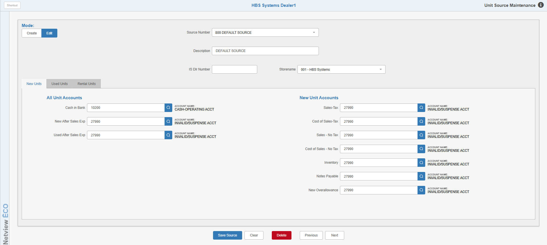

To access this function, you can either:

- Select “Units” from the menu. Choose the “Data Entry” submenu and click “Unit Source Maintenance.”
- Type “USM” in the Shortcuts Bar.

General Field Descriptions

Mode: This option controls how you intend to use the screen.

- Edit is the default mode and enables you to edit existing Source records.
- Change the option to Create if you want to add a new Source record.

Source Number: This field holds the Source Number for the selected source.

In Create mode, type in the number to begin creating the source record. It must be exactly 3 characters long and can consist of numbers, letters, or a mixture of both.

In Edit mode, select the source from the drop-down menu in order to open its record. You can also type in the number or its description to locate the source in the menu and select it.

Description: This field describes the unit source. A good description includes the type of equipment and the financing source. Examples: NH Equipment financed through NH, NH Equipment financed through the bank, Massey Ferguson Equipment financed through AGCO. NOTE: The description will also be displayed in the “Source Number” field in Edit mode.

IS Dlr Number: This is part of the setup for the Iron Solutions Interface. This field must contain the IS Dealer Number for the dealer location. This will allow multi-location dealers to identify in which location the inventory resides. Each location must have a unique number. The information required for these fields will be provided by Iron Solutions on EACH of the Unit Source records for the units being submitted through the interface.

Storename: This field is used by the NetView Rental system to show the location associated with the source. Use the drop-down menu to select an ID. NOTE: If the dealership is a single location, there will only be 1 option.

New Units Tab:

Cash In Bank: The Cash in Bank field is used at the time a unit is purchased. If you paid for the unit (or a portion of it) with a check at the time of purchase, the system will automatically credit the account number shown in this field.

New After Sales Expense: This field is used for any expense that is associated with a specific sold unit (i.e. prep for delivery, detail work, oil change, etc.) that had a previous status of New. If an Internal repair order is posted to a sold piece of equipment that was previously new, it will be charged (debited) to the account shown in the New After Sales Expense field.

Used After Sales Expense: This field is used for any expense that is associated with a specific sold unit (i.e. prep for delivery, detail work, oil change, etc.) that had a previous status of Used. If an Internal repair order is posted to a sold piece of equipment that was previously used, it will be charged (debited) to the account shown in the Used After Sales Expense field.

TIP—Taxable/Non-Taxable Fields: When making a unit sale, the system looks to the source file for the appropriate taxable or nontaxable account numbers.

If you indicate the unit being sold is taxable, the system will use the Taxable sales and cost of sales account numbers.

Likewise, if you say the unit being sold is not taxable, the system will use the Nontaxable sales and cost of sales account numbers.

Sales—Tax: This field holds the account number where taxable sales of new equipment for this source should be directed. The typical account number range for this account is 32001 through 32991. Type in the account number or search for it.

Cost of Sales—Tax: This field holds the account number where the cost of sales for taxable sales of new equipment for this source should be directed. The typical account number range for this account is 52001 through 52991.

Sales—No Tax: This field holds the account number where nontaxable sales of new equipment for this source should be directed. The typical account number range for this account is 32001 through 32991.

Cost of Sales—No Tax: This field holds the account number where the cost of sales for nontaxable sales of new equipment for this source should be directed. The typical account number range for this account is 52001 through 52991.

Inventory: This field holds the account number where the inventory of new equipment for this source should be directed. The typical account number range for this account is 12001 through 12991.

Notes Payable: This field holds the account number where notes payable amounts for new equipment for this source should be directed. The typical account number range for this account is 20200 through 20390.

New Overallowance: This field is normally used when accepting a trade-in at the time of sale. If you give the customer more for the used piece of equipment being traded than what you want to keep on the books for that unit, you could call this an over-allowance. Such amounts will “debit” the account number shown in this field. Typically, this is a sale or cost account in the Units section of your chart of accounts. Any amount entered as the over-allowance during a unit sale will reduce the value of the incoming trade-in and the offset will be applied to whatever account you indicate here. This field specifically deals with over-allowances applied to units with a previous status of New, as identified by their stock number.

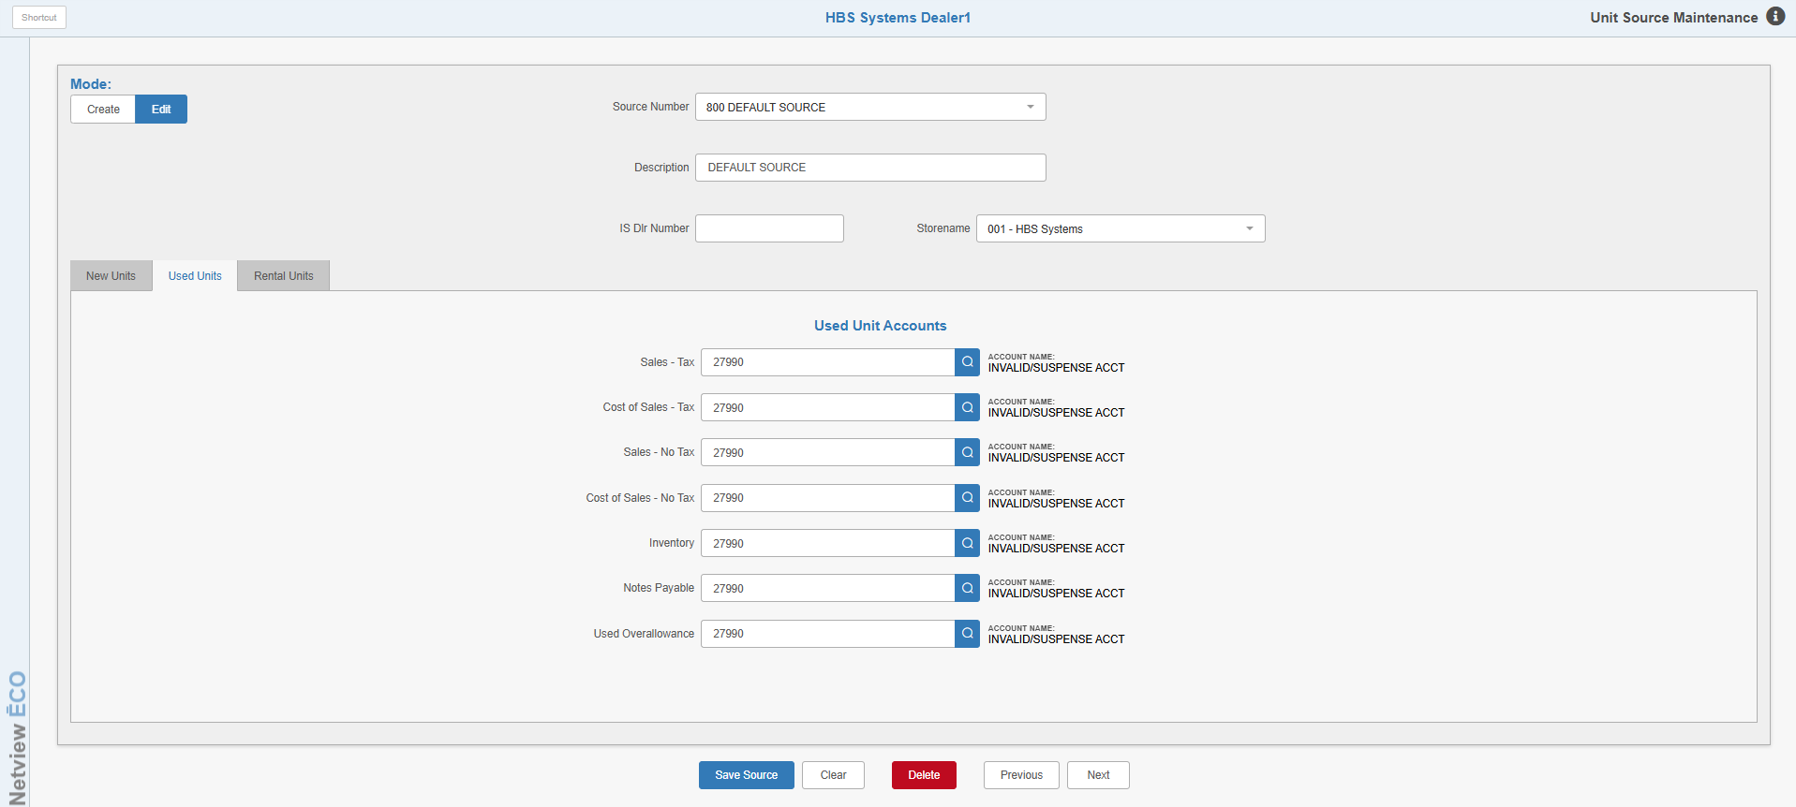

Used Units Tab:

Sales—Tax: This field holds the account number where taxable sales of used equipment for this source should be directed. The account number range for this account is 33001 through 33991.

Cost of Sales—Tax: This field holds the account number where the cost of sales for taxable sales of used equipment for this source should be directed. The number range for this account is 53001 through 53991.

Sales—No Tax: This field holds the account number where nontaxable sales of used equipment for this source should be directed. The number range for this account is 33001 through 33991.

Cost of Sales—No Tax: This field holds the account number where the cost of sales for nontaxable sales of used equipment for this source should be directed. The typical number range for this account is 53001 through 53991.

Inventory: This field holds the account number where the inventory of used equipment for this source should be directed. The typical number range for this account is 13001 through 13991.

Notes Payable: This field holds the account number where Notes Payable amounts for used equipment for this source should be directed. The typical number range for this account is 20400 through 20490.

Used Overallowance: This field is normally used when accepting a trade-in at the time of sale. If you give the customer more for the used piece of equipment being traded than what you want to keep on the books for that unit, you could call this an over-allowance. Such amounts will “debit” the account number shown in this field. Typically, this is a sale or cost account in the Units section of your chart of accounts. Any amount entered as the over-allowance during a Unit sale will reduce the value of the incoming trade-in and the offset will be applied to whatever account you indicate here. This field specifically deals with over-allowances applied to units with a previous status of Used, as identified by their stock number.

TIP—One source versus separate sources for New and Used: The Unit sources are designed so that you can have a single source for each line of equipment. For example, if you are a New Holland dealer, probably all of your New Holland equipment is in the same source. It does not matter if it is a new, used, or rental item. In this case you would use the same source number for all New Holland equipment with the same financing source. The source looks at the Status field on the unit to determine the set of accounts to use. If the unit is new, the system will use the series of account numbers designated for New equipment. Likewise, if the unit is used, the system will use the account numbers designated for Used equipment. A short sample of sources created like this might be:

- KUB (New & Used Kubota)
- MAS (New & Used Massey Ferguson)
- BUS (New & Used Bush Hog)
- MIS (New & Used Other Equipment)

However, some dealers prefer to use separate new and used sources. This separation allows for specific over-allowance and after sales expense accounts references for both new and used equipment. In these cases, the new sources are created just for new units. The fields for used units are typically filled with the invalid account (27990) or the
Unit Invalid account (27980), so mistaken entries there are easier found. Often a single used source is created which handles all used units. In this case, the fields for new units are typically filled with the Invalid account (27990) or the Unit Invalid account (27980) so mistaken entries there are easier found. A short sample of sources created like this might be:

- KUB (New Kubota)
- MAS (New Massey Ferguson)
- BUS (New Bush Hog)
- MIS (New Other Equipment)
- USE (Used Equipment)

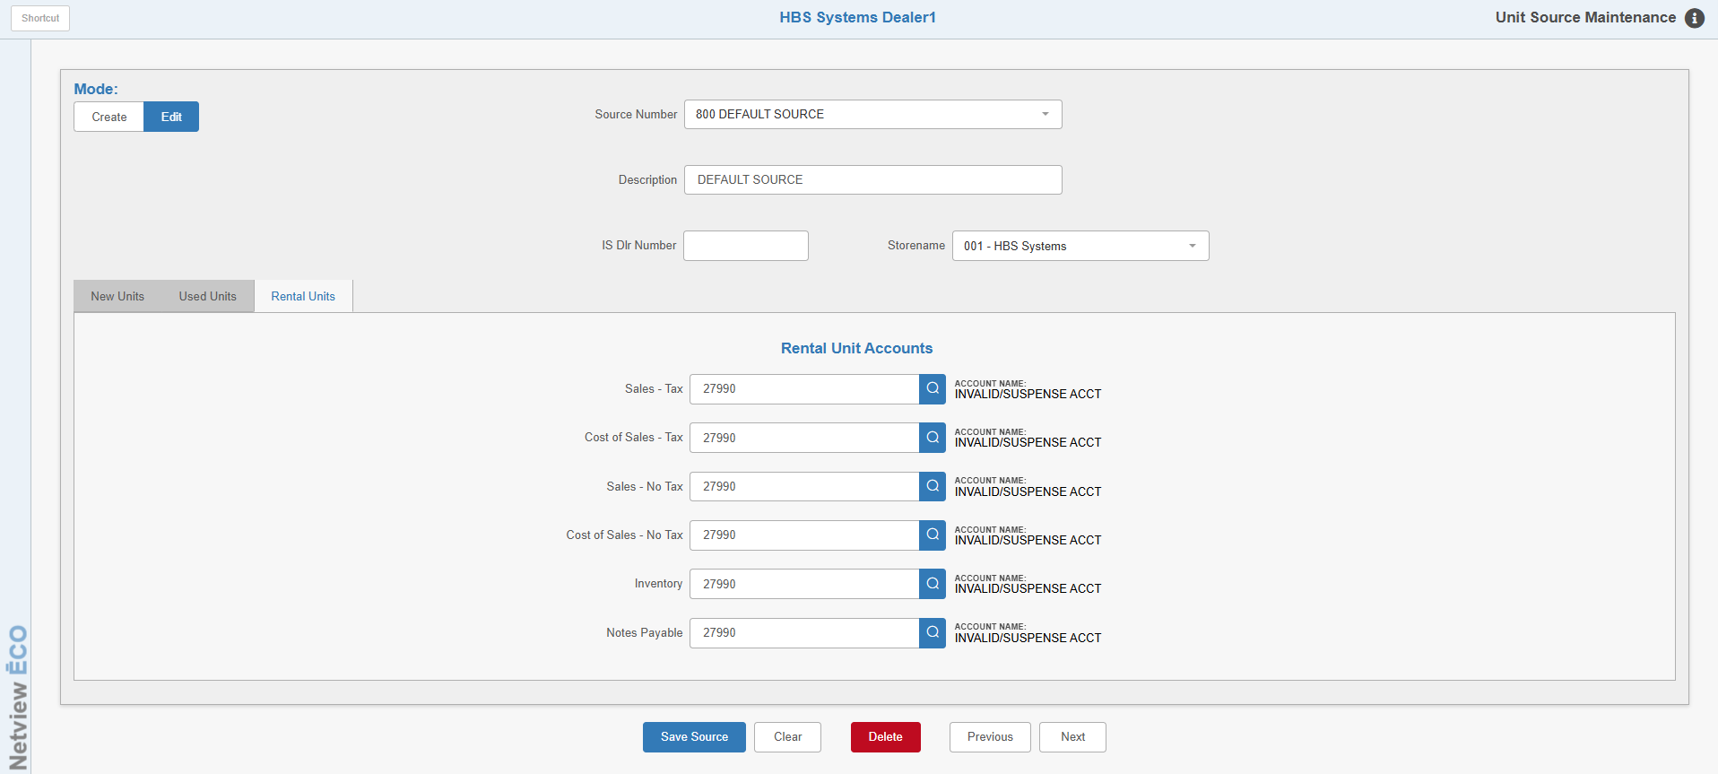

Rental Units Tab: The Rental Units Tab is used only for the Rental management package. DO NOT make entries on this screen unless you have the optional Rental package!

Sales Tax: This field functions exactly as it does for New or Used equipment. Here you enter the Sale account to be used when a Rental unit from this source is being sold while in the Rental system and the transaction is taxable.

Cost of Sales—Tax: Here you enter the Cost account to be used when a Rental unit from this source is being sold while in the Rental system and the transaction is taxable.

Cost of Sale—No Tax: Here you enter the Sale account to be used when a Rental unit from this source is being sold while in the Rental system and the transaction is nontaxable.

Inventory: This field holds the account number for the Inventory account where the value of the Rental units for this source is kept.

Notes Payable: This field holds the account number for the Notes Payable account where the liability of the Rental units for this source is kept.

