Unit Standard Report (USR)

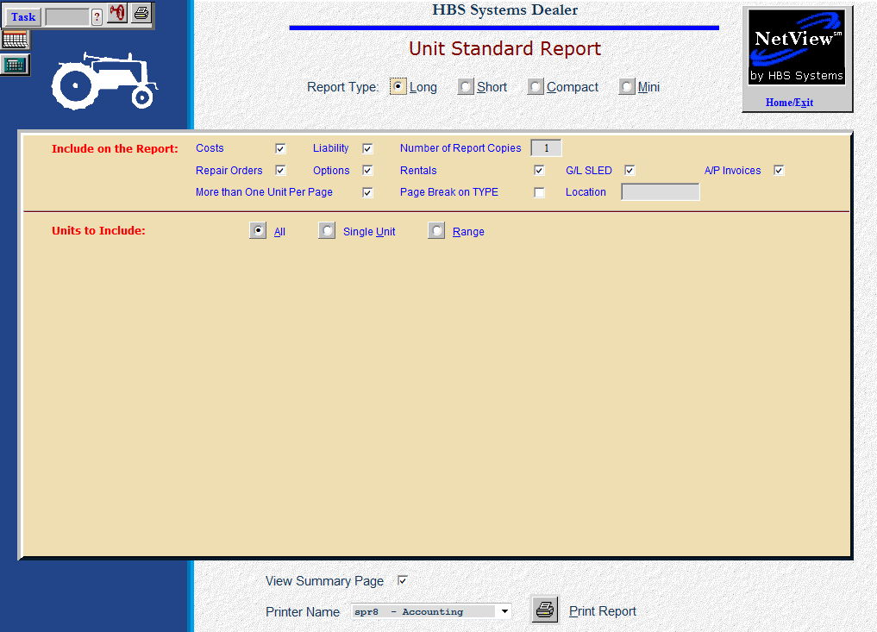

The Units Standard Report provides perhaps the most comprehensive detail about your unit information. It offers numerous ways to select and format the information contained in the units. You may include information on the report based on:

- Inventory units
- Sold units

To access this function, you can either:

- Select “Units” from the menu. Choose the “Reports” submenu and click “Unit Standard Report.”
- Type “USR” in the Shortcuts Bar.

Field Descriptions

Report Types: There are four available formats for this report. Each has its own style. You may choose between:

Long (Alt L): prints 2 units per page

Short (Alt S): prints 3 units per page

Compact (Alt C): shows 25 units per page

Mini (Alt M): shows one unit record per report line.

Info to include on the report: This collection of fields let you fine tune the information for your report. Click on the check box next to the elements you want to include.

Costs: This option provides an interesting level of flexibility. Here you choose if you want to see the costs printed on the report.

If you are printing a report for sales personnel, you may wish to have them printed.

On the other hand, if you print a report that may be useful to your customers, it would be wise to leave the costs off the printout.

Repair Orders: Depending on the purpose of the printout, you may choose to include the repair orders. Including this detail could be valuable to sales personnel and customers alike. This information is likely to be very valuable for used equipment.

Liability: Here you choose to have the liability, or amount owed, printed on the report.

Options: Here you determine if you want to have the options print on the report. In most cases, it would be wise to include this information on the printout. The options for the equipment provide a finer level detail that may be helpful in selling the units listed.

Rentals: If your business rents the inventory units, including the rental information may be helpful for your sales staff. The rental information comes from the Rental System or manual entries to the affected units.

GL SLED: If you want to include the SLED details for each unit selected for the report, click on this choice.

AP Invoice: If you want to include the AP Invoice details for each unit selected for the report, click on this choice.

More than One Unit Per Page: This prompt lets you determine how much paper will be used for the printout. Click on this box and it will print multiple units per page:

Long Report: Up to 2 units

Short Report: Up to 3 units

Compact Report: About 25 units

Mini Report: About 50 units

Number of Report Copies: Choose the number of copies you wish to have printed.

Page Break On Type: This option lets you generate page breaks when the report encounters a different type of equipment. For example, when your printout moves from tractors to loaders, it could break to a new page.

Location: For multi-location dealerships, you can enter a specific location you wish to have printed.

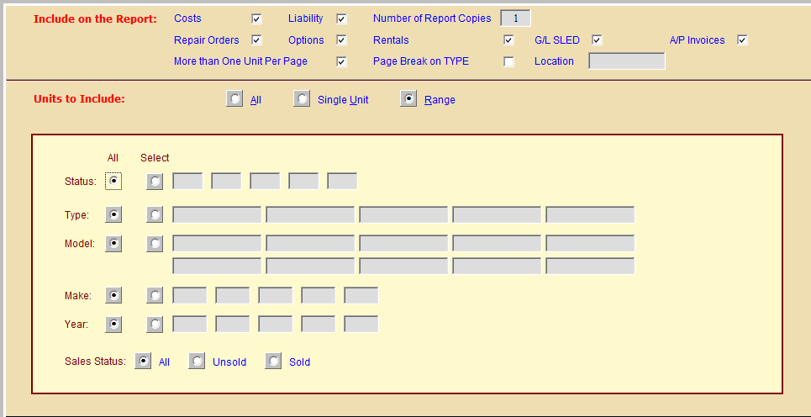

Units to include on the report: Click on the check box next to the kinds of units you want to include.

All (Alt A): Clicking this box will create a report of ALL units in inventory and ALL units previously sold. For most dealers, this selection would produce a mountain of paper.

Single Unit (Alt U): Click on this box and then type in the stock number.

Range (Alt R): This selection opens up six additional report selections.

Status: Here you can pick

New

Used

Rental

Sold

Type: This option lets you select a type or types to include on your printout.

Model: This choice lets you pick the models you want to print.

Make: This choice lets you select the make of the units to print.

Year: Here you can select the model year to include. Specify up to 5 years.

Sales Status: This choice lets you pick the status of the units you want to print:

All

Sold

Unsold

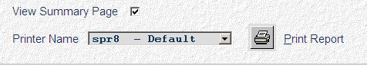

View Summary Page: This page is available for all variations of the report. It totals all dollar amounts of the units selected for the report.

Printer Name: A default printer is shown but you can select another printer as needed from the drop-down menu. Select the “see” printer to display without printing.

Print Report (Alt P): Press this button to start the report.

Long Report

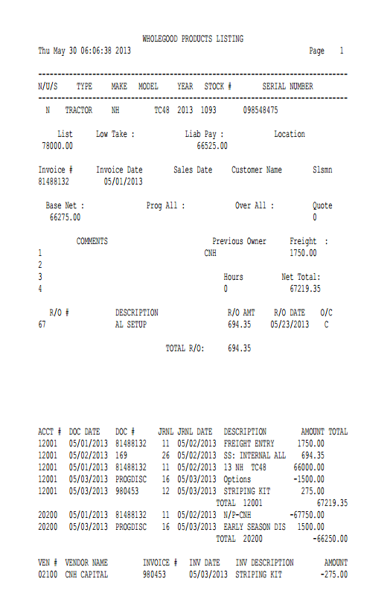

N/U: This shows the status:

New

Used

Sold

Ordered

Rental

Historical

Transfer

Type: The type field in the unit master tells you about the piece of equipment (i.e., Tractor, snow plow, chainsaw, etc).

Make: This three-character field identifies the manufacturer or make of the unit.

Model: This field holds the equipment’s Model Number.

Year: This field holds the four-digit model year of the unit.

Stock #: This field shows the stock number of the unit.

Serial Number: This field holds the unit’s main Serial Number.

List: This is your suggested selling price for this unit.

Low Take: This is the lowest price you would take for a unit or perhaps the cash price for the stock number.

Liab Pay: Here you will see the amount owed, or the liability, for this unit. It represents the total amount owed, and could be:

The amount owed on a note (floor plan)

The amount owed in accounts payable

A combination of both

Location: The location field can hold the physical location of the wholegood item.

Invoice #: This is the Manufacturer’s Invoice Number.

Invoice Date: This field goes hand-in-hand with the Invoice Number field. It holds the date for the invoice.

Sales Date: This field goes hand-in-hand with the Invoice Number field. It holds the date for the invoice.

Customer Name: When the unit is sold or transferred, the system records the name of the purchaser or customer in this field. It is updated when you write the Unit Sales Invoice or process a transfer through Enter Transfers and Adjustments (ETA).

Slsmn: When the unit is sold or transferred, the system records the salesperson’s number or initials here.

Base Net: This value is the base invoice for the unit (before freight, options, and repair orders).

Prog All: This field can hold the amount of Program Allowance or incentive discount for the unit.

Over All: This field is system maintained and typically is affected when the unit being viewed is a trade-in. It shows the over allowance amount on a trade-in, if used.

Quote: This field keeps the number of the last quote generated for this unit, if there is one.

Comments: There are four freeform comment lines available for additional information about this item. They can be used for additional descriptions, interest start dates, details of programs/incentive discounts, additional serial numbers, etc.

Previous Owner: This field identifies:

The company or person who previously owned the equipment if it was “used”

The manufacturer’s name if the unit was purchased directly from them

Freight: This field holds the freight charges for the equipment referenced if they have been itemized.

Hours: Here you will find the number of Engine Hours that the equipment has accumulated.

Net Total: This field provides the total cost of the inventory unit. Typically it includes the following:

Base Net

Freight

R/O Total

Options Net Total

R/O #: This field shows the Repair Order number.

Description: This area provides space to give the details of what the option really is, like the size of the optional tires, the description of the wheel weights, or the dimensions of the attached bucket.

R/O Amt: This field holds the dollar amount of the Repair Order or condition when it was closed. A total of all repair order amounts is included.

R/O Date:

- While the Repair Order is open, the date shown here is the date it was opened.
- When the Repair Order is closed, this field changes to the date the Repair Order was closed.

O/C: This field shows the status of the Repair Order or condition shown.

An O here indicates the Repair Order is still “in process” or open.

A C indicates the Repair Order is now a closed or completed.

R/O Total: This field shows the total amount of repair orders on this unit.

SLED Details: This area of the report shows the following:

Account Number

Document Date

Document Number

Journal

Journal Date

Description

Amount

A total for each GL account shown

AP Invoice Details: This area of the report shows the following:

Vendor Number

Vendor Name

Invoice Number

Invoice Date

Invoice Description

Amount

Short Report

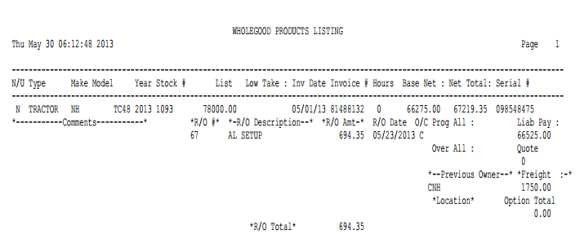

N/U: This shows the status:

New

Used

Sold

Ordered

Rental

Historical

Transfer

Type: The type field in the unit master tells you about the piece of equipment (i.e., Tractor, snow plow, chainsaw, etc).

Make: This three-character field identifies the manufacturer or make of the unit.

Model: This field holds the equipment’s Model Number.

Year: This field holds the four-digit model year of the unit.

Stock #: This field shows the stock number of the unit.

List: This is your suggested selling price for this unit.

Low Take: This is the lowest purchase price you will accept for this unit.

Description: This field provides a brief description of the Repair Order or condition referenced.

Low Take: This is the lowest price you would take for a unit or perhaps the cash price for the stock number.

Inv Date: This field goes hand-in-hand with the Invoice Number field. It holds the date for the invoice.

Invoice: This is the Manufacturer’s Invoice Number.

Hours: Here you will find the number of Engine Hours that the equipment has accumulated.

Base Net: This value is the base invoice for the unit (before freight, options, and repair orders).

Net Total: This field provides the total cost of the inventory unit. Typically it includes the following:

Base Net

Freight

R/O Total

Options Net Total

Serial Number: This field holds the unit’s main Serial Number.

Comments: There are four freeform comment lines available for additional information about this item. They can be used for additional descriptions, interest start dates, details of programs/incentive discounts, additional serial numbers, etc.

R/O #: This field stores the Repair Order applied to the unit.

R/O Description: This area provides space to give the details of what the option really is, like the size of the optional tires, the description of the wheel weights, or the dimensions of the attached bucket.

R/O Amt: This field holds the dollar amount of the Repair Order or condition when it was closed. A total of all repair order amounts is included.

R/O Date:

- While the Repair Order is open, the date shown here is the date it was opened.
- When the Repair Order is closed, this field changes to the date the Repair Order was closed.

O/C: This field shows the status of the Repair Order or condition shown.

An O here indicates the Repair Order is still “in process” or open.

A C indicates the Repair Order is now a closed or completed.

Prog All: This field can hold the amount of Program Allowance or incentive discount for the unit.

Liab Pay: Here you will see the amount owed, or the liability, for this unit. It represents the total amount owed, and could be:

The amount owed on a note (floor plan)

The amount owed in accounts payable

A combination of both

Over All: This field is system maintained and typically is affected when the unit being viewed is a trade-in. It shows the over allowance amount on a trade-in, if used.

Quote: This field keeps the number of the last quote generated for this unit.

Previous Owner: This field identifies the Company or person who previously owned the equipment.

Freight: This field holds the freight charges for the equipment referenced.

Location: This field can hold the physical location of the unit.

Option Total: This field shows the total option dollars for this unit.

Compact Report

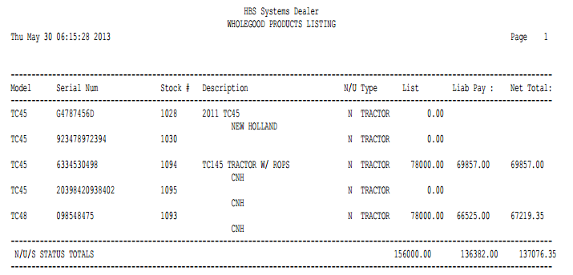

Model: This field holds the equipment’s Model Number.

Serial Num: This field holds the unit’s main Serial Number.

Stock #: This field shows the stock number of the unit.

Description: This field shows a brief description of the unit from the comment lines.

N/U: This shows the status:

New

Used

Sold

Ordered

Rental

Historical

Transfer

Type: This shows the Type of the unit.

List: This is your suggested selling price for this unit.

Liab Pay: Here you will see the amount owed, or the liability, for this unit.

Net Total: This field provides the total cost of the inventory unit. Typically it includes the following:

Base Net

Freight

R/O Total

Options Net Total

Additional Comments: The line below the detail can include comment lines 2 and 3.

Mini Report

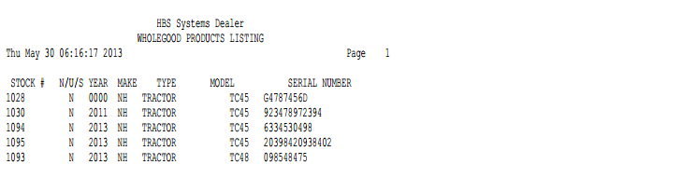

Stock #: This field shows the stock number of the unit.

N/U: This shows the status:

New

Used

Sold

Ordered

Rental

Historical

Transfer

Year: This field holds the equipment’s Model Year.

Make: This field holds the equipment’s make or manufacturer.

Type: This shows the type of the unit.

Model: This field holds the equipment’s Model Number.

Serial Number: This field holds the unit’s main Serial Number.

Summary Page: This summary page is available for all variations of the Unit Standard Report. It totals all dollar amounts of the units selected for the report.

