Unit Type Field Maintenance

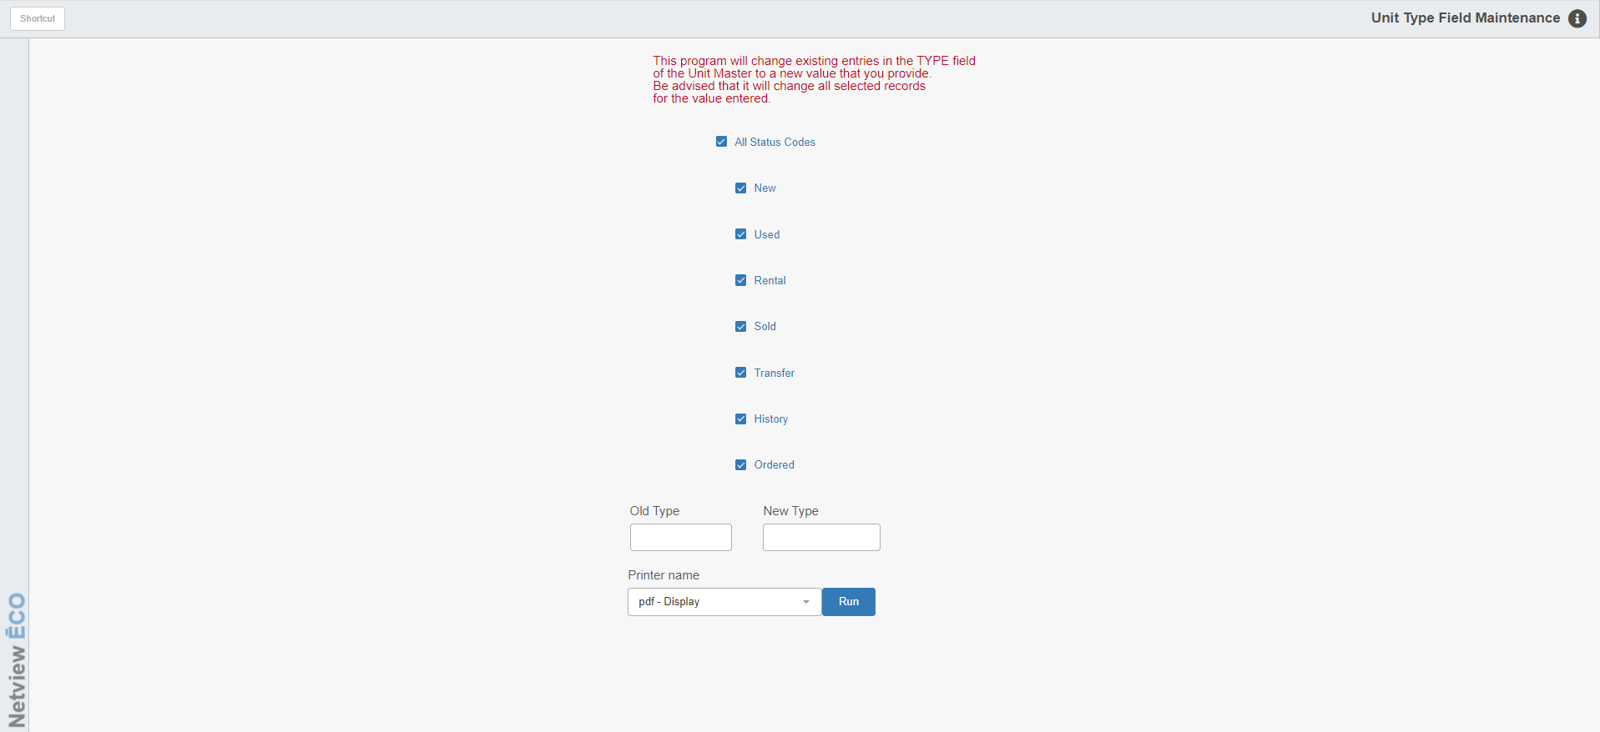

Unit Type Field Maintenance (UTM) lets you make your Units Type field values consistent.

To access this function, you can either:

- Select “Units” from the menu and choose the “Data Entry” submenu. Click on “Unit Type Field Maintenance.”
- Type “UTM” in the Shortcuts Bar.

Field Definitions:

Status Codes: You can process the changes for ALL status settings or select them individually by checking the desired codes.

Old Type: Enter the OLD value you want to change. For example, if you are changing the units with LDR to Loader, enter “LDR” in this field.

New Type: Enter the NEW value you want to show. For example, if you are changing the units with LDR to LOADER, enter “LOADER” in this field.

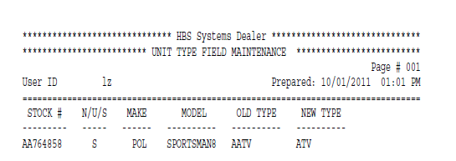

Report Fields: The report that is generated from your changes includes the following information:

Stock #: This column shows the stock numbers of the affected units.

N/U/S: This column shows the actual status of the units. This include:

New

Used

Ordered

Sold

Historical

Transferred

Rental

Make: This column shows the units’ makes.

Model: This column shows the units’ model numbers.

OLD Type: This column shows the original values in the Type field of the units.

NEW Type: This column shows the NEW values now in the Type field of the units.

