Vendor Address Labels (VAL)

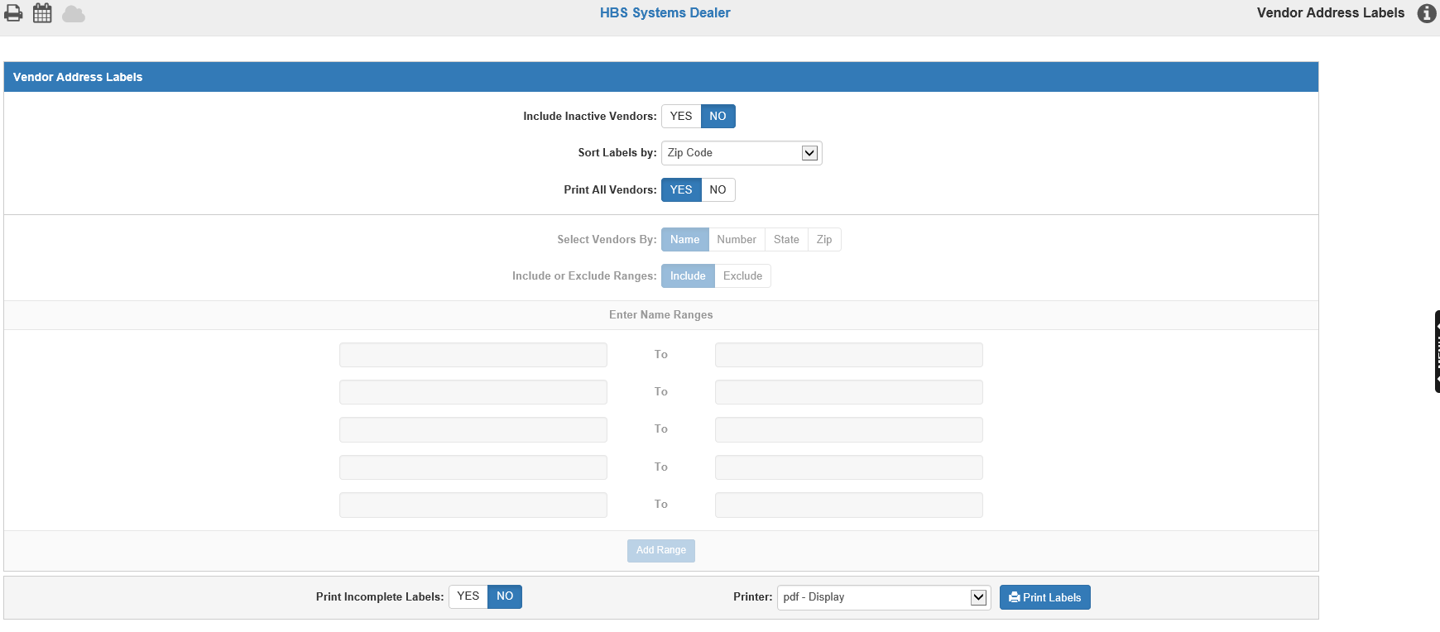

Vendor Address Labels (VAL) prints mailing labels for your A/P vendors. Labels can be printed on 3-up laser labels (Avery 5160/5260) using laser printers.

To access this function, you can either:

- Select “Accounts Payable” from the menu and choose the “Memo Reports” submenu. Click on “Vendor Address Labels.”
- Type “VAL” in the Shortcuts Bar.

Field Descriptions:

Print All Vendors: Here you select which group of vendors to print.

- Choose Yes to print labels for ALL vendors (this is the default setting).
- Choose No to enable the options that allow you to select specific vendors to print.

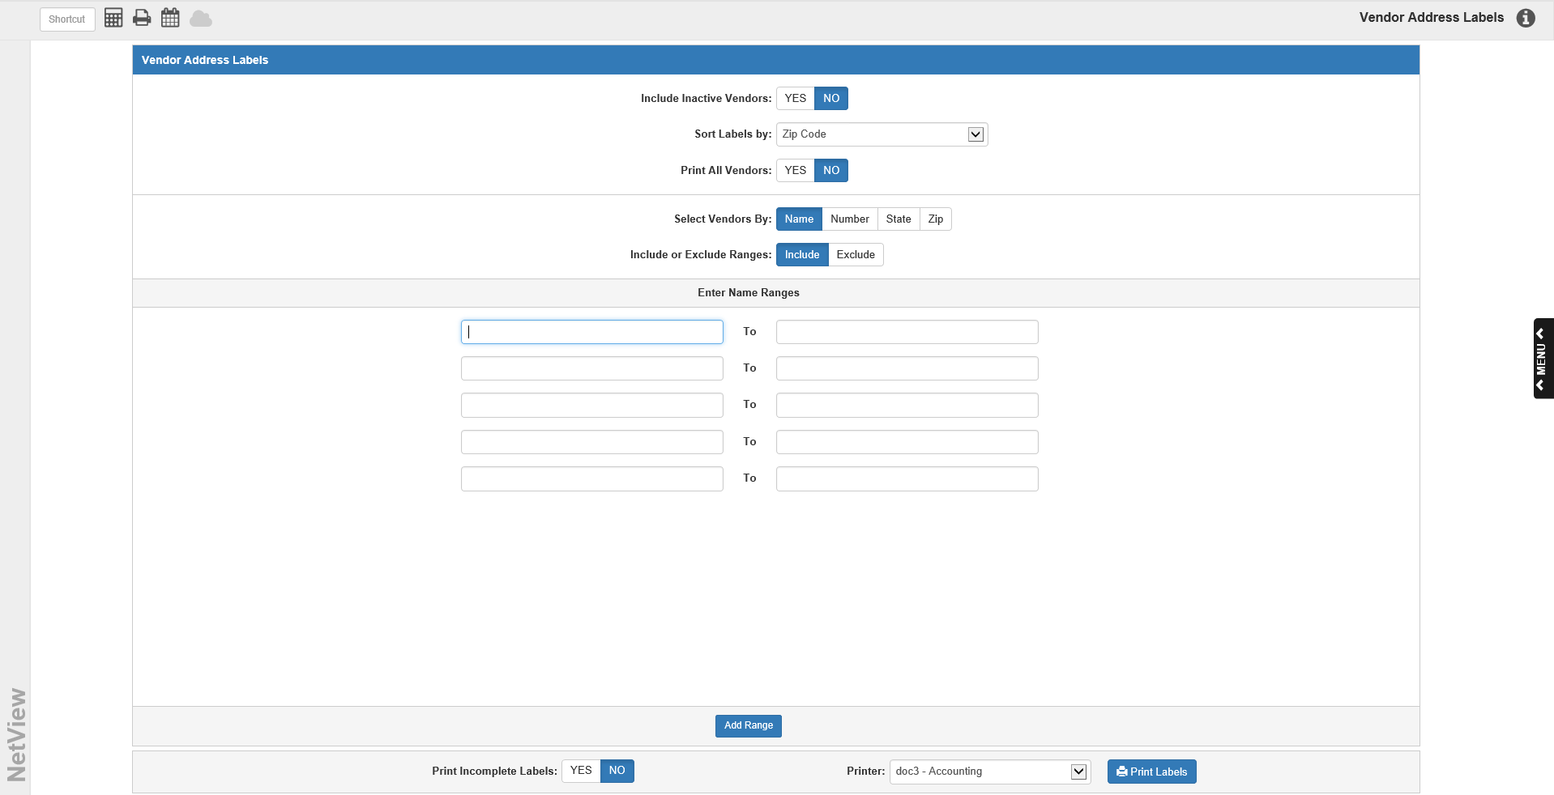

Select Vendors By: You may choose the group to print the labels by:

- Vendor Name (default selection)
- Vendor Number
- State
- Zip Code

Include or Exclude Ranges: Choose to include or exclude the ranges of vendors you will enter in the fields below (the default is “Include”).

Enter Ranges: You may enter multiple ranges to include or exclude from your selection of labels to print. You will have 5 sets of range fields by default, but if you need more, click the Add Range icon to generate another set of fields.

Sort Labels By:
This question determines how the labels are sorted. Choose one of the following options from the drop-down menu:

- Zip Code (default selection)
- Vendor Name
- Vendor Number
- State

NOTE: Bulk mailings are often sorted in Zip Code order, which is why Zip Code is the default selection.

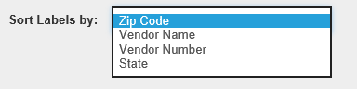

Print Incomplete Labels: Select whether or not you want to include incomplete labels, i.e. ones missing any information that typically goes on an address label (name, address, state, zip), from the print run. This option is set to No by default.

Include Inactive Vendors:

- Choose No to print labels for just Active vendors.
- Choose Yes to print labels for all vendors – Active or Inactive.

Printer: Identify the printer to receive your labels. VAL pre-fills this field with the default printer name, but you can change it as necessary. If you have not yet done so, load the labels NOW.

Print Labels: Press this button to generate the labels.

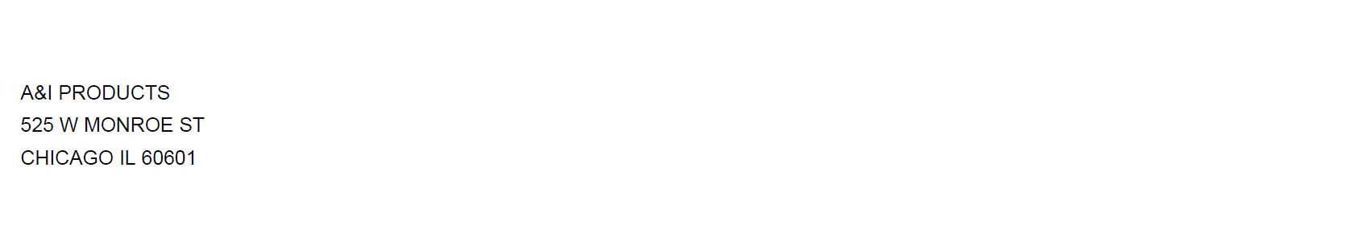

This example shows a sample of the printed address labels.

