Vendor History (VH/VBI)

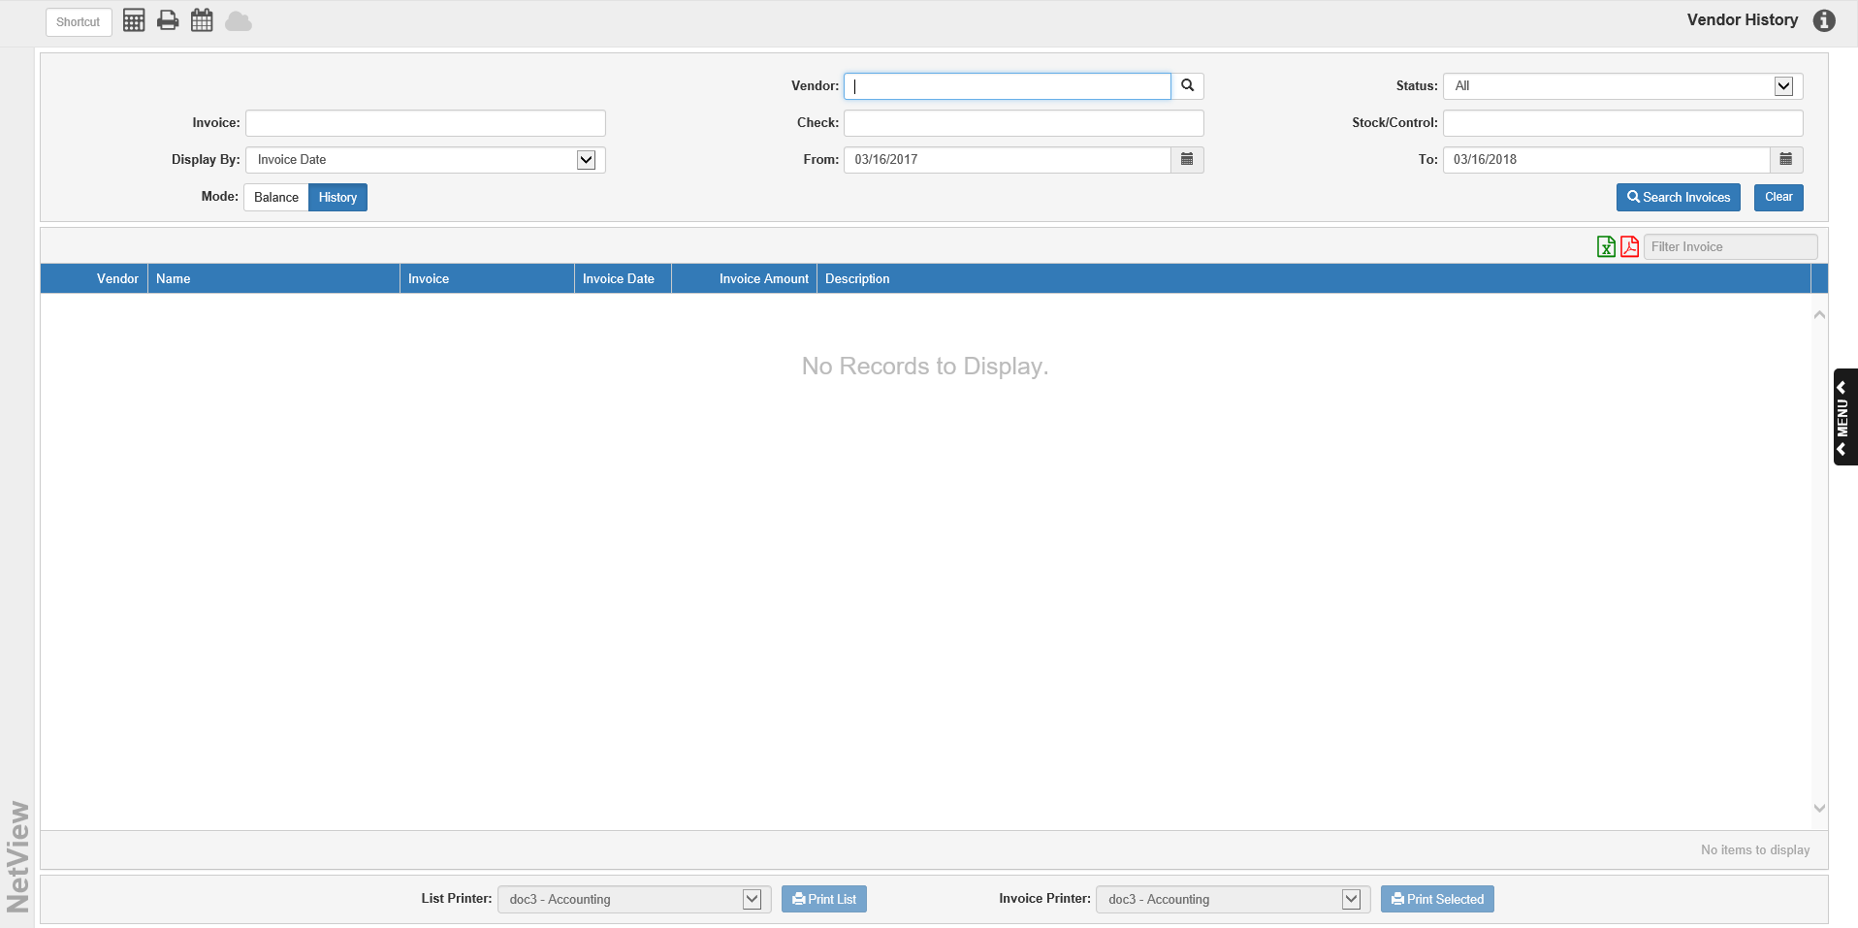

Vendor History (VH/VBI) organizes and stores all of your A/P invoices from the moment they are entered in your system. It preserves the purchase and payment detail for each invoice. For example, you can use A/P History to research when a particular invoice was paid and the amount of the check. You can also use Vendor History to view a vendor’s current balance information.

To access this function, you can either:

- Select “Accounts Payable” from the menu and click either “Vendor History” or “Vendor Balance Inquiry.”
- Type either “VH” or “VBI” in the Shortcuts Bar.



Mode
The program has two modes: Balance and History. The mode is driven by the shortcut used to access it: VBI sets it to Balance and VH sets it to History.

History Mode: History mode allows you to search for active and historical invoices.

Vendor: Use this field to search for invoices by a specific vendor. Enter the vendor or use the Vendor Search to look the vendor up. The vendor’s name and number will appear to the left of this field. Clicking the vendor’s name will open Vendor Insight (VI) for the selected vendor.

Status: This choice defaults to “All,” but you can choose “Active” (not paid in full) or “Historical” (paid in full) from the drop-down menu.

Invoice: If you want to search for a specific invoice number, enter the number in this field.

Check: If you want to search for a specific check number, enter the number in this field.

Stock/Control: If you want to search for a specific stock number or control number, enter the number in this field.

Display By: Choose which date type the results will display by. This will affect how the results appear in the grid. Select one of the following:

- Invoice Date
- Paid-In-Full Date
- Check Date

From/To: These fields default to a year ago today and the current date. You can change them as needed.

Search Invoices: Click this button to trigger the search and populate the Results Grid.

Clear: Click this button at any time to clear the search filters and the grid. The screen may revert to a different mode if you opened the screen in the other mode.

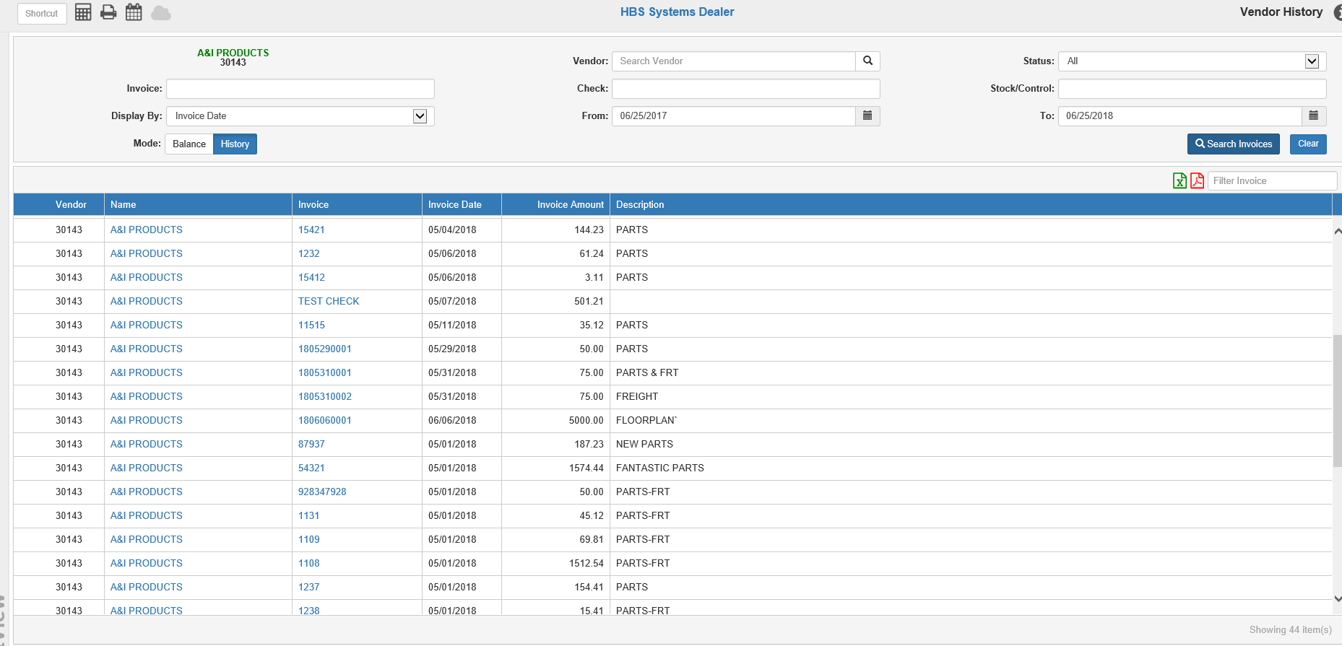

Results Grid-Descriptions: The Results Grid has two versions available for view in History Mode:

Invoice/Paid-In-Full

Check

Export to Excel: Click this icon to export the search results to an XLXS file.

Export to PDF: Click this icon to export the search results to a PDF file.

Filter Invoices: Use this field to filter the grid by entering specific information (invoice number, check number, amount, etc.). The grid will then only show entries with matching information.

Invoice/Paid-In-Full Results Grid: If you set the search results to display by Invoice Date or Paid-In-Full Date, the grid will appear as pictured. You will be able to resort the grid by clicking on a column header to order the grid by the entries in that column.

Vendor: This column shows the vendor number.

Name: This column shows the vendor name. Like in the header, clicking the vendor name opens the vendor’s page in Vendor Insight.

Invoice: This column shows the invoice number. Clicking on the invoice number lets you view the invoice’s history details.

Invoice Date: This column shows the invoice date.

Invoice Amount: This column shows the invoice amount.

Description: This column shows the invoice’s header description from EAPI.

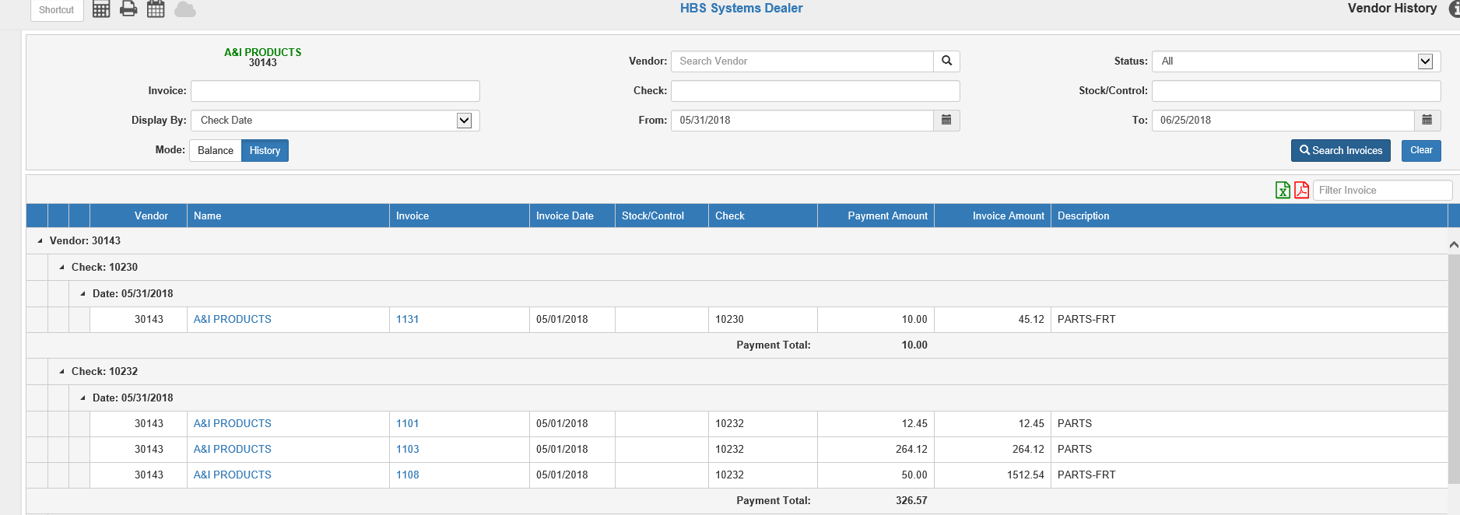

Check Results Grid: If you set the search results to display by Check Date, the grid will appear as pictured above. NOTE: If you search for this option, your results will only include documents with check dates; if the document does not have a check date, it will not appear in this grid.

The rows are grouped first by vendor, then by check number, then by check date. They are organized this way in order to distinguish checks with duplicate information from each other.

- Vendor: This column shows the vendor number, which should be the same for all rows grouped under a single vendor number.
- Name: This column shows the vendor name, which should be the same for all rows grouped under a single vendor number. Like in the header, clicking the vendor name opens the vendor’s page in Vendor Insight.
- Invoice: This column shows the invoice number. Clicking on the invoice number lets you view the invoice’s history details.
- Invoice Date: This column shows the invoice date.
- Stock/Control: This column shows any stock/control number associated with the check or invoice.
- Check: This column shows the check number for the invoice, which should be the same for all rows grouped under a single check number.
- Payment Amount: This column shows the amount of the check that went towards that particular invoice.
- Invoice Amount: This column shows the original invoice amount.
- Description: This column shows the invoice’s header description from EAPI.
- Payment Total: This appears on the last row of each check number section. It shows the total amount of the check.
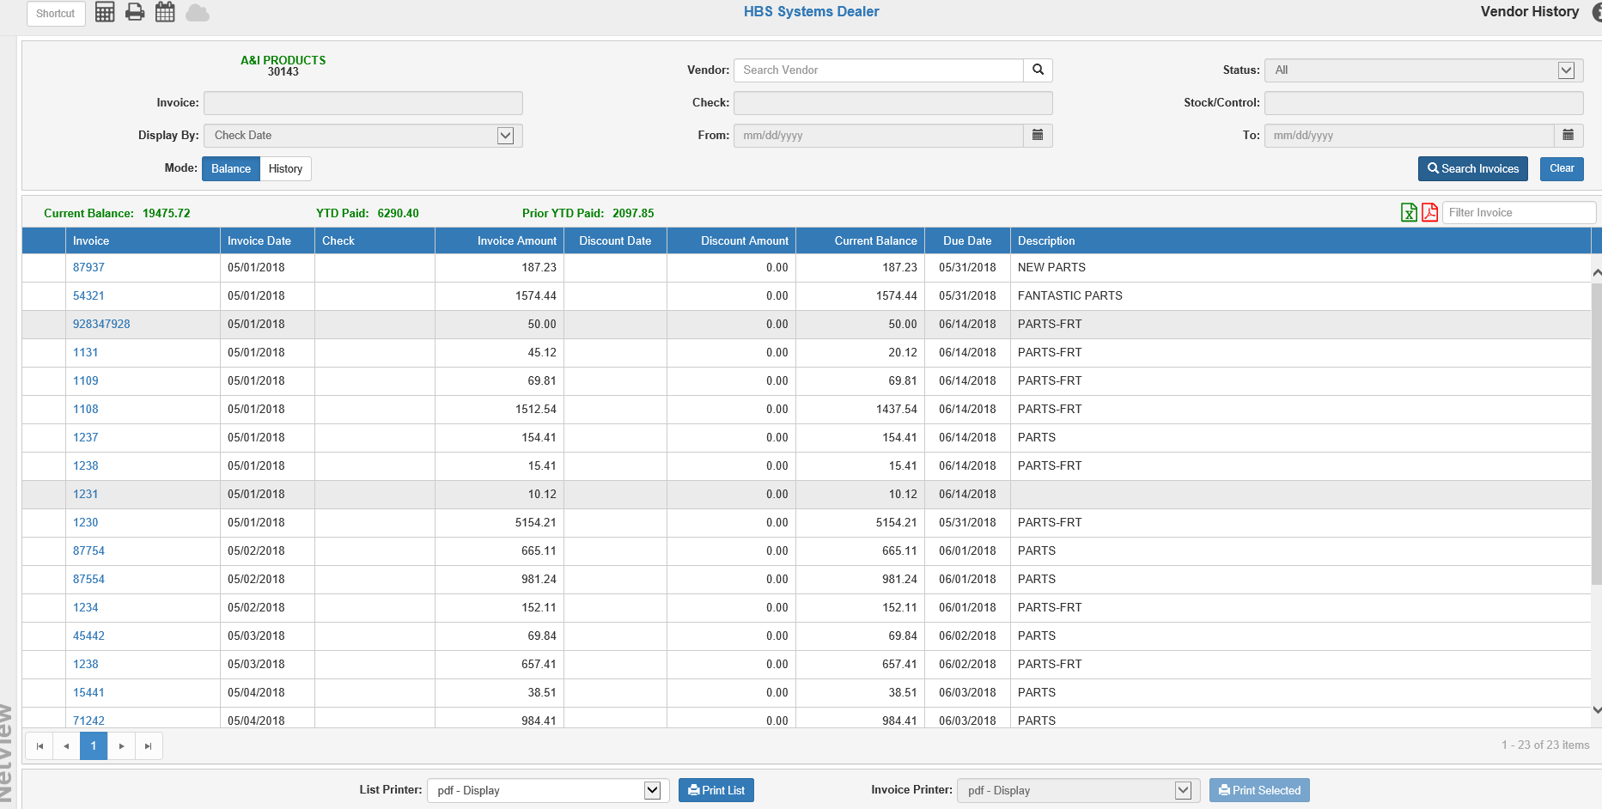

Balance Mode: Balance mode allows you to view current balance information for a specific vendor.

Vendor: Vendor is now the only active search field in the header. Use it to look up the vendor whose current balance you want to see.

Clear: Click this button at any time to clear the header (and the grid, if a search has populated it). The screen will reset to its default appearance. NOTE: If you switched modes at any point after opening the program, the screen will switch back to the mode you opened the program in. For example, if you opened the program in History mode and switched to Balance mode, clicking “Clear” will switch the screen back to History mode.

Search Invoices: Click this button once you have chosen your vendor. The Balance Results grid below will populate with all of the vendor’s current active invoices.

Current Balance: This field shows the vendor’s current balance.

YTD Paid: This field shows the amount you have currently paid to the vendor since the beginning of the calendar year.

Prior YTD Paid: This field shows the amount you paid to the vendor during the previous calendar year.

Results Grid-Descriptions: You can re-sort the grid by clicking on a column header.

Export to Excel: Click this icon to export the search results to an XLXS file.

Export to PDF: Click this icon to export the search results to a PDF file.

Filter Invoices: Use this field to filter the grid by entering specific information (invoice number, check number, amount, etc.). The grid will then only show entries with matching information.

Grid Columns:

- Invoice: This column shows the invoice number. As with the other versions of the grid, clicking on the invoice number lets you view the invoice’s history details.
- Invoice Date: This column shows the invoice date.
- Invoice Amount: This column shows the original amount of the invoice.
- Discount Date: If the invoice is eligible for a discount, this column shows the discount date.
- Discount Amount: If the invoice is eligible for a discount, this column shows the discount amount.
- Current Balance: This column shows the current balance due on the invoice.
- Due Date: This column shows the invoice’s due date.
- Description: This column shows the invoice’s header description from EAPI.

A/P History Invoice Details: To view an invoice’s history details from any mode in the program, click the invoice number in the grid. The following window will open:

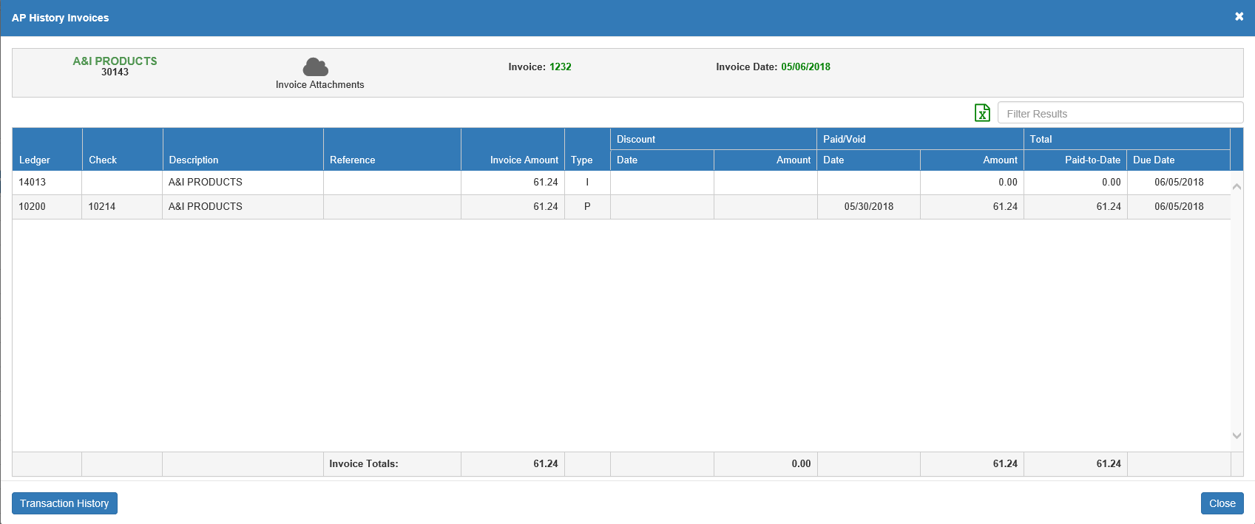

Vendor: The vendor name and number for the invoice display in the upper left-hand corner of the window.

Invoice Attachments: This icon indicates how many eDocs are attached to this invoice number. Clicking the icon lets you view a list of the invoice’s eDocs, as well as add new documents to the invoice’s record.

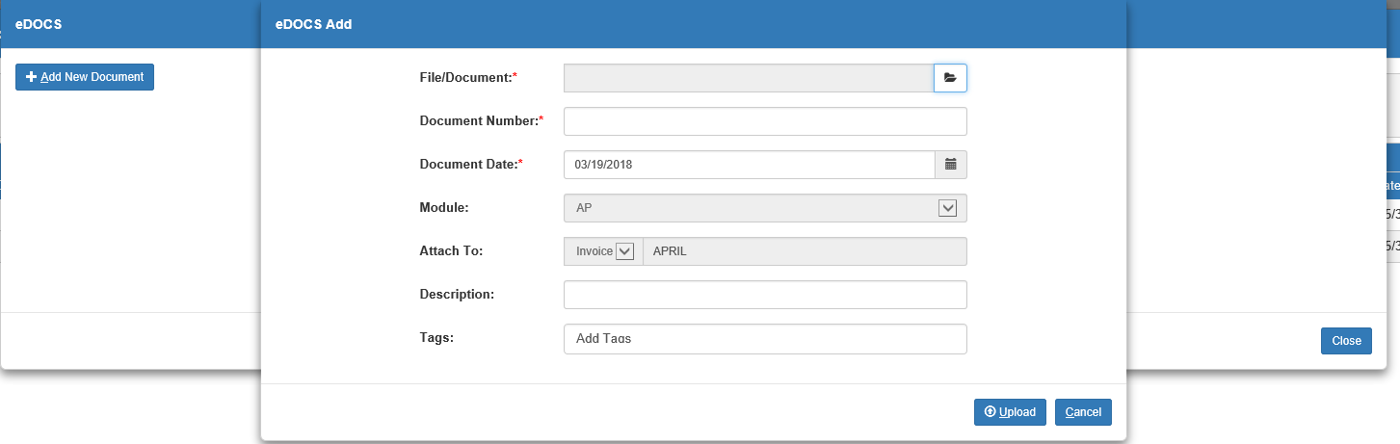

Invoice: This field shows the invoice number.

Invoice Date: This field shows the invoice date.

Grid Columns:

Ledger: This column shows the General Ledger accounts that have been used for the invoice during its history. In the example shown above, the invoice has two accounts related to it: the account assigned at its creation to receive the invoice dollars, and the account used for the check that paid the invoice in full.

Check: If the line represents a payment or write-off transaction, the check or document number will appear here.

Description: This column shows the invoice’s header description from Enter A/P Invoices (EAPI).

Reference: If the ledger account on the line required a stock number or control number, the number will appear here.

Invoice Amount: This column shows the full original amount of the invoice.

Discount Date: If the invoice was/is eligible for a discount, the discount date appears in this column.

Discount Amount: This returns the discount amount that was applied for payment.

Paid Date: If the line represents a payment or write-off on the invoice, this column will show the date on which that payment or write-off occurred.

Paid Amount: If the line represents a payment or write-off on the invoice, this column will show the amount of the payment or write-off.

Total Paid-to-Date: This column shows the total amount of the invoice paid on the date of the line’s transaction. For example, if the line refers to the invoice’s creation, this column will show “0.00.”

Total Due Date: This column shows the invoice’s due date.

Invoice Totals: This row at the bottom of the grid shows the following:

The total for the invoice amount

The final discount amount applied

The final amount paid

The total amount paid including discounts

Transaction History: Click this button to view the invoice’s transaction history.

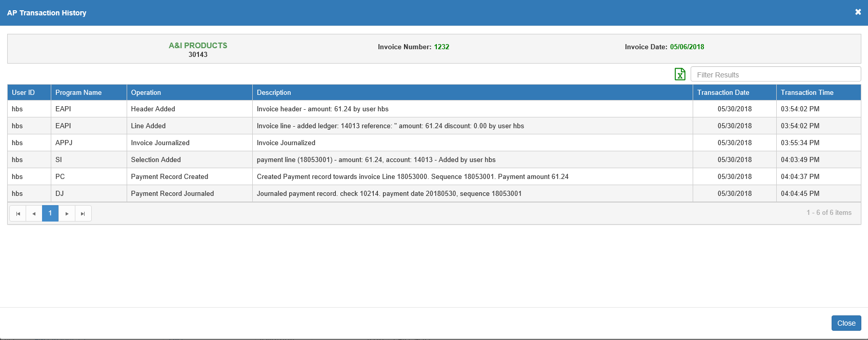

Each line shows the following:

- The user ID that performed the transaction
- The program the transaction occurred in
- The operation performed in the program
- A description of the transaction
- The date and time of the transaction

Close: Click this button to close the window and return to the main screen.

List Printer/Print List: This feature allows you to print out the contents of the grid. Select the desired printer and click Print List. You will receive a report driven by the grid details: one for History mode and one for Balance mode.

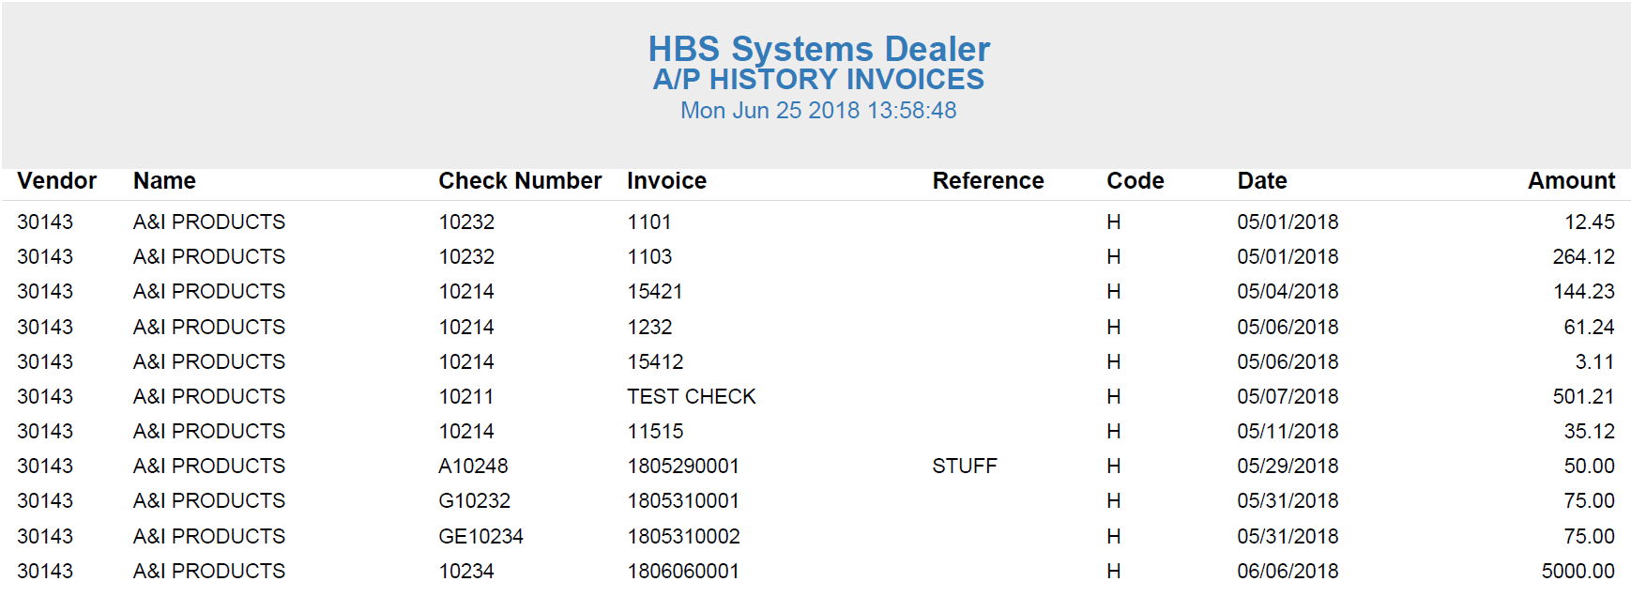

A/P History Invoices—List Report: The History mode version of the printout is identical to what you would receive if you exported the grid to PDF, being a list of all the invoices that resulted from your particular search.

Vendor: This column shows the vendor number.

Name: This column shows the vendor name.

Check Number: If a payment has been made on the invoice, the check number appears here. For invoices that have multiple payments in their history, the most recent check number will appear (you will have to look at the individual invoice for the details).

Invoice: This column shows the invoice number.

Reference: If a reference number is in any way tied to the invoice, it will appear here.

Code: This column prints the status of the invoice (J/H/V):

- Journaled (J): Open invoices that have been journalized, but not yet fully paid.
- History (H): Closed invoices that have been fully paid or written off.
- Void (V): Invoices that were paid, but the checks were voided through Void Checks (APVC).

Date: This column shows the invoice date.

Amount: This column shows the original invoice amount.

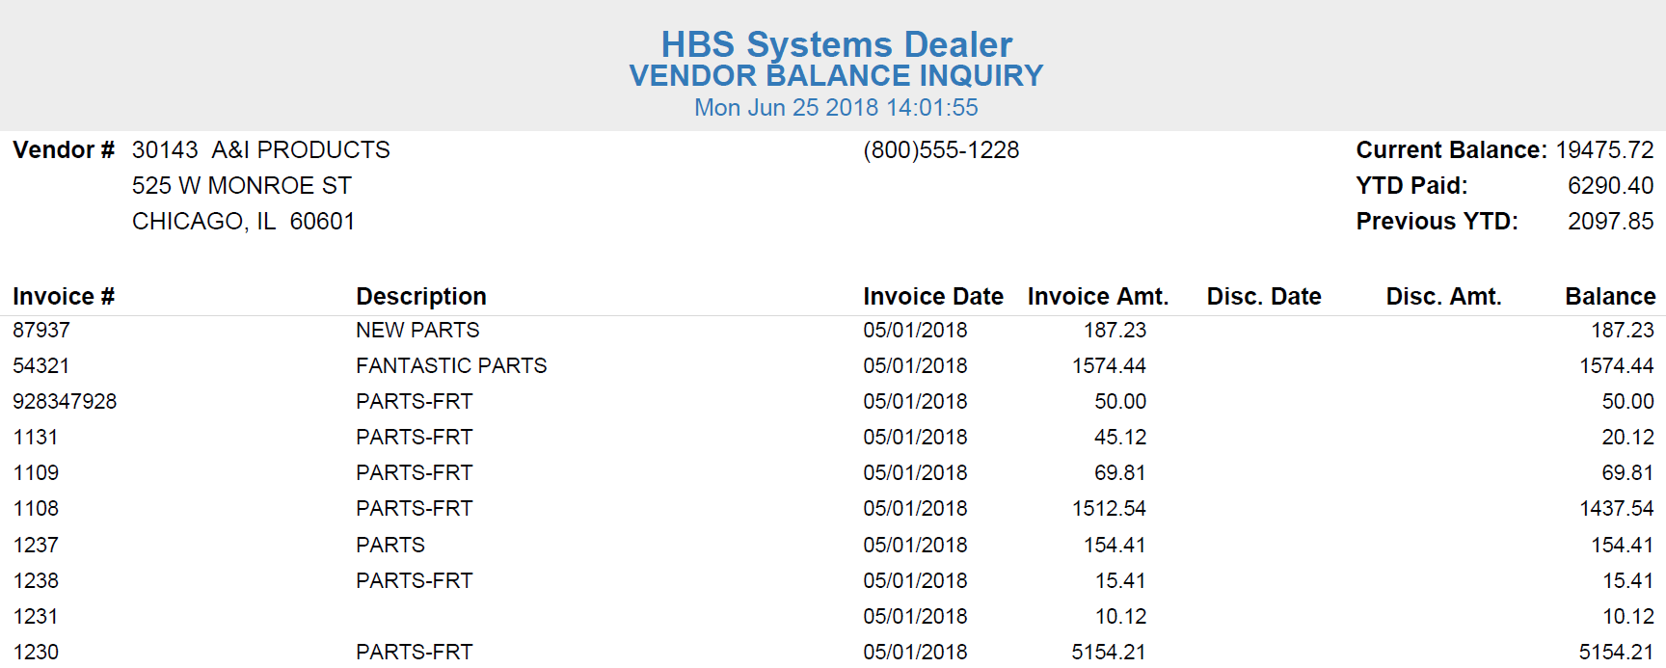

Vendor Balance Inquiry Report: The Balance mode version of the printout is called the Vendor Balance Inquiry Report. It essentially summarizes the vendor’s current balance information.

Vendor #: The report header shows the vendor’s number, name, address, and phone number.

Current Balance: This field in the report header shows the vendor’s current balance.

YTD Paid: This field in the report header shows the vendor’s current year-to-date-paid amount.

Previous YTD: This field in the report header shows the vendor’s previous year-to-date-paid amount.

Invoice #: This column shows the invoice number.

Description: This column shows the invoice’s header description from EAPI.

Invoice Date: This column shows the invoice date.

Invoice Amt.: This column shows the invoice’s original amount.

Disc. Date: This column shows the invoice’s discount date, if applicable.

Disc. Amt.: This column shows the invoice’s discount amount, if applicable.

Balance: This column shows the invoice’s current balance.

Invoice Printer/Print Selected: This feature allows you to print the A/P History Invoice detail for a single invoice result. Click the invoice’s line in the grid to select it, as in the image above. This will activate the Invoice Printer field and the Print Selected button. Set the printer to receive the A/P History Invoice report and click the button to print. NOTE: This report will be the same regardless of which mode you select the invoice in.

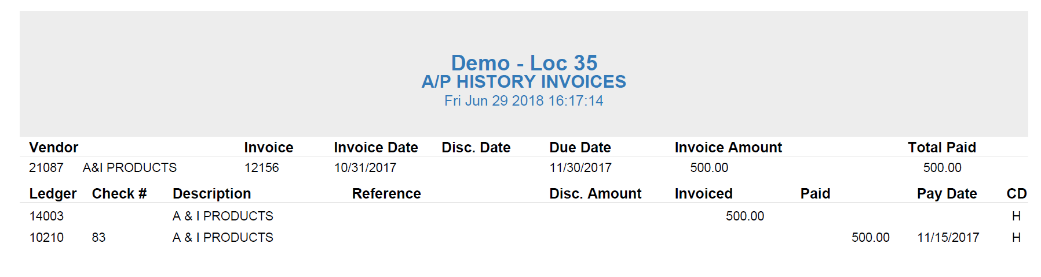

A/P History Invoices—Invoice Printout: The first row of fields gives general invoice information. The columns below that show a list of major transactions on the invoice, such as creation, payments, and voids.

Vendor: This field shows the vendor number and name for the invoice.

Invoice: This field shows the invoice number.

Invoice Date: This field shows the invoice date.

Disc. Date: This field shows the invoice’s discount date, if applicable.

Due Date: This field shows the invoice’s due date.

Invoice Amount: This field shows the original invoice amount.

Total Paid: This field shows the total amount paid on the invoice at this point. For historical invoices, this will always be the full amount of the invoice, as the invoice must be paid in full in order to become historical.

Ledger: This column lists the General Ledger accounts used for each transaction on the invoice.

Check #: A check number appears in this column if the transaction line represents a payment on the invoice.

Description: This column shows the invoice’s header description from EAPI.

Reference: This shows a reference number for the invoice, if applicable. It would most likely be a control number for a subledgered General Ledger account or a stock number for a unit.

Disc. Amount: This column shows any discount amount applied to the invoice, if applicable.

Invoiced: If the transaction represents an amount being invoiced, i.e. the invoice being created, the amount invoiced appears here.

Paid: If the transaction represents a payment on the invoice, the amount being paid appears here.

Pay Date: If the transaction represents a payment on the invoice, the date of the payment appears here.

CD: This column prints the status of the invoice (J/H/V):

- Journaled (J): Open invoices that have been journalized, but not yet fully paid.
- History (H): Closed invoices that have been fully paid or written off.
- Void (V): Invoices that were paid, but the checks were voided through Void Checks (APVC).

