Vendor File Report (VF)

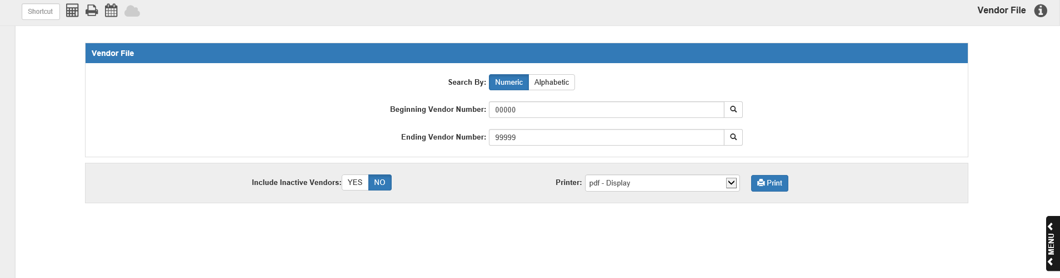

The Vendor File (VF) report lets you review the vendor account file data for:

- A single vendor
- A range of vendors
- All vendors

To access this function, you can either:

- Select “Accounts Payable” from the menu and choose the “Memo Reports” submenu. Click on “Vendor File.”
- Type “VF” in the Shortcuts Bar.

Field Descriptions:

Search By:

- To search for vendors by name, choose Name.
- To search for vendors by vendor number, choose Number.

Print All Vendors:

- Leave the default vendor numbers of 00000 through 99999 to print details for ALL of your vendors.
- If you are only interested in a single or range of vendor accounts, enter a vendor number or name in the Beginning and Ending fields.

Include Inactive Vendors:

- Choose No to see only active vendors.
- Choose Yes to include all vendors – active or inactive.

Printer: A default printer is pre-filled but you may change it as necessary. Use the pdf-Display printer to display the report on your screen. The report can also be directed to a spreadsheet. A sample is shown after the printed copy.

Press “Print” to generate the report.

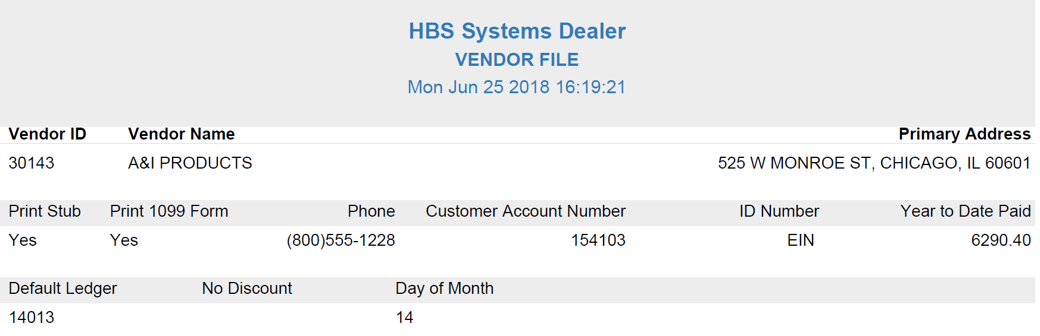

Vendor File Report: The report is separated into sections by vendor and lists various details about the vendor taken from their record in Vendor Information (VIM).

Vendor ID: The vendor’s account number appears here.

Vendor Name: The vendor’s name appears here.

Primary Address: The vendor’s primary address, as recorded in VIM, prints in this field.

Print Stub:

- Yes appears here if the dealer has set this vendor’s invoice information to print on their check stubs.
- No means the setting in VIM is turned off.

Print 1099 Form:

- If this vendor requires a 1099 Form, Yes is shown here.
- Otherwise, you will see No.

Phone: The vendor’s primary telephone number appears in this field.

Customer Account Number: This field prints the customer account number your business has with this vendor.

ID Number:

- If this vendor is an individual, this field displays “SSN” and the individual’s Social Security Number.
- If the vendor has provided you with an Employer Identification Number, this field displays “EIN” and the vendor’s Employer Identification Number.

Year To Date Paid: This field shows the vendor’s Year-to-Date Paid amount. It is the total amount of payments that have been made since January 1 of the current year. This information is updated every time a payment entry or a check run is made for this vendor.

Default Ledger: This field shows the default account number assigned to this vendor’s account, if any.

(No/Percent/Amount) Discount: This field’s title indicates whether or not the vendor has a discount type set in VIM.

- If they do, then the percent or amount (depending on the type) will show in the field.
- If there isn’t a discount, the field will be blank.

Day of Month/Number of Days: If this field appears in a vendor’s section, it means there is a set day of the month or number of days after the invoice date on which that vendor’s invoices are usually due. The field title will indicate which one, and the field will show the relevant day of the month/number of days.

Vendor Report – Spreadsheet Sample: The report can be directed to a spreadsheet.

