Vendor Insight (VI)

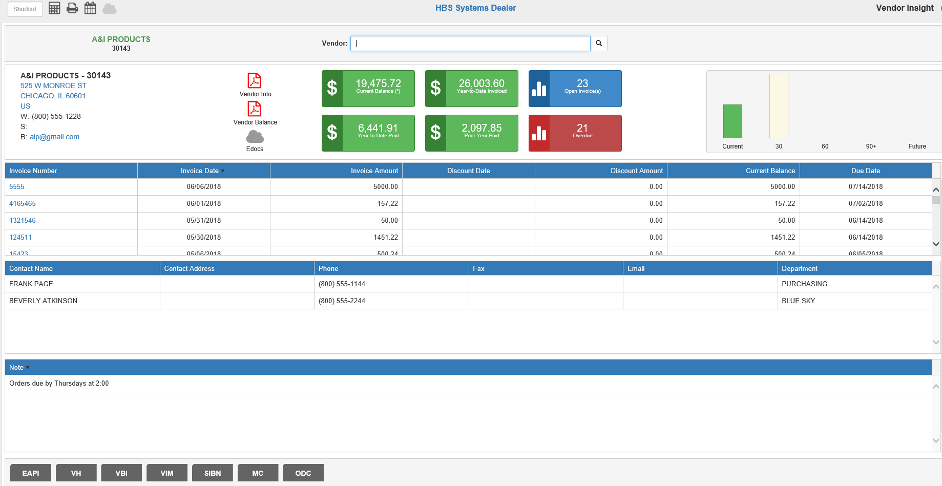

Vendor Insight (VI) focuses on a single A/P vendor and presents all related information for that vendor.

To access this function from the Desktop, type “VI” in the Shortcuts Bar. You can also access it in any A/P screen by clicking on the Vendor Name.

Vendor: When you open the screen from the Desktop, you can search for the desired vendor. Enter the vendor number or use the Vendor Search to locate the vendor. The vendor’s name and number will appear in the upper left-hand corner, and the screen will populate with the vendor’s information.

Header—Field Definitions:

General Vendor Data: The left side of the header shows the vendor’s name, number, address, phone number(s), and email address found in the vendor’s record in Vendor Information (VIM). Clicking on the vendor’s address will link to Google Maps™, which will show the location and allow you to find directions to the address. Clicking on the email address will let you directly email the vendor through your computer’s email service.

Vendor Info: Click this icon to generate a PDF report of the vendor’s record in VIM.

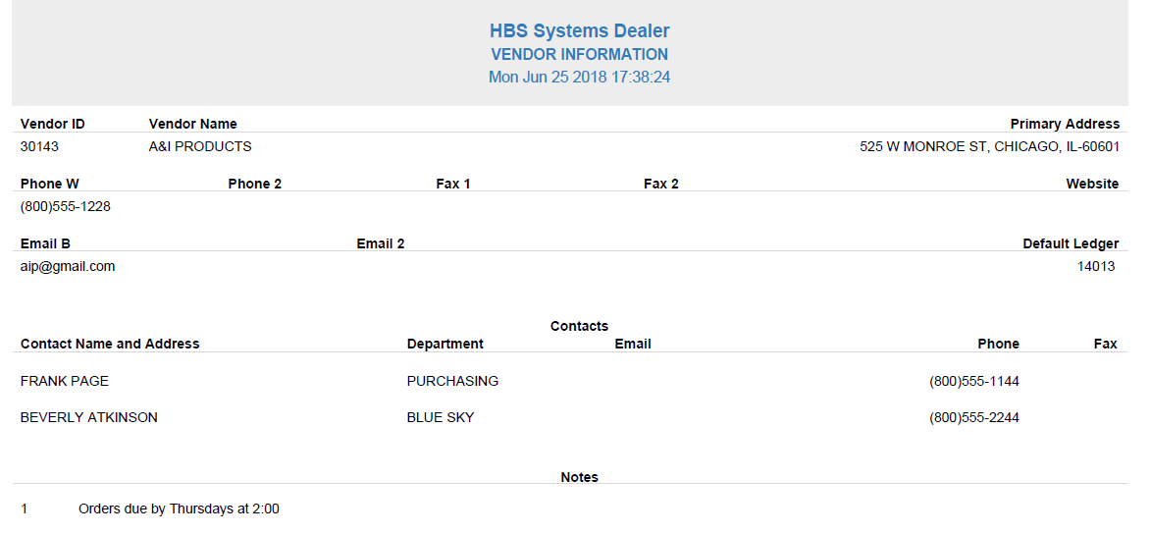

Vendor Balance: Click this icon to generate a PDF of the vendor’s current Vendor Balance Inquiry Report, which can also be printed from Vendor History.

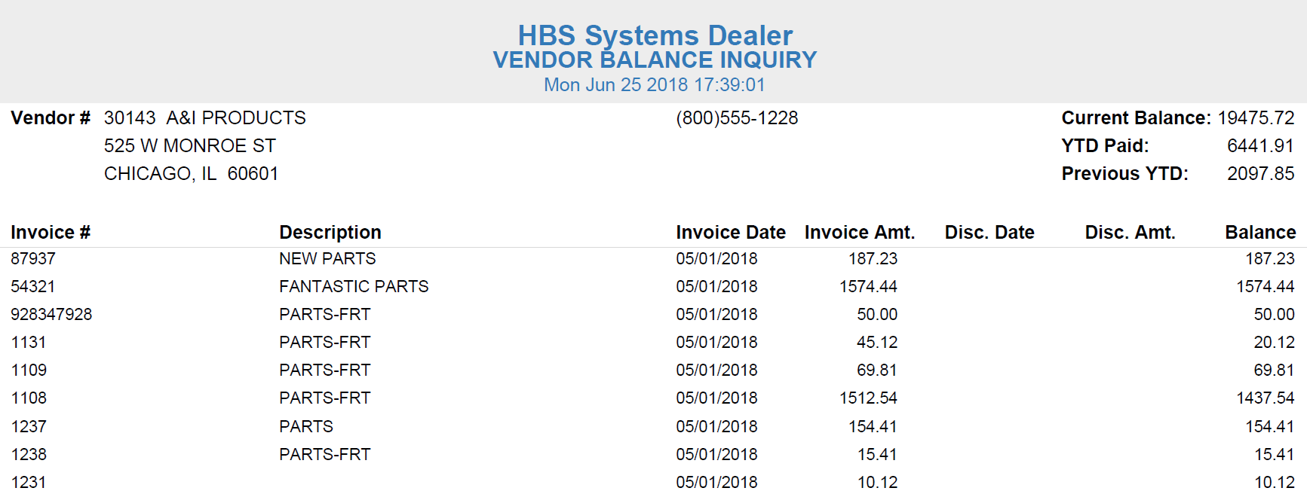

Edocs: Click this icon to view any eDocs attached to the vendor’s record.

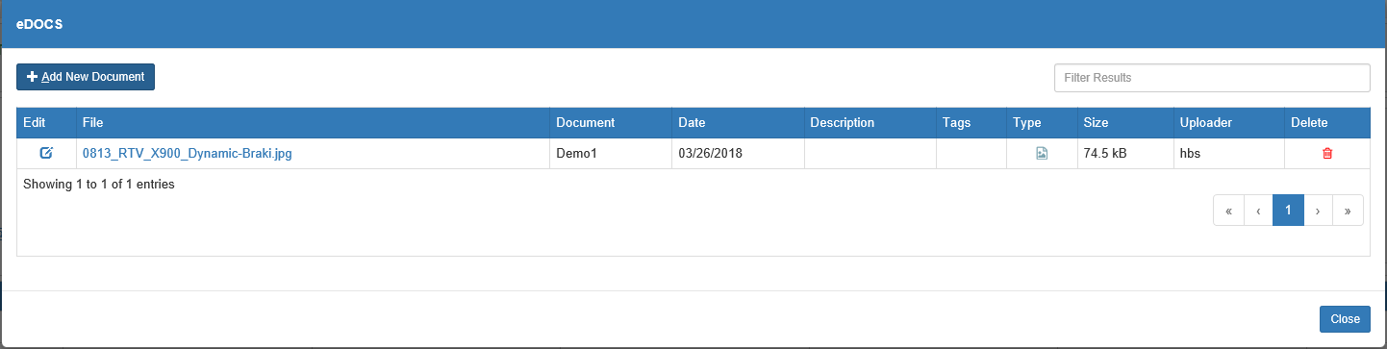

You can also use this window to add new documents to the vendor’s eDocs record by clicking on the Add New Document button.

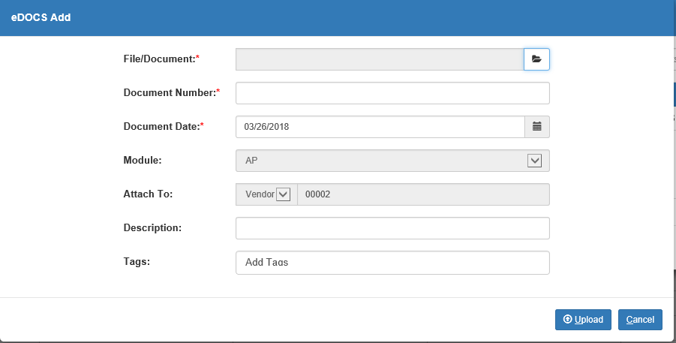

Current Balance: This box shows the vendor’s current balance amount.

Year-To-Date Paid: This box shows the vendor’s current year-to-date paid amount.

Year-To-Date Invoiced: This box shows the vendor’s currently year-to-date invoiced amount.

Prior Year Paid: This box shows the vendor’s prior year paid amount.

Open Invoice(s): This box shows the number of open invoices that currently exist for this vendor.

Overdue: This box shows the number of overdue invoices, i.e. unpaid invoices past their due date.

Invoice Aging Chart: The chart on the right side of the header shows the aging distribution of the vendor’s invoice values. If you hover your mouse over each column, you’ll be able to see the exact dollar amount, as in the image below.

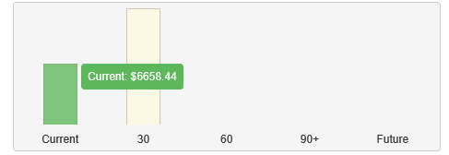

Open Invoice List Grid—Columns: The first grid below the header shows a list of all the vendor’s current open invoices. You can re-sort the list by clicking on the column headers to re-sort the grid by that column’s data.

Invoice Number: This column shows the open invoice number. Clicking the number opens the invoice’s AP History Invoice detail window.

Invoice Date: This column shows the invoice date.

Invoice Amount: This column shows the original invoice amount, before any payments or discounts.

Discount Date: This column shows the discount date for the invoice, if applicable.

Discount Amount: This column shows the discount amount for the invoice, if applicable.

Current Balance: This column shows the current balance due on the invoice.

Due Date: This column shows the invoice’s due date.

Vendor Contacts List Grid—Columns: The second grid on the screen lists all the vendor’s contacts recorded in VIM.

Contact Name: This column shows the contact name as recorded in VIM.

Contact Address: This column shows the contact’s primary address.

Phone: This column shows the contact’s primary phone number.

Fax: This column shows the contact’s primary fax number.

Email: This column shows the contact’s primary email address.

Department: This column can show extra information for the contact.

Vendor Notes: The last grid on the screen shows all notes attached to the vendor record in VIM.

Application Shortcuts Toolbar: The bottom of the screen shows a series of buttons that will launch that program with the selected vendor’s information.

EAPI: This link will open a new invoice record in Enter A/P Invoices (EAPI) for this vendor.

VH: This link will open Vendor History and automatically trigger a search in History mode for all invoices, active and historical, belonging to this vendor.

VBI: This link will also open Vendor History, but instead will automatically trigger an inquiry in Balance mode for the vendor’s current balance data and active invoices.

VIM: This link will automatically open the vendor’s record in Vendor Information.

SIBN: This link will open Select A/P Invoices (SIBD/SIBN) in Vendor mode (SIBN shortcut), with the vendor selected and all their open invoices displayed. You can then proceed to select whichever of their invoices you desire to pay.

MC: This link will open a new payment record in Manual Checks (MC) for the vendor.

ODC: This link will open a new invoice/payment record in On Demand Checks (ODC) for the vendor.

