Vendor Information (VIM)

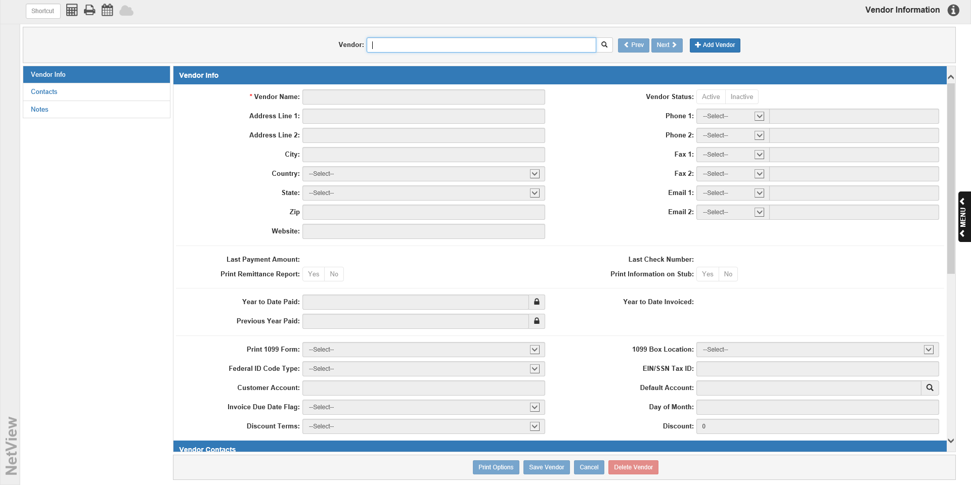

Vendor Information (VIM) displays all information about each vendor.

To access this function, you can either:

- Select “Accounts Payable” from the menu and choose the “Vendor Maintenance” submenu. Click on “Vendor Information.”
- Type “VIM” in the Shortcuts Bar.

Vendor: Use this field to select the vendor record. You may search for the vendor by typing in all or part of the vendor’s name, then press “Enter” or click the Search icon. You can also click the Search icon to look at all vendor records.

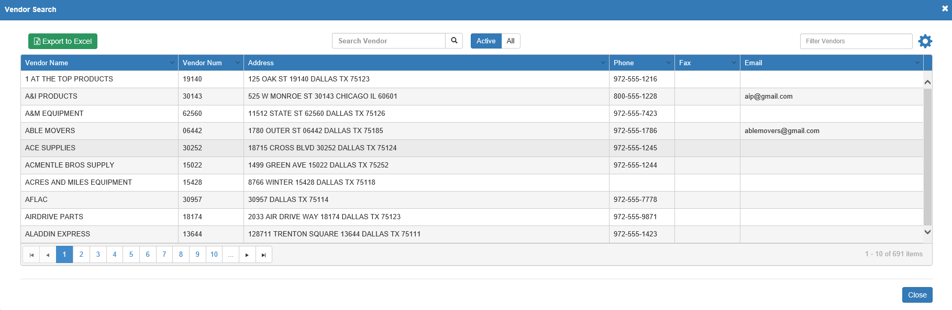

You can use the sortable column headers to reorder the display order. You can also filter the results by typing information in the Filter Vendors field. Once you find the vendor you want, click on it to populate the screen.

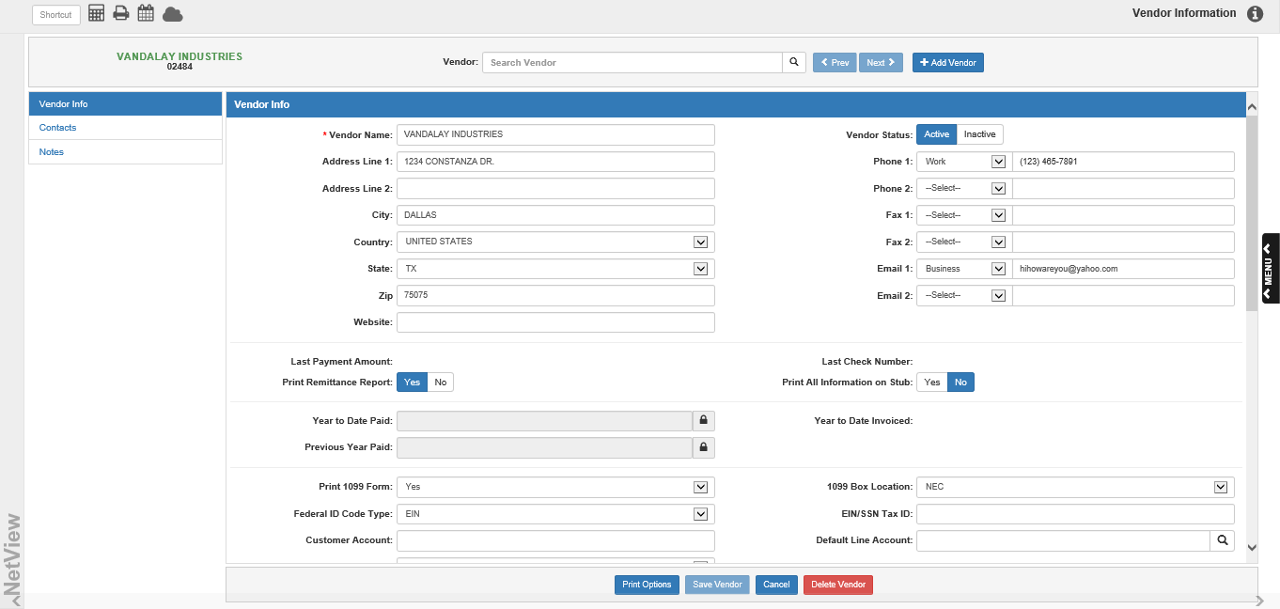

The vendor’s name and number will also display to the left of the field. You can click on the vendor’s name to view their Vendor Insight (VI) page.

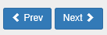

Prev/Next: If you use the Vendor Search to find your vendor, these buttons allow you to switch to the previous and next vendor in your search results list. If you do not use the Vendor Search, these buttons will be inactive.

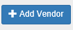

Add Vendor: To add a new vendor record, click the Add Vendor button. The system will automatically generate a vendor number once you save it.

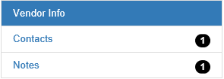

Sidebar Shortcuts: The vendor record is divided into 3 sections:

- Vendor Info
- Vendor Contacts
- Vendor Notes

You can use these tabs on the left side of the screen to jump to a particular section. In Contacts and Notes, you may see a number indicating how many contacts/notes the vendor has.

Vendor Info:

Vendor Name: This field holds the vendor name.

Address Line 1: This field holds the first line of the vendor’s primary address.

Address Line 2: This field holds a second address line, if necessary.

City: This field holds the city for the address.

Country: This field holds the country for the address (USA or Canada).

State: Choose the state/province for the vendor.

Zip: This field holds the zip/postal code for the address.

Website: This field can hold the website address for the vendor.

Vendor Status: This field sets whether the vendor is an Active or Inactive vendor. Marking a vendor “Inactive” removes them from the default Vendor Search results. You can only mark a vendor inactive if they have no active invoices currently in the system.

Phone 1: This field can hold a phone number for the vendor. You can also set what type it is:

- Cell
- Home
- Work

Phone 2: This field can hold a second phone number. You can also set what type it is:

- Cell
- Home
- Work

Fax 1: This field can hold a fax number for the vendor. You can also set what type it is:

- Other
- Home
- Work

Fax 2: This field can hold a second fax number. You can also set what type it is:

- Other
- Home
- Work

Email 1: This field can hold an email address for the vendor. You can also set what type it is:

- Personal
- Business

Email 2: This field can hold a second email address. You can also set what type it is:

- Personal
- Business

Last Payment Amount: This field shows the amount of the last payment made to the vendor.

Last Check Number: This field shows the last check number paid to the vendor.

Print Remittance Report/Print Information on Stub: These two fields together control if and how you will receive Check Stub/Remittance Report information on the checks for this vendor.

- If you choose Yes at Print Remittance Report and Yes for Print Information on Stub, all the invoice information will print on the check stub. If the lines exceed the space on the stub, it voids across as many check stubs as necessary. It will void any checks where only the stub section is used and uses the last check number for the live check and journal entry.
- If you choose Yes at Print Remittance Report and No for Print Information on Stub, all the invoice information will print on the first check stub only if it fits. If the number of stub lines exceeds the space printed on the check, then all of the stub information will be put on a Full Stub Invoice Remittance Report. A “See Remittance Report” message will be written on the check stub to indicate the information is on the report.
- If you choose No at Print Remittance Report, Print Information on Stub will automatically set to No. Only an invoice line total will be reported on the stub.

Year to Date Paid: YTD Paid equals the value paid to the vendor from January 1 to December 31 of the current year. Each time you process a payment (through Manual Checks, Print Checks, or On Demand Checks), the system updates this field. At the end of the calendar year, the value here is moved to the Previous Year Paid field and this field is cleared to “0.00”.

Year to Date Invoiced: This field shows the dollar amount in invoices entered for this vendor from January 1 to December 31 of the current year. Each time you enter an invoice for this vendor in the system, this field updates. At the end of the calendar year, the number will reset to “0.00”.

Previous Year Paid: This field records the value paid to the vendor from January 1 to December 31 of the previous year. At the end of the calendar year, this field is updated with the Year to Date Paid amount for that past year when that field resets for the new year.

Print 1099 Form: If you have to run a 1099 form for this vendor, choose Yes.

1099 Box Location: This field is active activates if you choose “Yes” for Print 1099 Form. You can choose which box location for the 1099 form. Choose the desired location from the drop-down menu.

NOTE: As of 2020, the non-employee compensation amount has been moved to an auxiliary form 1099-NEC, which has replaced box “7” in the dropdown menu. You must choose the option “NEC” from the menu in order to print this new form.

Federal ID Code Type: This field for 1099’s sets the vendor’s federal identification. Choose either EIN (Employer Identification Number) or SSN (Social Security Number). If this vendor will not receive a 1099 form, either value is fine.

EIN/SSN Tax ID: Type either the vendor’s Employer Identification Number or Social Security Number, depending on your type selection in the previous field. If this vendor will not receive a 1099 form, you can leave this field blank.

Customer Account Number: Type your dealership’s customer account number with this vendor. This info will print on the check stub.

Default Line Account: This is the default General Ledger account number for each vendor. If most of the invoices you enter are usually for the same account number (such as Parts Inventory), type this account number in this field. Then, when you enter an invoice for this vendor, Enter A/P Invoices (EAPI) pre-fills this number automatically. You may always override the default account number while entering invoices.

Invoice Due Date Flag: The system can suggest a Due Date if you use this field and the following one. Enter the vendor’s type of due date. Most vendors have due dates that are based on a particular day of the month or a certain number of days past the invoice date.

- M-Day of Month means that a vendor’s due date is a specific day of the month (example: 15th).
- D-Number of Days means the due date is usually a certain number of days past the invoice date (such as 20 days after invoice date).

Day of Month/Number of Days: Enter a number corresponding to your selection in the Due Date field. For example, if you chose M-Day of Month, enter the day of the month that most invoices are due for this vendor (i.e. 20 for the 20th of the month). If you chose D-Number of Days, enter the number of days past the invoice date when the invoice is normally due for payment (i.e. 15 for 15 days after the invoice date). NOTE: You may always override the system-calculated due date when entering an invoice.

Discount Terms: The Discount Terms field determine a default discount type for the vendor. Choose None, Percent, or Amount.

If the vendor usually gives you a discount as a percentage of the invoice total, choose “Percent.”

Choose “Amount” if the vendor usually gives a dollar amount for a discount.

Discount (Amount/Percent): This field works with the previous field, and may display a Discount Amount or Discount Percentage, depending on which was selected in the Discount Terms field. Enter the amount or the percentage of the discount.

Vendor AP Account: If you have the Multiple A/P Accounts feature turned on in Information Defaults (ID), this field will appear.

Use the drop-down menu to set a default A/P account for this particular vendor’s invoices. NOTE: This does not prevent you from using other A/P accounts on this vendors’ invoices if desired.

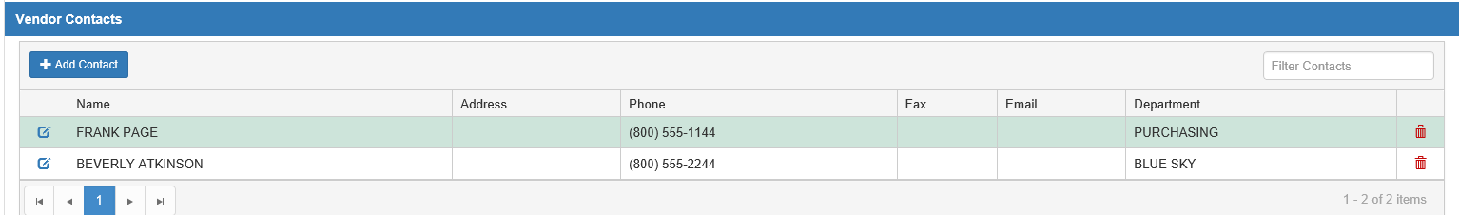

Vendor Contacts: This section allows you to add and maintain contact information for the vendor. For example, if the vendor is a company, but you typically deal with a specific individual in a specific department of that company, you could add the company’s general information in the Vendor Info section and put that specific employee’s information here.

Add Contact: Click this button to add a new contact to the vendor record.

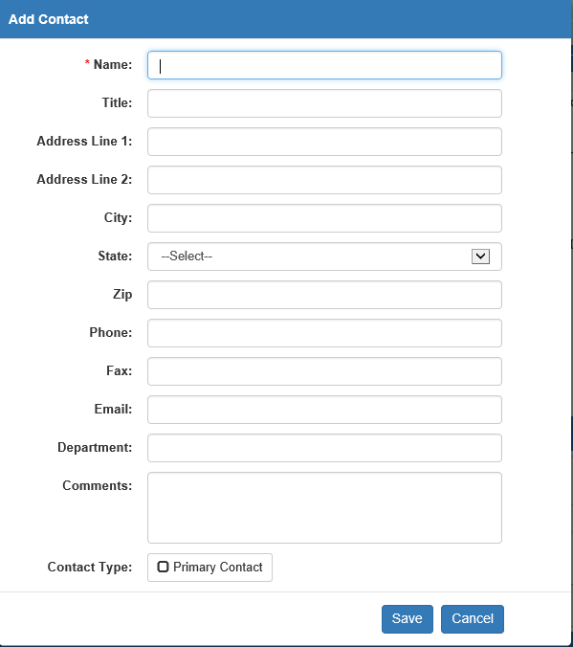

Name: Enter the contact’s name in this field.

Title: You can optionally enter the contact’s title in this field.

Address Line 1: Enter the first line of the contact’s specific address here, if needed.

Address Line 2: Enter the second line of the contact address, if required.

City: Enter the city for the contact address.

State: Select the state for the contact address from the drop-down menu.

Zip: Enter the zip/postal code for the contact address.

Phone: Enter the contact’s phone number here.

Fax: Enter the contact’s fax number here.

Email: Enter the contact’s email address here.

Department: If the contact belongs to a specific department of the vendor business, like Parts, Units, or Service, you can optionally record that here.

Comments: You can put any comments you have about the contact here.

Contact Type: Check this box if the contact is your primary contact at the vendor.

Save: Click this button to save the contact.

Cancel: Click this button to cancel adding the contact.

Filter Contacts: Use this field to filter your contacts list by entering specific information for that contact. The grid will then display records with matching information.

Grid Columns:

Edit Contact: Click on the blue icon on the far left of a contact’s row to edit their information.

Name: This column shows the contact’s name.

Address: This column shows the contact’s address.

Phone: This column shows the contact’s phone number.

Fax: This column shows the contact’s fax number.

Email: This column shows the contact’s email address.

Department: This column shows the contact’s department.

Delete Contact: Click the red trash can to delete the contact. The following warning will appear:

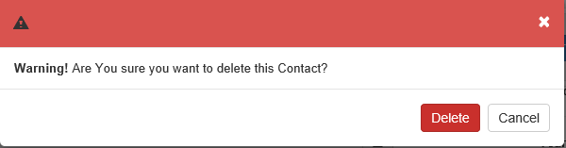

- Click Delete to delete the contact.
- Click Cancel to keep the contact.

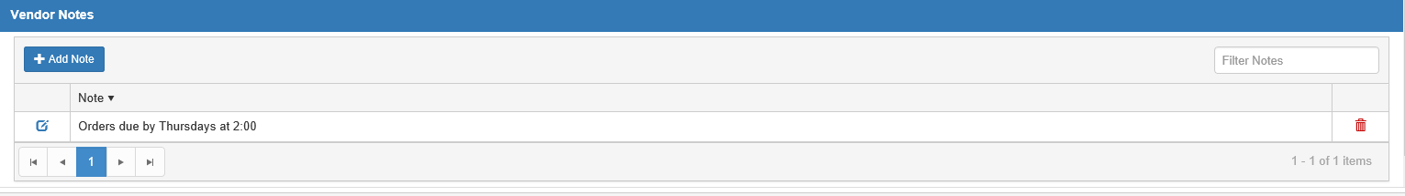

Vendor Notes: The last section allows you to add and edit any notes about the vendor.

Add Note: Click this button to add a new note.

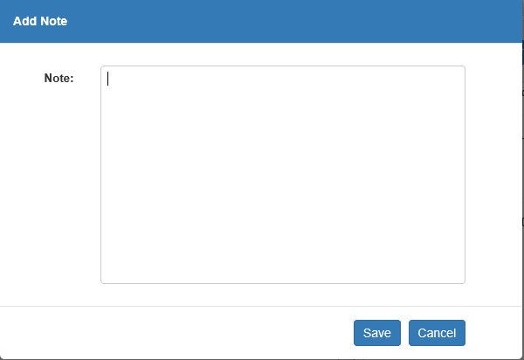

Enter the note and click Save to add it. Click Cancel to cancel adding the note.

Filter Notes: Use this field to filter your notes by entering in specific information contained in a note. The grid will then display records with matching information.

Grid Columns:

Edit Note: Click the blue icon to edit it.

Note: This shows the note. You can sort this column by clicking on the header to re-order the notes.

Delete Note: Click the red trash can to delete the note. The following warning will appear:

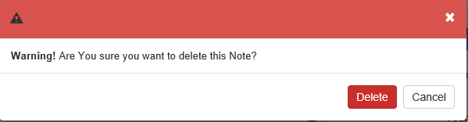

- Click Delete to delete the note.
- Click Cancel to keep it.

Footer Buttons:

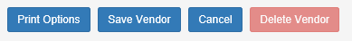

Print Options: Click this button to view your options for printing out the vendor record.

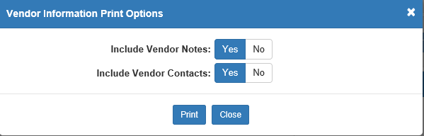

Include Vendor Notes: Select whether or not you want to print the Vendor Notes section along with the Vendor Info section.

Include Vendor Contacts: Select if you want to print the Vendor Contacts with the Vendor Info.

Close: Click this to close the print options.

Print: Click this to receive a display PDF of the VIM printout.

The example below has both the Vendor Info and Vendor Contacts sections included.

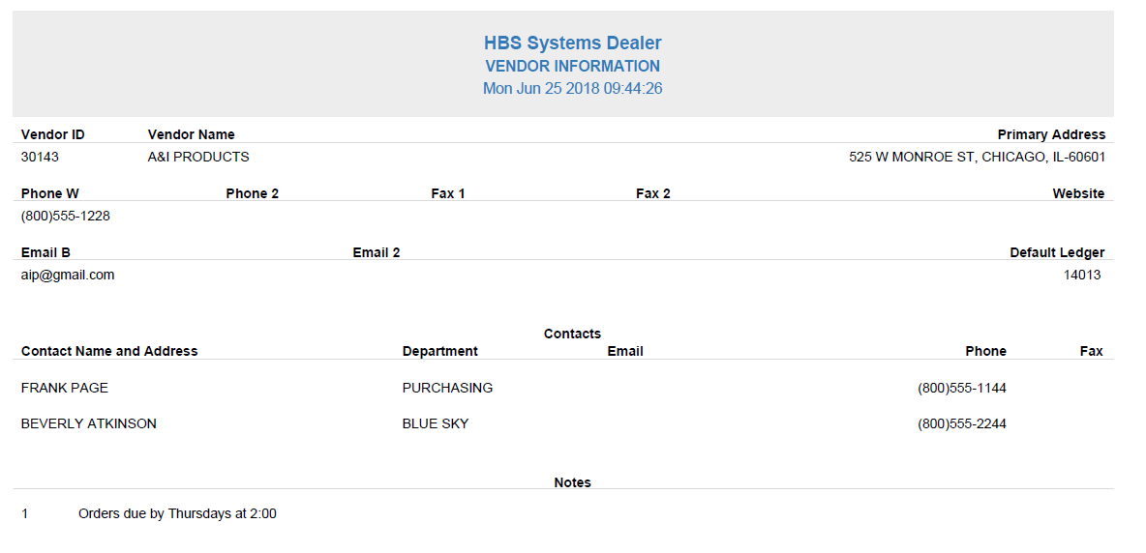

Save Vendor: This button is active whenever you make a change to the Vendor Info section. Click it to save your changes to the record.

Cancel: Click this button to cancel any changes made to the Vendor Info section. If you have made changes, the following warning will appear when you click the button:

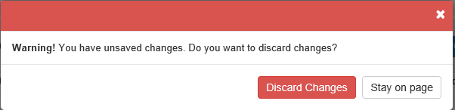

- Click Discard Changes to discard the changes.
- Click Stay on page to keep the changes.

Delete Vendor: This button is only active if the vendor has no A/P activity (invoices journaled in the system). Click it to delete the vendor from the system. The following warning will appear:

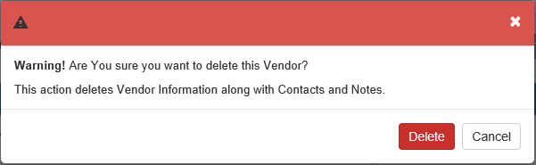

- Click Delete to delete the vendor.
- Click Cancel to keep it.

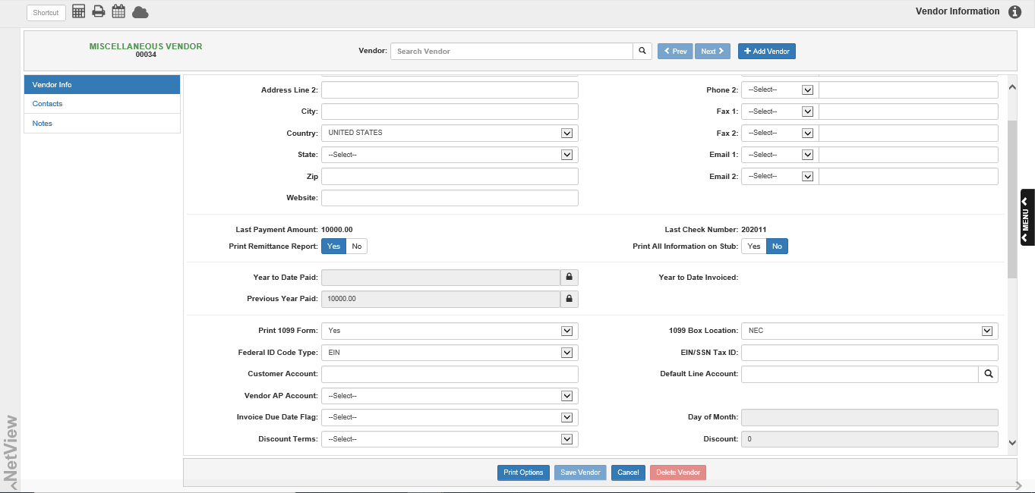

Add Miscellaneous Vendor Accounts: Ideally, you should have an AP Vendor Number for most businesses and individuals you do business with. You can also use a Miscellaneous Vendor to cover on-the-spot bills for those companies and individuals that do not have a Vendor Number. The Miscellaneous Vendor is most useful for On Demand Checks (ODC), where it is possible to enter and pay on-the-fly bills in a few moments. When creating the vendor, be sure you type “MISC” for the Vendor Name and leave the rest of the fields blank.

