Vendor Master Maintenance (VMM)

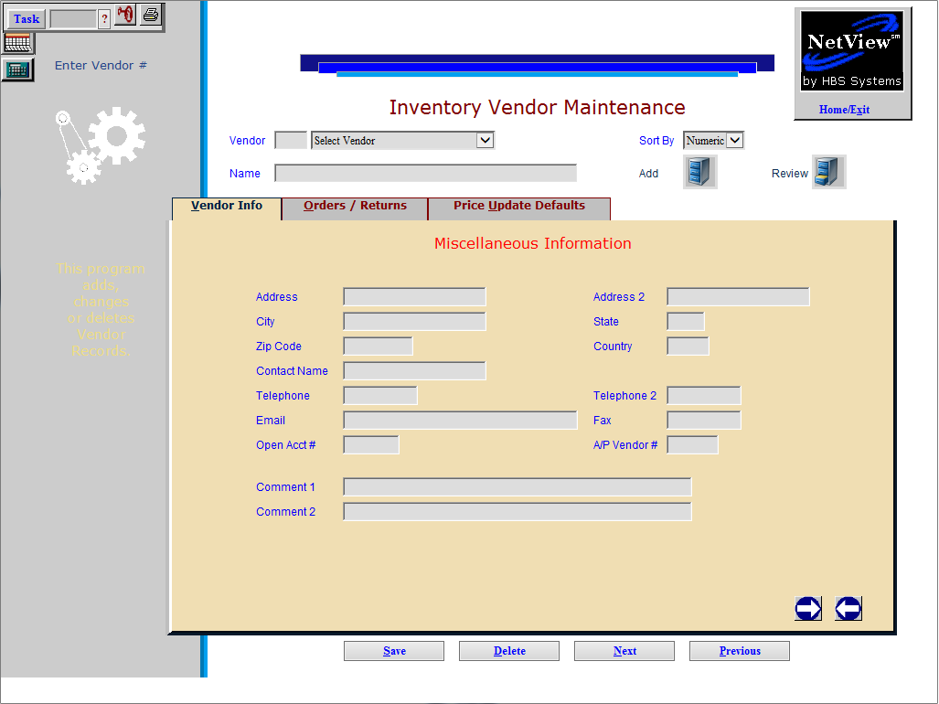

Vendor Master Maintenance (VMM) collects information about all of the manufacturers/vendors for any parts in inventory. Each vendor record contains basic information (vendor address, telephone number, fax number, and so on). In addition, VMM tracks parts order and price change activities for each vendor.

- To access this function, either:
  - Select “Inventory” from the drop-down menu. Choose the “Parts/Source Update” sub-menu and click on “Vendor Master Maintenance.”
  - Type “VMM” in the Shortcuts Bar

TIP—When to Update the Vendor Master Maintenance Files: If new part lines or manufacturers are added to the business, they MUST be added as vendors in Vendor Master Maintenance and as sources in Source Master Maintenance (SMM) before creating any parts for these new lines.

General Fields

Vendor: Every manufacturer/vendor the dealership uses must be assigned a three-digit number. This number MUST BE the same as the Manufacturer Price File Number (numbers from 100-799). Type in a vendor number in this field or use the drop-down menu to look it up.

If the vendor does not have a Manufacturer Price File Number (such as a short line), then it must be assigned a miscellaneous number between 800 and 899.

If creating Special Charges, like shop labor or mileage, then assign a Vendor Number in the 900-999 range.

Name: This field automatically fills with the vendor name when an existing vendor is selected. When creating a new vendor record, add the vendor name here.

Sort By: This field offers the ability to sort the Vendors numerically or alphabetically by Vendor Name. The default for this is kept in IPOS on the Inventory Defaults Tab.

Save: Click this button to save any changes made to the record.

Delete: Click this button to delete a record.

Next: Click this button to go to the next record in the system.

Previous: Click this button to go to the previous record in the system.

Right Arrow/Next Tab: Click the right arrow icon to move to the next tab in the record.

Left Arrow/Previous Tab: Click the left arrow icon to move to the previous tab in the record.

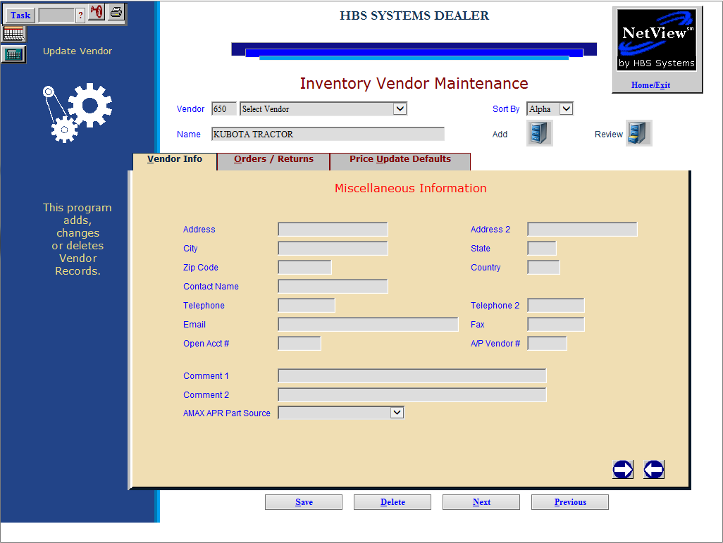

Vendor Info Tab (Alt V)

Address / Address 2: Enter the vendor's mailing address in these two fields.

City and State/Province and Zip/Postal Code/Country: The vendor's city, State/Province abbreviation, zip/postal code, and country can be (optionally) entered in these fields.

Contact Name: Enter the name of the primary contact at this vendor location into this field.

Telephone / Telephone 2: Enter the company's main telephone number in the Telephone field. If a second number is used, enter it in the Telephone 2 field. Do not enter dashes or spaces.

Email: This field holds the email address for the vendor or contact. Currently, this field is informational only.

Fax: Enter the vendor's fax number in this field.

Open Acct #: Enter the account number for the vendor here. Currently, this field is informational only.

A/P Vendor #: Enter the A/P five-digit Vendor Account Number in this field. Currently, this field is informational only.

Comment 1/Comment 2: Enter any informational comments or notes about the Vendor in this field.

AMAX APR Part Source: This field is present if AMAX is installed on the system. When AMAX is installed for CNH dealers, this will show if this vendor record is mapped to an AMAX APR source. The drop-down menu shows the possible choices.

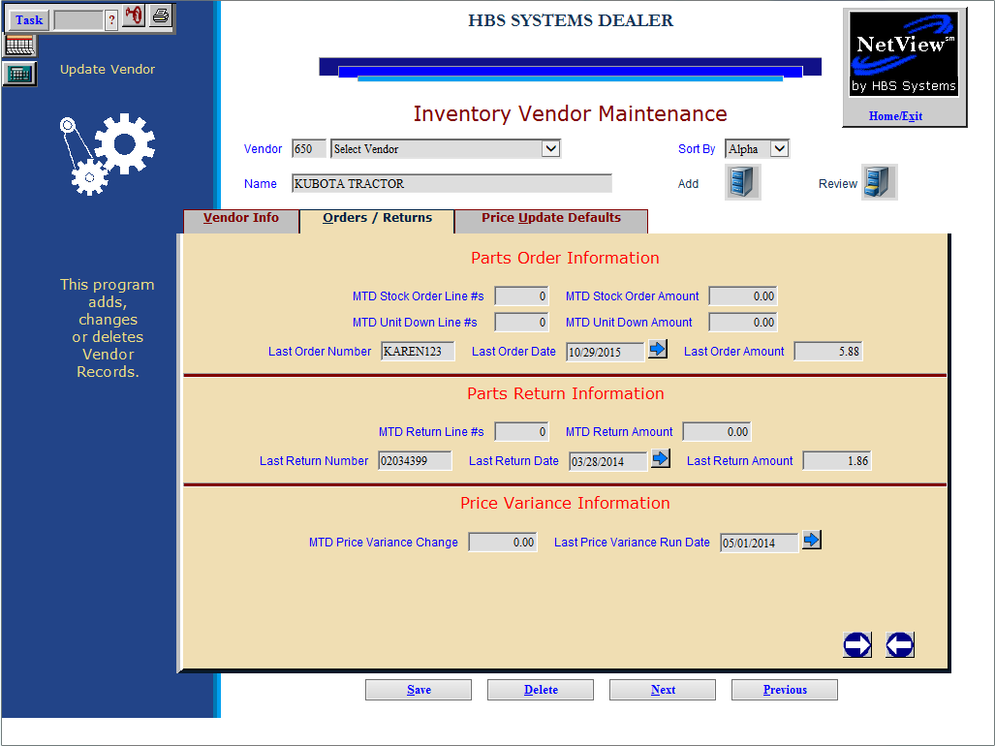

Orders/Returns Tab (Alt O): The fields on this tab collect information for the Parts Trend Report (TR). These fields are all system maintained and collect information from various programs to feed the report.

MTD Stock Order Lines: This field collects the number of different lines (individual part numbers) of stock orders received for the current month.

MTD Stock Order Amount: This field shows the dollar value of the stock orders received for the current month.

MTD Unit Down Lines #s: This field collects the number of lines (individual part numbers) of unit down orders received for the current month.

MTD Unit Down Amount: This field shows the dollar value of unit down orders received for the current month.

Last Order Number: This field shows the last parts order number received.

Last Order Date: This field shows the date of the last parts order number received. You can also use the button next to it to view and select a date for this field from a calendar.

Last Order Amount: This field shows the value of the last parts order number received.

MTD Return Line #s: This field collects the number of lines (individual part numbers) of parts return recorded for the current month.

MTD Return Amount: This field shows the value of parts returns recorded for the current month.

Last Return Number: This field shows the last parts return number processed.

Last Return Date: This field shows the date of the last parts return number processed. You can also use the button next to it to view and select a date for this field from a calendar.

Last Return Amount: This field shows the value of the last parts return number processed.

MTD Price Variance Change: This field shows the dollar value of the change in inventory due to the running of Price Update and Variance (usually due to loading a new price file).

Last Price Variance Run Date: When the Price Update and Variance is run, this field will show the date of the last change in inventory. You can also use the button next to it to view and select a date for this field from a calendar.

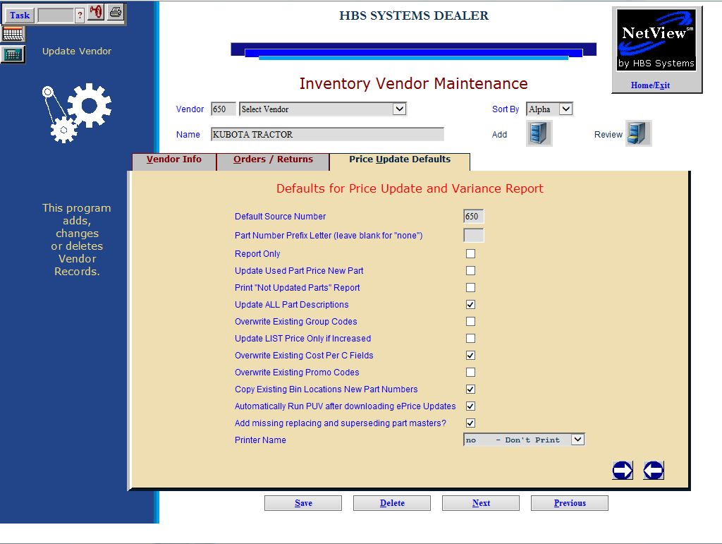

Price Update Defaults Tab (Alt U): This screen offers the option to run Price Update and Variance automatically after downloading Price Files via the ePrice software.

Default Source Number: The primary source for this vendor auto-fills in this field.

Part number prefix letter (leave blank for “none”): This field is provided for if the part number for this vendor comes with a Prefix letter. Note: Parts with prefixes can be more effectively handled as duplicate parts within Parts Inventory.

Report only: Leave this box blank to have the process run and update the identified parts. Check this box to run a report for ONLY what the price file would update, if it were run.

Update Used Part Price New Part:

Check this box to have PUV update used parts (type U) from the pricing of new parts (type N) with the same part number.

Leave empty to leave the used parts pricing as is.

Print “Not Updated Parts” Report: Check this box to print a report to identify parts with the Update Code field set to NO in the Part Master (i.e. parts which will NOT be updated). The report will also identify parts in inventory not found within this vendor’s price file. This report can be a helpful tool in analyzing the effect of the price file on inventory.

Leave the box empty to bypass the report.

Update ALL Part Descriptions:

Check this box to update the Description field in the Parts Master.

Leave the box empty if the descriptions are not to be updated. Be sure not to select the box if there are customized or manually maintained descriptions of parts for this vendor.

Overwrite Existing Group Codes:

- Check this box to have the Group ID in the Part Master updated with the latest information.
- Leave it blank if there are manually placed codes in the Group ID fields, as the system overwrites all entries if you choose to have the codes updated. Some vendors provide information in the group codes that assists in ordering.

Update LIST Price Only if Increased:

- Check this box to update or change the LIST price (the manufacturer’s suggested selling price) ONLY if the price has increased.
- Leave it blank to update all LIST prices whether they have increased or decreased.

Overwrite Existing Cost Per C fields:

- Check this box to update the Cost/C field for all this vendor’s parts.
- Leave blank to keep the existing information in the Cost/C field as is.
  - Be sure to leave the box empty if this field is manually maintained.

Overwrite Existing Promo Codes:

- Check this box to update the Promo Codes for all this vendor’s parts.
- Leave blank to keep the existing information in the Promo Codes as is.
  - Be sure to leave the box empty if this field is manually maintained.

Copy Existing Bin Locations New Part Numbers:

- Check this box to use the bin location on the existing part number being replaced as the bin location for the new part number.
- Leave it blank to build the part master for the new part number with a blank bin location.
  - In this case, manually enter the bin location at a later time.
  - We do NOT recommend blank bin locations.

Automatically Run PUV after downloading ePrice Updates:

- Check this box to automatically run PUV after the system downloads new price files via ePrice updates.
- Leave it blank to manually run PUV after the ePrice updates. Remember, if left blank it is your responsibility to run PUV to update pricing.

Add missing replacing and superseding part masters?:

- Check this box to have the system create any missing replacement or superseded part numbers found during the price update process.
- Leave blank to bypass adding the missing part numbers.

Printer Name: Select the printer to create the printout. A default printer name is auto-filled, but can be changed as necessary. This printer will receive the printout information from the automated running of PUV. Use the “No Printer” setting if the process is to run but not generate any reports (not recommended).

The following questions only appear when processing Price File 198 (Case) or 140 (New Holland).

Load Case–IH DS01 COST into Price Code: This field asks where DS01 figures in the Parts Masters affected by this Price File are to be loaded. Enter the Price Code (1-6) where DS01 costs are identified. The code selected in the past auto-fills in this field.

Load New Holland DS01 COST into Price Code: This field asks where DS01 figures in the Parts Masters affected by this Price File are to be loaded. Enter the Price Code (1-6) where DS01 costs are identified. The code selected in the past auto-fills in this field.

