View Technician Work Activity (VTWA)

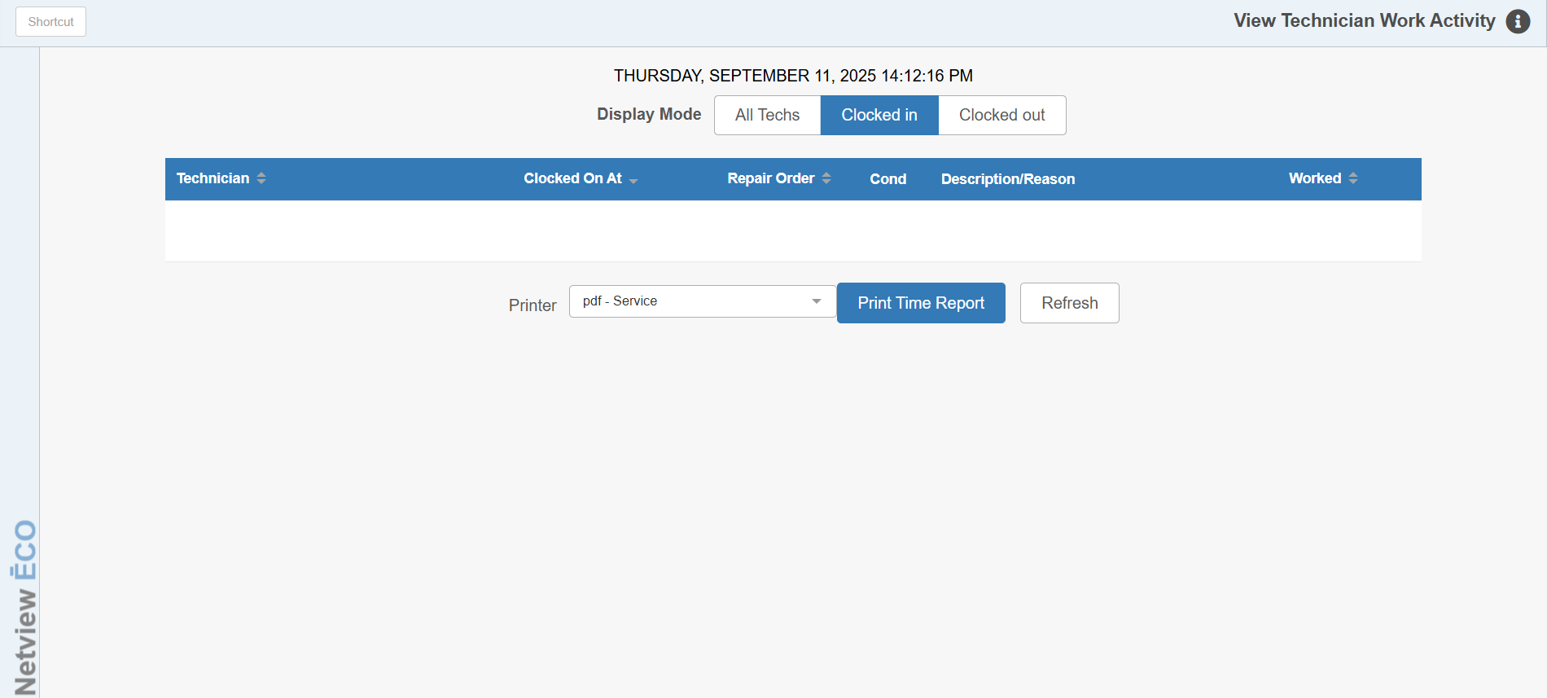

This program allows you to view and print a report of technician work details. A time stamp showing the last date and time the program was updated will show at the top of the screen.

To access this function, type “VTWA” in the Shortcuts Bar.

Display Mode: Select which technician category to display:

- All Techs
- Clocked In
- Clocked Out

Results Box: This box will display the list of technicians whose current status matches the Display Mode selected. The column headers are as follows:

Technician: Lists the technician’s name.

Clocked On At: Shows the time the technician clocked in to a repair order, if applicable.

Repair Order: Lists the RO the technician is currently working on, if clocked in.

Cond: Lists the specific RO condition the tech is clocked in on, if applicable.

Description/Reason: Gives a description of the technician’s current status. For example, if they are clocked out, it shows that, as well as what date and time they clocked out. This column will also show if a technician has never clocked in or out.

Worked: Shows how long the technician has worked since their clock-in time (in hours) if they are currently clocked in.

Refresh: Click this button to refresh the list currently displayed at any time. This will update the date/time stamp at the top of the program to show the moment that the statuses were refreshed.

Select Printer: Select a printer from the drop-down menu if you want to receive a printout of the technicians listed for the selected Display mode. Select a pdf printer to view a copy of the report.

Print Time Report: Click this button to print the report.

Sample Report

