Unit Defaults (WGDF)

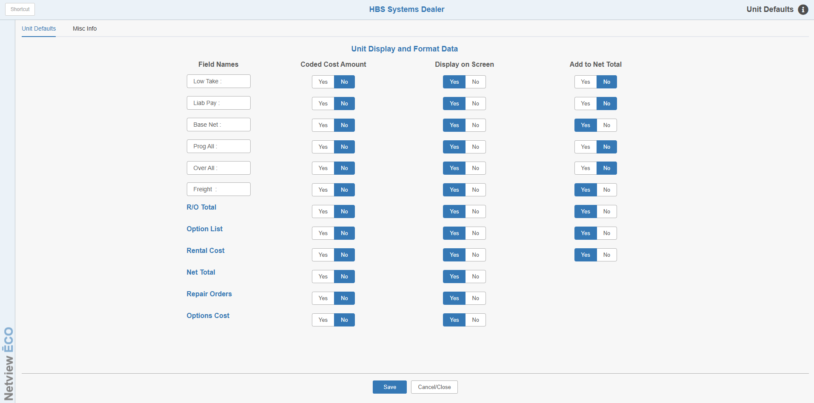

Unit Defaults (WGDF) lets you specify how you want the data in certain fields to show in the Unit Master during inquiries or searches. Your choices will probably depend on if you typically have customers “looking over your shoulder” as you are looking up unit information on a terminal. This area also holds your choices for a variety of options within your unit operations. In a nutshell, you have three choices that apply to the dollar amounts in the Unit Master:

- The information may show all the time.
- The information may be hidden all the time with an option to briefly display it.
- The information may show, but appear in a “coded” or scrambled format and can be briefly “uncoded.”

To access this function, you can either:

- Select “System Maintenance” from the menu. Choose the “Company File” submenu and click “Unit Defaults.”
- Type “WGDF” in the Shortcuts Bar.

Field Definitions – Unit Defaults Tab

Field Names - Low Take, Liab Pay, Base Net, Prog All, Over All, and Freight: The descriptions of these fields can be changed to suit your dealership’s needs. While Low Take and Prog All do not automatically receive any amounts from the system’s processes, the others do. If you change the descriptions for the fields listed below, keep in mind that the system uses them based on their original description and puts amounts in them according to that definition.

Liab Pay is the liability you owe (A/P and/or Notes Payable).

Base Net is the base cost or original invoice amount.

Over All is the over-allowance on a trade in.

Freight is the itemized freight/handling for the unit.

Field Names – R/O Total, Option List, Rental Cost, Net Total, Repair Orders, Options Cost: The descriptions of these fields cannot be changed. They are listed in this column so the user can apply the other settings to them.

Coded Cost Amount: If this field is set to Yes, the system will display a coded amount when you use Unit Inquiry (UI) so that a customer cannot see the amounts in these fields. A coded format means that the system “scrambles” the field and inserts a letter into the rearranged format.

- The system has a pattern for the coding process.
  - The numbers to the right of the decimal point (the cents) are brought to the beginning of the code.
  - The first digit of the dollar figure followed by a letter is placed next.
  - Finally, the remaining digits are placed to the right of the letter.
  - Example: the value 001C5375 is actually 15,375.00.
- The system is consistent with the letters it uses in the code. For each beginning digit of the original amount, a specific letter will follow. These are shown below:
  - 1=C
  - 2=E
  - 3=G
  - 4=I
  - 5=K
  - 6=M
  - 7=P
  - 8=R
  - 9=T

To “decode” the amount on the screen in UI, simply press the  icon. The decoded amount will appear on the screen for a few seconds, and then revert back to a coded format.

Display on Screen:

- If this field is set to Yes, it will always display on the Unit Inquiry (UI) screen. If you “code” a field, be sure to answer “Yes.”
- However, if this field is set to No, it will hide the amount until the icon is pressed. The amount will then flash on the screen for a few seconds, then go back to a hidden status.
  - If you choose No, the unit inquiry will see it as being hidden instead of coded. You can still view it by pressing the icon, but you will never see the amount in a coded format.

Example 1 - Coded and Displayed on Screen: The example below illustrates how a unit inquiry looks if the defaults are set to “Yes” for Coded and “Yes” for Display on Screen for the Liability Pay, Base Net, and Net Total fields.

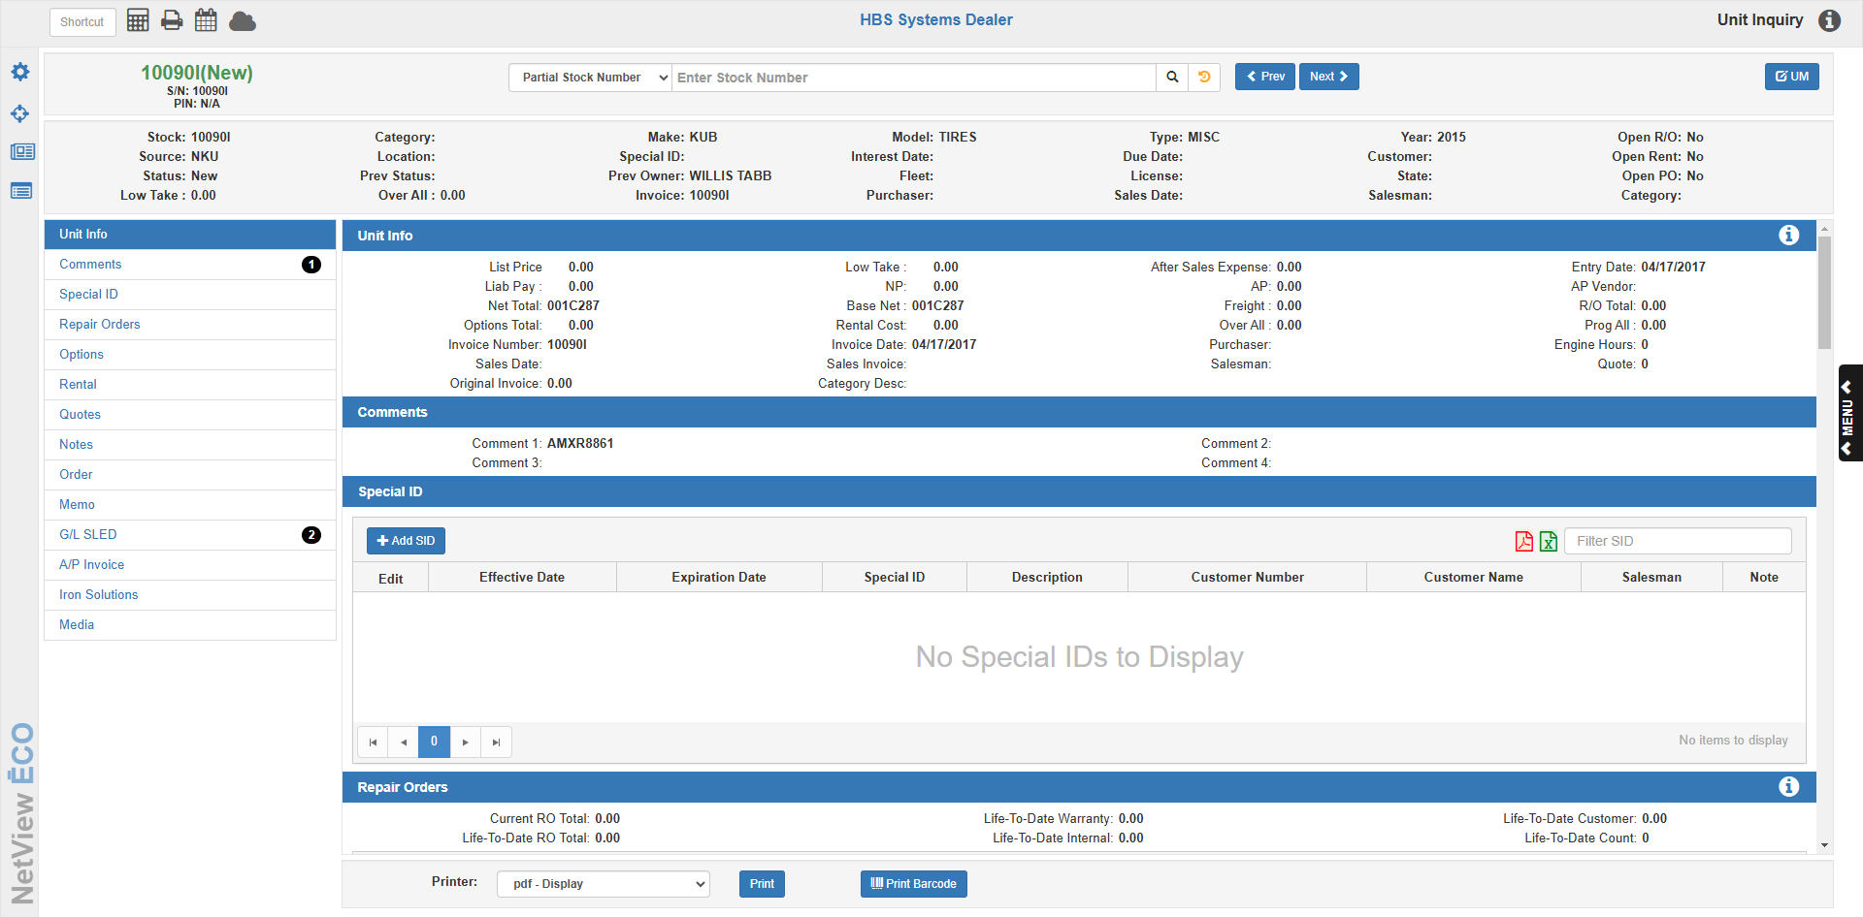

When you press the icon, the screen changes to the example below.

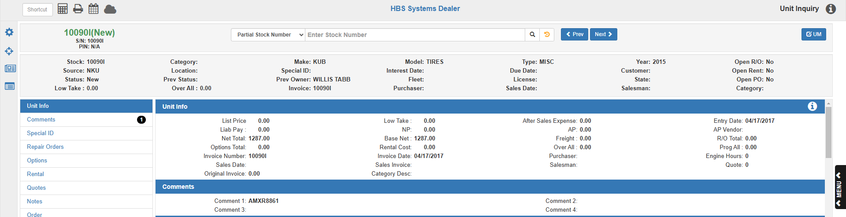

Example 2 - Not Coded and Not Displayed on Screen: The example below shows how a unit inquiry looks if the defaults are set to “No” for Coded and “No” for Display on Screen.

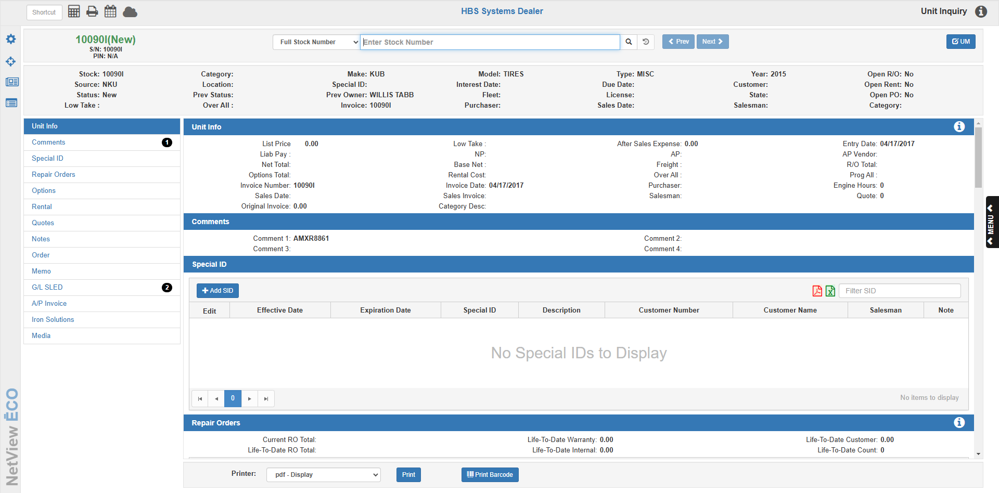

When you press the icon, the screen changes to the example below.

Add to Net Total: These fields are controlled primarily by the integration question that follows. Modification of the information in this column may dramatically affect the values of your Units inventory. Please contact a member of the HBS Support Team before making changes to these fields.

If your units are integrated, the choices for fields in this column are pre-selected, allowing no changes to the fields.

If your units are not integrated, this column can be used to select which fields to add together to create the Net Total.

Permissions for Unit Inquiry by login: Some of the information available in UI can be controlled by login permissions. The permissions by login offer these possibilities:

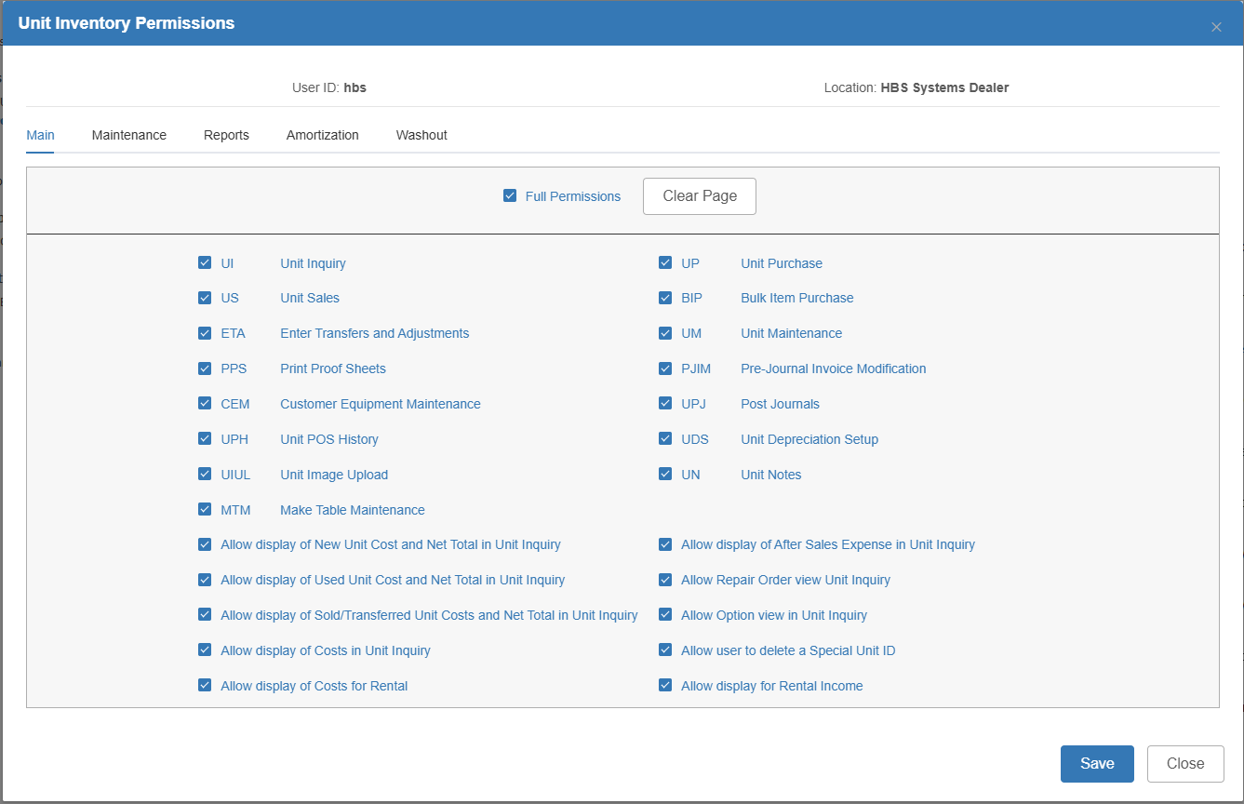

The Master setting in these choices is Allow display of Costs in Unit Inquiry. If this is checked, any of the other settings can be checked or un-checked. If this is un-checked, NO OTHER settings are recognized. The settings are:

- Allow display of New Unit Cost and Net Total (shows cost/net total for NEW units)
- Allow display of Used Unit Cost and Net Total (shows cost/net total for USED units)
- Allow display of Sold/Transferred Unit Cost and Net Total (shows cost/net total for SOLD units)
- Allow display of Costs in Unit Inquiry – MASTER setting – Must be checked to see any costs or use any of the other settings
- Allow display of Costs for Rental (shows cost for RENTAL units)
- Allow display of After Sales Expense (shows after sales expense for Sold units)
- Allow Repair Order view in Unit Inquiry (ability to view the PDF for the Repair Order)
- Allow Option view in Unit Inquiry (ability to view the option info for the unit)
- Allow user to delete a Special Unit ID (enables ability to delete SIDs listed in UI)
- Allow display for Rental Income (ability to view the Rental Income value for the unit if applicable)

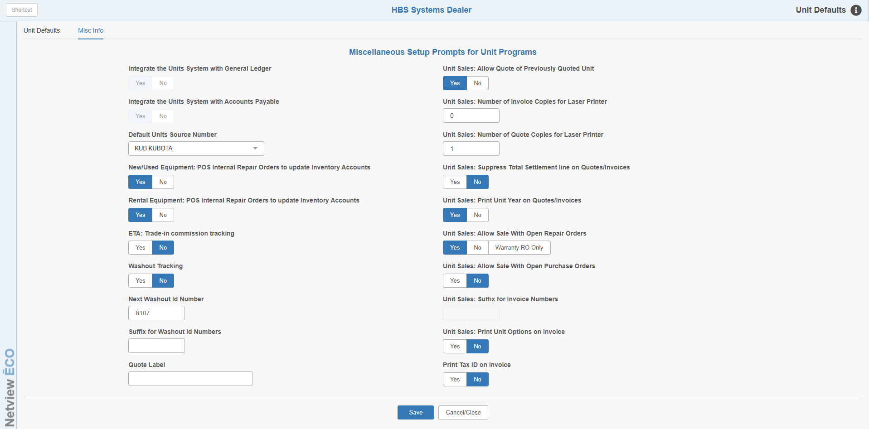

Field Definitions – Misc Info Tab:

Integrate the Units System with General Ledger: This field indicates if Units is integrated with the General Ledger. This setting is locked for editing. Please contact HBS Support if you have any questions on this setting.

Yes means the two packages are integrated and information is passed from Units to the General Ledger to handle the accounting entries.

No means that these two packages do not receive information from each other and the accounting is handled manually and independently.

Integrate the Units System with Accounts Payable: This field indicates if Units is integrated with Accounts Payable. This setting is locked for editing. Please contact HBS Support if you have any questions on this setting.

- Yes means the two packages are integrated and information is passed back and forth between Units and Accounts Payable.
- No means that these two packages do not receive information from each other and the accounting is handled manually and independently.

Default Units Source Number: Units uses this source number for historical records (status H) added for equipment that your dealership did not sell to its current owners. Some dealers create a unit source specifically for these historical units. While there is no accounting implications for the source entered here, a separate source provides more division of historical units from the rest of the units in sales history information. A common setting is “ZZZ Historical Units.”

New/Used Equipment: POS Internal Repair Orders to update Inventory Accounts: This field determines if internal repairs should add to the Net Total of new or used units in inventory. Yes means the internal repair orders from Point Of Sale (POS) or Netview Service (SS) will add to the value of your inventory units. YES is the recommended setting.

Rental Equipment: POS Internal Repair Orders to update Inventory Accts: This field determines if internal repairs should add to the Net Total of rental units in inventory. Yes means the internal repair orders from Point Of Sale (POS) or Netview Service (SS) will add to the value of your rental inventory units. YES is the recommended setting.

ETA: Trade-In Commission Tracking: This setting offers the option to write information to the Sales Commission file for ETA transaction.

- The default setting is No, which is appropriate for most dealerships.
- Choose Yes and it activates the first line in ETA with the ability to affect the Sales Commission file (and Sales Commission Reports accordingly).
  - Two fields are added to ETA:
    - Update Commission File
    - Salesman, which affects the Sales Commission file and writes the Salesman ID to GLDI.

Washout Tracking: This setting offers the option to turn on Washout Tracking. This tracking opens another field in US to tie a trade-in to a unit being sold. These relationships are called washout chains and linked related sales together until no more trade-ins are taken. The last trade taken ends the washout chain. The activity in a washout chain can be tracked via printout.

Next Washout ID: Here you set the next Washout ID number to be used (default is 1 when program is first used, afterwards will default to the next available number).

Suffix for Washout ID Numbers: You can set a Suffix for the Washout ID numbers (useful for multi-locations). You might consider the same Suffix as is used for Unit Sales (US) Invoices.

Quote Label: You may enter a “name” for the US quote. If none is entered, it defaults to “Quote.”

Unit Sales: Allow Quote of Previously Quoted Unit: This field is no longer in use.

Unit Sales: Number of Invoice Copies for Laser Printer: This field is used when you are printing your Unit Sales Invoices on a laser printer. It holds the number of copies you wish to print per invoice.

Unit Sales: Number of Quote Copies for Laser Printer: This field is used when you are printing your Unit Sales Quotes on a laser printer. It holds the number of copies you wish to print per quote.

Units Sales: Suppress Total Settlement Line on Quotes/Invoices: This option lets you exclude the Total Settlement Line on Unit Quotes and Invoices.

- Choose Yes to exclude the line.
- Choose No to have the line print on the Quotes and Invoices.

Unit Sales: Print Unit Year on Quotes/Invoices: This setting determines if the Model Year prints on the Unit Sales Quotes and Invoices.

- Choose Yes to print the Model Year.
- Choose No to suppress printing of the Model Year.

Unit Sales/POS: Allow Sale with Open Repair Orders: This setting offers the option to sell Units with Open ROs.

- If you set this to Yes, you will be able to process Sales in US or POS for units that have open ROs.
  - When the unit is sold, it will be costed with the values present on the unit at that point.
  - When the RO is later invoiced, the value of the RO will be posted according to the RO type:
    - Internal will post to the GL account number designated in the After Sales field in the Unit Source.
    - Warranty will post to the Warranty Receivable account.
- Choose No to prevent the sale if there are open ROs.
- Choose Warranty RO only to allow the sale when there is an open RO that is Warranty pay.

Unit Sales: Allow Sale with Open Purchase Orders: This setting offers the option to sell Units with Open POs (if you have the Purchase Order system).

- If you set this to Yes, you will be able to process Sales in US or POS for units that have open POs. When the unit is sold, it will be costed with the values present on the unit at that point.
- Choose No to prevent the sale if there are open POs.

Unit Sales: Suffix for Invoice Numbers: This setting is locked for editing. Please contact HBS Support if you have any questions on this setting.

Unit Sales: Print Unit Options Invoice: This setting determines if the checkbox at the bottom of the Unit Sales screen to Print Options is filled in or blank.

- Choose Yes here and the box in US will be pre-filled with a check and means that the Options will print on a Unit Sale or Quote.
- Choose No here and the box in US will be blank.
- In either case, you check or uncheck the box in US for that particular sale or quote.

Print Tax ID on Invoice: This setting turns on the printing of the Tax ID field in Enter Customer Information (ECI) on a US invoice. Select Yes to turn on printing and No to turn it off.

Save: Click this button at any time in either tab to save your settings. Note that clicking this button will also close the program.

Cancel/Close: Click this button at any time in either tab to close the program without saving any settings. The following alert will appear:

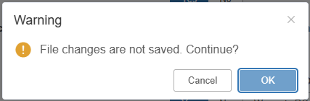

Click OK to close the program without saving. Click Cancel if you want to go back and save your settings first.

