Washout Report (WOR)

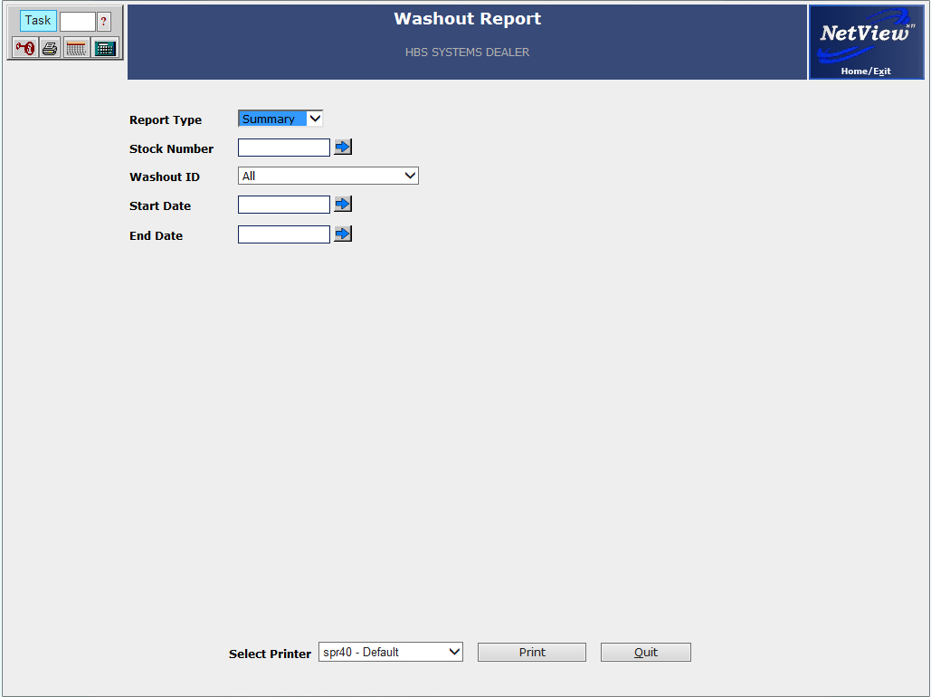

This report provides the ability to track the washout of a chain of equipment sales and trade-ins until the last unit in the chain has been sold. The process begins in Unit Sales (US) and tracks sales transactions as well as all other transactions (repairs, options, etc.) applied to the units in the washout chain. By referencing them together, it creates or continues the washout chain. The chain itself continues as long as a trade comes in on the sale. As soon as you sell the last item in the chain and don’t take a trade, the chain ends.

To access this function, you can either:

- Select “Units” from the menu and choose the “Washout” submenu. Click on “Unit Washout Report.”
- Type “WOR” in the Shortcuts Bar.

Here is an example:

Deal #1
Sell 12345 Take in 98765

Deal #2
Sell 98765 Take in 23456

Deal #3
Sell 23456 Take in 87654

Deal # 4
Sell 87654 No trade, so chain ends

The Washout Report will track all expenses to the units from the date of Deal #1 (by stock number) through the date of Deal #4. The expenses are ROs, Options, etc. that are directed to the specific stock numbers (the trade-ins in the chain).

Field Definitions:

Report Type: The choices are Summary or Detail.

- Detail gives all line items contributing to the final WO Margin and Percent.
- Summary just includes a one-line total.

Stock Number: Type a unit number or use the arrow next to Stock Number field, which calls up the Unit Search screen. If a selected unit does not have a Washout ID, the screen will create an alert informing you of this.

Washout ID: This entry can be used in combination with a stock number or cut-off date. If you select only a Washout ID, the report will list all units involved with the Washout ID.

Start/End Date:

- Type in starting and ending dates to limit the report to a certain range of dates.
- Leave these fields blank for all activity up through the current date for the selected stock number or Washout ID.

Detail Report:

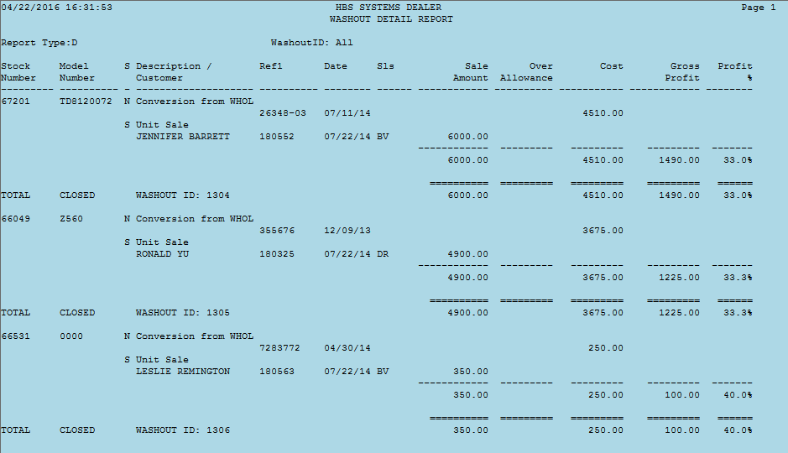

Stock Number: This column lists the units with the same Washout ID.

Model Number: This shows the model number of the unit sold.

S: This shows the unit’s status (N=New, S=Sold, U=Used, etc.).

Description/Customer: This shows the type of transaction and the customer’s name.

Refl: This shows the document number of the transaction.

Date: This shows the date of the transaction.

Sls: This shows the salesperson ID for the transaction.

Sale Amount: This column lists the sales amount for the unit sold in Unit Sale (US).

Over Allowance: This column shows the over allowance, if any.

Cost: This column shows the cost for any entries made.

Gross Profit: This shows the gross profit for this part of the chain.

Profit %: This shows the percent of profit on all units sold and traded with this Washout ID.

Total Lines: A total line appears after each part of the washout chain. A report total line appears as the very last line of the report.

Summary Report:

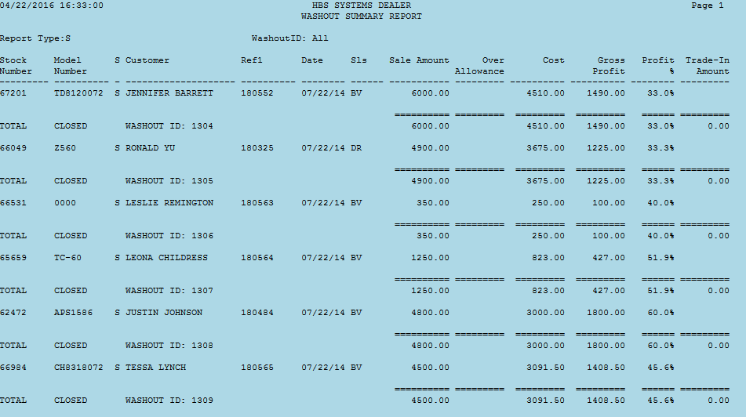

The Summary Report includes a one-line total for each Washout ID up through the End Date selected for the report (or the current date, if no End Date was picked). A report total line appears as the very last line of the report.

Trade-In Processing with the Washout option: The Trade-In process changes when the Washout option is turned on. There is an additional field to complete when the trade is brought in.

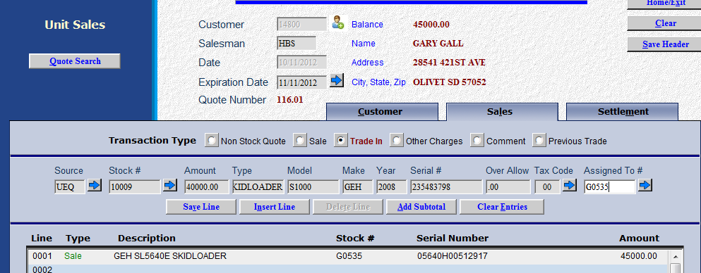

The Assigned To # field is available to indicate which piece the trade is coming in on. This establishes the washout chain or continues it if the unit being sold was a trade-in on a previous sales transaction. Type the stock number of the unit being sold.

The previous trade Transaction Type is also available to reference a previously taken trade to a unit sold on this invoice.

