Inventory Parts Master: This file pulls data from the Parts Master and Parts Sales History in the Parts Master Maintenance program. There are multiple screens of information for this large file.

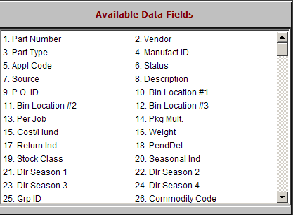

Part Number: The 20 character Part Number field holds the complete part number.

Vendor: This three-digit number identifies the manufacturer of the part number.

Part Type: The Type Code identifies what the part is. It can be one of the following:

(N)=New

(R)=Rebuilt or Remanufactured

(C)=Core

(U)=Used

(M)=Memo

Manufact ID: The manufacturer ID is provided by certain manufacturer price files.

Appl Code: The Application Code is used primarily for New Holland and Ford Motor dealers to specify sorting preferences. Its field holds up to 8 alphanumeric characters.
- Status: This is an informational field only and does not affect any programs. The field accepts:
  - “A” for Active
  - “O” for Obsolete.

Source: Every part master is tied to a three-digit Source Number. The source contains the necessary information to:

Price the part

Maintain its stock class

Determine BSL and BRP for ordering

Handle the accounting from POS and SMS.

Description: This field holds the part master description, a shortened description (provided from a price file, if available) that appears on parts invoices and reports.

P.O. ID: The P.O. ID field is a reference-only field that can contain miscellaneous information. It does not affect any inventory or ordering function, or any standard inventory reports.

Bin Location #1: The Bin Location #1 field may contain up to 12 alphanumeric characters. This manually-entered and maintained field shows the primary physical location of the part

Bin Location #2: The Bin Location #2 field may contain up to 12 alphanumeric characters. This manually-entered and maintained field shows the secondary physical location of the part

Bin Location #3: The bin location #3 field may contain up to 12 alphanumeric characters. This manually-entered and maintained field shows the third physical location of the part.

Per Job: The Per Job Quantity field represents the quantity needed to complete a shop job. This helps the ordering programs maintain proper shelf quantity.
- Pkg. Mult.: This is the Package Multiple field. NOTE: The default is 1, but if the vendor always ships 2 or more of this part number as a package, this field displays that information.

Cost/Hund: This field stands for cost per 100. It prompts the system to divide the factored list price and cost by the number shown here (which can be from 1 to 999). This field is used when the pricing on the part number is for a quantity of the part rather than an individual part.

Weight: This field is the actual weight of a single part. If available, this information is supplied by the Manufacturer’s Price File.

Return Ind: The Return Indicator field is updated by the Manufacturer Price Files. The codes found in this field indicate if the part master can be returned to the vendor.

PendDel: The Pending Deletion field is maintained by the Month End Process (INME) and identifies the parts that have been flagged for deletion.

A “D” in this field means the part has been flagged.

Stock Class: Stock Class is the code used to identify the part's stocking status (i.e., fast-moving or non-stocking). The standard stock classes the inventory system uses are 1, 5, 6, 7, 8, 9, U, F, and A.

Seasonal Ind: The seasonal indicator can be either a “#” or a “*”

DIr Season 1: This is the first season defined for the part. The first position shows the beginning of the season, while the second position shows the end. Valid seasons are:

1-9 for the months January through September

“O,” “N,” and “D” for the months of October, November, and December.

Dlr Season 2: This is the second season defined for the part. The first position shows the beginning of the season while the second position shows the end. Valid seasons are:

1-9 for the months January through September

“O,” “N,” and “D” for the months of October, November, and December.

Dlr Season 3: This is the third season defined for the part. The first position shows the beginning of the season while the second position shows the end. Valid seasons are:

1-9 for the months January through September

“O,” “N,” and “D” for the months of October, November, and December.

Dlr Season 4: This is the fourth season defined for the part. The first position shows the beginning of the season while the second position shows the end. Valid seasons are:

1-9 for the months January through September

“O,” “N,” and “D” for the months of October, November, and December.

Grp ID: This field holds the Group ID. It is often supplied by the price file and may be used to identify parts for promotional orders.

Commodity Code: This field contains the special pricing codes or commodity codes that the vendor has set up for ordering purposes (i.e., codes that determine grouping, pricing, discounts and bulk ordering).

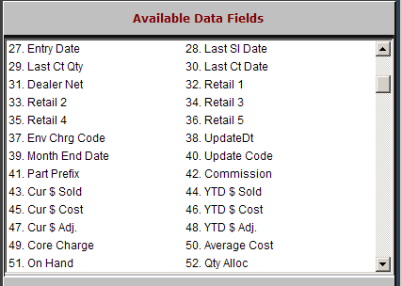

Entry Date: The Entry Date field shows the month, day, and year the part master was added to system. It is used for comparison purposes or inventory obsolescence. When a part is added, the current date is placed in this field.

Last Sl Date: The Last Sales Date field shows the month, day, and year of the last sale of this part. This system-maintained field is updated each time a part is sold on a POS or SMS invoice, or in Post Sales/Adjustments (POA).

Last Ct Qty: The Last Count Quantity field shows the final physical count (quantity) for this part when the inventory system was last updated from the Physical Inventory process.

Last Ct. Date: The Last Count Date field stores the date of the last physical inventory taken on the system.

Dealer Net: This field shows the manufacturer cost for the part number, often provided from the price file.

Retail 1: This retail field stores the Manufacturer's Suggested Retail Price (MSRP) for this part. When a price file is present for this parts source, the displayed value is often pulled directly from the price file.

Retail 2: This field may hold an additional price code defined for the part, shown in the part master as “Price Code 3.”

Retail 3: This field may hold an additional price code defined for the part. It is shown in the part master as “Price Code 4.”

Retail 4: This field may hold an additional price code defined for the part. It is shown in the part master as “Price Code 5.”

Retail 5: This field may hold an additional price code defined for the part. It is shown in the part master as “Price Code 6.”

Env Chrg Code: This field may hold the code for an environmental charge that applies to this part number. The Environmental Codes can be used to comply with local, state/provincial or federal taxes or charges on specific items. It can also be used to add “dealership generated” fees to items.

UpdateDt: The Update Date field is updated by Price Update and Variance (PUV), and records the effective date of the last price file installed on your system that may have affected this part.

Month End Date: The Month End Date field is maintained by the Month End Process (INME). It is automatically updated and shows the date the last time the Month End Process was run.

Update Code: The Update Code field indicates if this part number is to be affected by a price file update.

“Y” means the Price Update and Variance (PUV) updates the price file information for this part master.

“N” means the part is not to be updated when a new price file is loaded.

Part Prefix: This field is reserved for future use.

Commission: The Commission field determines if the part is eligible to be included on the Parts Commission Reports (SCR and SCN).

“Y” in this field means that it can be included on the commission reports.

“N” in this field means this item is not included in the sales dollars used to calculate commission.

Cur $ Sold: The Current Dollars Sold field summarizes the sales activity in dollars for the current month. As each part sold through POS and SMS is processed, the actual selling price at the time of the sale is added to this field.

YTD $ Sold: The Year to Date Dollars Sold field summarizes the Year to Date sales activity in dollars for the current calendar year through the last parts month end. The Month End Process (INME) updates this field from month to month

Cur $ Cost: The Current Dollar Cost field summarizes the cost of sales activity in dollars for the current month. As each part sale through POS and SMS is processed, the actual cost at the time of the sale is added to this field.

YTD $ Cost: The Year to Date Dollars Cost field summarizes the Year to Date cost of sales activity in dollars for the current calendar year through the last parts month end. The Month End Process (INME) updates the information in this field from month to month.

Cur $ Adj.: The Current Dollar Returns and Adjusted field summarizes the adjustment activity from Post Sales/Adjustments (POA). NOTE: It is updated only when the OT (Order Type) field and Code field are filled with an “A.” The dollar value in this field is based on cost.

YTD $ Adj.: The Year to Date Dollars Returns and Adjusted field summarizes the Year to Date adjustment activity in dollars for the current calendar year through the last parts month end. The Month End Process (INME) updates the information in this field from month to month.

Core Charge: This field is no longer active.

Average Cost: This field holds the system calculated Average Cost when this type of costing is selected for the system.

On Hand: This system-maintained field reports the current total quantity on hand in all bin locations for this part number, and is defined in the units sold.

Qty Alloc: The Quantity Allocated field contains the quantity of this part that has been placed on open picking tickets (in POS and SMS). These parts may actually still be in the bin, but they have already been dedicated to a picking ticket for sale.

Parts that have been assigned to a picking ticket reduce the On Hand field.

When the picking ticket becomes an invoice, the quantity shown in the Qty Alloc field is relieved.

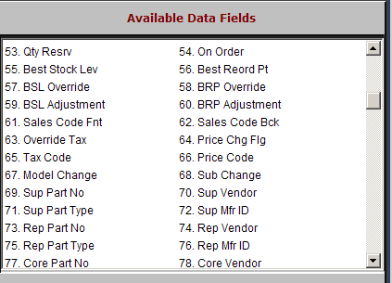

Qty Resrv: The Quantity Reserved field is manually entered and maintained. This is a multi-location feature. When the Inter-Store Parts Transfer (ISPT) Program is run, it considers the quantity value in this field before letting on-hand quantities move to another location.

On Order: The Quantity On Order field is system-maintained. It shows the quantity of outstanding orders (regular and back order) for this part. It is a total of ALL orders on the system, and is updated each time a new order is created, changed, or receipted.

Best Stock Lev: This field holds the system-calculated best stocking level determined by the Standard Stock Order (SSO) Program.

Best Reord Pt: This field holds the system-calculated best reorder point determined by the Standard Stock Order (SSO) Program.

BSL Override: The Best Stocking Level Override field is manually entered and maintained. It also holds the best stocking level for this part master. When a quantity is entered here, it overrides the BSL value calculated by the Standard Stock Order (SSO).

BRP Override: The Best Reorder Point Override field is manually entered and maintained. It holds the best reorder point for this part master. When a quantity is entered here, it overrides the BRP value calculated by the Standard Stock Order for best reorder point.

BSL Adjustment: The Best Stocking Level Adjustment field is manually entered and maintained. Instead of overriding, as the BSL/BRP Override fields do, the system calculates the best stocking level for this part master through the Standard Stock Order program and then gets adjusted by an entry in this field.

BRP Adjustment: The Best Reorder Point Adjustment field is manually entered and maintained. Instead of overriding, as the BSL/BRP Override fields do, the system calculates the best reorder point for this part master through the Standard Stock Order program and then gets adjusted by an entry in this field.

Sales Code Fnt: The Sales Code (Front Counter) field is used when the Override Tax Code Field is set to “Y.” In this case, it holds the appropriate sales code for parts counter sales, which identifies where the accounting entry will be posted when this part is added to a picking ticket.

Sales Code Bck: The Sales Code (Back Counter) field is used when the Override Tax Code Field is set to “Y.” In this case, it holds the appropriate sales code for parts shop/service sales, which identifies where the accounting entry will be posted when this part is added to shop/repair order picking ticket.

Override Tax: The Override Tax Code field lets the user override the customer's taxable status when this part is put on a POS picking ticket.

This field works with three other fields:

Tax Code (where a tax code is entered)

SLS CD FR (where the sales code for parts counter sales is entered)

SLS CD BK (where the sales code for shop parts sales is entered).

“Y” means the tax code and sales codes set up in this part master override the customer’s taxable status on the picking ticket.

“N” means the customer’s taxable status should be used.

Price Chg Flg: Price Update and Variance (PUV) maintains this field.

If the price has changed (increased in value) on this part master during the update, a “Y” displays in this field.

If the price has not changed, an “N” displays in this field.

Other values besides “Y” and “N” may be shown here, if available in the price file. Their definition will vary by vendor.

Tax Code: This field is used when the Override Tax Code Field is set to “Y.” In this case, it contains the tax record used to calculate tax when the parts are sold.

Price Code: The Manufacturer Price File updates the two-digit price code when Price Update and Variance (PUV) is run. This price code is vendor-specified for discounts, etc.

Model Change: The Model Change field is updated from the Manufacturer Price File when Price Update and Variance (PUV) is run.

A “Y” in this field indicates the MUO (Machine Used On) information for this part has been changed.

An “N” indicates that no MUO changes from the new price file have been entered.

Sub Change: The Substitute Change field is updated from the Manufacturer Price File when Price Update and Variance (PUV) is run.

A “Y” in this field indicates the price file has changed the substitute information for this part.

An “N” indicates the price file has not changed or updated the substitute information.

Sup Part No: Superseded (old) part number. If this part number replaced another number, the old number is shown here.

Sup Vendor: Superseded (old) vendor. If this part number replaced another number, the vendor of the old number is shown here.

Sup Part Type: Superseded (old) part type. If this part number replaced another number, the part type of the old number is shown here.

Sup Mfr ID: Superseded (old) manufacturer ID. If this part number replaced another number, the Mfr ID of the old number is shown here.

Rep Part No: Replacing (new) part number. If this number has been replaced by another number, the new number is shown here.

Rep Vendor: Replacing (new) vendor. If this part has been replaced by another number, the vendor of the new number is shown here.

Rep Part Type: Replacing (new) part type. If this part has been replaced by another number, the part type of the new number is shown here.

Rep Mfr ID: Replacing (new) manufacturer ID. If this part has been replaced by another number, the manufacturer ID of the new number is shown here.

Core Part No: If the part master is linked to a core part, then the core number is shown in this field.

Core Vendor: If the part is linked to a core part, this field shows the vendor of the core part number.

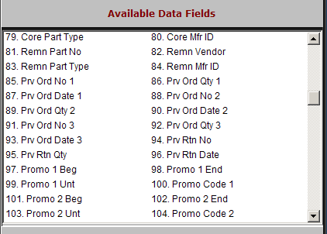

Core Part Type: If the part is linked to a core part, this field shows the part type (C) of the core part number.

Core Mfr. ID: If the part is linked to a core part, this field shows the manufacturer ID of the core part number.

Remn Part No: If the part master is linked to a rebuilt or remanufactured part record, the rebuilt part number is shown in this field.

Remn Vendor: If the part is linked to a rebuilt or remanufactured part, the vendor for that number is shown in this field.

Remn Part Type: If the part is linked to a rebuilt or remanufactured part, the part type of that number is shown in this field.

Remn Mfr ID: If the part is linked to a rebuilt or remanufactured part, the manufacturer ID for that number is shown in this field.

Prv Ord No 1: This field shows the latest order number that contained this part number.

Prv Ord Qty 1: This field shows the last order quantity of the latest order for this part.

Prv Ord Date 1: This field shows the date of the latest order for this part.

Prv Ord No 2: This field shows the previous order number for this part.

Prv Ord Qty 2: This field shows the order quantity of the previous order for this part.

Prv Ord Date 2: This field shows the order date of the previous order for this part.

Prv Ord No 3: This field shows the third most recent order number for this part.

Prv Ord Qty 3: This field shows the order quantity of the third most recent order for this part.

Prv Ord Date 3: This field shows the order date of the third most recent order for this part.

Prv Rtn No: This field shows the last return number that included this part.

Prv Rtn Qty: This field shows the quantity of this part on the last return.

Prv. Rtn Date: This field shows the date of the last return that included this part number.

Promo 1 Beg: This field may hold the beginning date (supplied by the manufacturer) of the first promo code for this part.

Promo 1 End: This field may hold the ending date (supplied by the manufacturer) of the first promo code for this part.

Promo 1 Unt: This field may hold the number of units (supplied by the manufacturer) that can be accumulated for this promo code.

Promo Code 1: This field may hold the promo code (supplied by the manufacturer) that applies to this part.

Promo 2 Beg: This field may hold the beginning date (supplied by the manufacturer) of the second promo code for this part.

Promo 2 End: This field may hold the ending date (supplied by the manufacturer) of the second promo code for this part.

Promo 2 Unt: This field may hold the number of units (supplied by the manufacturer) that can be accumulated for this promo code.

Promo Code 2: This field may hold the promo code (supplied by the manufacturer) that applies to this part.

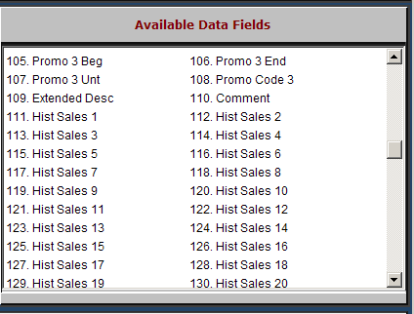

Promo 3 Beg: This field may hold the beginning date (supplied by the manufacturer) of the third promo code for this part.

Promo 3 End: This field may hold the ending date (supplied by the manufacturer) of the third promo code for this part.

Promo 3 Unt: This field may hold the number of units (supplied by the manufacturer) that can be accumulated for this promo code.

Promo Code 3: This field may hold the promo code (supplied by the manufacturer) that applies to this part.

Extended Desc: The Extended Description field can hold a longer description provided by the manufacturer or it can be manually maintained.

Comment: This is a set of two lines. The first line can be printed on a POS invoice and on the parts order printouts. The second can be printed on the parts order printouts.

Hist Sales 1 – 48: This series of 48 fields holds the monthly sales quantities for the last four years. Hist Sales 1 is the current month, Hist Sales 2 is one month ago, etc.

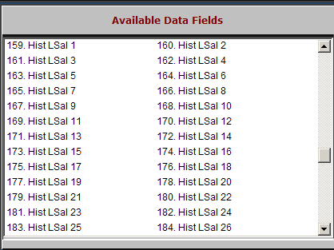

Hist L Sal 1 – 48: This series of 48 fields holds the monthly lost sales quantities for the last four years. Hist LSale 1 is the current month, Hist LSal 2 is one month ago, etc.

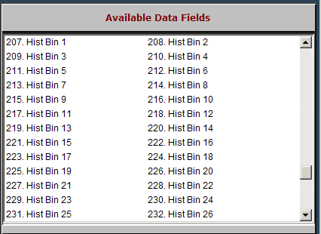

Hist Bin 1 – 48: This series of 48 fields holds the monthly bin trip counts for the last four years. Hist Bin 1 is the current month, Hist Bin 2 is one month ago, etc. Inventory Parts Master

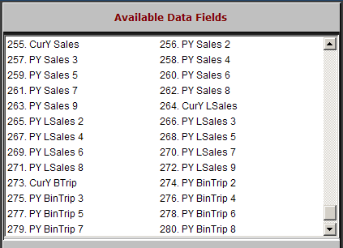

CurY Sales: This field holds the total sales quantity of parts sold in the current calendar year.

PY Sales 2 – 9: This series of 8 fields holds the yearly sales quantity of parts sold in the last nine years. PY Sales 2 is last year, PY Sales 3 is the year before that, etc.

CurY LSales: This field holds the total quantity of lost sales for parts in the current calendar year.

PY LSales 2 – 9: This series of eight fields holds the yearly quantities of lost sales for parts. PY LSales 2 is one year ago, PY LSales 3 is two years ago, etc.

CurY Btrip: This field holds the total bin trip counts for parts in the current calendar year.

PY BinTrip 2 – 9: This series of eight fields holds the yearly bin trip counts for the part. PY BinTrip 2 is one year ago, PY BinTrip is two years ago, etc.

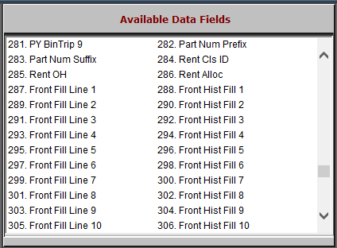

Part Num Prefix: This field is not active.

Part Num Suffix: This field is not active.
- Rent CIs ID: This field is reserved for future use.
- Rent OH: This field is reserved for future use.
- Rent Alloc: This field is reserved for future use.
- Front Fill Line 1-25: These 25 Fill History (Front Counter) fields indicate the quantity of the part replaced at the front counter per month for the past 25 months. Front Fill Line 1 is for the current month, Line 2 for the previous month, etc.
- Front Hist Fill 1-25: These 25 Fill Line (Front Counter) fields indicate how many times the front counter’s supply of that part was refilled per month for the past 25 months. Front Fill Line 1 is for the current month, Line 2 for the previous month, etc.

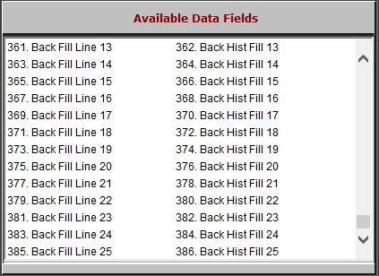

- Back Fill Line 1-25: These 25 Fill Line (Back Counter) fields indicate the quantity of the part replaced at the back counter per month for the past 25 months. Back Fill Line 1 is for the current month, Line 2 for the previous month, etc.
- Back Hist Fill 1-25: These 25 Fill Line (Back Counter) fields indicate how many times the back counter’s supply of that part was refilled per month for the past 25 months. Back Fill Line 1 is for the current month, Line 2 for the previous month, etc.

